Performance Based Learning and Assessment Task

Sand Castle
- ASSESSSMENT TASK OVERVIEW & PURPOSE:
Students will find and compare the volumes of geometric solids including spheres, pyramids, cones, and cylinders.
- UNIT AUTHOR:
Holly Legge - Sherando High School, Frederick County
- COURSE:
Geometry
- CONTENT STRAND:
G.13, G.14
- OBJECTIVES:
The task uses an investigation of real world three-dimensional figures by finding the volume of several types of objects. Students will demonstrate mastery of the concept by working through the task.
- REFERENCE/RESOURCE MATERIALS:
Geometry 2009 Formula Sheet, computers, rulers, compasses, large graph paper, play dough (optional)
- PRIMARY ASSESSMENT STRATEGIES:
The task includes a checklist and a rubric. These documents will perform two functions: (1) for the student it will be a checklist and provide a self-assessment and (2) for the teacher it will be used as a rubric.
- EVALUATION CRITERIA:
Assessment will be based on the attached rubric. Students will be given the opportunity to present their drawings and to self-assess before the teacher assesses the student's work. The evaluation criteria handouts are attached. A benchmark of exemplary work is attached.
- INSTRUCTIONAL TIME:
This activity should take two 90-minute blocks or four 45-minute blocks.

Sand Castle
Strand
Geometry, Measurement

Mathematical Objective(s)
Students will find and compare the volume of real world three-dimensional figures. Students will explore the effect on a shape’s volume when certain measurements are changed. Students will examine the relationship of a cylinder and a cone.
Related SOL
G.13 The student will use formulas for surface area and volume of three-dimensional objects to solve real-world problems.
G.14 The student will use similar geometric objects in two- or three-dimensions to
a) compare ratios between side lengths, perimeters, areas, and volumes;
b) determine how changes in one or more dimensions of an object affect area and/or volume of the object;
c) determine how changes in area and/or volume of an object affect one or more dimensions of the object; and
d) solve real-world problems about similar geometric objects.

NCTM Standards
•analyze properties and determine attributes of two- and three-dimensional objects;
•explore relationships (including congruence and similarity) among classes of two- and three-dimensional geometric objects, make and test conjectures about them, and solve problems involving them;
•establish the validity of geometric conjectures using deduction, prove theorems, and critique arguments made by others;
•make decisions about units and scales that are appropriate for problem situations involving measurement
•analyze precision, accuracy, and approximate error in measurement situations;
•understand and use formulas for the area, surface area, and volume of geometric figures, including cones, spheres, and cylinders
•use unit analysis to check measurement computations

Materials/Resources
- Geometry 2009 Formula Sheet
- Large graph paper
- Computers
- Graphing Calculators
- Rulers, compasses
- Play dough (optional)
Assumption of Prior Knowledge
Students should be familiar with three-dimensional shapes of different orientations and know the properties that describe each shape. Students should be working on at least level 2 of the Van Hiele Scale which means they should be familiar with the names of the shapes, their properties, and their formulas but may not see the connections between shapes or between a shape’s properties and its formulas. Students should be able to discuss the relationships between physical objects and geometric representations. Students should know how to properly use a ruler and compass. Students should be familiar with the concept of a sand castle.

Introduction: Setting Up the Mathematical Task
In this activity, the teacher will ask the students to use previously-learned knowledge about three-dimensional figures to construct and analyze a sand castle made up of cylinders, pyramids, cones, and hemispheres. The students will complete the attached worksheets, the attached assessment list and follow the attached rubric. Students will present their drawings to the class. The activity should take about three hours.

Student Exploration
To introduce the task, the teacher should arrange the students in groups of 2 or 3 and give them the first page of the activity sheet. The teacher should allow students to read the directions then direct the students to begin answering the questions. These first few questions ask the students about the properties of each geometric three-dimensional shape. When the groups finish, the teacher should check each group to make sure they are on the right track.

As the groups complete the first worksheet, the teacher should check to be sure their answers make sense then give each group the second student worksheet. While the students are working, the teacher should walk around the room keeping students on task.
As the groups complete the sand castle design, the teacher should check the designs to be sure they meet the given specifications and give each group the third page of the activity. The teacher should allow students to read over the worksheet and answer any questions before the students begin.
As the groups complete the third part of the activity, the teacher should continue to monitor the students. If a group completes the three worksheets with plenty of time to spare, they may construct a rough three-dimensional model of their sand castle out of play dough.
Once all groups complete all three worksheets, each group will present their projects then the teacher should instruct the students to complete the student assessment portion of the Assessment Checklist. Once this has been completed, students can make any corrections that he/she feel are necessary before submitting the final activity for assessment by the teacher.

Monitoring Student Responses
Students will communicate their thinking and knowledge with their group members and with the whole class by presenting their finished project. As the teacher walks around the room while students are working, the teacher will assist groups who are having difficulties. If a group finishes the entire activity sooner than expected, that group may design a three-dimensional model out of play dough.

To summarize the activity, students will be asked to write briefly about the activity using a prompt.
“Summarize what you did in this activity then add to your writing by answering the following question. We were able to find and compare the volumes of different three-dimensional shapes. Give another example of how you might use such a concept in the real-world.”

Assessment List and Benchmarks

An Assessment List is attached for students to use as a checklist and for the teacher to use while scoring student work.

A Benchmark example of excellent student work is attached
- Journal/writing prompts
  - Summarize what you did in this activity then add to your writing by answering the following questions.
  - We were able to find and compare the volumes of different three-dimensional shapes. Give an example of how you might use such a concept in the real-world.
  - How did this activity go for you? Did you have any complications?
  - What new knowledge did you gain by completing this activity?

Sand Castle
Student Worksheet 1

You will be designing a sand castle out of household items shaped like pyramids, cones, cylinders, and hemispheres (half of a sphere). You may design your sand castle on graph paper. All measurements must be accurate and include appropriate units. You will be constructing the sand castle using two different sizes of pyramids, two different sizes of cylinders, two different sizes of cones and two different sizes of hemispheres.
Here is an example of what the household items may look like and how a couple of them may look as sand formations.
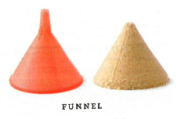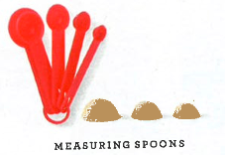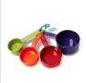
In order to be able to accurately draw the shapes, you need to know a few things.

- List the characteristics of a square-based pyramid.

- Which measurements do you need in order to draw a pyramid?

Volume Formula:_____________________ Surface Area Formula:________________

- List the characteristics of a cone.

- Which measurements do you need in order to draw a cone?

Volume Formula:___________________ Surface Area Formula:_____________________

- List the characteristics of a cylinder.

- Which measurements do you need in order to draw a cylinder?

Volume Formula:__________________ Surface Area Formula:____________________

- List the characteristics of a hemisphere.

- Which measurements do you need in order to draw a hemisphere?

Volume Formula:__________________ Surface Area Formula:______________________

Sand Castle
Student Worksheet 2

It is time to draw your sand castle. Use graph paper, a ruler, and compass. Be sure to label each dimension of each shape with appropriate units on your drawing. Once you are finished drawing your sand castle, raise your hand for the teacher to check.

When calculating how much sand is used to build your sand castle, are you finding the volume or the surface area?

All measurements should be in centimeters. You must include at least two different sizes of each geometric three-dimensional shape in your drawing with the following specifications.

- Cones: The radius of the larger cone should be twice the radius of the smaller cone.

- Pyramids: The height of the larger pyramid should be twice the height of the smaller pyramid.

- Hemispheres: The radius of the larger hemisphere should be twice the radius of the smaller hemisphere.

- The radius of the cones should be equal to the radius of the cylinders.

Sand Castle
Student Worksheet 3

You will be calculating and comparing the volume, or the amount of sand, in each shape.

Volume of Pyramid 1:______________ Volume of Pyramid 2:______________

Volume of Cone 1:_________________ Volume of Cone 2:________________

Volume of Cylinder 1:_______________ Volume of Cylinder 2:______________

Volume of Hemisphere 1:____________ Volume of Hemisphere 2:_____________

Questions:

- How much sand is required to build your entire sand castle?_______________
Show work here.

- How many times larger is the volume of pyramid 1 than pyramid 2?________________
How do you know? Explain.

- How many times larger is the volume of cone 1 than cone 2?_____________________
How do you know? Explain.

- How many times larger is the volume of cylinder 1 than cylinder 2?_________________
How do you know? Explain.

- How many times larger is the volume of hemisphere 1 than hemisphere 2?__________
How do you know? Explain.

- When only one dimension of one geometric three dimensional shape is doubled what happens to its volume? (see the pyramids or spheres)

- When two dimensions of one geometric three dimensional shape are doubled, what happens to its volume? (see the cones)

- What is the relationship between the volume of a cylinder and the volume of a cone? Explain. If you need assistance understanding this relationship, refer to this video: http://www.youtube.com/watch?v=xwPiA0COi8k

Extension Questions

- What happens to the surface area of one geometric three-dimensional figure if one of its dimensions is doubled?

- What happens to the surface area of one geometric three-dimensional figure if two of its dimensions are doubled?

- What happens to the surface area of a cube if all three dimensions are doubled?

Optional:
If time permits, you may design a three dimensional model of your sand castle out of play dough. You do not need to worry about measurements for this model, just construct it to match your drawing. This is not required and will not affect your grade but will serve as an additional visual aid for your presentation.

Example of Student Work – Benchmark
Graph Paper Drawing
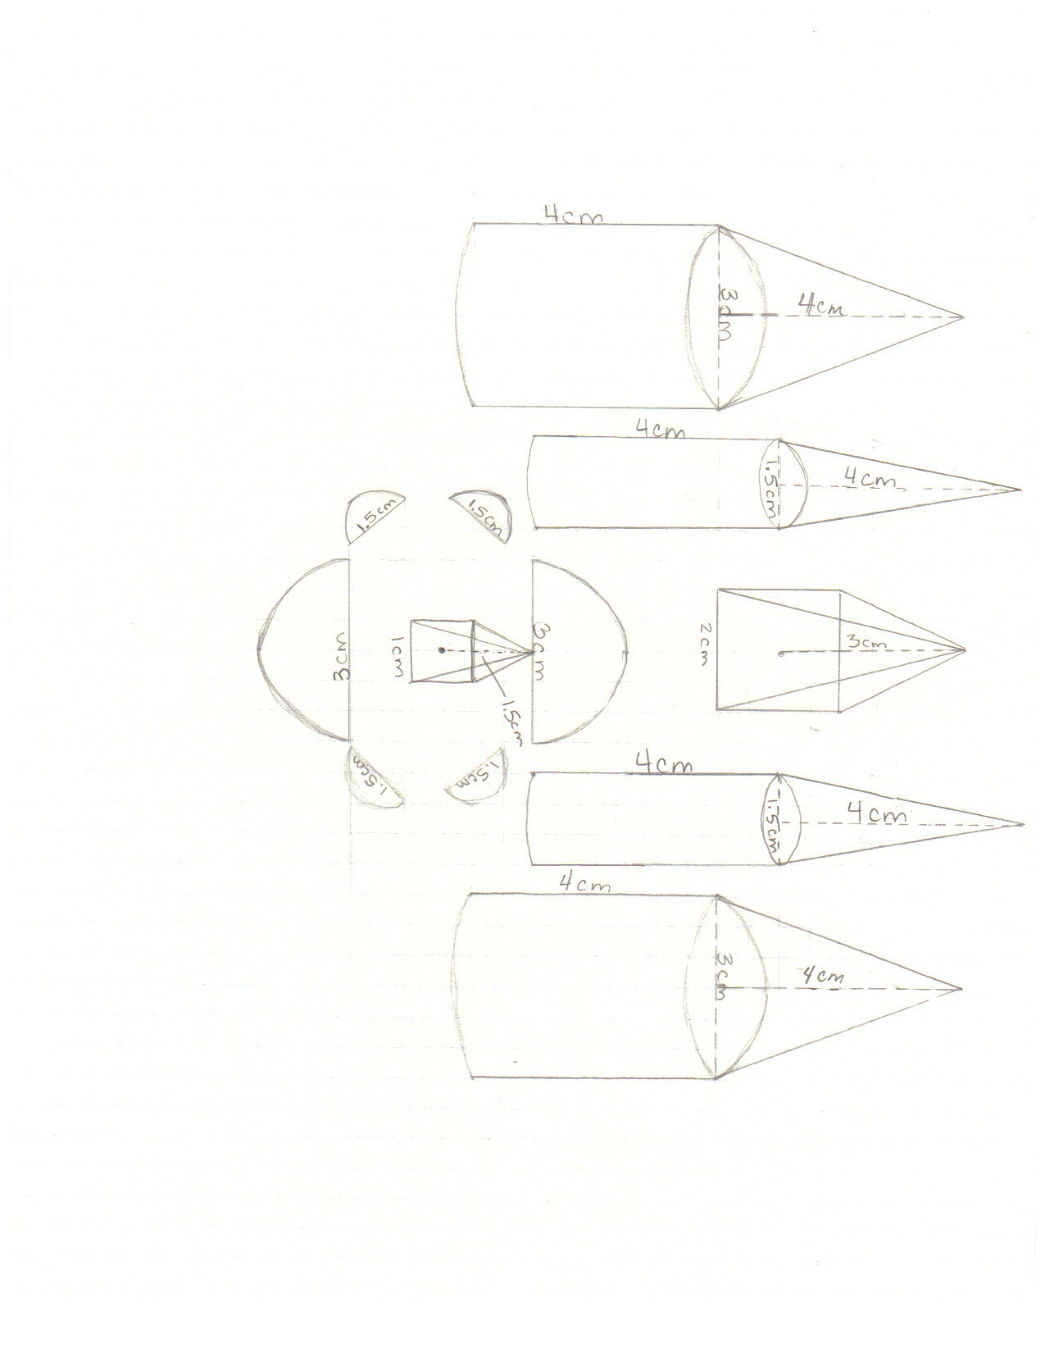

Sand Castle
Student Worksheet 1

You will be designing a sand castle out of household items shaped like pyramids, cones, cylinders, and hemispheres (half of a sphere). You may design your sand castle on graph paper. All measurements must be accurate and include appropriate units. You will be constructing the sand castle using two different sizes of pyramids, two different sizes of cylinders, two different sizes of cones and two different sizes of hemispheres. In order to be able to accurately draw the shapes, you need to know a few things.

- List the characteristics of a square-based pyramid.
The base of the pyramid is a square with all sides measuring the same, all of the other edges meet at a single vertex, it has only one base, the altitude will go from the top vertex to the base forming a right angle with the base, the four faces are triangles of equal size

- Which measurements do you need in order to draw a pyramid? The measure of one side of the base, the altitude, the slant height

Volume Formula: $V=\frac{1}{3}Bh$ Surface Area Formula: $SA=\frac{1}{2}lp+B$

- List the characteristics of a cone.
It has a circular base and one vertex. The altitude goes from the vertex to the base forming a right angle.

- Which measurements do you need in order to draw a cone? Radius or diameter of the base, altitude

Volume Formula: $V=\frac{1}{3}πr^{2}h$ Surface Area Formula: $SA=πr(l+r)$

- List the characteristics of a cylinder.
It has two circular bases and one curved side that forms a rectangle when “unwrapped”. The altitude can be found along the curved side.

- Which measurements do you need in order to draw a cylinder? The diameter or radius of the circular bases, the altitude

Volume Formula: $V=πr^{2}h$ Surface Area Formula: $SA=2πr(h+r)$

- List the characteristics of a hemisphere.
It is exactly half of a sphere, which is shaped like the planet Earth.

- Which measurements do you need in order to draw a hemisphere?
The radius or diameter.

Volume Formula: $V=(\frac{1}{2})\frac{4}{3}πr^{3}$ Surface Area Formula: $SA=(\frac{1}{2})4πr^{2}$

Sand Castle
Student Worksheet 2

It is time to draw your sand castle. Use graph paper, a ruler, and compass. Be sure to label each dimension of each shape with appropriate units on your drawing. Once you are finished drawing your sand castle, raise your hand for the teacher to check.

- When calculating how much sand is used to build your sand castle, are you finding the volume or the surface area? Volume

For the drawing, measurements should be in centimeters. You must include at least two different sizes of each geometric three-dimensional shape in your drawing with the following specifications.

- Cones: The radius of the larger cone should be twice the radius of the smaller cone.

- Pyramids: The height of the larger pyramid should be twice the height of the smaller pyramid.

- Hemispheres: The radius of the larger hemisphere should be twice the radius of the smaller hemisphere.

- The radius of the cones should be equal to the radius of the cylinders.

Sand Castle
Student Worksheet 3

You will be calculating and comparing the volume, or the amount of sand, in each shape. Round your answers to the tenths place.

Volume of Pyramid 1: 4 cm³ Volume of Pyramid 2:_0.5 cm³

Volume of Cone 1:__9.4 cm³____ Volume of Cone 2:__2.4 cm³

Volume of Cylinder 1:__28.3 cm³ Volume of Cylinder 2:__7.1 cm³__

Volume of Hemisphere 1:_7.1 cm³_ Volume of Hemisphere 2:_0.9 cm³___

Questions:

- How much sand is required to build your entire sand castle?__116.7 cm³______
Show work here.

4+0.5+9.4(2)+2.4(2)+28.3(2)+7.1(2)+7.1(2)+0.9(4)=116.7

- How many times larger is the volume of pyramid 1 than pyramid 2?__8 times larger
How do you know? Explain.
I divided the volume of Pyramid 1 by the volume of Pyramid 2 which equals 8 so I knew Pyramid 1 is 8 times larger.

- How many times larger is the volume of cone 1 than cone 2?_4 times larger___________
How do you know? Explain.
I divided the volume of Cone 1 by Cone 2 which equals 4 so I knew Cone 1 is 4 times larger.

- How many times larger is the volume of cylinder 1 than cylinder 2?_6 times larger_
How do you know? Explain.
I divided the volume of cylinder 1 by the volume of cylinder 2 which is 6 so I knew cone 1 is 6 times larger.

- How many times larger is the volume of hemisphere 1 than hemisphere 2?_4 times larger
How do you know? Explain.
I divided the volume of hemisphere 1 by the volume of hemisphere 2 which is 4 so I knew the volume of hemisphere 1 is 4 times larger.

- When only one measurement is doubled what happens to the volume?
It causes the volume to be four times larger.

- When two measurements are doubled, what happens to the volume?
It causes the volume to be eight times larger.

- What is the relationship between the volume of a cylinder and the volume of a cone? Explain. If you need assistance understanding this relationship, refer to this video:
http://www.youtube.com/watch?v=xwPiA0COi8k
The volume of the cone is one third the volume of the cylinder.

Extension Questions

- What happens to the surface area of a three-dimensional figure if one measurement is doubled?
It doubles also.

- What happens to the surface area of a three-dimensional figure if two measurements are doubled?
It will quadruple.

- What will happen to the surface area of a cube if all three dimensions are doubled?
It will be eight times larger.

Optional:
If time permits, you may design a three dimensional model of your sand castle out of play dough. You do not need to worry about measurements for this model, just construct it to match your drawing. This is not required and will not affect your grade but will serve as an additional visual aid for your presentation.

Sample of Play Dough Model
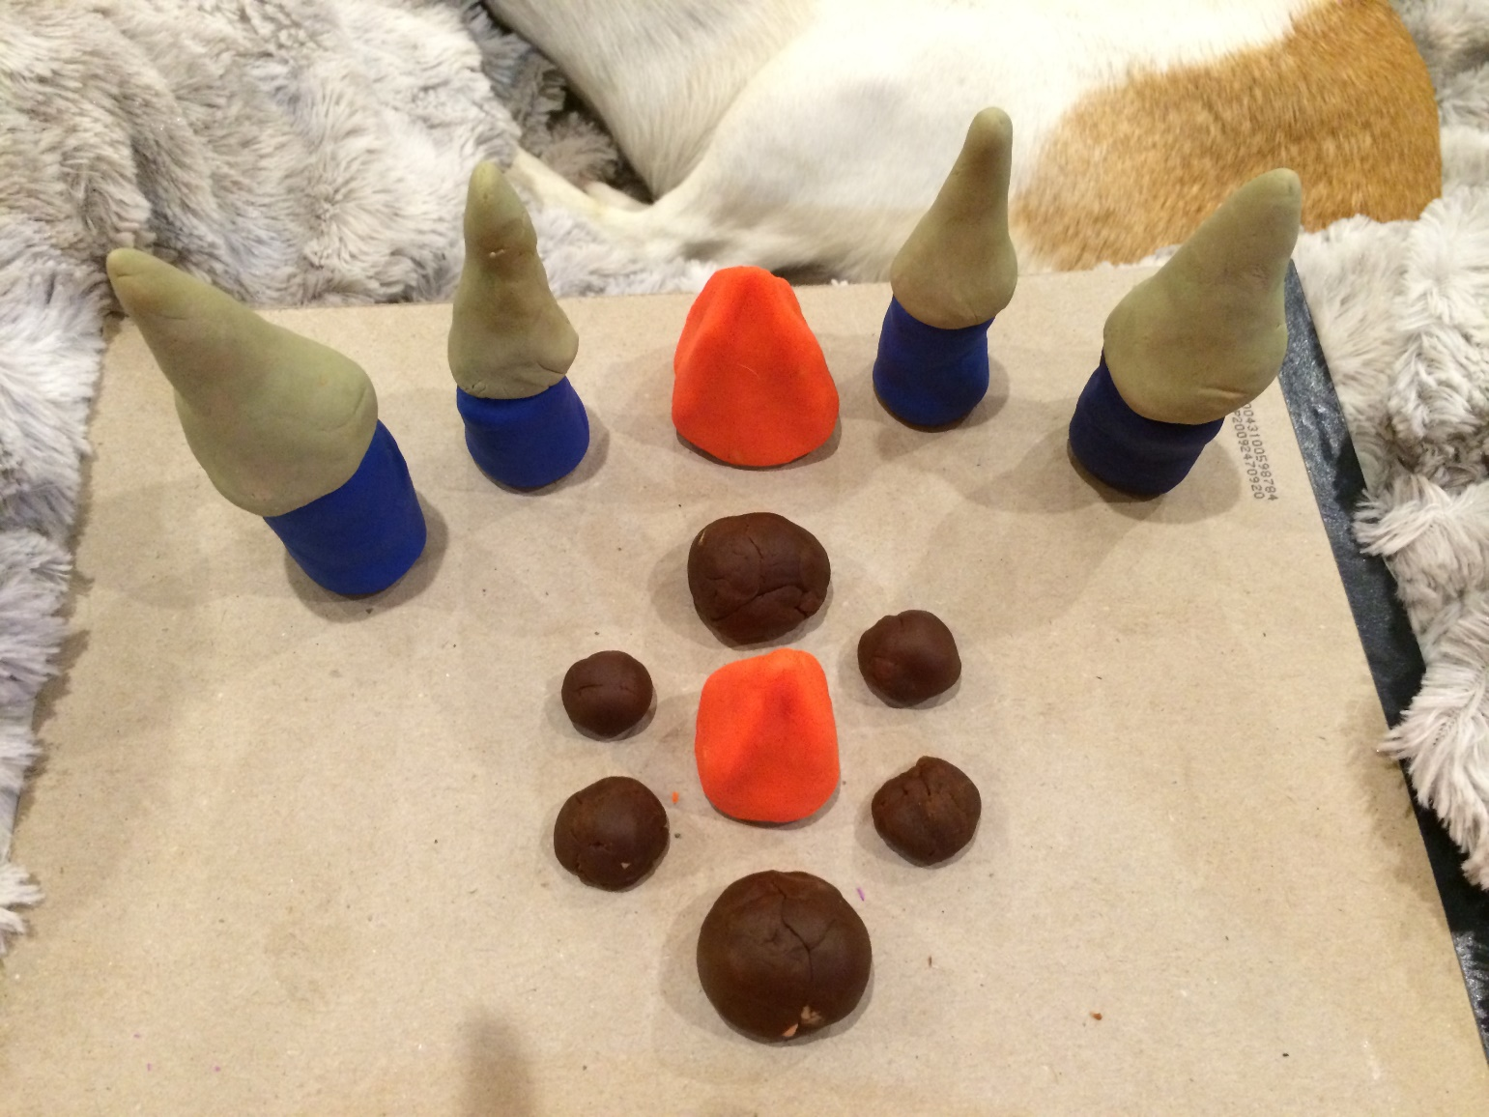

Assessment Checklist: Sand Castle

 |  |  | Earned Assessment
Num. | Element | Point Value | Self | Teacher
1 | I listed all of the important characteristics of a square-based pyramid | 2
2 | I listed the measurements necessary to draw a square-based pyramid | 2
3 | I wrote down the volume and surface area formulas for a pyramid | 2
4 | I listed all of the important characteristics of a cone | 2
5 | I listed the measurements necessary to draw a cone | 2
6 | I wrote down the volume and surface area formulas for a cone | 2
7 | I listed all of the important characteristics of a cylinder | 2
8 | I listed the measurements necessary to draw a cylinder | 2
9 | I wrote down the volume and surface area formulas for a cylinder | 2
10 | I listed all of the important characteristics of a hemisphere | 2
11 | I listed the measurements necessary to draw a hemisphere | 2
12 | I wrote down the volume and surface area formulas for a hemisphere | 2
13 | I answered question #1 on Student Worksheet 2 | 2
14 | I included all 8 shapes on my sand castle drawing | 2
15 | My sand castle is neatly drawn | 2
16 | I included all appropriate measurements with units on my drawing | 2
17 | I correctly calculated the volume for all 8 shapes and included appropriate units | 2
18 | I answered all of the questions on Student Worksheet 3 and my explanations are thorough | 2
19 | I completed the extension activity | 2
20 | I stayed on task for the duration of the activity | 2

Sand Castle
Rubric
 | 3 | 2 | 1 | 0 | Student Score | Teacher Score
Worksheet 1  Pyramid | All important characteristics are listed, all necessary measurements are listed, correct formulas given | Missing 1 important characteristic or missing 1 necessary measurement, correct formulas given | Missing 1 or more important characteristics, some necessary measurements given, formulas contain errors | No important characteristics are listed, no necessary measurements are listed, no/incorrect formulas are given
Worksheet 1  Cone | All important characteristics are listed, all necessary measurements are listed, correct formulas given | Missing 1 important characteristic or missing 1 necessary measurement, correct formulas given | Missing 1 or more important characteristics, some necessary measurements given, formulas contain errors | No important characteristics are listed, no necessary measurements are listed, no/incorrect formulas are given
Worksheet 1  Cylinder | All important characteristics are listed, all necessary measurements are listed, correct formulas given | Missing 1 important characteristic or missing 1 necessary measurement, correct formulas given | Missing 1 or more important characteristics, some necessary measurements given, formulas contain errors | No important characteristics are listed, no necessary measurements are listed, no/incorrect formulas are given
Worksheet 1  Hemisphere | All important characteristics are listed, all necessary measurements are listed, correct formulas given | Missing 1 important characteristic or missing 1 necessary measurement, correct formulas given | Missing 1 or more important characteristics, some necessary measurements given, formulas contain errors | No important characteristics are listed, no necessary measurements are listed, no/incorrect formulas are given
Worksheet 2  Pyramid 1 | All measurements are accurate, units are included, shape is neatly drawn | All measurements are accurate, units missing, shape is neatly drawn | Most measurements are accurate, units are missing, shape is not neatly drawn | This shape is missing from the drawing
Worksheet 2  Pyramid 2 | All measurements are accurate, units are included, shape is neatly drawn | All measurements are accurate, units missing, shape is neatly drawn | Most measurements are accurate, units are missing, shape is not neatly drawn | This shape is missing from the drawing
Worksheet 2  Cone 1 | All measurements are accurate, units are included, shape is neatly drawn | All measurements are accurate, units missing, shape is neatly drawn | Most measurements are accurate, units are missing, shape is not neatly drawn | This shape is missing from the drawing
Worksheet 2  Cone 2 | All measurements are accurate, units are included, shape is neatly drawn | All measurements are accurate, units missing, shape is neatly drawn | Most measurements are accurate, units are missing, shape is not neatly drawn | This shape is missing from the drawing
Worksheet 2  Cylinder 1 | All measurements are accurate, units are included, shape is neatly drawn | All measurements are accurate, units missing, shape is neatly drawn | Most measurements are accurate, units are missing, shape is not neatly drawn | This shape is missing from the drawing
Worksheet 2  Cylinder 2 | All measurements are accurate, units are included, shape is neatly drawn | All measurements are accurate, units missing, shape is neatly drawn | Most measurements are accurate, units are missing, shape is not neatly drawn | This shape is missing from the drawing
Worksheet 2  Hemisphere 1 | All measurements are accurate, units are included, shape is neatly drawn | All measurements are accurate, units missing, shape is neatly drawn | Most measurements are accurate, units are missing, shape is not neatly drawn | This shape is missing from the drawing
Worksheet 2  Hemisphere 2 | All measurements are accurate, units are included, shape is neatly drawn | All measurements are accurate, units missing, shape is neatly drawn | Most measurements are accurate, units are missing, shape is not neatly drawn | This shape is missing from the drawing
Worksheet 3 | All volumes are accurate, questions 1-6 are answered correctly, explanations are thorough | Most volumes are accurate, questions 1-6 are answered correctly, explanations are lacking pertinent information | Some volumes are accurate, some questions 1-6 are answered correctly, explanations are vague or missing | No volumes are accurate, no questions are correct, no explanations provided
Worksheet 3  Extension | All work is accurate and explanations are thorough | Most work is accurate, explanations are adequate | Some work is accurate, explanations are vague | No work is accurate, no explanation is provided

Final Score________

