Performance Based Learning and Assessment Task

Parallel Lines Task
- ASSESSMENT TASK OVERVIEW & PURPOSE:
Students will analyze, modify and reanalyze a physical model of parallel lines in the coordinate plane to help them to move from the concrete to the abstract in their understanding of the characteristics of parallel lines.
- UNIT AUTHOR:
Nathan Hansard, Community High School, Roanoke VA
- COURSE:
Geometry
- CONTENT STRAND:
Geometry
- OBJECTIVES:
Students will discover the relationships between angles and between slopes when two parallel lines are cut by a transversal.
- REFERENCE/RESOURCE MATERIALS:
None
- PRIMARY ASSESSMENT STRATEGIES:
Parallel Analysis Handouts, Parallel Concept Application Handout, Parallel Lines at Home Handout
- EVALUATION CRITERIA:
Students' work is progressively evaluated throughout the activity using the Parallel Analysis Handout, while it is also assessed at the end using the Parallel Concept Application Handout. Students' ability to apply the ideas in the lesson to real-world situations will be assessed with the Parallel Lines at Home Handout.
- INSTRUCTIONAL TIME:
One ninety-minute class session

Discovering Relationships Formed When Two Parallel Lines Are Cut by a Transversal
Strand
Geometry

Mathematical Objective(s)
Students should discover the relationships between the angles formed by two parallel lines cut by a transversal and the relationship between the slopes of parallel lines. This lesson is designed to encourage students to move from a concrete study of a specific case to an abstract understanding of a general case. Moreover, it is specifically designed as a discovery activity that does not require access to computers that may or may not be available on the day assigned to this topic.
Related SOL
SOL G.2 (a, b, c)

NCTM Standards
- Analyze characteristics and properties of two- and three-dimensional geometric shapes and develop mathematical arguments about geometric relationships
- analyze properties and determine attributes of two- and three-dimensional objects
- explore relationships (including congruence and similarity) among classes of two- and three-dimensional geometric objects, make and test conjectures about them, and solve problems involving them
- Specify locations and describe spatial relationships using coordinate geometry and other representational systems
- investigate conjectures and solve problems involving two- and three-dimensional objects
- use Cartesian coordinates and other coordinate systems, such as navigational, polar, or spherical systems, to analyze geometric situations

Materials/Resources
Students will use: Two different colors of tape, protractor
Assumption of Prior Knowledge
- Students should already be able to determine the slope of a line by means of either counting slope or else using the definition of slope in the form of the slope equation and to use a protractor to measure angles.
- To succeed with this activity, students should have passed Algebra I and be operating on now lower than Analysis level on the VanHiele scale in terms of understanding angles.
- Students should express their findings using appropriate units for angles, and should express slopes as rational expressions, not as decimals.
- Students might find inverse slopes by juxtaposing y ("rise") with x ("run") in their preferred method for finding slope.
- Students should already know how to use a protractor and how to find slope using counting and/or formulaic means.
- All problems involving linear modeling (and modeling by power and exponential functions with curve straightening) require a deep understanding of slope to construct models that make sense in context.

Introduction: Setting Up the Mathematical Task
- In this task/activity students should discover the relationships between the angles formed by two parallel lines cut by a transversal and the relationship between the slopes of parallel lines.
- Students should walk in with the room already prepared for the lesson. As many coordinate planes as possible should be prepared with the two parallel lines and the transversal included (second, so that they can be removed). To set up the gridlines, teachers should follow these directions:
- The teacher will have used masking tape of Color #1 to create coordinate plane axis on the floor of the classroom before class begins. As many as possible will be created to allow for a minimization of group size, with a minimum size of each area being 5x5 floor tiles, allowing for the creating of planes centered at the origin ranging from -3 to 3 on each axis with at least one floor tile between each set of axis. Onto each set of axis, the teacher will have created three lines using tape of Color #2> (This MUST be placed second, so that it can be removed without disrupting the tape that represent the axes.) The first shall be the line x=1. The second shall pass through the points (1, 1) and (4, 3). The third shall pass through the points (1, -3) and (4, -1). The teacher will have placed one protractor into each area for student use. Example of the diagram is attached in this document.
- At the beginning of class, the teacher asks the students what they see, using appropriate wait time and leading questions to elicit as much as possible from the students. All valid observations are written on the board.
- This lesson is meant to be a collaborative exercise, but the size of the groups is dictated by class size as well as the size and shape of the classroom or hall space available. Groups should be constructed by the classroom teacher to fit any differentiation or other instructional goals as they see fit.
- Students should be encouraged to/helped to verbally express their discoveries as they occur by the teacher as they observe the discovery process.
- The teacher should offer leading questions to student groups that seem stuck, but should NOT provide answers to questions!
- Outstanding work that results from this activity should be posted publically (in the hallway or on a classroom bulletin board (with student permission).

Student Exploration
Whole Class Sharing/Discussion
- Students should wander freely to explore the graphs on the floor of the classroom at the beginning of class and to share ideas about what they see
Small Group Work
- Once class discussion of things seen on the initial graphs is complete:
- Teacher assigns students to pre-determined groups and distributes the Parallel Analysis Handout to the students for analysis of their assigned plot.
- Students work together to compete the Parallel Analysis Handout.
- Class discussion of what they discovered.
- Each group should remove all tape representing parallel lines and transversals (color # 2).
- Each group should make one line on their plane passing through a pair of points whose points are bounded by [-3, 3].
- Groups should be rotated "clockwise" to the next group's plane and fill out the second row of the Parallel Analysis Handout.
- Students should construct lines on their new planes parallel to those who came before them using tape (color #2) and a transversal between them that passes though points with integral coordinates.
- Teacher checks for success at this activity before moving on, re-teaching as necessary with groups as needed.
- Students rotate to the next plane "clockwise" once more and complete the Parallel Analysis Handout for their new diagram. Teacher should be moving quickly between groups to help with leading questions when errors occur.
- Repeat this process as much as time/teacher on the spot assessment allows/deems necessary to still allow for Individual Work below.
Individual Work
- Students complete the Parallel Concept Application Handout.
- Students complete the Parallel Lines at Home Handout as homework, due the next class.

Student/Teacher Actions:
- Students should be working collaboratively to discover the patterns in the angles formed by the intersection of two parallel lines cut by a transversal and the relationship between the slopes of the parallel lines.
- The teacher should be moving between groups as frequently as possible to address questions and/or help the students to correct their own errors throughout the lesson.
- The teacher should be on the lookout for lines missing two points with integral coordinates and lines that are not parallel.
Monitoring Student Responses
- Students should be actively engaged with the analysis of their differing parallel line setups, and should be actively sharing and analyzing each others' answers
- Students should be actively engaged with the analysis of their differing parallel line setups, and should be actively sharing and analyzing each others' answers
- Students should be actively analyzing and critiquing each others' work throughout
- Topics that are the focus of student/teacher interaction: Slopes of parallel lines, angle relationships when two parallel lines are cut by a transversal
- The teacher can interject linear expressions for constants for any group which masters the ideas quickly during repeated creation of new setups with lines in the coordinate plane (congruent or supplementary pairs, as determined by the teacher)
- Students should be allowed at least 5 minutes of time after the closing activity to discuss the key points that they discovered, led by the teacher
- Students' work is collected for later analysis throughout the lesson.

Assessment List and Benchmarks
Students are to be evaluated during the discovery process by way of the Parallel Analysis
Handouts and the Parallel Concept Application Handout, poor results on which might suggest re-teaching this concept to address a different set of leaning modalities. Students' ability to apply the concepts of the lesson are assessed by means of the Parallel Lines at Home Handout.
Scoring rubrics (which should also be given to the students with all assignments so that they can "score themselves" as they go using the same tool the teacher will be using) are included for each of the assessments. How to translate rubric scores to actual grades in the teacher's classroom is left up to the individual teacher.

How Teacher Should Set-up Masking Tape Grid for Students
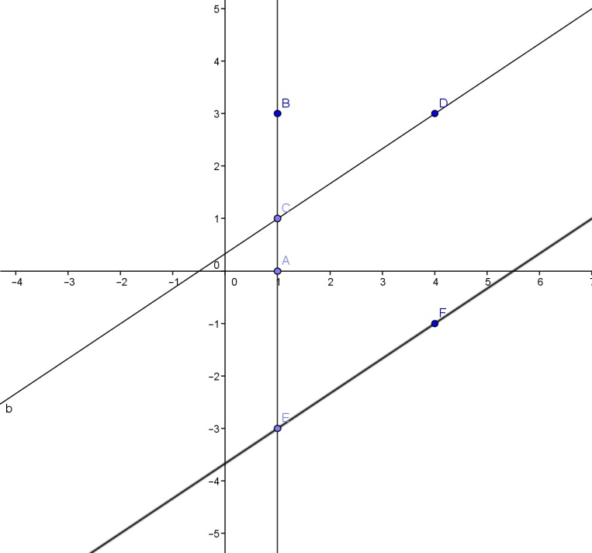

Parallel Analysis Handout
Look at the set of lines on the floor in front of you. Answer the following questions in your own words, including appropriate units!
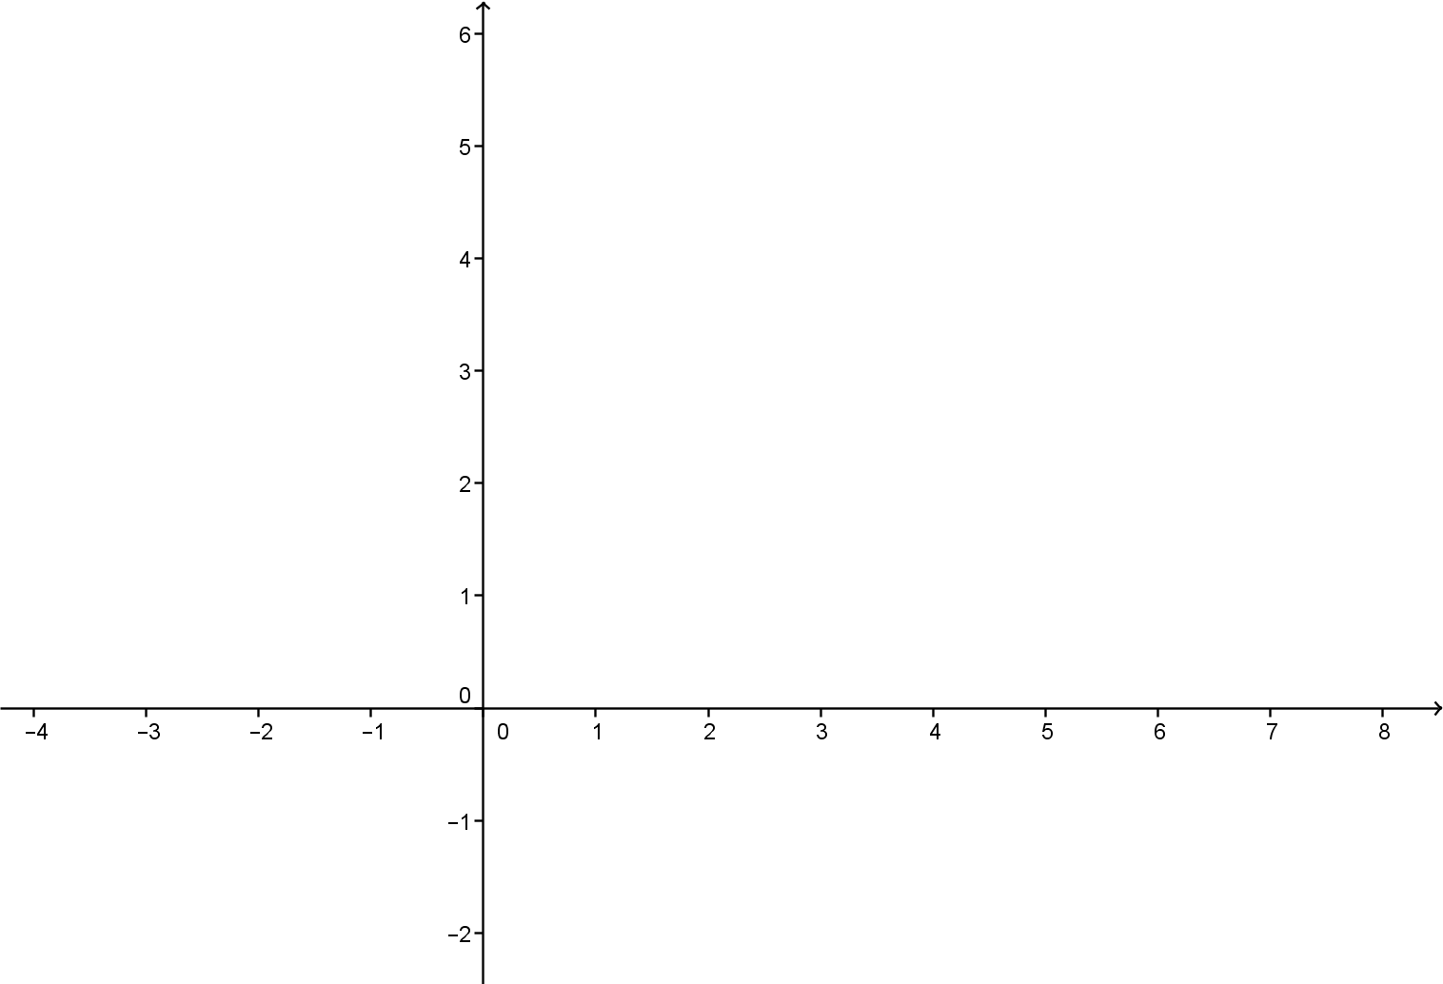
Draw a sketch of the lines on the floor above, then number the angles you see 1-8. Label the lines that you see as a, b and c.
Label each line above with its slope and each angle above with its measure (using the protractor as necessary.
Looking at the slopes of the lines above, in your own words describe the patterns you see, if any:
_____________________________________________________________________
_____________________________________________________________________
_____________________________________________________________________
Now look at the angles you have labeled. What patterns if any do you see in their measures?
_____________________________________________________________________
_____________________________________________________________________

Parallel Analysis Handout Scoring Rubric
 | 2 | 1 | 0
Diagram Quality | Diagram is accurate and neatly drawn and includes all labels (not of computed values, just object names) | Diagram is accurate but sloppy and/or missing labels (not of computed values, just object names) | Diagram in inaccurate outright or else too sloppily drawn to tell if it is accurate
Slopes of Lines | Slopes of all three lines properly computed with method shown, correct pattern analysis is given | Slopes of at least the parallel lines properly computed with method shown, pattern analysis is missing or incorrect | Slopes of lines are incorrect and/or no method shown (NOTE: Correct answers with no method shown receive zero points)
Angles Formed | All angles are labeled using correct notation (e.g.: "$m∠1={35}^{o}$") and are reasonably accurate (to within 5 degrees). A useful pattern has been identified. | All angles are labeled using weaker notation (e.g.: "${35}^{o}$") and are fairly accurate (to within 10 degrees). A useful pattern has been identified. | Angles are not labeled at all or else are woefully inaccurate (off by more than 10 degrees) and/or no useful pattern has been identified

Parallel Concept Application Handout
Use the diagram below to answer the questions and to perform the following tasks.
1) Label all angles in the diagram above with accurate angle measures.
2) Compute the slopes by your preferred method with work shown, and fill in your answers below:
Slope of $\overset{⃡}{AB}$ = ________

Slope of $\overset{⃡}{CD}$ = ________

3) In your own words, give two different arguments that the lines $\overset{⃡}{AB}$ and $\overset{⃡}{CD}$ are parallel:
First Reason | Second Reason

Parallel Concept Application Handout Scoring Rubric

 | 2 | 1 | 0
Diagram Quality | Diagram is accurate and neatly drawn and includes all labels (not of computed values, just object names) | Diagram is accurate but sloppy and/or missing labels (not of computed values, just object names) | Diagram in inaccurate outright or else too sloppily drawn to tell if it is accurate
Angles Labeled | All angles are labeled accurately using correct notation | All angles are labeled accurately using weaker notation  (e.g.: "${35}^{o}$") | Angles are not labeled at all or else are labeled inaccurately
Slopes of Lines | Slopes of all both lines properly computed with method shown | Slopes of all both lines computed with only minor errors, method shown | Slopes of lines are incorrect and/or no method shown (NOTE: Correct answers with no method shown receive zero points)
Application of Reasoning  (does NOT require a proof!) | Two different reasons are given, both solidly stated and supported | Only one reason is given (but it is solidly stated and supported)  OR  Two different reasons are given, but the support is weak | Only one reason given, but with weak support  OR  No reasons given/reasoning is incorrect

Parallel Lines at Home Handout

1) Parallel lines appear all over the place! For class tomorrow, find several examples of parallel lines in this school, your home or somewhere else entirely. Provide at least two examples, and explain why in each case how you know that the lines are indeed parallel!

2) Use what you know to lay out an aerial view of a set of roads. You are free to do this however you choose, but your map must include markings for all parallel lines and all angle measures. Your map MUST contain at least three roads that are parallel to one another and at least one road that crosses the three parallel roads.

Scoring Rubric

 | 2 | 1 | 0
Real-world Examples | At least two examples are given with solid reasoning as to why parallel lines exist in the example | Only one example is given with solid reasoning as to why parallel lines exist in the example | No examples given, or else no solid reasoning is provided for the examples given, regardless of their number
Created Road Map | All required roads provided and all marks are both present and correct in terms of how parallel lines behave | All required roads provided with only minor errors/omissions in terms of labeling and angle measures | All required roads are NOT provided or else there are major errors/omissions in terms of labeling and angle measures

Benchmarks

