Performance Based Learning and Assessment Task

Properties of Different Quadrilaterals
- ASSESSSMENT TASK OVERVIEW & PURPOSE:
This activity will help students solidify the properties of quadrilaterals through a performance- based task
- UNIT AUTHOR:
Cara Saavedra, Yorktown High School, Arlington Public Schools.
- COURSE:
Geometry
- CONTENT STRAND:
Geometry
- OBJECTIVES:
Students will show mastery of understanding the properties of quadrilaterals
- REFERENCE/RESOURCE MATERIALS:
Students will use a worksheet for the task.
- PRIMARY ASSESSMENT STRATEGIES:
Pre-assessment followed by group activity and assessment
- EVALUATION CRITERIA:
Pre-Evaluation and teacher Assessment, Teacher Assessment Rubric
- INSTRUCTIONAL TIME:
One 45-minute class session.

Strand
Ge o m e t r y

Mathematical Objective(s)
Students will explore a variety of sets of quadrilaterals to investigate the properties of them.
Students will apply characteristics and properties or them throughout the lesson.

Related SOL

G.1 Use Venn diagrams to represent set relationships
G.9 The student will verify characteristics of quadrilaterals and use properties of
quadrilaterals

NCTM Standards :
Analyze characteristics and properties of two- and three-dimensional geometric shapes and develop mathematical arguments about geometric relationship. • Use visualization, spatial reasoning, and geometric modeling.

Materials/Resources
Student Handout (Teacher Key Attached)

Assumption of Prior Knowledge
• Students should have completed the unit which covers properties of parallelograms before
attempting the worksheet. Students should be at a Van Hiele Level of either a one
(Visualization) or 2 (Analysis) meaning that they should be able to name some of the
properties associated with the different quadrilaterals but are still struggling relating the
properties together
• Due to variations in definitions of a trapezoid and a kite, students should be using the
following definitions:

o A trapezoid is a quadrilateral with exactly one pair of parallel sides, called bases. The
nonparallel sides are legs.
o A kite is a quadrilateral with two pairs of adjacent, congruent sides and one pair of
opposite angles congruent.

2

Introduction: Setting Up the Mathematical Task
• In this task/activity, you will investigate the relationship between all quadrilaterals and to
be able to identify and explain their thinking for the different figures. This task should be
completed in 45 minutes. The task will have students explain their thinking by looking at different groups of quadrilaterals and determining which shape does not belong with the
others. Students should complete this in a Think/Pair/share activity. It is important for each student to have time to formulate their own ideas and then be able to express them.
• Another useful technique that could be used in this activity is to have students explain their
thinking to one another but then have the partner rephrase the thinking of their partner.
Math discourse should be used throughout this entire activity.

3

Pre-Assessment: Student Worksheet

Please note, the following definitions will be used in the instrument below:
A trapezoid is a quadrilateral with exactly one pair of parallel sides, called bases. The
nonparallel sides are legs.
A kite is a quadrilateral with two pairs of adjacent, congruent sides and one pair of opposite
angles congruent.

_____ 1. A rhombus is a quadrilateral.

_____ 2. If a quadrilateral is a square then it is also a rectangle.

_____ 3. If a quadrilateral is a trapezoid then it is also a parallelogram.

_____ 4. If a quadrilateral is a rectangle then it is also a square.

_____ 5. If a quadrilateral is a rhombus then it is also a square.

_____ 6. If a quadrilateral is a parallelogram then it is also a rhombus.

_____ 7. If a quadrilateral is a square then it is also a parallelogram.

_____ 8. An isosceles trapezoid is a parallelogram.

_____ 9. A rectangle is an isosceles trapezoid.

_____ 10. A quadrilateral with four congruent sides is a square.

_____ 11. A quadrilateral with four right angles is a rectangle.

_____ 12. A trapezoid has two pairs of parallel sides.

_____ 13. A rectangle has congruent opposite sides.

_____ 14. A parallelogram has one pair of parallel sides.

_____ 15. A parallelogram always has four congruent sides.

_____ 16. A kite has perpendicular diagonals.

4

STUDENT HANDOUT Name __________________________________

Please note, the following definitions will be used in the instrument below:
A trapezoid is a quadrilateral with exactly one pair of parallel sides, called bases. The
nonparallel sides are legs.
A kite is a quadrilateral with two pairs of adjacent, congruent sides and one pair of opposite
angles congruent.

1) With a partner, create a venn diagram or a tree diagram which relates all quadrilaterals.
Kites, Trapezoids, Rectangles, Rhombi, Squares, Parallelograms

2) Take time to review your pretest based on the diagram you created above. If there is an answer you change please provide an explanation as to why you have changed your answer.

3) Grouping activity:

Directions: Look at each set of figures. Which shape(s) would you exclude from the rest? You must justify why you believe your answer to be correct. There may be more than one correct
answer so your justification is what will provide you with points. Assume all figures are not
drawn to scale so look at the markings on the figure to help you. Be as detailed and specific as possible.

Set #1

A
B

C

D
E

5

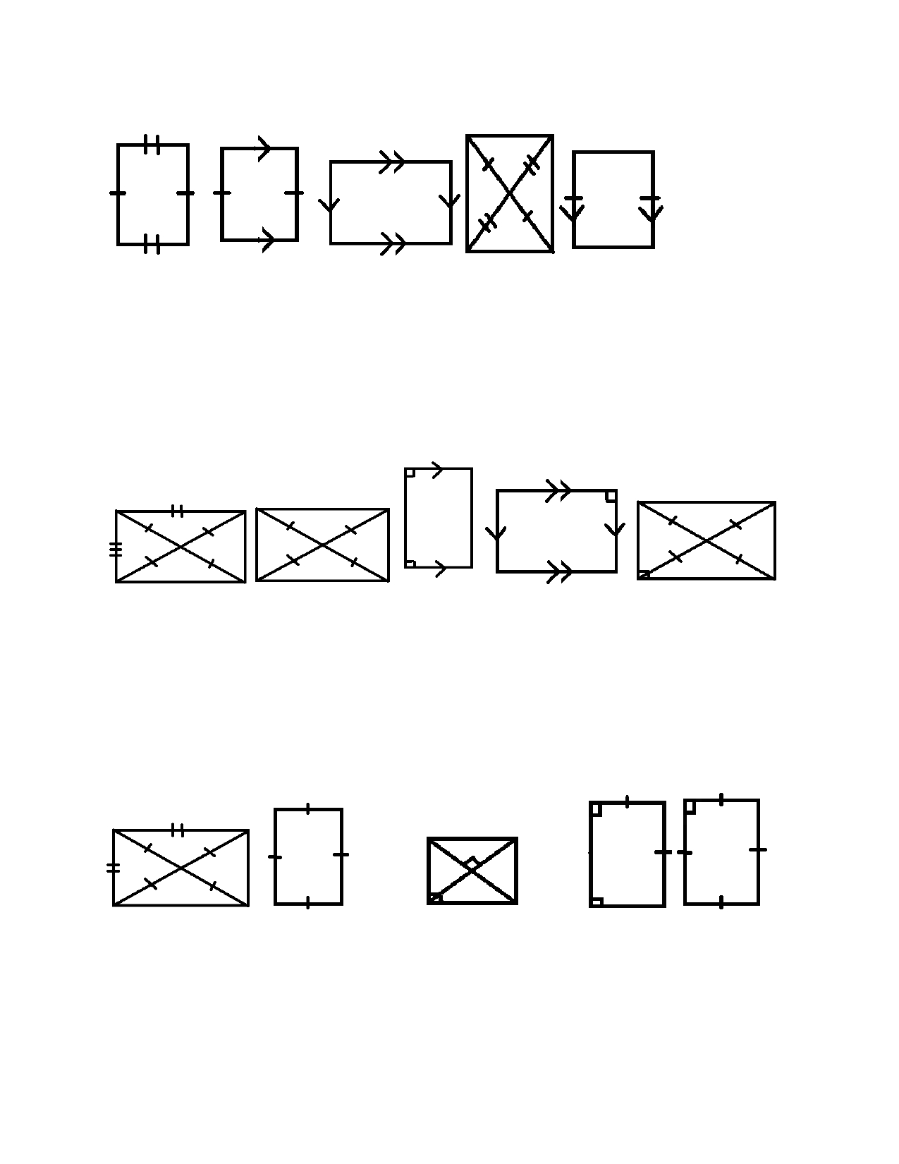Set #2

A

Set #3

A

B

B

C

C

D

D

E

E

Set #4 - Assume all are parallelograms

B D E

C
A

6

Set # 5 and beyond: With a partner, make your own set of a group of 5 or more objects where
one shape does not belong. Swap with another partner group and discuss. Does your answer match the other group? If no, are you both correct? Explain.

Extension Questions:
1) Draw as many different quadrilaterals that you can with the following properties
a) congruent diagonals.

b) perpendicular diagonals

c) exactly one pair of congruent sides

d) at least one pair of opposite angles congruent

e) at most one pair of opposite congruent sides

7

2) You have decided to make a rectangular picture frame with side lengths 20 in by 16 in. You
hope that your frame is in the shape of a rectangle but you don't have a way to measure the angles.
a) You measure the diagonals of your frame and find that one diagonal measures 23
cm. Is your frame a rectangle? Explain why or why not. If not, explain what type of shape you have.

b) What other measurement(s) could you find in order to be sure your frame is
rectangular?

3) At home activity: Find a trapezoid, rectangle, square, kite and parallelogram. Take a picture
and then print it in order to bring to school tomorrow. Use your picture to do one last check of the properties that we reviewed/reinforced yesterday in class. How can you be sure your shape
is what you think it is?

8

Student Exploration
The order and components of exploration is up to you.
Individual Work: Students should individually examine the groups of quadrilaterals and
determine the shape the does not belong. Correct answers are based on the students' answers and how they are able to support their thinking.
Whole Class Sharing/Discussion: Students should have to justify their answers in a whole group format.
Student/Teacher Actions:
• Students should be investigating quadrilaterals and looking at common properties between
the figures. They should come up with the shape that doesn't belong with the others. The
key idea of this activity is that students are able to justify why they believe the shape does not actually fit with the others.
• The teacher should play the role of facilitator in making sure there is discussion between
the students and overall whole class. The teacher should ask for students to support their
classmates or offer counter statements if they disagree with a student.
• Students tend to confuse the properties of quadrilaterals so this activity will help to explain
and solidify their knowledge
Monitoring Student Responses
Students should be communicating throughout this activity as they discuss the shapes
within their groups. Based on their responses, the teacher should ask more leading
questions if necessary. Students should be able to defend their answers and share with the class.
Students should first do the Pre-Assessment and the results should be discussed in a
whole group discussion. Then students should be given the sets of quadrilaterals within their groups. Each group should come up with the one shape they would exclude from the others but more importantly be prepared to discuss their thinking.
After each group has doing the four provided sets, they should then try to make up their own and swap with another pair.
As a post assessment check, teacher could have students list out the properties associated with the different quadrilaterals in their own words.

Assessment List and Benchmarks
Preassessment: Allow students to answer the true/false questions on worksheet 1.
Grouping Activity: Handout Attached. The discussion should be a key to assessing student understanding.
• Included is a key which should help the teacher guide students through the work.
• Sample Rubrics
o http://www.rubrics4teachers.com/pdf/PerformanceTaskRubric.pdf

9

BENCHMARKS
Pre-Assessment:

TRUE_____ 1. A rhombus is a quadrilateral.

TRUE_____ 2. If a quadrilateral is a square then it is also a rectangle.

FALSE_____ 3. If a quadrilateral is a trapezoid then it is also a parallelogram.

FALSE_____ 4. If a quadrilateral is a rectangle then it is also a square.

FALSE_____ 5. If a quadrilateral is a rhombus then it is also a square.

FALSE_____ 6. If a quadrilateral is a parallelogram then it is also a rhombus.

TRUE_____ 7. If a quadrilateral is a square then it is also a parallelogram.

FALSE_____ 8. An isosceles trapezoid is a parallelogram.

FALSE_____ 9. A rectangle is an isosceles trapezoid.

FALSE_____ 10. A quadrilateral with four congruent sides is a square.

TRUE_____ 11. A quadrilateral with four right angles is a rectangle.

FALSE_____ 12. A trapezoid has two pairs of parallel sides.

TRUE_____ 13. A rectangle has congruent opposite sides.

FALSE_____ 14. A parallelogram has one pair of parallel sides.

FALSE_____ 15. A parallelogram always has four congruent sides.

TRUE_____ 16. A kite has perpendicular diagonals.

10

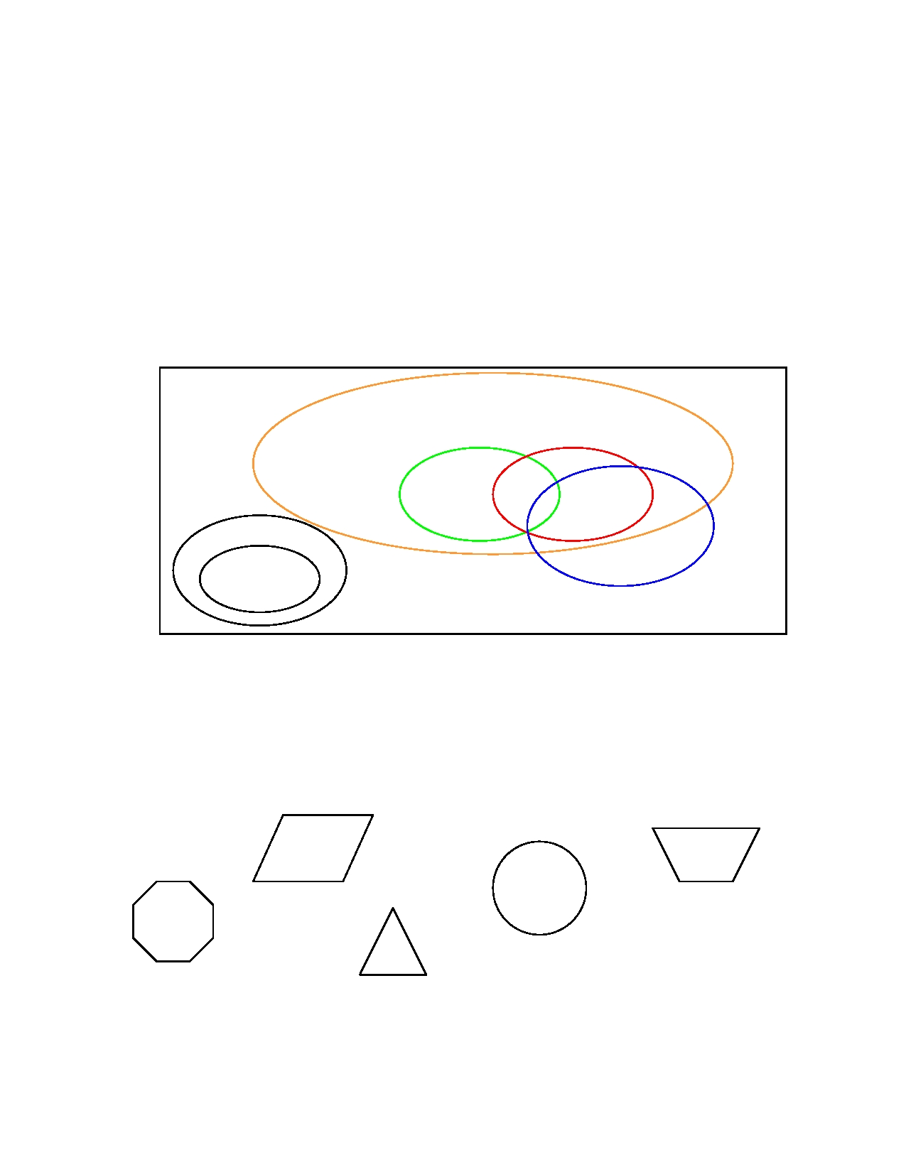Please note, the following definitions will be used in the instrument below:
A trapezoid is a quadrilateral with exactly one pair of parallel sides, called bases. The
nonparallel sides are legs.
A kite is a quadrilateral with two pairs of adjacent, congruent sides and one pair of opposite
angles congruent.

1) With a partner, create a venn diagram or a tree diagram which relates all quadrilaterals.
Kites, Trapezoids, Rectangles, Rhombi, Squares, Parallelograms
Answers may vary in how the venn diagram is designed to fit rhombi and squares within kites.
This is a simplistic model but there are others available on the internet which are more complex, that students would enjoy exploring.

Quadrilaterals

Parallelograms

Rectangles Squares
Rhombi
Trapezoids
Kites
Isosceles
Trapezoids

2) Take time to review your pretest based on the diagram you created above. If there is an answer you change please provide an explanation as to why you have changed your answer.

See above for the pre-test answers.

Grouping activity:
Set #1

A
B

C

D
E

SET 1 TEACHER NOTES - Shape D should be excluded since it has rounded edges thus not a
polygon. AGAIN ANSWERS MAY VARY SO LISTEN TO YOUR STUDENTS AS THEY DISCUSS

11

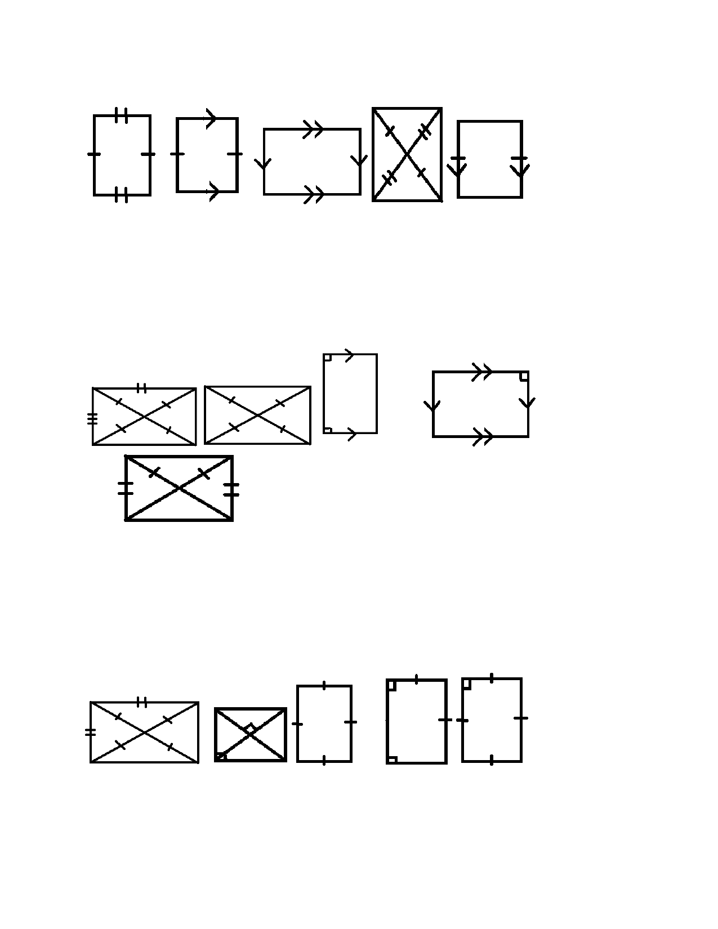Set #2
D
A B E
C

SET 2 TEACHER NOTES - Shape B should be excluded since it is not necessarily a
parallelogram. Since we are using the definition of a trapezoid which is provided above, B
could be a parallelogram but it could also be a trapezoid. All of the others fit the properties
of a parallelogram. AGAIN ANSWERS MAY VARY SO LISTEN TO YOUR STUDENTS AS THEY
DISCUSS

Set #3

C
D
A B

E

SET 3 TEACHER NOTES - Shape E should be excluded since it is not necessarily a rectangle.
AGAIN ANSWERS MAY VARY SO LISTEN TO YOUR STUDENTS AS THEY DISCUSS

Set #4 - Assume all are parallelograms

A

B

C

D

E

SET 4 TEACHER NOTES - Shape C should be excluded since it is not necessarily a square.
AGAIN ANSWERS MAY VARY SO LISTEN TO YOUR STUDENTS AS THEY DISCUSS

12

Set # 5 and beyond: With a partner, make your own set of a group of 5 or more objects where
one shape does not belong. Swap with another partner group and discuss. Does your answer match the other group? If no, are you both correct? Explain.

Extension Questions:
1) Draw as many different quadrilaterals that you can with the following properties
a) congruent diagonals. (Rectangle, Square, Isosceles Trapezoid, some kites)

b) perpendicular diagonals (Rhombus, Square, Kite)

c) exactly one pair of congruent sides (Isosceles Trapezoid)

d) at least one pair of opposite angles congruent (Kite, Rhombus, Parallelogram,
Square, Rectangle)

e) at most one pair of opposite congruent sides (Trapezoid, Isosceles Trapezoid)

2) You have decided to make a rectangular picture frame with side lengths 20 in by 16 in. You
hope that your frame is in the shape of a rectangle but you don't have a way to measure the angles.
a) You measure the diagonals of your frame and find that one diagonal measures 23
cm. Is your frame a rectangle? Explain why or why not. If not, explain what type of shape you have. This shape is not a rectangle since the diagonals would have to measure 25.6 in order to make a rectangle. Based on the following measurement, all you can assume is that your shape is a parallelogram.

b) What other measurement(s) could you find in order to be sure your frame is rectangular? The diagonals would have to be congruent.

13

3) At home activity: Find a trapezoid, rectangle, square, and parallelogram. Take a picture and
then print it in order to bring to school tomorrow. Use your picture to do one last check of the properties that we reviewed/reinforced yesterday in class. How can you be sure your shape is what you think it is? Answer may vary.

3) Have students go home and find a trapezoid, rectangle, square, and parallelogram. Have students take and then print out a picture and bring it in the following day. Use the pictures they took to do one last check of the properties they should worked on the prior day.

14

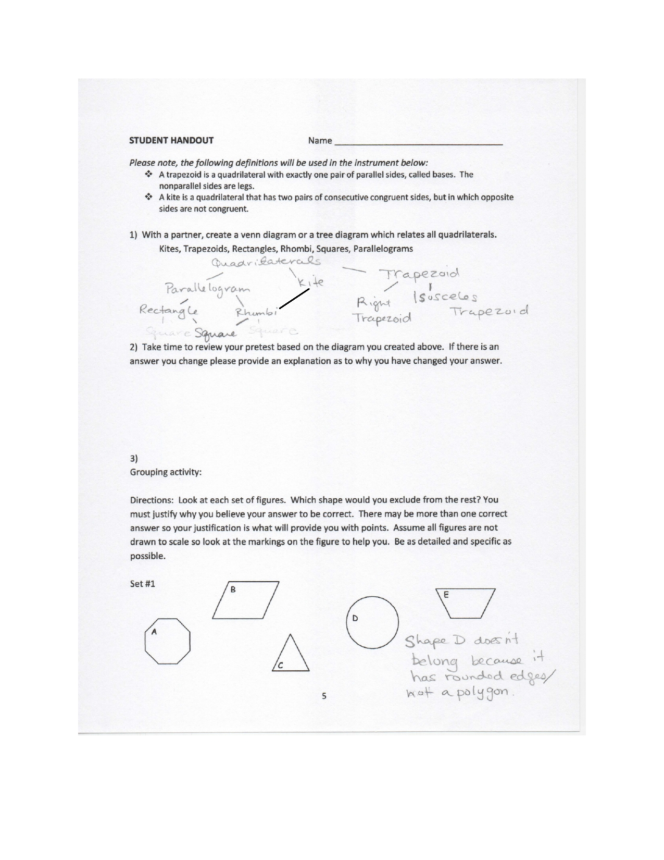

15

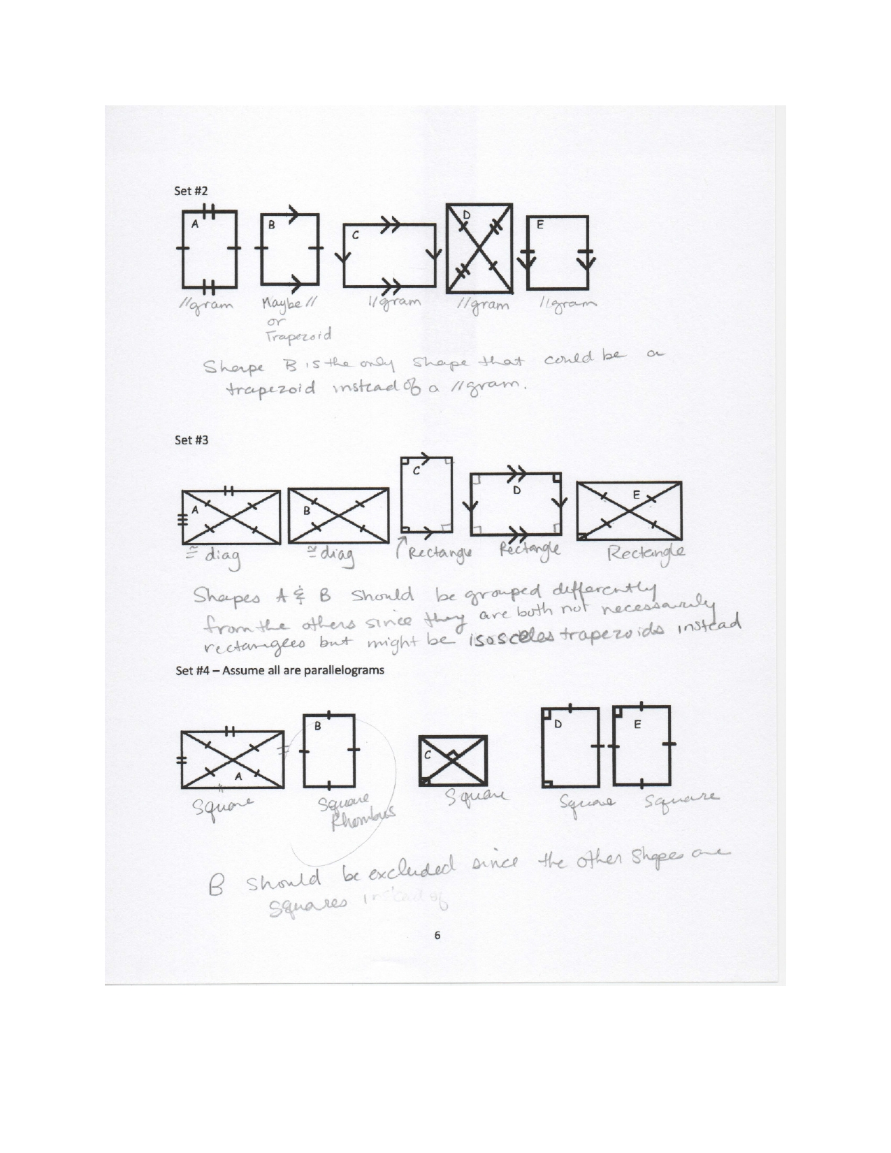

16

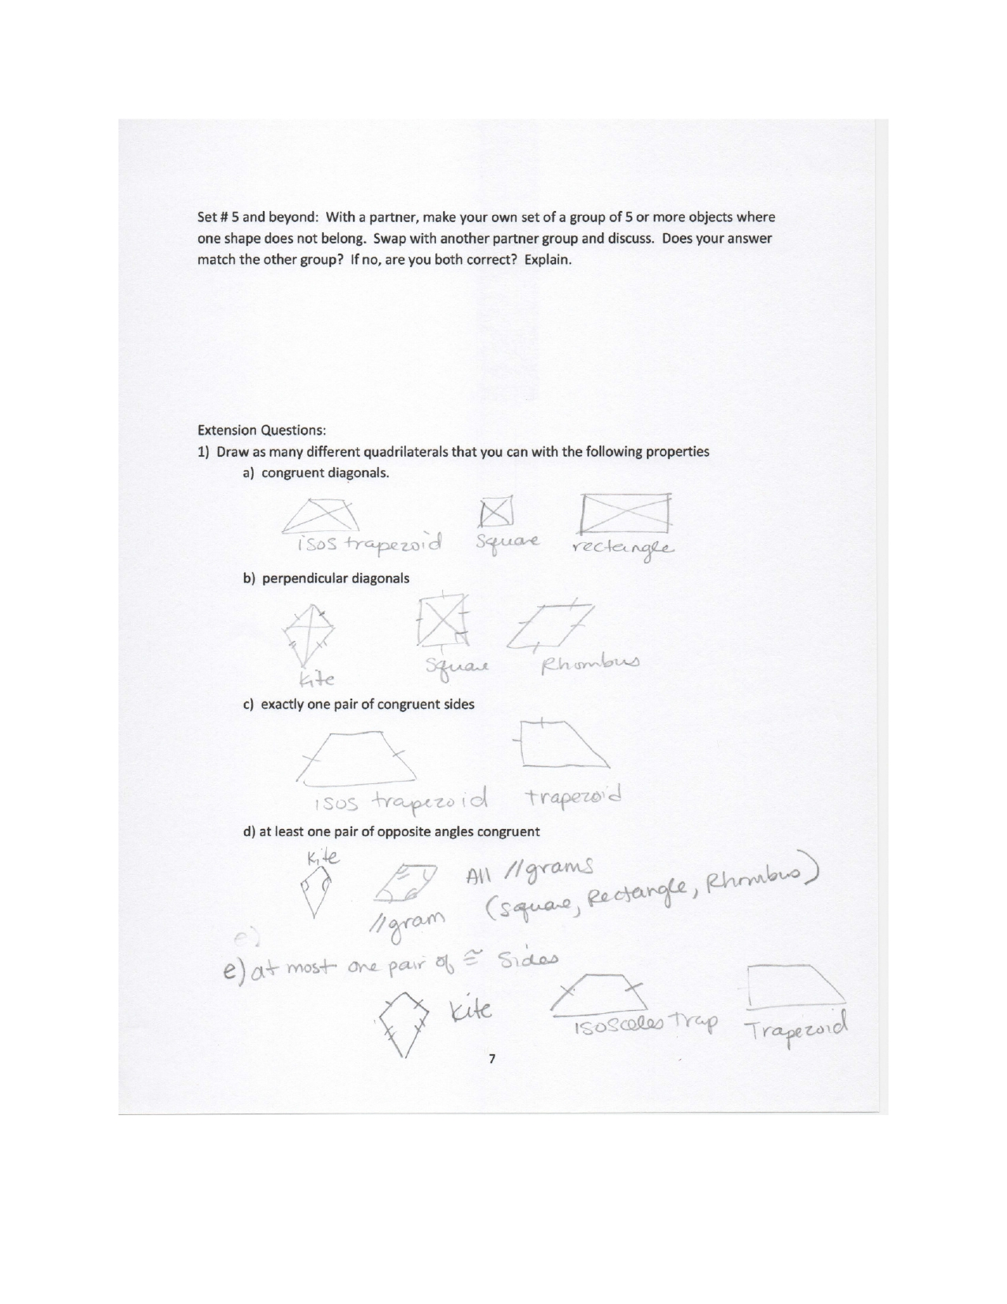

17

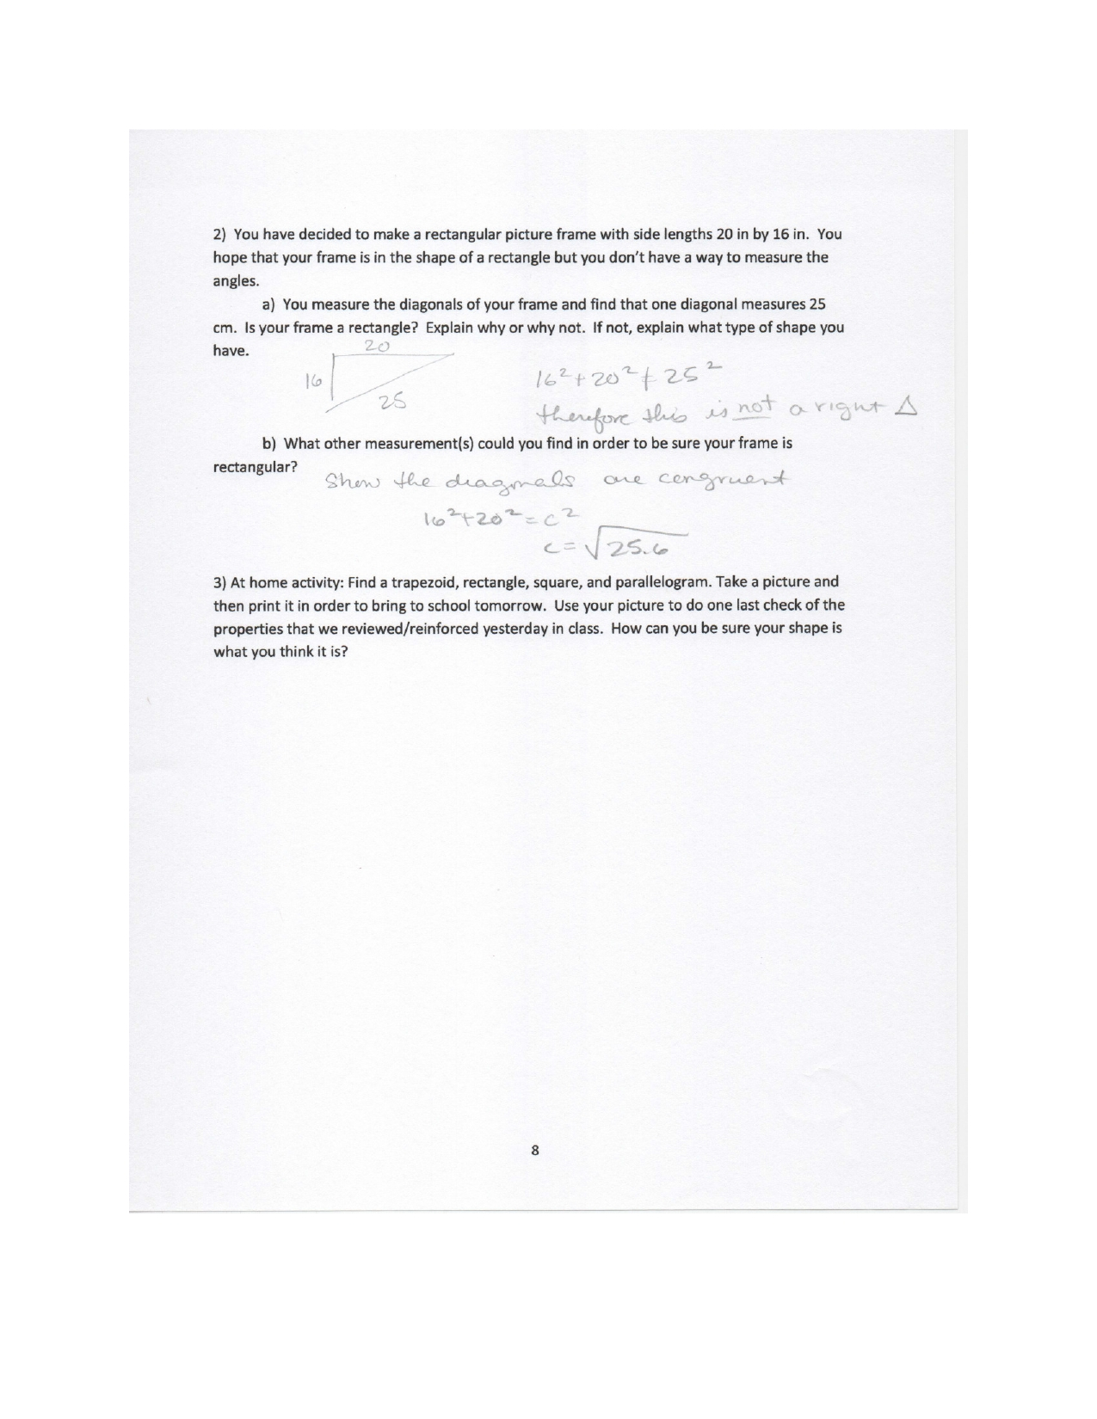

18

