**Plastic tadpoles lab – post-lab assessment ANSWER KEY AND EXPLANATIONS**

***Learning objective 1: Students will be able to define phenotypic plasticity.***

1. Phenotypic plasticity is:
   1. The ability of predators to feed upon certain organisms that differ in their behavior, morphology or coloration
   2. **The ability of an organism to respond to changes in its environment during its lifetime by changing behavior, morphology, or coloration**
   3. The ability of organism to evolve new behaviors, morphologies or colors over many generations
   4. The fact that different species have different behaviors, morphologies or colors
   5. I don’t know

**Explanation: B is correct because phenotypic plasticity occurs during the life of a single organism. A describes predation, C describes evolution and D describes variation between species that may or may not result from phenotypic plasticity.**

1. Which of the following is an example of phenotypic plasticity?
   1. Butterfly A has larger wings and can fly more efficiently than butterfly B which means it is less likely to get eaten by predators
   2. An invasive species of treefrog ends up in a new habitat by accidentally stowing away in a shipping container. Over the course of many generations the new population develops a phenotype which differs from the original but which helps them better avoid predation on the new island
   3. **A prairie vole normally leaves its burrow to forage at dusk but detects a predator so remains hidden in its burrow, choosing not forage**
   4. Tadpoles that hatch from larger eggs grow to be larger tadpoles
   5. I don’t know

**Explanation: C is correct because it describes a form of behavioral plasticity. The vole assesses its environment and changes its behavior. A describes variation between two individuals that does not have a plastic nature, B describes evolution and D describes developmental effects from the maternal environment.**

***Learning objective 2: Students will practice extracting meaning from published methods section.***

Read the following methods section and answer questions 3–6 below it.

“To measure the choices of laying eggs above or below water by mating pairs of frogs we allowed frogs to breed in pools with and without fish predators. Frogs in these pools normally lay eggs in the water. We hypothesized that fish being present would cause frogs to lay eggs out of the water on the leaves of plants. We built six 1.3 mdiameter pools filled with aged tap water and containing emergent plants. Four fish were placed into each of three pools (‘predator’ pools), while the other three were left as predator-free controls. Between July 26th and August 16th, we tested 18 mating pairs of frogs. Pairs of frogs were caught at a nearby natural pond and transplanted to the experimental pools at approximately 2200 hr. Only one pair of frogs was placed in a pool at a time. We left pairs undisturbed overnight to breed and released them at the pond the following morning. Female frogs lay 3–8 separate egg masses per night. We recorded the number of egg masses laid aquatically (entirely underwater), arboreally (entirely above water, on plants) or at the water surface (with some eggs both in and out of water).” Modified from: Touchon, J.C. and Worley, J. 2015. Oviposition site choice under conflicting risks demonstrates that aquatic predators drive terrestrial egg-laying. *Proceedings of the Royal Society B—Biological Sciences.* 282(1808):20150376

1. What is the sample size of the experiment?
   1. 3
   2. 6
   3. **18**
   4. 1.3
   5. I don’t know

**Explanation: C is correct because 18 is the number of frogs that were tested. A is how many cages were used for each treatment, B is the number of cages in total, and D is the diameter of the pools.**

1. Why were fish only placed into half of the pools?
   1. Because the researchers probably could not find enough for all of them
   2. **Because it is necessary to have a control to know where frogs lay their eggs in the absence of fish**
   3. Because only one pair of frogs was placed into a pool per night
   4. Because the pools were too small to hold more fish
   5. I don’t know

**Explanation: B is correct because having a predator-free control is the only way to know if the presence of predators actually affects the behavior of the frogs. A, C and D are essentially nonsensical.**

1. What is the predictor (or independent) variable?
   1. **Number of egg masses laid aquatically, arboreally or at the water surface**
   2. Number of eggs laid
   3. Predator treatment
   4. Number of fish used
   5. I don’t know

**Explanation: A is correct because the number of egg masses laid in each location is the only data recorded. B would be feasible to analyze, but it was not recorded. C is the predictor and D is not appropriate.**

1. What is the response (or dependent) variable?
   1. Number of egg masses laid aquatically, arboreally or at the water surface
   2. Number of eggs laid
   3. **Predator treatment**
   4. Number of fish used
   5. I don’t know

**Explanation: C is correct because fish presence or absence is the experimental question and so is the appropriate predictor. A the response variable, B was not recorded and D is not appropriate.**

***Learning objective 3: Students will generate meaningful hypotheses, given a context for investigation.***

Read the following scenario and answer questions 7–8 below it.

“You are waste deep in a pond and you look down and notice hundreds of tadpoles swimming in the place just below the surface of the water. You notice that they happen to be in a sunny patch of the pond. Right next to the sunny patch is an area shaded by a nearby tree and looking very carefully, you notice hardly any tadpoles at all. As you walk around the pond you notice several other sunny patches that all contain lots of tadpoles, and in every shady area you look at, you see very few tadpoles if any at all.”

1. Based on the information provided, what is the most plausible hypothesis for the relationship between the abundance of tadpoles and sunny areas of the pond?
   1. There is no relationship, the tadpoles just happened to be in the sunny areas by chance
   2. Tadpole predators like the sunny areas so tadpoles also like to swim there
   3. Tadpoles are afraid of shady areas and so don’t visit them very much
   4. **Tadpoles swim in the warmest part of the pond because it increases there rate of development**
   5. I don’t know

**Explanation: D is correct because it provides a plausible explanation based on possible organismal biology. A is unlikely because the pattern is presented as quite strong, B is unlikely because tadpoles should avoid predators and C is untestable.**

1. Which of the following is NOT a testable hypothesis?
   1. **Tadpoles are afraid of the darker parts of the pond**
   2. Tadpole density is higher in warmer parts of the pond
   3. Predator density is higher in cooler parts of the pond
   4. Tadpole growth rate increases when they experience in warmer temperatures
   5. I don’t know

**Explanation: A is correct because it is the only option that is not testable. We cannot if the tadpoles are afraid or not. B, C and D are all quantifiable.**

Read the following scenario and answer questions 9–10 below it.

“In the northeast of the United States, deer have become highly overpopulated during the past 50 years or so. During that same time, there has also been an increase in the number of collisions between automobiles and deer and deer abundance has increased in towns, leading to deer eating peoples garden vegetables and ornamental plants. During the same period, there has been an increase in the number of cases of Lyme disease in humans. Humans get Lyme disease when they get bit by a tick carrying the disease. Maps of the number of cases of Lyme disease closely match maps showing the density of deer.”

1. Based on the information provided, what is the most plausible hypothesis for rise in Lyme disease incidence in the northeastern United States?
   1. Ticks like to live on garden vegetables, so when deer eat garden vegetables ticks have no place to go and bite humans
   2. **Lyme disease is transmitted to ticks by deer and the increase in deer has therefore increased the number of ticks with Lyme disease**
   3. Lyme disease is transmitted to ticks by deer and the increase in traffic collisions with deer has increased the humans exposure to ticks
   4. Lyme disease prevalence has gone up because of climate change
   5. I don’t know

**Explanation: This question is similar to Question 7 but is designed to be harder. There is more information given to the student and so deciding on the correct hypothesis is more difficult. B is correct because it is the only biologically plausible choice. A does not make sense nor does it provide a way for ticks to get Lyme disease. C provides a way for ticks to get Lyme disease but the method of ticks getting to humans does not make sense. Although D is potentially feasible, but is not based on the information provided nor does it provide a mechanism for ticks to get Lyme disease.**

1. Assume you use tranquilizers and examine many deer in the northeast, discovering 1) that they have thousands of ticks on them but 2) blood samples show that deer never carry Lyme disease, ruling out the idea that ticks get the disease directly from deer. You also discover that the population sizes of small mammals has increased too tremendously and small mammals often do carry Lyme disease. Based on this new information, which of the following is the most plausible hypothesis?
   1. Small mammals and deer might have burrows together and that is where ticks get the disease
   2. Ticks don’t like being on deer during car accidents so they seek out small mammals instead
   3. Small mammals and deer come into contact in human back yards because humans have gardens and feed small mammals seeds and nuts, and that is when ticks get the disease
   4. **Because deer can host so many ticks, deer overpopulation has increased the population size of ticks, which increases the probability that some ticks will then get the disease from small mammals and pass it to humans**
   5. I don’t know

**Explanation: This question is designed to make students incorporate new information and reassess their hypothesis. D is correct because it is the only biologically plausible choice. A does not make biological sense. B is untestable. C is potentially feasible but is not reasonable.**

***Learning objective 5: Students will be able to measure, describe, and interpret variation among individuals within and across treatments.***

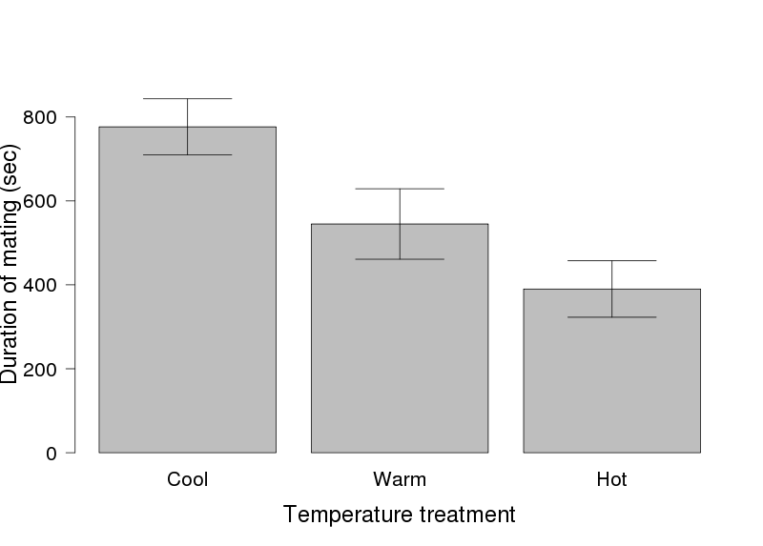The figure to the right shows the duration of mating (in seconds) for 20 pairs of beetles, in each of three different temperatures. The bars represent means ± 1 standard error. Use the figure to answer questions 11–13.

1. What statistical test would you use to analyze these data?
   1. Student’s t-test
   2. **Analysis of Variance (ANOVA)**
   3. Simple linear regression
   4. Chi-square goodness of fit test
   5. I don’t know

**Explanation: B is correct because the data are divided into more than two categories. A requires exactly two categories, C requires a continuous predictor and D is for analyzing counts.**

1. Which of the following p-values might you expect from a statistical comparison of the three means?
   1. **0.001**
   2. 0.46
   3. 1.125
   4. 0.87
   5. I don’t know

**Explanation: A is correct because the data are likely to be significantly different. B and D are highly non-significant and C is nonsensical.**

1. Which of the following is the best summation of these results?
   1. Beetles don’t like it when it is hot and so they do not want to mate for as long
   2. Beetles mate for shorter amounts of time as temperature decreases
   3. Beetle mating duration is not affected by temperature
   4. **Beetles mate for shorter amounts of time as temperature increases**
   5. I don’t know

**Explanation: D is correct because the data clearly show a trend towards decreasing mating time with increasing temperature. A is untestable, B is the opposite pattern from that shown and C is incorrect.**

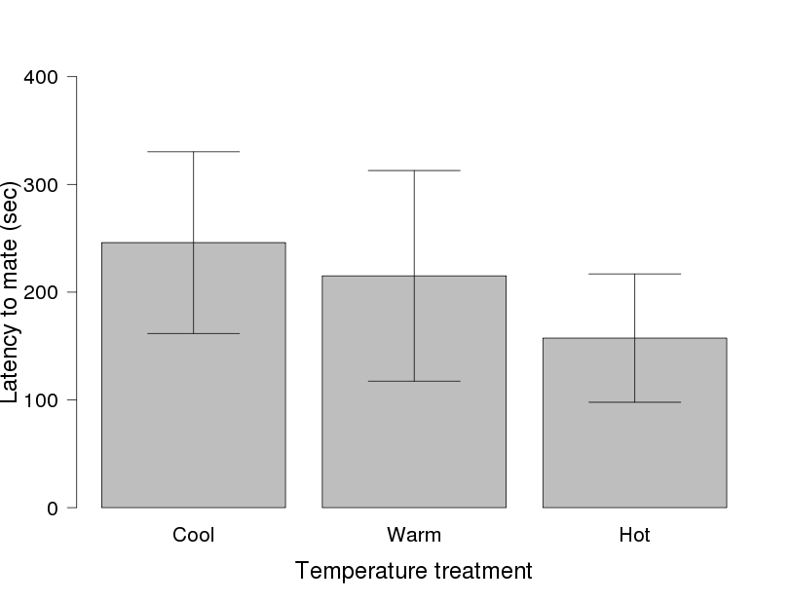The figure to the right shows the latency to mate (in seconds) for the same beetles in three different temperatures from the previous questions. Latency to mate is the amount of time it took a male and female to begin copulating after they were put in a petri dish together. The bars represent means ± standard error. Use the figure to answer questions 14–15.

1. Which of the following p-values might you expect from a statistical comparison of the three means?
   1. **0.46**
   2. 1.125
   3. 0.046
   4. 0.01
   5. I don’t know

**Explanation: A is correct because the data clearly are not significantly different because of the overlap in error bars. B is nonsensical, and C and D would indicate significantly different treatments.**

1. Which of the following is the *best* summation of these results?
   1. **From these data, we can't conclude that temperature affects latency to mate**
   2. Beetles have reduced latency to mate with increasing temperature
   3. Beetles always mate sooner when temperatures are warmer
   4. Latency to mate in beetles is strongly affected by temperature
   5. I don’t know

**Explanation: A is correct because the data clearly are not significantly different because of the overlap in error bars. B, C and D are all overconfident in stating that there is a difference when in fact there is not.**

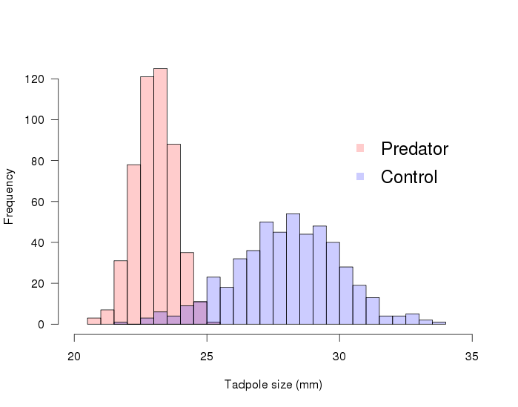***Learning objective 6: Students will be able to construct bar charts with standard error bars and frequency histograms.***

The figure to the right shows frequency histograms of size for two groups of tadpoles, raised either with predators or in a predator-free control environment. Use the figure to answer questions 16–19.

1. Which of the following statements is true?
   1. Tadpoles raised without predators are always larger than tadpoles raised with predators
   2. **Tadpoles raised with predators have less variation in size than tadpoles raised without predators**
   3. Tadpoles raised with predators have more variation in size than tadpoles raised without predators
   4. Tadpoles raised with predators are always larger than tadpoles raised without predators
   5. I don’t know

**Explanation: This question is focused on understanding the variation in a histogram. B is correct because the control treatment clearly has a wider spread of data. A ignores the overlap in the two histograms, C is backwards, and D is backwards and ignores the overlap.**

1. Which of the following statements is true?
   1. Tadpoles raised without predators are always larger than tadpoles raised with predators
   2. Tadpoles raised with predators are on average smaller than tadpoles raised without predators
   3. Tadpoles raised with predators live longer than tadpoles raised without predators
   4. **Tadpoles raised with predators are on average larger than tadpoles raised without predators**
   5. I don’t know

**Explanation: As opposed to question 17, this question is focused on understanding something about the mean from viewing a histogram. D is correct because it states that control tadpoles are on average, not always, larger than tadpoles with predators. A is too absolute, B is backwards and C is not related to the histogram at all.**

1. You randomly selected one tadpole and its size was 24.0 mm. Which of the following statements is true?
   1. **The tadpole is most likely from the predator treatment.**
   2. The tadpole is most likely from the control treatment.
   3. The tadpole is equally likely from either treatment.
   4. There is no way to know what treatment it came from.
   5. I don’t know.

**Explanation: A is correct because although 24 mm is within the range of both frequency distributions, the height of the bar for the predator treatment is much higher, indicating a higher probability. B, C and D are just plain wrong.**

1. Which of the following sets of tadpole sizes (in mm) likely come from the Predator environment?

|  |  |  |  |
| --- | --- | --- | --- |
| A | B | C | **D** |
| 12 | 30 | 21 | **23** |
| 4 | 29 | 19 | **23** |
| 14 | 27 | 30 | **24** |
| 16 | 20 | 15 | **22** |
| 16 | 30 | 15 | **21** |
| 15 | 36 | 16 | **24** |
| 17 | 39 | 19 | **22** |
| 14 | 30 | 20 | **26** |
| 14 | 30 | 22 | **19** |
| 18 | 38 | 18 | **21** |

**Explanation: This question requires students to look at a set of raw data and connect it to the histogram. D is correct because the values are all within the bounds of the predator bars. A is too small, B is too the Control treatment, and C has some overlap with the predator bars but has too much variation.**

1. For the following dataset, which frequency histogram is most likely?



|  |
| --- |
| Size |
| 6.6 |
| 4.9 |
| 7.2 |
| 6.7 |
| 5.0 |
| 3.4 |
| 4.8 |
| 3.2 |
| 2.0 |
| 7.1 |
| 4.7 |
| 6.2 |
| 2.9 |
| 5.1 |

**Explanation: The correct answer is A. B has the same spread of values in the histogram, but the values are too large to match the table. C has the same mean but too much variation, so the values shown all fall within figure C, but so would many other values and so it is not the most likely. D is far too large.**

***General questions to assess student attitude towards the module and understanding of what they have done.***

1. In general, image analysis refers to:
   1. Determining the meaning of images
   2. Using software like Photoshop to alter images
   3. Producing quality graphs and figures that describe analysis of scientific information
   4. Obtaining data from images
   5. I don’t know
2. It is clear to me that mathematics and statistics are a critical part of the scientific process for biologists.
   1. Strongly disagree
   2. Disagree
   3. Agree
   4. Strongly agree
3. I would have been able to analyze and quantify variation in tadpole morphology without mathematics and statistics.
   1. Strongly disagree
   2. Disagree
   3. Agree
   4. Strongly agree
4. Learning about statistics was more interesting as part of the plastic tadpoles/ image analysis lab than it would have been otherwise.
   1. Strongly disagree
   2. Disagree
   3. Agree
   4. Strongly agree
5. Learning about statistics was more interesting because of the story of the researchers who actually conducted the original study on tadpoles.
   1. Strongly disagree
   2. Disagree
   3. Agree
   4. Strongly agree
6. It was helpful to be able to read the actual Introduction and Methods from the published research article.
   1. Strongly disagree
   2. Disagree
   3. Agree
   4. Strongly agree
7. In general, I am interested to learn to use mathematics and statistics in biology.
   1. Strongly disagree
   2. Disagree
   3. Agree
   4. Strongly agree
8. I feel confident that I can learn mathematics and statistics.
   1. Strongly disagree
   2. Disagree
   3. Agree
   4. Strongly agree
9. I am more interested to learn to use mathematics and statistics in biology after completing the plastic tadpole/image analysis lab.
   1. Strongly disagree
   2. Disagree
   3. Agree
   4. Strongly agree