Section 10.4: Tangent Vectors and Normal Vectors

Practice HW from Larson Textbook (not to hand in)
p. 637 # 3-9 odd, 25-35 odd (just find T(t) and N(t))

Note: Sometimes, it is convenient to normalize a vector tangent to a vector valued function. This gives the unit tangent vector.

Unit Tangent Vector

Given a vector function r on an open interval I, the unit tangent vector T(t) is given by

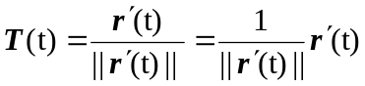 where 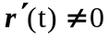

Example 1: Find the unit tangent vector T(t) to the curve given by r(t ) = i + 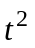 j when t = 1.

Solution:

Example 2: Find the unit tangent vector T(t) for r(t ) = 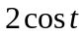 i + 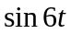 j + 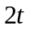 k at 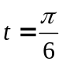.

Solution: The unit tangent vector is given by the formula

.

Using r(t ) = 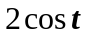 i + j + k, we see that

and

Thus,

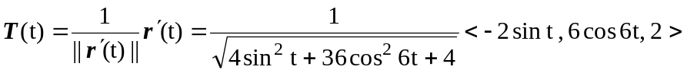

At , we have

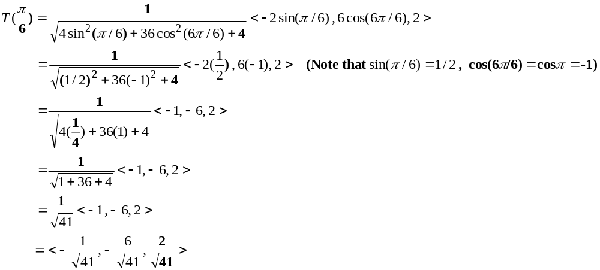 (continued on next page)

The following graph plots in 3D space the vector function r(t) and the corresponding unit tangent vector T(t) evaluated at .
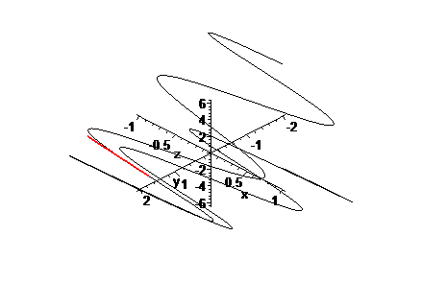
█
Calculating the Unit Normal Vector

In describing motion, sometimes it can be an advantage to calculate a vector orthogonal to the unit tangent vector T of the vector function r(t ) = f (t) i + g (t) j + h (t) k.

x
y
z
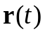

One method is the use the fact that the T is a unit vector. Then, we know that

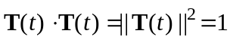

If we use the product rule and differentiate both sides of this equation, we obtain

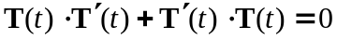

or

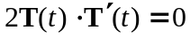.

Thus,

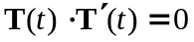

Hence, the derivative of T, 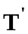, is orthogonal to T. Normalizing T will give the principal unit normal vector N at t.
Principal Unit Normal Vector N

For the vector valued function r(t ) = f (t) i + g (t) j + h (t) k with unit tangent vector T, the unit normal vector, assuming 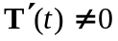, is given by

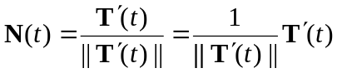

Note: Unless the function r(t) is simple, the unit normal vector N can be very computationally intensive. Maple can be a very convenient tool for simplifying the computations.

Example 3: Find the unit normal vector N for the vector to the curve given by
r(t ) = i + j when t = 1.

Solution:

t

█
Example 4: Find the unit normal vector N for the vector 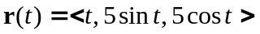. Use your result to find the unit normal vector at the point 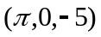

Solution: To find the unit normal vector N, we must first find the unit tangent vector T. Recall that the formula for the unit tangent vector T is given by

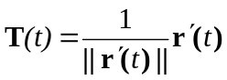

For , we have 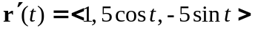 and

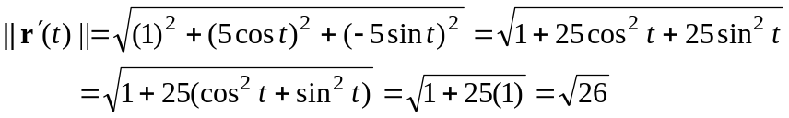

Thus,

To get the unit normal vector, we use the formula

Using 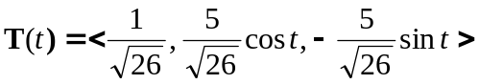, we see that 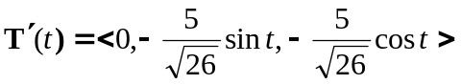

and

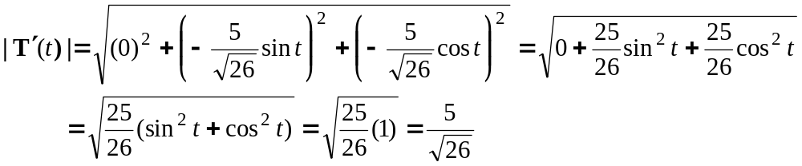

Then, (continued on next page)
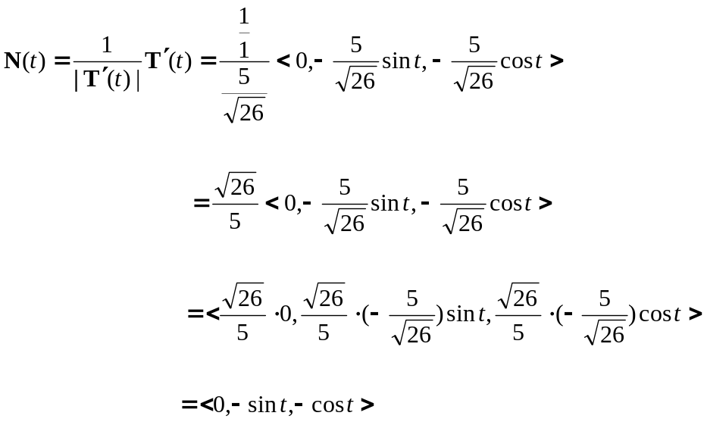

We last want to evaluate 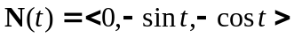 at the point . We need to find the value of t that produces this point. Since , 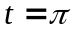 since and 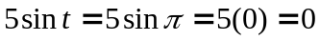 and 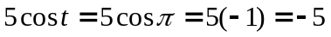. Thus,

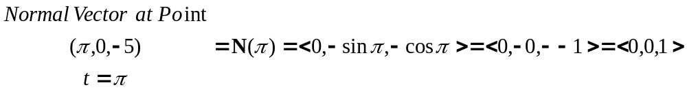

The following shows a framed graph of (in green) with the unit tangent vector (in red) and unit normal vector (in blue) displayed at the point .

 

