Section 5.6: Differential Equations: Growth and Decay

Practice HW from Larson Textbook (not to hand in)
p. 364 # 1-7, 19, 25-34

Differential Equations

Differential Equations are equations that contain an unknown function and one or more of its derivatives. Many mathematical models used to describe real-world problems rely on the use of differential equations.

The differential equations we will study in this section involve the first order derivative and are of the form

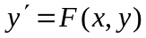

Our goal will be to find a function 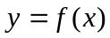 that satisfies this equation. The following two examples illustrate how this can be done for a basic differential equation and introduce some basic terminology used when describing differential equations.

Example 1: Find the general solution of the differential equation 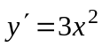

Solution:

█
The general solution (or family of solutions) has the form 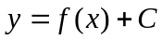, where C is an arbitrary constant. When a particular value concerning the solution (known as an initial condition) of the form 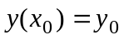 (read as 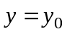 when 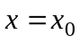) is known, a particular solution, where a particular value of C is determined, can be found. The next example illustrates this.

Example 2: Find the particular solution of the differential equation 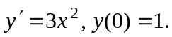

Solution:

█

Finding Solutions Analytically – Separation of Variables

Suppose we are given the initial value problem.

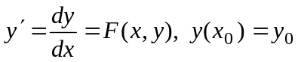

and suppose we can write 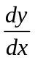 as product of a function of x and a function of y.

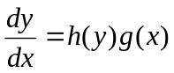

We can then find a solution, y(x), by “separating” the variables.

Steps – Separation of Variables
1. Get all terms involving y on one side of the equation and all terms involving x on the
other side.
2. Integrate both sides.
3. Solve for the solution y(x) (if possible).

Some Useful Facts
1. 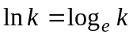
2. 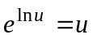
3. 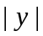 means 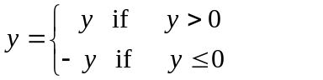
Example 3: Solve the differential equation 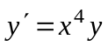.

Solution:

█

Example 4: Solve the differential equation 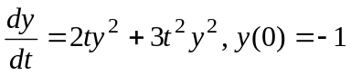.

Solution:

█
Example 5: Solve the differential equation 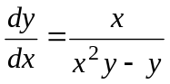.

Solution: We solve this differential equation using the following steps”

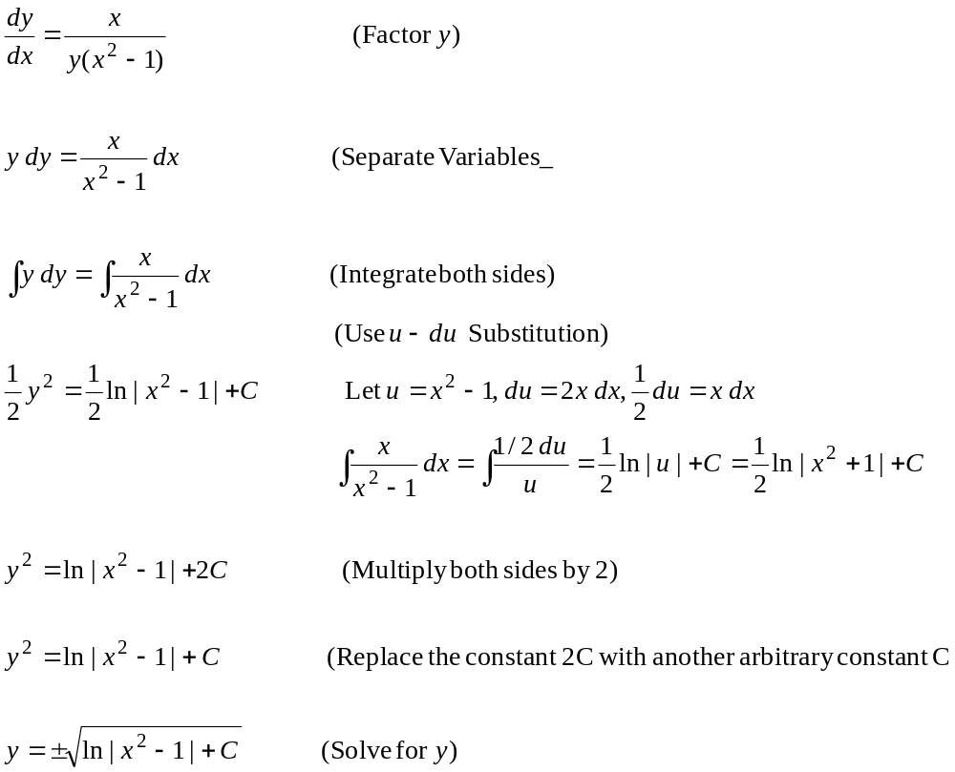

█
The Exponential Growth Model

When a population grows exponentially, it grows at a rate that is proportional to its size at any time t. Suppose the variable P(t) (sometimes we use just use P) represents the population at any time t. In addition, let 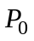 be the initial population at time t = 0, that is, 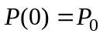. Then if the population grows exponentially,

(Rate of change of population at time t) = k (Current population at time t)

In mathematical terms, this can be written as

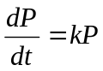.

We can solve this equation using separation of variables. That is,

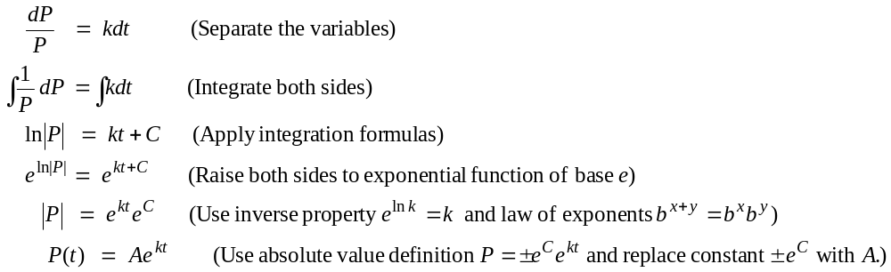
The equation 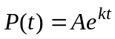 represents the general solution of the differential equation. Using the initial condition , we can find the particular solution.

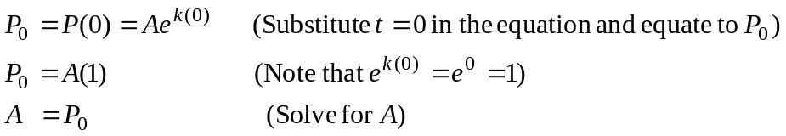

Hence, 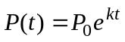 is the particular solution. Summarizing, we have the following:

Exponential Growth Model

The initial value problem for exponential growth

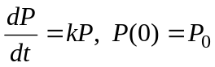

has particular solution

where = initial population (population you that with) at time t = 0,
k = relative growth rate that is constant
t = the time the population grows.
P(t) = what the population grows to after time t.

Notes[
1. When modeling a population with an exponential growth model, if the relative growth rate k is unknown, it should be determined. This is usually done using the known population at two particular times.
2. Exponential growth models are good predictors for small populations in large populations with abundant resources, usually for relatively short time periods.
3. The graph of the exponential equation has the general form

P
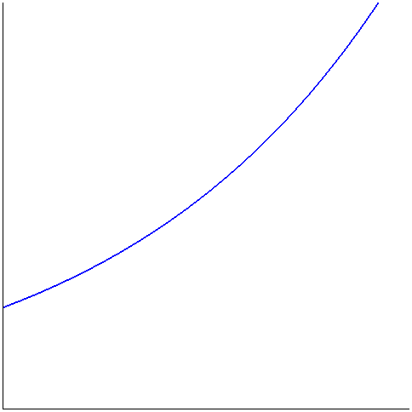
t

Example 6: Solve a certain organism develops with a constant relative growth of 0.2554 per member per day. Suppose the organism starts on day zero with 10 members. Find the population size after 7 days.

Solution:

█

Example 6: A population of a small city had 3000 people in the year 2000 and has grown at a rate proportional to its size. In the year 2005 the population was 3700.
a. Find an expression for the number of people in the city t years after the year 2000.
b. Estimate the population of the city in 2006. In 2010.
c. Assuming the growth continues at the same rate, when will the town have 25000
people?

Solution:

█

Exponential Decay

When a population decays exponentially, it decreases at a rate that is proportional to its size at any time t. The model for exponential decay is

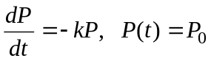
Using separation of variables in a process similar to exponential growth, it can be shown that the solution to the initial value problem is 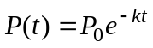. Summarizing, we have the following:

Exponential Decay Model

The initial value problem for exponential decay

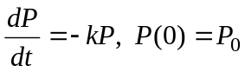

has particular solution

where = initial population (population you that with) at time t = 0,
k = relative decay rate that is constant. Note that k > 0.
t = the time the population decays.
P(t) = the population that is left after time t.

Notes
1. Many times the rate of decay is expressed in terms of half-life, the time it takes for half of any given quantity to decay so that only half of its original amount remains.
2. Radioactive elements typically decay exponentially.

Example 7: Bismuth-210 has a half-life of 5.0 days.
a. Suppose a sample originally has a mass of 800 mg. Find a formula for the mass
remaining after t days.
b. Find the mass remaining after 30 days.
c. When is the mass reduced to 1 mg.
d. Sketch the graph of the mass function.

Solution: (Part a) Since this is an exponential decay problem, we will use the formula 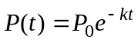. Since we start with 800 mg, then we know that 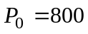. Thus the formula becomes
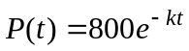

To complete the equation that models this population, we need to find the relative decay rate k. We can use the half life of the substance to do this. The half life of Bismuth-210 is 5 days. This says that after t = 5, the original population of 800 mg has decay to half of its original amount, or 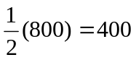 mg. Mathematically, since 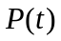 represents that amount of population of the substance left after time t, this says that 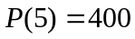. Using the decay equation, we have

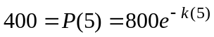

or rearranging, we have

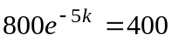

We must solve this equation for k. We proceed with the following steps.

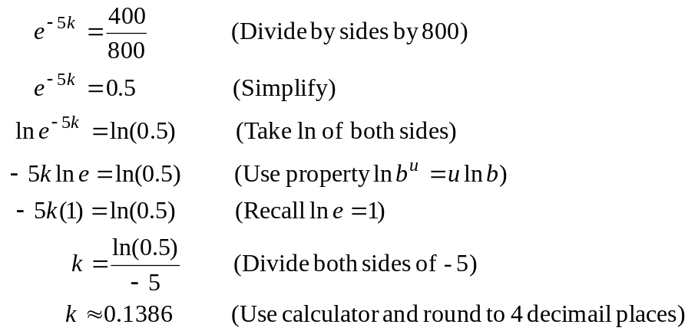

Substituting 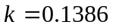 and gives a formula for finding the remaining mass.

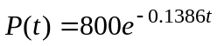
(continued on next page)
Part b.) Using the formula found in part a, we see that

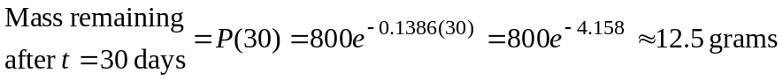

Part c.) In this problem, we want the time t it takes for the mass to have reduced down to 1 mg. That is, we want t when 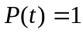. We perform the following steps using to solve for t.

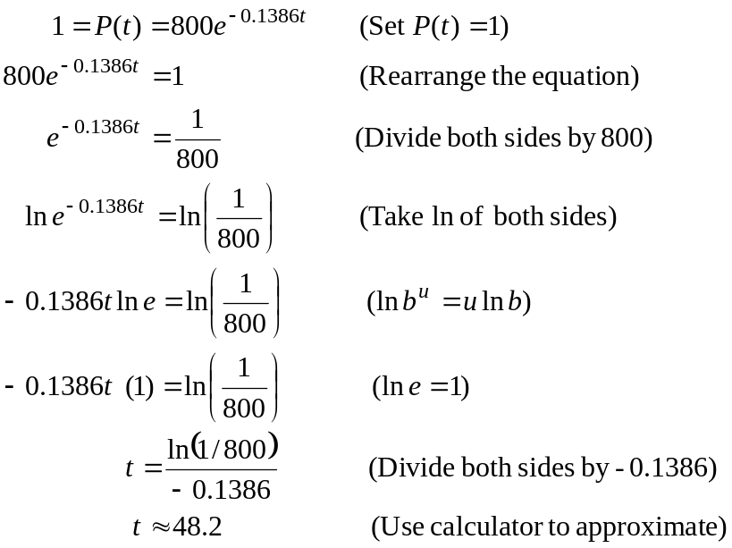

Thus, it takes approximately 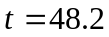 days for the substance to decay to 1 mg.

(Continued on next page)

d. The following Maple commands will generate the desired graph:

> P := 800*exp(-0.1386*t);
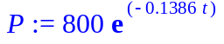
> plot(P, t = 0..60, color = blue, thickness = 2, view = [-1..60, -10..1000], title = "Graph of 800e^(-0.1386t) for t = 0..60 for Bismuth-210");

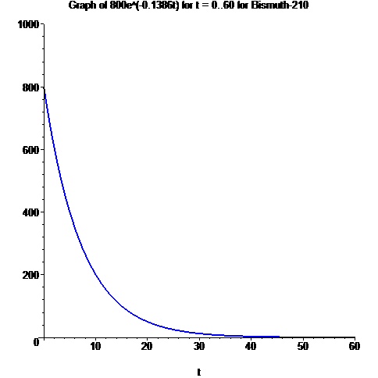

█
Example 8: Radiocarbon Dating. Scientists can determine the age of ancient objects (fossils, for example) using radiocarbon dating. The bombardment of the upper atmosphere by cosmic rays converts nitrogen to a radioactive isotope of carbon, 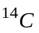, with a half life of about 5730 years. Vegetation absorbs carbon dioxide through the atmosphere and animal life assimilates through food chains. When a plant or animal dies, it stops replacing its carbon and the amount of begins to decrease through radioactive decay. Therefore, the level of radioactivity must also decay exponentially. Suppose a fossil found has about 35 % as much radioactivity as normal animals do on Earth today. Estimate the age of the fossil.

Solution:

█

