Section 5.1: Area of a Region Between Two Curves

Practice HW from Larson Textbook (not to hand in)
p. 312 # 1-5 odd, 9, 13-23 odd

Areas Between Curves

Suppose we are given a continuous function y = f (x) where 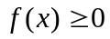 over the interval
[a, b].

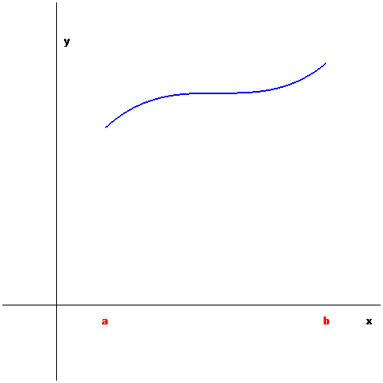

Recall: 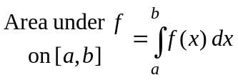

Suppose we are given two functions f and g and we want to find the area bounded between the functions from x = a and x = b.

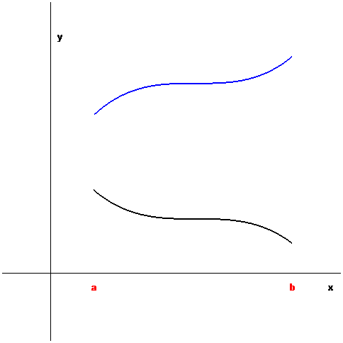

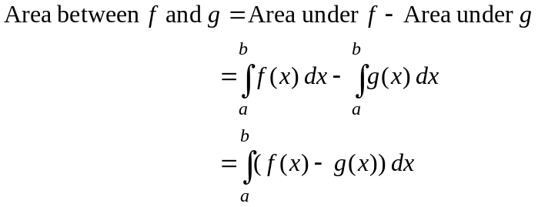

Area Between Two Curves

Given f and g are continuous functions on [a, b] and 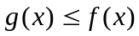 for all x in [a, b]. Then

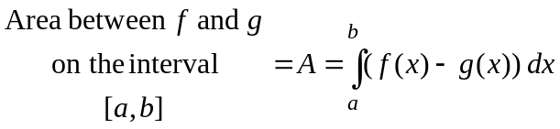

Example 1: Determine the area bounded between the graphs of 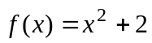 and 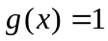 between x = -1 and x = 2.

Solution:

█

Note: When asked to find the area bound by two graphs, to find the interval we many times have to find the points of intersection.

Example 2: Sketch the graph and find the area enclosed by the graphs of 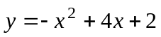 and 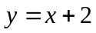.

Solution:

█

Note: The upper and lower curves can switch over an interval. In this case, we must divide the interval and switch the upper and lower curves when integrating to find the area.

Example 3: Sketch the graph and find the area enclosed by the graphs of 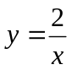, 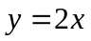, and 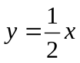 where x > 0.

Solution: The following represents the graphs of the functions , , and for x > 0.

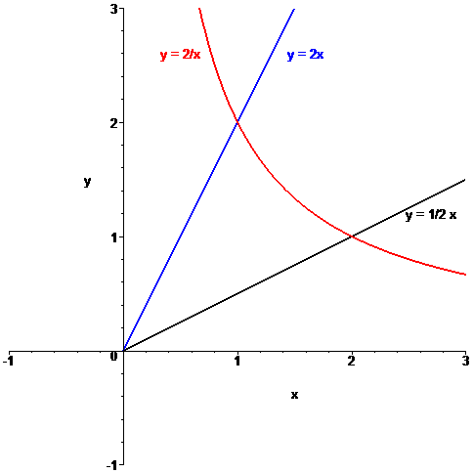

As the graphs indicate, from x = 0 to x = 1, is the upper curve and is the lower curve. From x = 1 to x = 2, the upper curve becomes and the lower curve is
. Hence,

(Continued on Next Page)
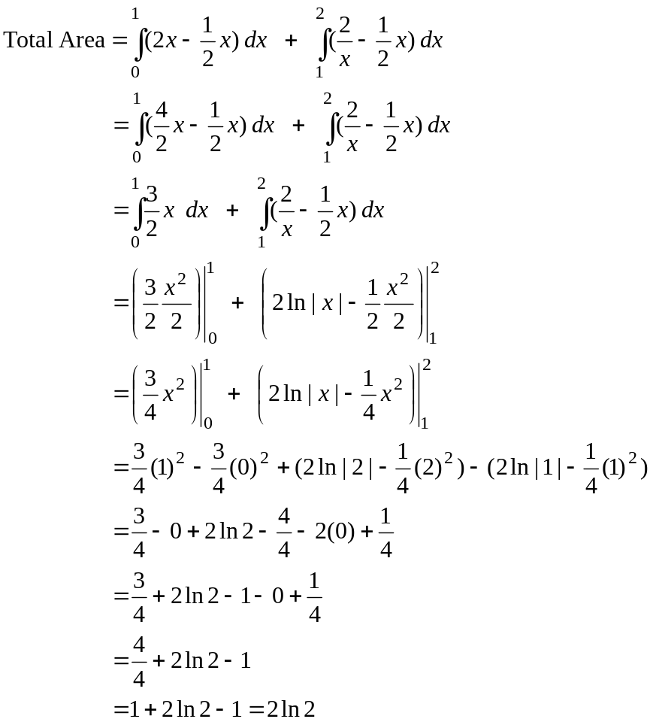

█

Horizontal Area Representation

Involves integrating with respect to y to find the area when x is written as a function of y.

Example 4: Find the area enclosed by 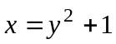and 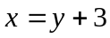 .

Solution:

█

