Section 1.6: Evaluating Limits Analytically

Practice HW from Larson Textbook (not to hand in)
p. 56 # 1-35 odd, 39-45, 77 odd

Properties of Limits

Suppose 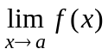 and 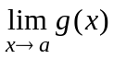 exist, k a constant (for our purposes, a real number).

1. 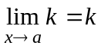 (limit of a constant is the constant itself).

2. 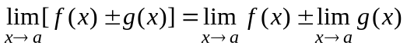

3. 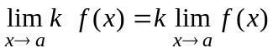

4. 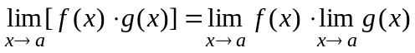

5. 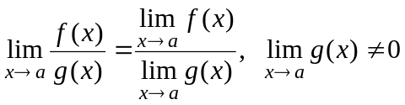

Example 1: Given the graphs of f and g.

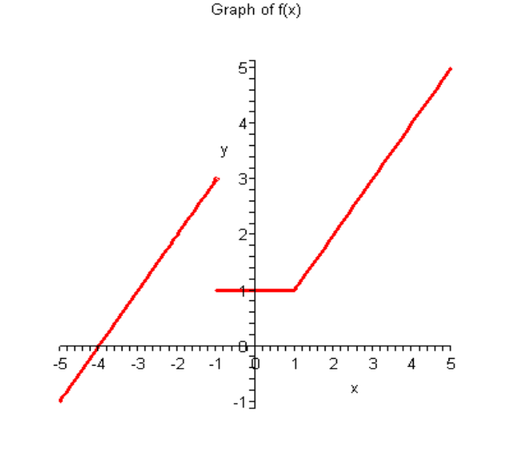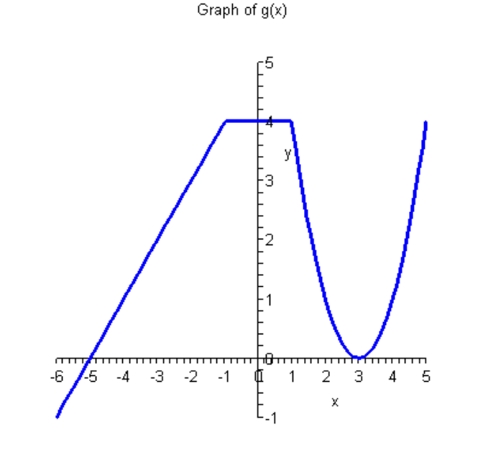

Find:

a. 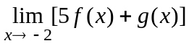

b. 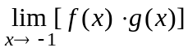

c. 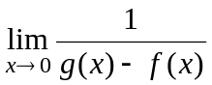

█

Evaluating Limits Algebraically

If a function is defined at x = c (it is in the domain of f ), substitute x = c into to find the limit.

Example 2: Evaluate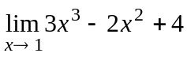

Solution:

█

Example 3: Evaluate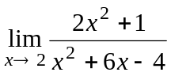

Solution: On this problem, we should always look to see if direct substitution works when evaluating the limit. Here, we see that it does. We have

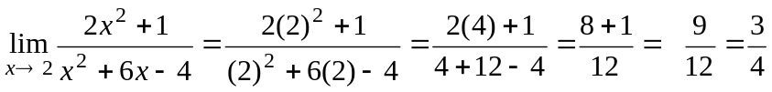

█
Note: If you try direct substitution and obtain the indeterminate form 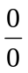, try to algebraically simplify, eliminating the term in the denominator that gives the division by zero. Then substitute to find the limit. If you try direct substitution and obtain a result of 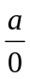, where 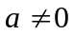, then the limit does not exist and is infinite. Attempt to graph and analyze the long term behavior of the limit (will look at more closely in Section 1.8).

Example 4: Evaluate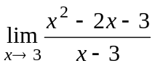

Solution:

█

Example 5: Evaluate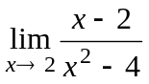

Solution:

█
Example 6: Evaluate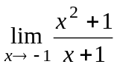

Solution:

█

Example 7: Evaluate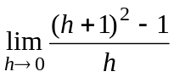

Solution: Note that direct substitution for this limit gives

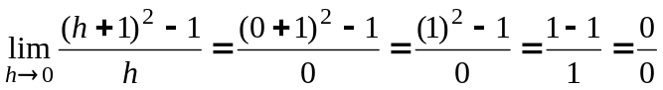,

which is an in-determinant form. We evaluate this limit by simplifying using the following steps:

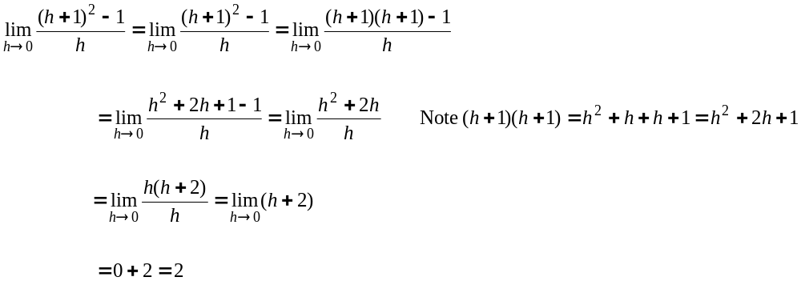

█
Example 8: Evaluate 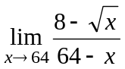

Solution:

█

Example 9: Evaluate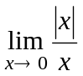

Solution:

█

Example 10: Evaluate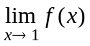 where 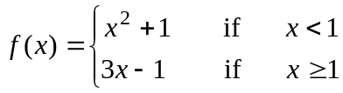

Solution: Since this function is piecewise and has two different formulas depending on what value of x is input into the function - values that are to the left (less than) of 1 and values that are to the right (greater than) 1. Thus, we check the left and right limits. This gives

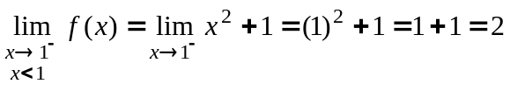

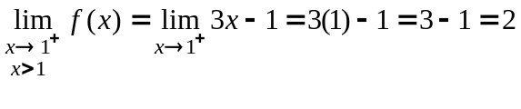

Since 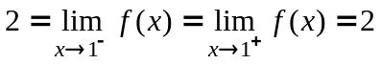, the limit is exists and the limit equals the common value of the left and right hand limit. Thus

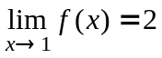

█

Special Trigonometry Limits

1. 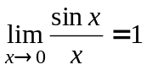.
2. 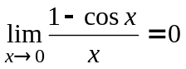.

Example 11: Evaluate 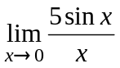

Solution:

█

Example 12: Evaluate 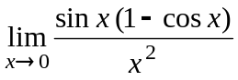

Solution: We evaluate the limit as follows:





