Section 3.3: Increasing and Decreasing Functions and The
First Derivative Test

Section 3.4 Concavity and The Second Derivative Test

Practice HW from Larson Textbook (not to hand in)
p. 177 # 1-29 odd, 33, 39, 47, 49
p. 185 # 1-29 odd

Increasing and Decreasing Test for Functions

Given a function f defined on an interval.
1. If 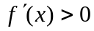 on an interval, then f is increasing on that interval.
2. If 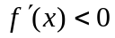 on an interval, then f is decreasing on that interval.

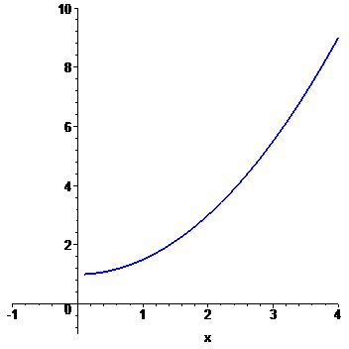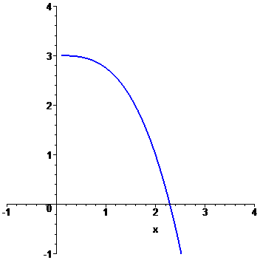

Example 2: State whether the function 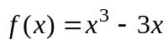 is increasing, decreasing, or neither on an interval “near” x = 2.

Solution:

█

First Derivative Test

Suppose x = c is a critical number of a continuous function f .
1. If for x < c and for x > c, 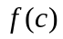 is a relative maximum.
2. If for x < c and for x > c, is a relative minimum.

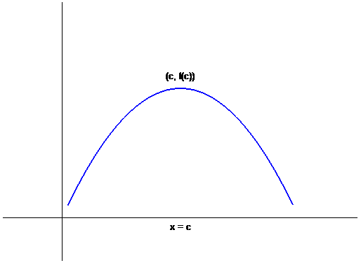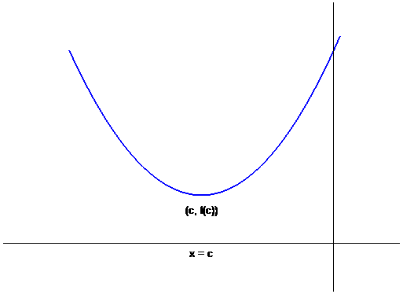

Concavity

- A function f is concave up on an interval I if 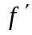 is increasing on I.

- A function f is concave down on an interval I if is decreasing on I.

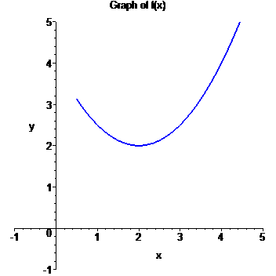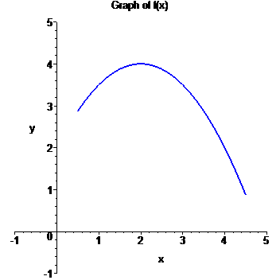
Concavity Test for Functions

Given a function f defined on an interval.
1. If 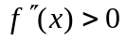 on an interval, then f is concave up on that interval.
2. If 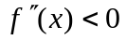 on an interval, then f is concave down on that interval.

Example 2: State whether the function is concave up, concave down, or neither on an interval “near” x = -1.

Solution:

█

Inflection Points

Inflection points are points where the concavity of the graph of a function f changes.

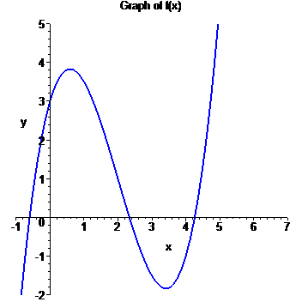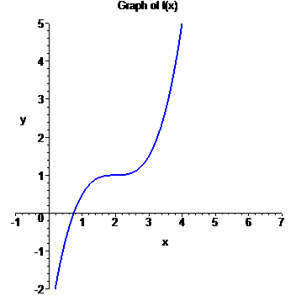

Note: If 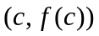 is a point of inflection of the graph of f , then either 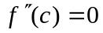 or 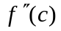 is undefined.

Second Derivative Test (Test For Relative Maximum and Relative Minimum Points)

Let f be a function where x = c is a critical point where 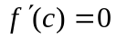.
1. If 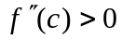, then is a relative minimum.
2. If 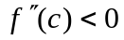, then is a relative maximum.
3. If or is undefined, the test fails – use the 1st derivative test.

Procedure For Graphing Functions Using Derivatives

Given a function .
1. State the domain of the function.
2. Compute and 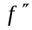.
3. Find the critical numbers, which are values of x where either 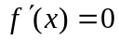 or 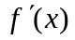 is
undefined. Find the y coordinates of these points by substituting these x values back
into the original function . These points represent the candidates for the local
maximum and minimum points.
4. Use the 2nd derivative test to determine whether critical numbers are local
Maximum or local minimum points. If the 2nd derivative test
fails, use the 1st derivative test with a sign diagram, testing whether the 1st derivative
is positive or negative to the left and right of the critical numbers.
5. Look for candidates for the points of inflection by finding values of x where either
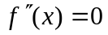 or 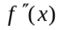 is undefined. Find the y coordinates of these points by substituting
these x values back into the original function . These points represent the
candidates for the points of inflection.
6. Test the inflection point candidates by testing the concavity to the left and the right of
inflection point candidates using a sign diagram with the 2nd derivative.
7. Use the information to sketch the graph.

Example 3: For the function 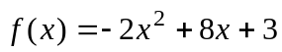, determine the intervals where the function is increasing and decreasing, local maximum and local minimum points, the intervals where the function is convave up and convave down, and the points of inflection.
Use the information to sketch the graph.

Solution:

█
Example 4: For the function 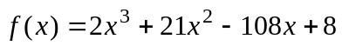, determine the intervals where the function is increasing and decreasing, local maximum and local minimum points, the intervals where the function is convave up and convave down, and the points of inflection.
Use the information to sketch the graph.

Solution:

█
Example 5: For the function 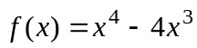, determine the intervals where the function is increasing and decreasing, local maximum and local minimum points, the intervals where the function is convave up and convave down, and the points of inflection.
Use the information to sketch the graph.

█
Example 6: For the function 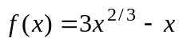, determine the intervals where the function is increasing and decreasing, local maximum and local minimum points, the intervals where the function is convave up and convave down, and the points of inflection.
Use the information to sketch the graph.

Solution: Note that for this function , there is no values of x where the is undefined. Hence, the domain of this function is all real numbers or 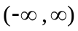. We next compute the first and second derivatives. We see that

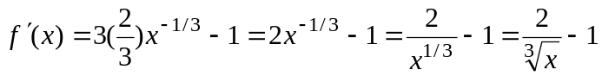.

Using the form 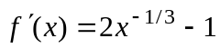 for the first derivative, we see that

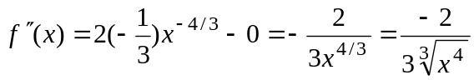.

Hence, 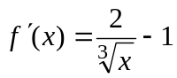 and 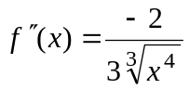.

We next find the critical numbers. Note that in this case, is undefined at
x = 0. Therefore, x = 0 is one critical number. We next look for critical numbers where . This gives
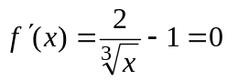

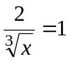 (add 1 to both sides)

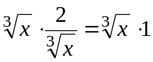 (Multiply both sides by 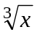)

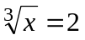 (Rearrange and simplify0

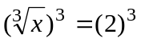 (Eliminate the radical by raising both sides to the 3rd power)

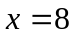 (Simplify and solve for x)

Hence, the critical numbers are x = 0 and x = 8. (continued on next page)

For the critical numbers, we find their corresponding y coordinates. To do this, we must use the original function . This gives the following.

gives the point (0, 0)
gives the point (8, 4)

Hence, (0, 0) and (8, 4) are the local maximum and minimum point candidates.
To test these points, we first try the 2nd derivative test using . This gives the following information for each candidate.

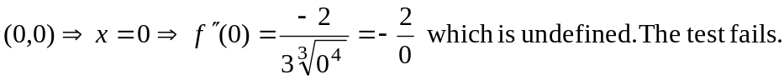
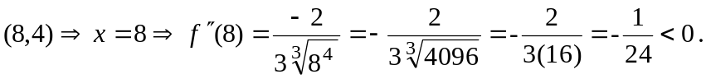 This says the graph is concave down at this point or that (8, 4) is a local maximum.

Hence, the 2nd derivative test says (8, 4) is a local maximum but is inconclusive for the point (0, 0). So we need more information. We get it by using the 1st derivative test by testing the sign of the 1st derivative to the left and right of each critical number (which of course are the same as the x coordinates of the local maximum and minimum candidates).
1st Derivative Test Table for 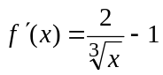
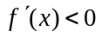  _ _ _ _ _ _ _ _ _  Decreasing | Crit Num  x = 0 | 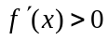  + + + + + + + + +  Increasing | Crit Num  x = 8 | _ _ _ _ _ _ _ _ _  Decreasing
Choose  x = -1 < 0  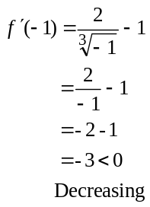 |  | Choose  x = 1  Note 0 < 1 < 8  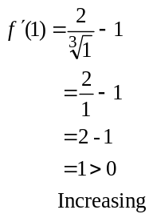 |  | Choose  x = 9 > 8  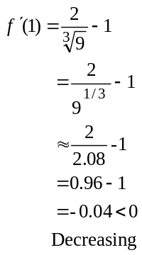
(continued on next page)
To the left of the critical number x = 0, the 1st derivative test table says the graph of is decreasing. To the right of x = 0, the 1st derivative test table says the graph of is increasing. By definition, this says the point (0, 0) is a local minimum.

To the left of the critical number x = 8, the 1st derivative test table says the graph of is increasing. To the right of x = 8, the 1st derivative test table says the graph of is decreasing. By definition, this says the point (8, 4) is a local maximum (which agrees with the assertion already established by the 2nd Derivative test).

The table also gives information where the graph of is increasing and decreasing. Summarizing, we see that

is increasing when 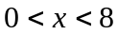 or in interval notation (0, 8)
is decreasing when 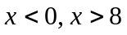 or in interval notation 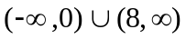

Now, we look for points of inflection. Recall that points of inflection occur at points where the second derivative 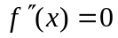 or where is undefined. Above, we computed the second derivative. Note that is undefined at x = 0. Thus x = 0 is inflection point candidate. If we set

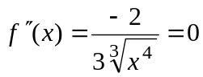

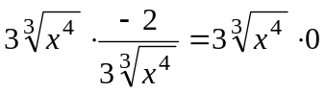 (Multiply both sides by 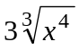 to eliminate the fraction)

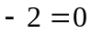 (Simplify)

Since 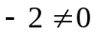, this produces not solution. Thus, x = 0 is the only inflection point candidate. Recall that its y-coordinate on the graph is obtain by substituting into the original function . Recall that this gives the following.

gives the point (0, 0)

To test whether the concavity changes, we use a test table involving the second derivative.

(continued on next page)

2nd Derivative Test Table for
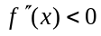  _ _ _ _ _ _ _ _ _  Concave Down | Inflection point  Candidate  x = 0 | _ _ _ _ _ _ _ _ _  Concave Down
Choose  x = -1 < 0  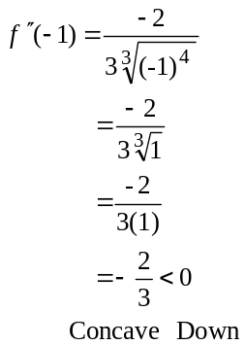 |  | Choose  x = 1 > 0  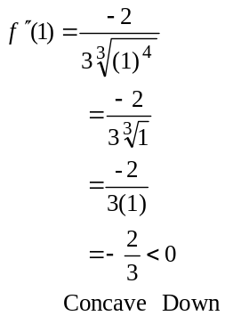

Since the concavity of the graph does not change to the left and right of x = 0 (it remains concave down), the point (0, 0) does not produce a point of inflection. Since there are no other candidates, the graph of has to points of inflection. Using the table, we see that we have the following intervals for concavity.

Concave Down: When x < 0, x > 0 or in interval notation 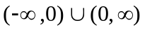.
Concave Up: Never

In summary, this is the information we have produced:

1. The point (0, 0) is a local minimum, the point (8, 4) is a local maximum.
2. is increasing on the interval (0, 8).
is decreasing on the interval .
3. There are no points of inflection.
4. The graph is concave down on the interval .
The graph is never concave up.
5. Note that the local minimum, (0, 0), was obtained from an undefined critical point,
that is, was undefined at x = 0. A function has an undefined derivative at a point where the graph is not continuous, has a sharp point, or a vertical tangent. The function is continuous at x = 0. Since (0, 0) is a local minimum, the graph changes from decreasing to increasing at this point. In addition, the concavity remains down to the left and right of this point. Hence, the graph produces a sharp point at (0, 0).
(continued on next page)
The following is the graph of the function .





