Section 2.2: Derivatives of Polynomials and Exponential Functions

Practice HW from Larson Textbook (not to hand in)
p. 99 # 1-49 odd, 75-81 odd

Alternative Notations for the Derivative

If 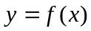, then

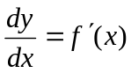

is known as the derivative of y with respect to x.

For example, if we have the function 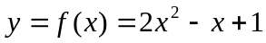, then we can write

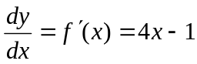.

For doing intermediate computations, we have the following notation:

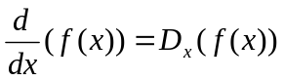

Thus, we can say

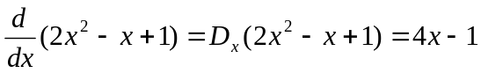

Also, to evaluate a derivative at a point, say x = a, we write

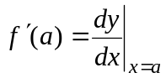

Hence, if 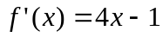, then

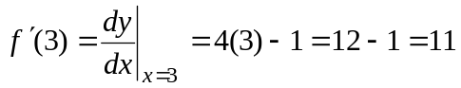.

Basic Derivative Formulas

1. 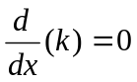, where k is a constant (for our purposes, a real number).

2. 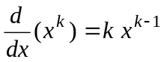

3. 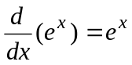

4. 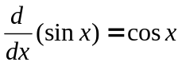

5. 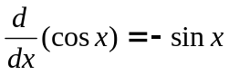

Example 1: Differentiate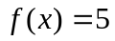.

Solution:

█

Example 2: Differentiate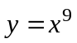.

Solution:

█
Example 3: Differentiate 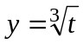.

Solution:

█

Example 4: Differentiate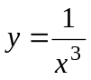.

Solution:

█

Properties of Differentiation

1. 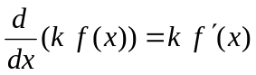 (k is a constant)

2. 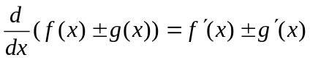

Example 5: Differentiate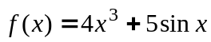.

Solution:

█

Example 6: Differentiate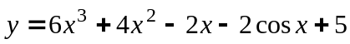.

Solution:

█

Example 7: Differentiate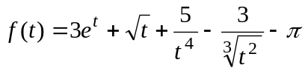.

Solution:

█

Example 8: Differentiate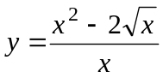.

Solution: Using the following property of fractions that 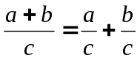, we first rewrite the function as
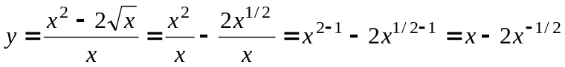

Differentiating 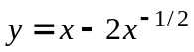, we obtain
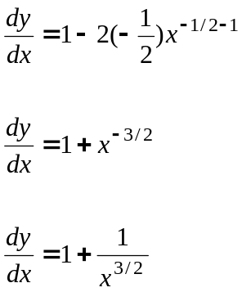
█
Example 9: Find the equation of the line tangent to the graph of 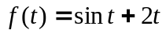 at the point 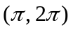.

Solution: To find the equation of any line, including a tangent line, we need a point (this is given to be ) and the slope. Recall that the derivative at a point gives the slope of the tangent line at that point. To find a formula for calculating the slope, we calculate the derivative of the function which is given by

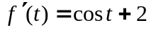

Then,
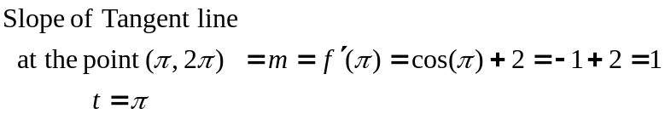

Then, using the slope intercept equation of a line (in terms of t) given by

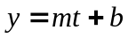

we use the slope of the tangent line we just found m = 1 to find the equation of the tangent line as follows:

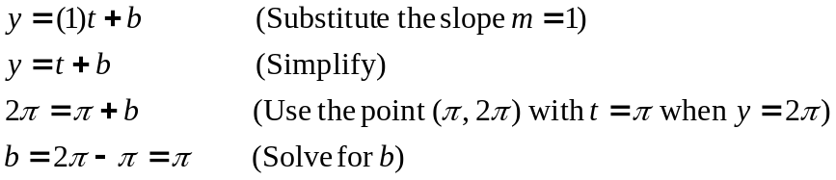

Hence, substituting the slope m = 1 and 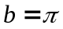 into gives the tangent line equation:

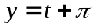

(Continued on next page)

The graph of the function and its tangent line can be seen as follows using the Maple command

> plot([sin(t)+2*t, t + Pi], t = -Pi..2*Pi, y = -10..15, color = [red, blue],thickness = 2, title = "Graph f(t) = sin(t)+t (red), tangent line y = t+Pi (blue) at point (Pi, 2Pi)");

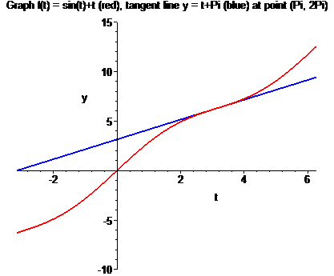

█
Example 10: Find the point)s on the graph of 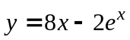 that has a horizontal tangent line.

Solution: On this problem, a horizontal tangent line means that the slope of the tangent line is 0. Since the derivative gives a formula for the slope of the tangent line, we can find the point that gives a tangent line slope of 0 by taking the derivative of the function, setting it equal to 0, and solving for x. The result of this calculation is as follows:

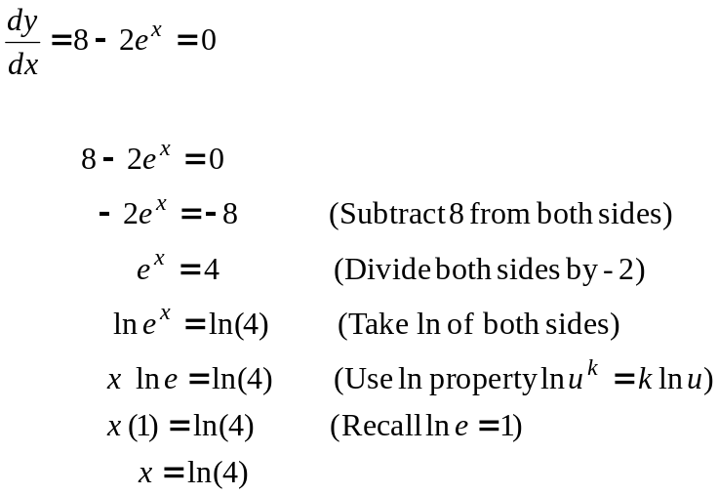

To complete the problem, we must find the y-coordinate of the point by substituting 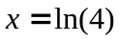 back into the original function . Keeping in mind the inverse property 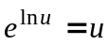, this is done as follows:

Thus, the coordinates of the point that have a horizontal tangent line is

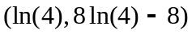

█

Average Velocity

Suppose the position of a moving object starting from rest is given by the position function 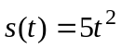 feet where t is the time given in seconds.

t
0

1

2

3

4

We define the average velocity on the time interval from t = a to t = b as follows:

Formula For Average Velocity

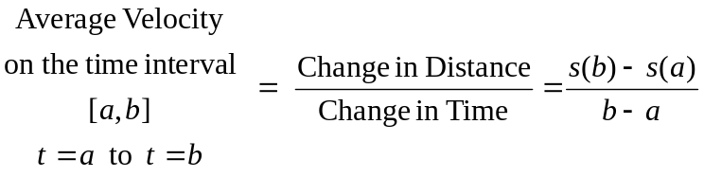.

Example 11: Find the average velocity for the time intervals [1, 3] and [3, 4] for an object if the position starting from rest is given by .

Solution:

█
Suppose we now desire to find the velocity of the object precisely when t = 1 second for the position function .

A method for approximating would involve finding average velocities on an interval that is “close” to t = 1.

Example 12: Find the average velocity for the time intervals [1, 1.01] and [1, 1.001] for an object if the position starting from rest is given by .

Solution: To assist in the calculations, we find the position function at the following times.

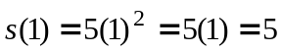
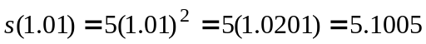

Then, using the average velocity formula

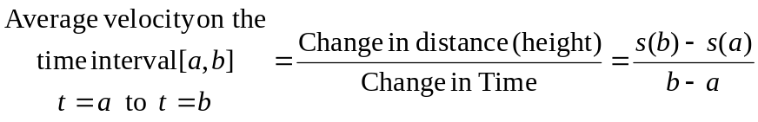

we obtain

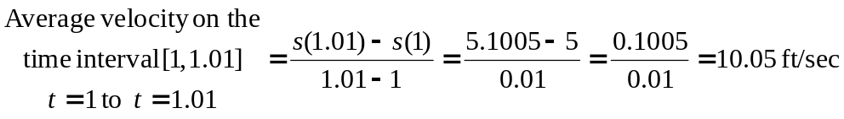

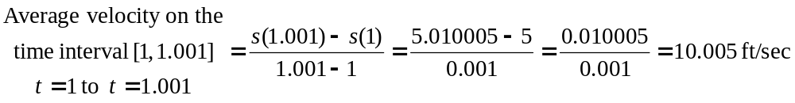

█

In general, for an object moving from time 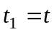 to time 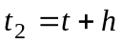,

Average Velocity
on the time interval =
[t, t + h]

To get the instantaneous velocity at , we let h→0 which gives the following definition.

Instantaneous Velocity and Instantaneous Rate of Change

Given a position function 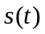, the instantaneous velocity 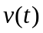 is given by the derivative of the position function. That is,

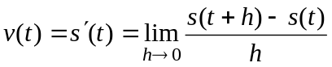

In general, if we are given a function ,

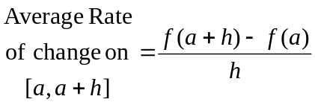

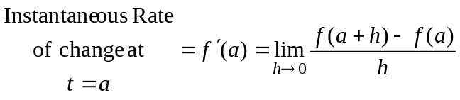.

Example 13: Find the instantaneous velocity for the position function at t = 1.

Solution:

█

Example 14: The position function representing the height of a freely falling object is given by 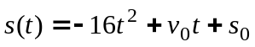, where 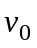 is the initial velocity of the object and 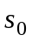 is the initial height of the ball at time t = 0. Here the height s is in feet and the time t is in seconds. Suppose someone throws a baseball from 6 feet off the ground with a initial velocity of 100 ft/s.
a. Determine the position and velocity functions for the ball.
b. Find the average velocity for the time intervals [4, 4.1], [4, 4.01], and [4, 4.0001].
c. Find the instantaneous velocity when t = 4 and t = 5 seconds.
d. Find the time required for the ball to reach ground level.
e. Find the velocity of the coin at impact.

Solution part a: Since the ball starts 6 ft off the ground, the initial height is 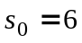. The initial velocity is 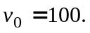 Substituting into the equation gives the position equation

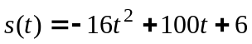

To get the velocity equation, we take the derivative of the position equation . This gives

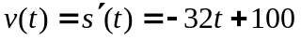

Solution part b: Recall that given a time interval 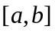, if s represents the height of the ball (the position) after time , then

.

To find the average velocities for the given intervals, we will use the following calculations:

.
Hence,

Continued on the next page
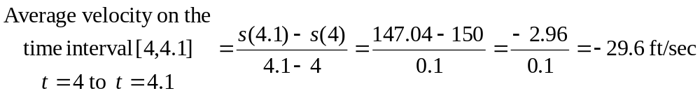

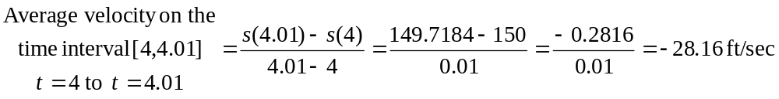

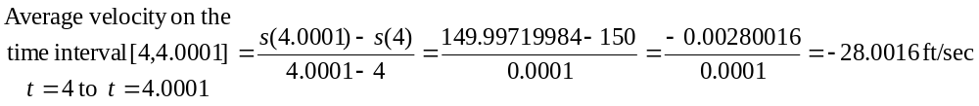
Note that the negative average velocities indicate that the ball is falling down instead of going up.

Solution part c: The average velocities found in part b indicate the instantaneous velocity at the specific time 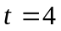 should be close to -28 ft/sec. From part a, we found the equation for the instantaneous velocity at a particular time t to be

Thus, at we have

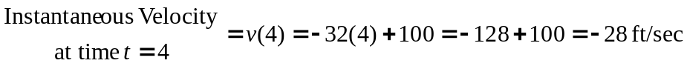

We can easily use this same equation to find the velocity at t = 5 seconds.

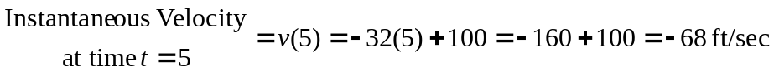

Solution part d: When the ball reaches ground level, its height s = 0. Thus, the find the time when the ball reaches ground level, we set the position equation

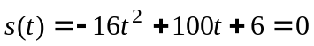

and solve for t. Since this quadratic equation is not easily factorable, we use the quadratic formula to find its approximate solution.

Continued on the next page

Recall that the quadratic formula says that the solution to the quadratic equation is given by 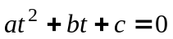 is given by

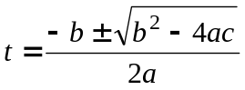

For , setting a = -16, b = 100, and c = 6 we obtain

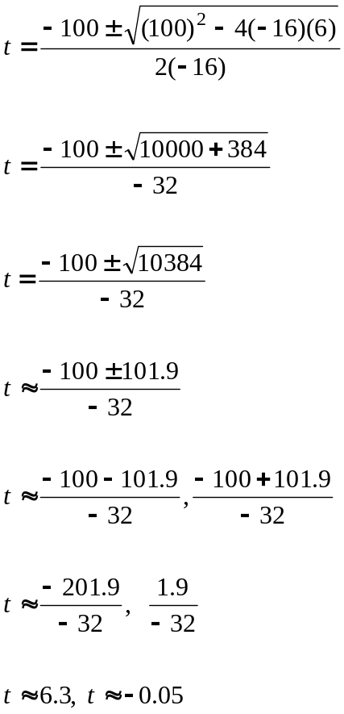

Thus, the ball hits the ground in approximately 6.3 seconds.

Solution part e: From part d, we found out the ball hits the ground after t = 6.3 seconds. To find the velocity when the ball impacts the ground, we substitute t = 6.3 into the velocity equation we found in part a 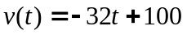. Thus,





