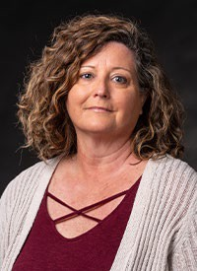
Message from the Director

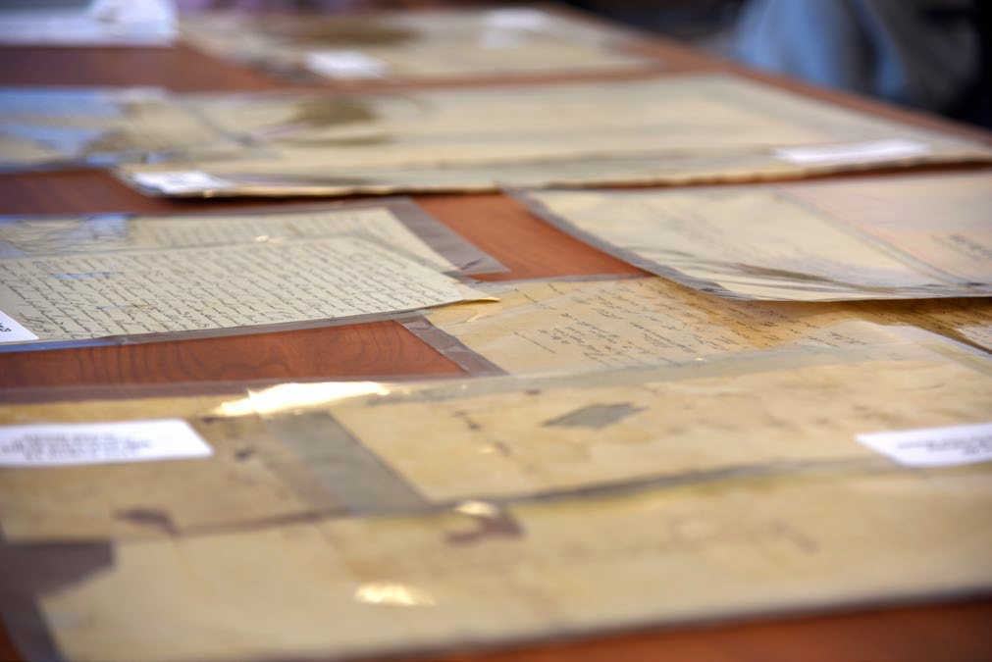
I am excited as we enter into the third year of the Department of History’s Center for Archives and Digital History. Our programming is growing as we now have faculty in all three areas of the CADH: digital archives, digital history, and public history. A CADH advisory board has been established to help guide us as we more forward in our endeavors. Our curriculum has expanded to include both an introductory and an advanced topics course in all three of those areas. We will continue our CADH speaker series, targeting one or two speakers each semester. Our newest projects include working with the Giles County Historical Society in preserving and digitizing their records. We also recently had a donation of a collection of family materials that include letters from the Civil War – my personal favorite letters to work on.

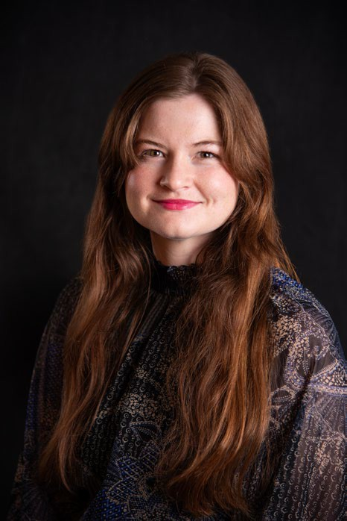
Dr. Greer’s interests include gender and religion in the early American republic, and she completed a dissertation entitled “Sites of Spectacle and Sites of Sacrifice: The Female Itinerant Preacher’s Body in the Early American Republic.” This book project combines body studies with religious history with the intersection of gender and race and is centered mostly on New England and the Mid-Atlantic in the early nineteenth-century United States. She is dedicated to public history and digital humanities, with projects including a community-engaged museum exhibit at Old Town Alabama in Montgomery, Alabama; multiple mapping projects, and time as a project manager at the Roy Rosenzweig Center for History and New Media. She further emphasizes public-facing history writing, including work at the Encyclopedia of Alabama out of Auburn University and as an affiliate editor for the National Council of Public History’s blog History@Work. She has degrees from Louisiana State University, Auburn University, and George Mason University.
Meet our newest faculty member

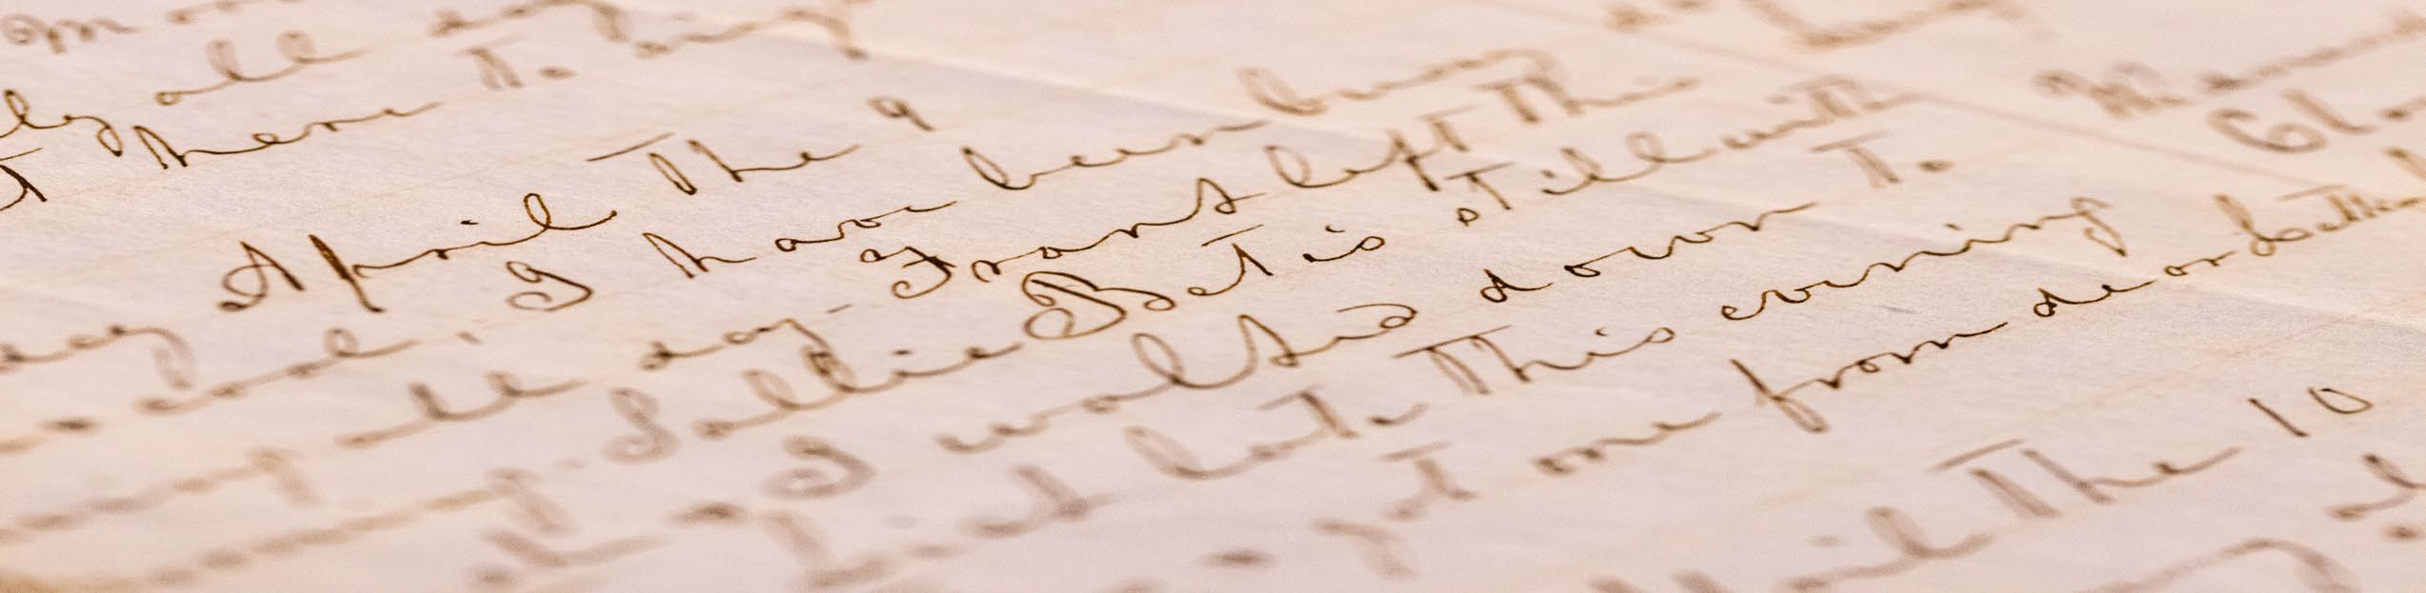

the Department of history’s Center for arChives anD Digital history
Issue 2: January 2026

Center for Archives and Digital History

The McKay-Mowbray Collection
Collection Spotlight
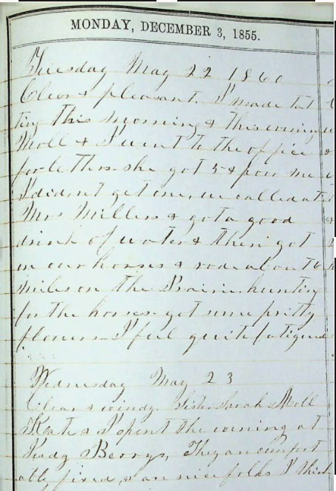
The McKay-Mowbray collection primarily consists of correspondence between Aurelia "Kay" McKay and her husband, Perry Mowbray.
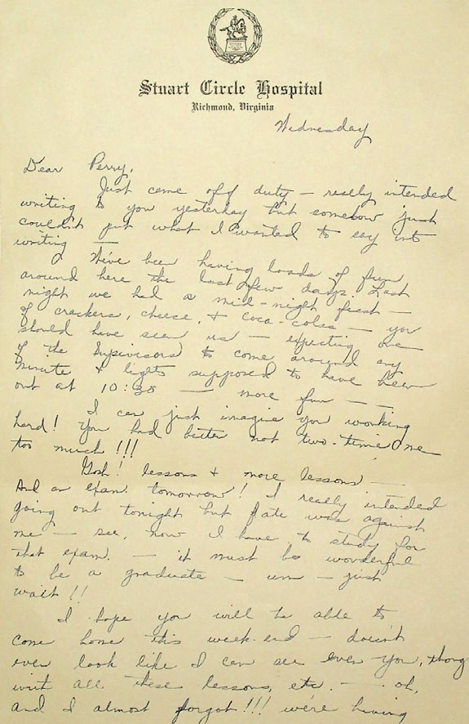
Between 1936 and 1945, Kay and Perry wrote each other hundreds of letters spanning their courtship, marriage, and Perry's enlistment into the
U.S. Navy. As WWII progressed, Perry kept Kay updated with his military activities and planned visits home to see her and to visit their respective families. The collection also includes letters and cards from the couple's friends, family, and coworkers. Also included in the McKay-Mowbray collection is a diary from 1856 that has entries leading into 1860, written by a young girl named Lucie C. Buck as she traveled through Virginia.

Interesting discoveries in the collection include various pressed flowers from the 1800s preserved within the Buck Diary, and many adorable vintage holiday cards have been found amongst the McKay-Mowbray correspondence.
This collection was donated to us by Elizabeth Mowbray Usher and Perry Mowbray, who are both children of Perry and Kay. Elizabeth Usher even met with many of the students working on the collection to answer questions and clear up some holes in the research.
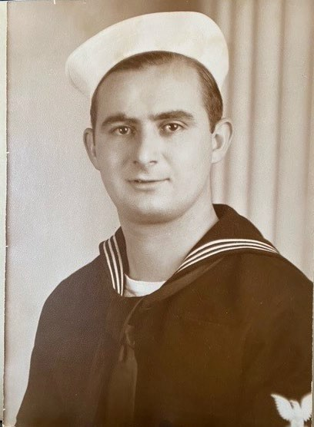


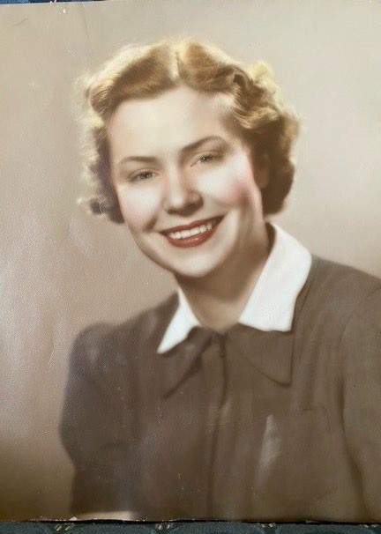
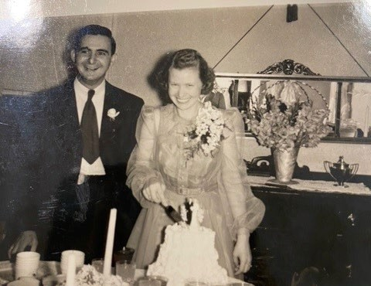

Aurelia "Kay" Marguerite McKay was born on November 29th, 1915, in Front Royal, Virginia. She was the last member of her family to be born on their homestead after seven generations of settlement on the property.
Perry Doniel Mowbray was born on October 2nd, 1919, in Flint, Michigan. Before enlisting in the Navy, he worked for a company building houses in Little Creek, Virginia

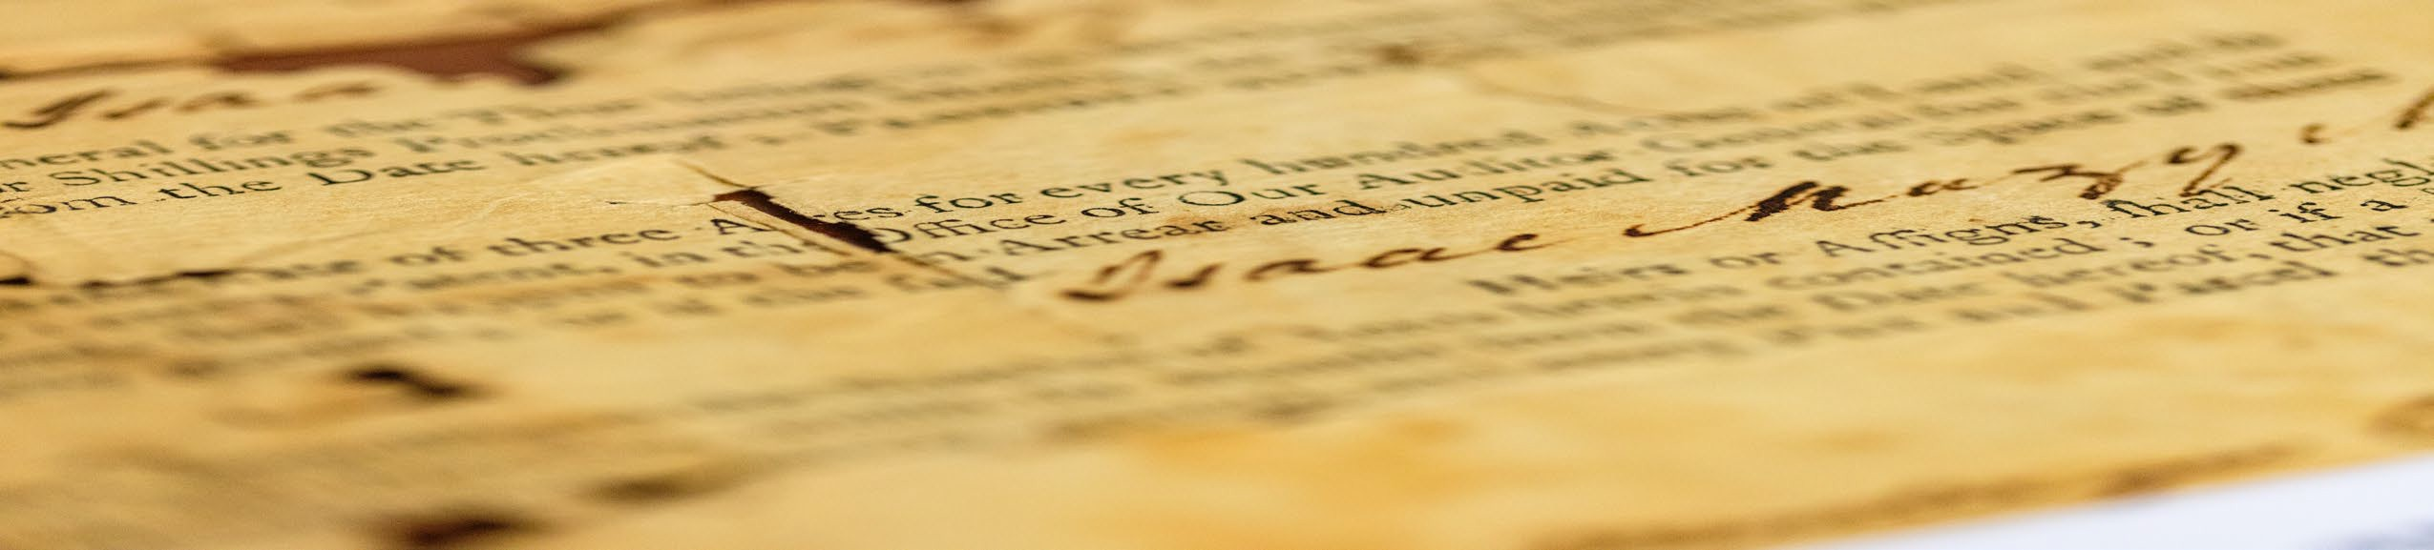

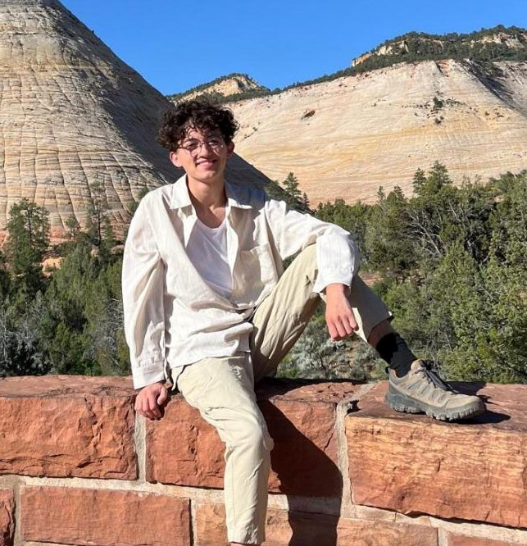
Meet a Student Archivist
Glenn Bost is a senior at Radford University studying for an undergraduate degree in History. He has spent three years as a Student Archivist for the CADH and worked with several professors on independent research projects, covering a variety of topics such as medical treatment for enslaved women in antebellum Appalachia and serpent-handling rituals in Pentecostal churches. Currently, Glenn assists Dr. Hepburn in her Introduction to Digital Archives class teaching students to handle and digitize historical documents.

Meet a student

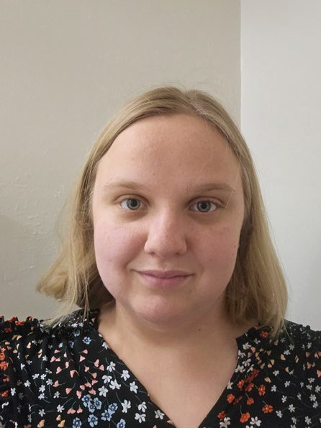
My name is Hannah Morris, and I am a Junior at Radford University. This has been my first semester here, as I am a transfer student from Virginia Western Community College. I am majoring in history with a double minor in applied history and archaeology. My favorite area of history is atomic and scientific history, especially anything related to radiation! After graduating from Radford University, I plan to attend graduate school and pursue a career at a science museum.

From students: Working with the Center for Archives and Digital History has been an incredible opportunity to gain hands-on experience with primary source documents and learn how to preserve them according to archival standards. The CADH provides students with real-world responsibilities, such as making decisions about organizing collections and applying best practices for document handling. This environment fosters practical skill development that benefits both the institution and future professional settings.

The CADH offers access to a wide range of historical materials, from the American Civil War to World War II, including court records, personal letters, and other unique documents. By partnering with historical societies and facilitating internships, the Center creates valuable networking opportunities for students interested in archival work, digital history, and public history. This experience has been one of the most rewarding and practical aspects of my time at Radford University, preparing me for success in graduate school and beyond.

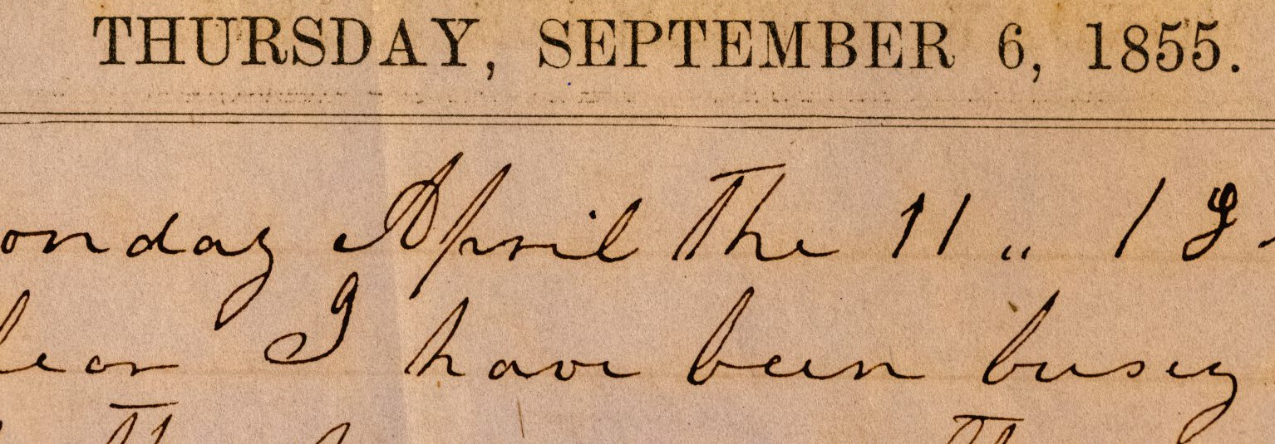
Center for Archives and Digital History
New Collaborative Project
Radford University has a rich and complex story—and we want to tell it together! The Community History Research Collective (RUCHRC) brings scholars, students, alumni, and community members together to explore Radford’s journey from its 1910 founding to today. As we look ahead to the university’s 125th anniversary in 2035, we’re working to uncover and share stories that connect Radford to Southwest Virginia and Appalachian communities.
Launching in 2025–2026, RUCHRC will partner with local voices and campus experts to build stronger connections and a deeper understanding of our shared history.

Through the Community Digitization Project, the Department of History’s Center for Archives & Digital History provides community members and organizations with a range of free services to preserve and make more accessible their family documents or other original archival materials. If you or someone you know has original family documents such as letters or diaries that they are interested in preserving and digitizing, contact the CADH director: shepburn@Radford.edu
Services we offer:
- Organize and inventory your family documents
- Put the documents in archival sleeves and archival boxes for preservation
- Digitize the archival materials
- Transcribe the documents
- Conduct research into the collection’s contents
Community Digitization Project

Give here to the CADH Foundation Fund. Thank you for your support! Invest in a student's future today!

