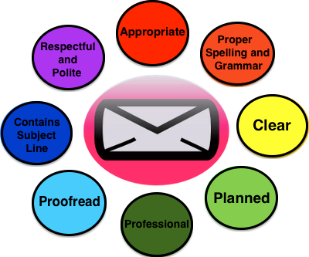
E-mail Etiquette

Appropriate professional communication is a critical skill set to develop. E-mail correspondence should demonstrate professionalism. Think about school E-mail as a practice for how you will use E-mail in a professional situation.

Greetings matter. Use standard greetings (Dear… Hello… Hi…). Beginning an E-mail to a professor with “Hey” does not make you look good. The safest way to start is with “Dear Professor So and So” (using their last name). That way you will not be getting into the issue of whether the prof has a Ph.D. or not, and you will not seem sexist when you address your female-professor as “Ms.” or, worse yet, “Mrs.”
Make sure that your E-mail clearly identifies who you are and the class that you are in. Teachers have multiple classes; knowing which one you are in will make it easier for an instructor to answer your questions promptly.
Make sure that your message is clear. Be specific. You know what you are working on or thinking about when you write your E-mail, but the person who reads it does not know what you are thinking if you are not clear. Statements like “I am confused about the assignment” are often meaningless to an instructor; he or she will not know what confuses you or even to which specific assignment you are referring.
Be courteous. This takes many forms, including using a polite and friendly tone. Do not write in all uppercase letters, which is an E-mail convention for anger or other strong emotions. Ask, rather than make demands of your instructors. Thank them for their time and assistance.
Use diction, grammar, punctuation, and spelling appropriate to a formal situation. Everything that you put into writing makes an impression. Strive to make a good one. Think of this as practice for ultimately working as a professional--E-mail is used in most professions now to generate and respond to memos, and you will be judged by the impression that you make.
- Make an effort to write correctly and professionally with standard conventions of grammar, punctuation, and spelling (capitalization, commas, periods, and so on).
- Use complete sentences.
- Avoid slang. Do not use text, Twitter, Snapchat or other social media language.
- This is not Facebook. Do not write the professor in the way you would write on your friends’ wall.
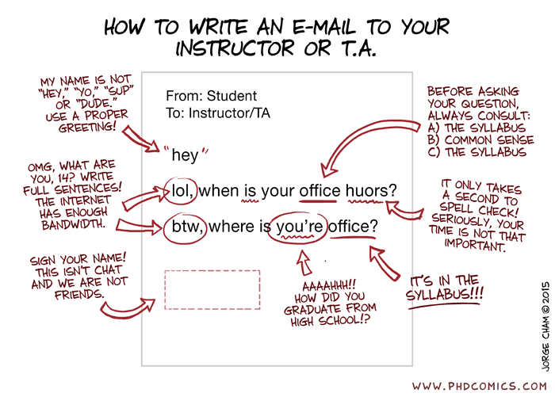
- This is not CollegeHumor.com. Resist the temptation to talk about the “bad ass” paper you need help with or the “crappy” grade you just got on the midterm.
- Proofread your E-mail.

Signoffs and signatures count. Always end by thanking the professor for his or her time, and closing with “Best wishes” or “Regards” (or some other relatively formal, but friendly, closing Always sign with your (entire) real name.

