REAL Assessment Guide

Updated: 5-12-2020
Table of Contents
The REAL Curriculum 3
REAL Areas 3
Program Requirements 4
REAL Learning Goals, Outcomes, and Conditions 5
REAL OVERSIGHT 6
The Executive Director of General Education 6
The REAL Council 6
REAL approval pathways 8
understanding assessment 10
What Is Assessment? 10
What Assessment Is Not 10
Why Conduct Assessment? 10
Drivers of Academic Assessment 11
The assessment process 13
The Assessment Cycle 13
Effective Assessment Processes 13
the real assessment process 15
The Assessment Cycle and Measure Mapping 15
Measures and Data Collection 16
Targets/Criteria for Success 17
Results/Findings 18
Feedback and Action Plans 19
Results of Action Plans 19
Real assessment documentation 21
real assessment guidelines 22
real assessment planning 23
real assessment Options 24
real assessment plans 26
General Information 26
Measures 26
Targets/Criteria for Success 27
Action Plans 27
REAL Assessment Plan Revision 28
real assessment reporting 29
real resources 41

The REAL Curriculum

The REAL Curriculum resulted from a three-year, faculty-led general education reform process. This innovative approach acknowledges that students develop general education learning competencies within courses and majors, minors, and certificates across their entire Radford University experience. With a student-centered focus, REAL builds on the strength of academic departments and on faculty expertise.

The REAL Areas

Students choose degree programs (majors, minors, and certificates) to fulfill four areas of knowledge and complete general education:

- Scientific and Quantitative REASONING: Major, minor, or certificate includes courses in math, natural science, and/or other related areas. Degree programs fulfilling this area incorporate the tools of mathematics and quantitative reasoning and the methodologies of scientific inquiry.

- Humanistic or Artistic EXPRESSION: Major, minor, or certificate includes courses in humanities, fine arts, and other related areas. Degree programs fulfilling this area integrate methods/techniques and areas of inquiry that explore and describe the human experience.

- Cultural or Behavioral ANALYSIS: Major, minor, or certificate includes courses in social science, behavioral science, and other related areas. Degree programs fulfilling this area examine individual, social, or cultural factors that influence human behavior and shape reciprocal relationships between people and society.

- Applied LEARNING: Major, minor, or certificate includes courses incorporating skills immediately applicable to the workplace; a focus on how academic subjects apply to real world problems and opportunities; and applied courses focus on practice (doing—knowledge in action) within a profession.

Students complete foundational writing focused on composition and mechanics (can cross credit with degree program but not E area fulfillment) and foundational math focused on numerical literacy (can cross credit with degree program but not R area fulfillment)

Students must complete two three-credit writing intensive courses, at least one at the 300 level or higher. These may be completed within or outside of student degree programs.

Students must fulfill a personal and professional development area with activities, engagements, and/or coursework. A three-credit course can fulfill this requirement but many other activities and engagements can also support students in this area.

Program requirements:
- Students fulfill the REAL Curriculum by identifying a combination of majors, minors, and certificates that meet their educational goals that complete the R, E, A, and L areas.
- Any degree program that fulfills a REAL area must include at least 9 unique credit hours, with at least 3 credit hours at the 300 level or above for the area covered.
- All minors that fulfill REAL areas must be a minimum of 15 credit hours.
- Within the REAL Curriculum, course designation is limited to one R, E, A, or L area.
- Students also complete foundational courses in mathematics and writing.
- The two writing intensive courses required by REAL curriculum must be at least 3 credits each.
- All majors, minors (including REAL Studies minors), and certificates, covering R, E, or A must identify at least one course that meets the SACSCOC definition of general education in order to cover those claimed areas.
- Students must complete 15 documented participation/contact/activity hours for 1 credit hour equivalent of professional and personal development. A total of 3 credit hours or equivalent must be documented to fulfill the Personal/Professional Requirement for the REAL Curriculum.
- REAL area general studies minors allow students to fulfill areas with more diverse collections of courses or to change their minds about minors or majors.

REAL LEARNING GOALS, OUTCOMES, AND CONDITIONS

Designation | Learning Goals | Learning Outcomes | Conditions
FW | To develop a student’s understanding of the principles and elements of effective written communication through applied practice, self-evaluation, and revision. | (1) Students employ reading strategies to facilitate written communication. (2) Students engage in the recursive writing process, including pre-writing, drafting, revising, editing, and proofreading to improve written communication. (3) Students use appropriate vocabulary, mechanics, grammar, and style. | English 111, or competency, fulfills this requirement.
FM | To apply the tools of mathematics to conceptualize and solve problems in everyday life. | (1) Students translate information among various mathematical forms (e.g., equations, graphs, diagrams, tables, words). (2) Students successfully solve problems using appropriate mathematical tools. (3) Students draw appropriate conclusions based on mathematical evidence. | Math 100, Math 121, and Math 125, or competency, fulfill this requirement.
R | To apply scientific and quantitative reasoning to questions about the natural world, mathematics, or related areas. | (1) Students apply scientific and quantitative information to test problems and draw conclusions. (2) Students evaluate the quality of data, methods, or inferences used to generate scientific and quantitative knowledge.
E | To explore humanistic or artistic expression through inquiry or creativity. | (1) Students demonstrate understanding of diverse ideas, languages, products, or processes of humanistic inquiry or artistic expression.  (2) Students critically evaluate, synthesize, or create forms of human expression or inquiry.
A | To examine the context and interactions of culture(s) and/or behavior(s) | (1) Students describe behaviors, beliefs, cultures, social institutions, and/or environments. (2) Students analyze the interactions of behaviors, beliefs, cultures, social institutions, and/or environments.
L | To explore professional practice through the application of knowledge, skills, and critical reflection. | (1) Students apply acquired knowledge and skills to develop professional identity or professional practice. (2) Students critically reflect on their learning, abilities, experiences, or role within professional contexts.
PPD | To prepare students for lifelong success, students explore an area of physical, social, emotional, financial, scholarly, spiritual, cultural, and/or professional development. | (1) Students identify a personal or professional goal(s) through engagement in activities or coursework. (2) Students reflect on their progress in achieving a personal or professional development goal(s), including how it affects themselves and/or those around them.
WI | Through instruction and feedback, students become more adept at producing appropriate and effective written work. | (1) Students demonstrate proficiency in the writing conventions of a discipline. (2) Students communicate through writing their understanding of disciplinary content and/or texts. | (1) Courses substantially integrate sole-authored student writing within the course objectives and assessments. (2) Courses use discipline-specific reading strategies to facilitate effective written communication. (3) Courses engage students in a recursive writing process that includes revision supported by consistent, detailed instruction and the incorporation of feedback.
The REAL Curriculum Oversight
The Executive Director of General Education
The Executive Director of General Education leads the general education efforts, oversees its ongoing integration into undergraduate degree programs at Radford University, and serves as a member of the Academic Affairs Leadership Team.

Reporting to the Provost and Vice President for Academic Affairs, the Executive Director of General Education works closely with faculty and staff, college deans, department chairs, and school directors, the Academic Success Center Executive Director, and the Office of the Registrar to coordinate the implementation of the general education curriculum and to ensure its continued success.

The REAL Council
In the fall of 2019, the Faculty Senate voted to approve establishment of the REAL Council, an academic governance committee to oversee the REAL Curriculum at Radford University. Prior to implementation of the REAL Curriculum, the initial function of the REAL Council is to establish procedures for program alignment to the REAL curriculum. After the REAL Curriculum implementation, the Council’s continued functions are to maintain program alignment and to ensure REAL curriculum quality.

Membership
- (2) faculty from each undergraduate college – (staggered 3 year terms)
- Executive Director of General Education – non-voting
- (2) undergraduate students – non-voting, appointed annually by Student Affairs
- Representative from Institutional Effectiveness & Quality Improvement - non-voting
Faculty members are elected by their respective undergraduate colleges. Nominations for faculty members must be received by colleges no later than close of business on Friday of week 10 of the spring semester. Voting must conclude no later than the close of business on Friday of week 12 with the results being communicated to the Provost during week 13 of the of spring semester. In the case of faculty membership vacancies, new members would be elected by their college to fulfill the remainder of the original terms.

Charges
- Interim Charges: (To be addressed prior to the launch of Real Curriculum)
- Develop a schedule for REAL Council review of campus-wide assessment for fulfillment of REAL knowledge areas and Cornerstone and Foundation courses.
- Establish competency criteria to meet learning outcomes in REAL studies minors.
- Establish minimum benchmarks for students achieving competencies in the REAL areas, Foundation and Cornerstone courses in consultation with the Office of Institutional Effectiveness and Quality Improvement.
- Liaise with administrative units and/or committees to identify appropriate procedures and infrastructure to support interdisciplinary and multidisciplinary courses, majors, minors, and certificates.
- Partner with the Executive Director of Faculty Development to identify strategies to support faculty development related to the Real Curriculum.
- Standing Charges
- Review and make recommendations to Faculty Senate about the learning goals and outcomes for REAL knowledge areas and Cornerstone and Foundation courses.
- Review, maintain, and administer process, procedures, timeline, competency criteria, and templates for REAL designations of courses.
- Review proposals for REAL course designations (approval authority).
- Review, maintain, and administer process, procedures, timeline, and templates for REAL alignment of majors, minors, and certificates.
- Review approval of REAL proposals for majors, minors, and certificate alignment (recommendation authority).
- Review proposals for courses to fulfill Foundational course requirements within the Real Curriculum (approval authority).
- Review and course proposals for Writing Intensive course designation within the Real Curriculum (approval authority).
- Review and proposals for courses to fulfill Personal and Professional Development area within the Real Curriculum (approval authority).
- Annually review programming activities approved by the Executive Director of General Education to fulfill the Personal and Professional Development area.
- Periodically review assessment results related to REAL learning goals and outcomes for degree majors, minors, and certificates and make subsequent recommendations to Faculty Senate Executive Council.
- Partner with the Executive Director of Faculty Development to identify strategies to support faculty development related to the Real Curriculum.
- Review an annual report on the status of General Education (could include, but is not limited to, information such as: progression to degree, resource capacity and concerns, student impact, and advising support), compiled by the Executive Director of General Education, and makes subsequent recommendations to Faculty Senate Executive Council.
- On an annual basis, review report, provided by the Executive Director of General Education, that details updates and changes to REAL major, minor, and certificate alignment and course designations and rotations from departments, and make subsequent recommendations to Faculty Senate Executive Council.
Designated Administrator: Provost
OPERATING RULES
- Designating departments decide criteria or standards for determining whether students have successfully achieved learning outcomes for courses (including Foundational and Cornerstone courses), majors, minors, and certificates.
- Course designation decisions can be appealed to the Faculty Senate Curriculum Committee for recommendation to Faculty Senate, which has final approval.
- The review process for course designations and major, minor, and certificate alignment occurs as part of academic program review.
REAL Approval Pathways
Each REAL proposal generated from within an academic department must obtain the following approvals:
- Departmental Curriculum Committee
- Department Chair
- College Curriculum Committee
- College Dean
- The REAL Council
- Faculty Senate Curriculum Committee
- Faculty Senate (as a whole)
- Provost
- Registrar
Once each committee has signed off on the proposal, the proposal will go into effect. Proposals should be submitted both electronically and on paper, due to the need to collect signatures. When a proposal leaves the college curriculum committee for REAL Council, an electronic version should be sent to Dr. Nicole Hendrix via email.
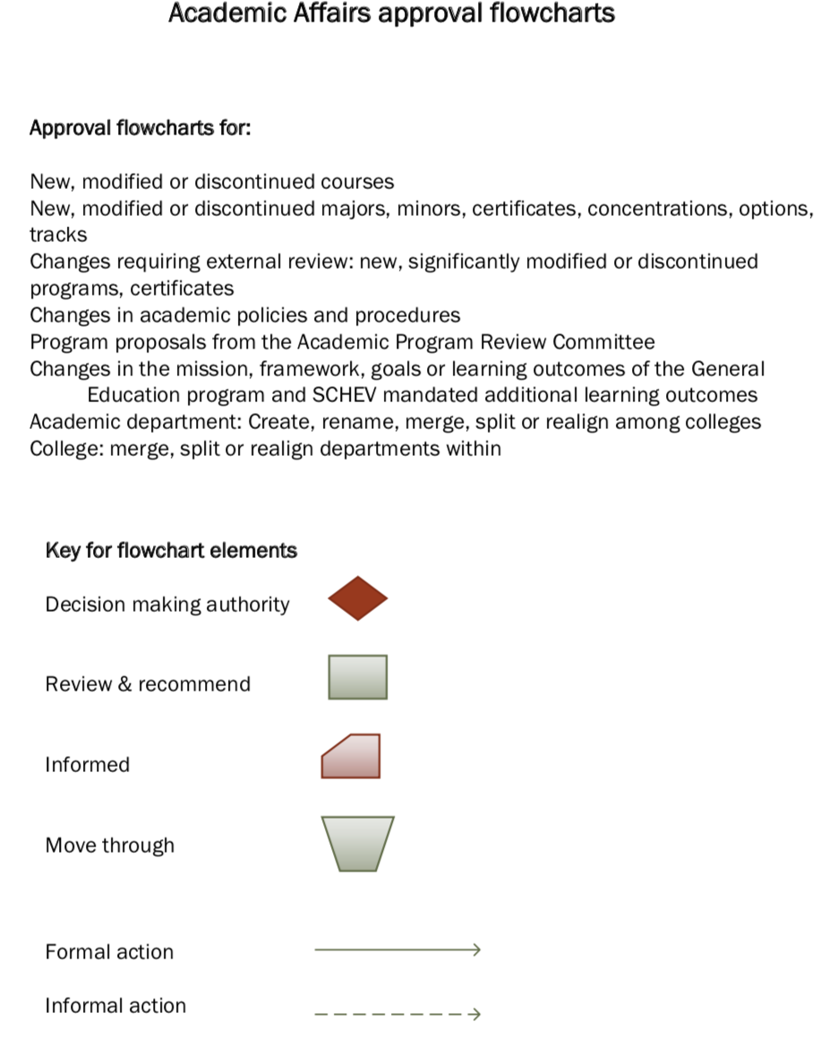

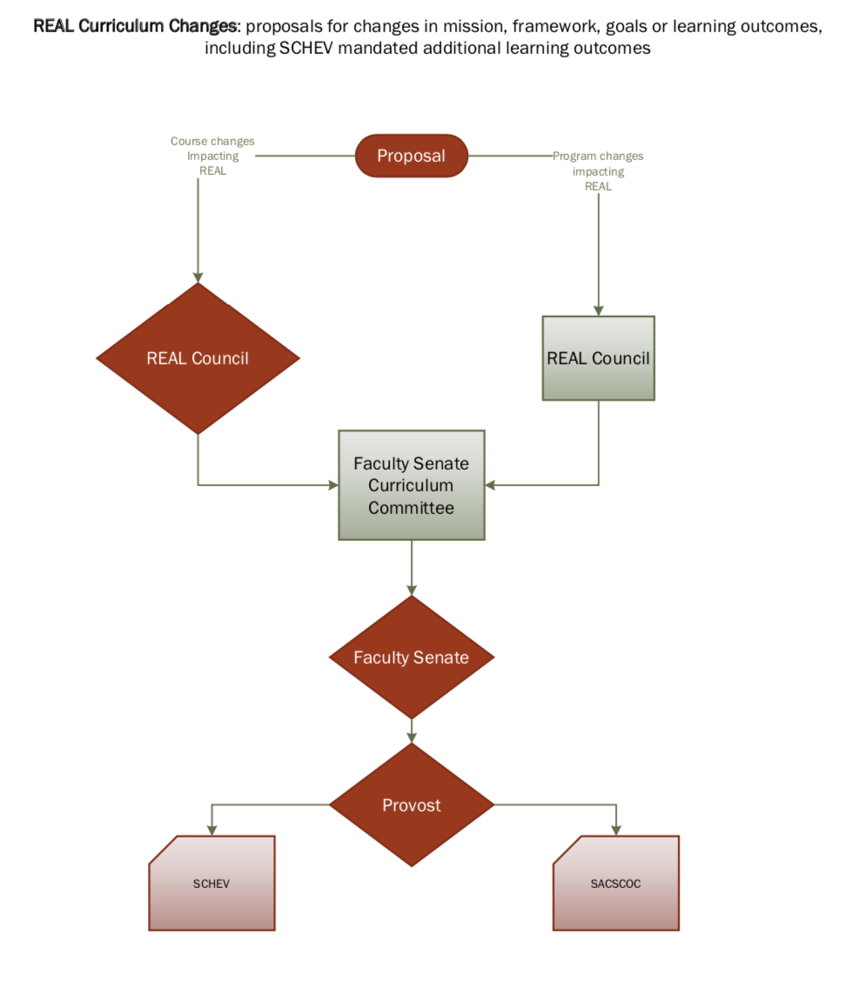
Understanding Assessment
General education develops capacity in important student learning areas. Assessment of the REAL Curriculum offers faculty and departments opportunities to demonstrate the program’s value and to document success.
What is Assessment?
“Assessment is an ongoing process aimed at understanding and improving student learning. It involves making our expectations explicit and public; setting appropriate criteria and high standards for learning quality; systematically gathering, analyzing, and interpreting evidence to determine how well performance matches those expectations and standards; and using the resulting information to document, explain, and improve performance.” (Angelo, 1995, p. 7)
First and foremost, the main purpose of assessment is to improve student learning. The goal of a well-designed assessment process should be to answer important questions about students, programs, and the institution as a whole. While faculty regularly examine ways improve student learning, the processes are often not systematically documented. Since the primary purpose of conducting assessment is to enhance student learning, assessment of learning is driven by the desire for continuous improvement.

What Assessment is NOT
- Student grades. Grades are not by themselves an assessment. Assessment looks at the alignment between the program curriculum and student learning outcomes. Grades may be used as assessment if they are directly linked to specific learning outcomes and data are collected for that purpose.
- Evaluation. Assessment is a process of improvement and should never be used to judge any faculty.
- Just for accreditation. Assessment should not be conducted just to meet accreditation requirements. To be meaningful it should be an ongoing process of development, measurement, and reflection geared toward continuous improvement.
- Useless. Assessment (if conducted properly) contributes to program development and to student learning.

Why Do We Conduct Assessment?

Assessment is conducted to improve programs and student learning:
- Helps to identify areas for improvement
- Shows strengths of programs
- Provides evidence of student learning attainment
- Encourages a focus on curriculum rather than on courses

Accountability:
- Assists the university and programs in meeting accreditation standards
- Assists the university in meeting state mandates
Drivers of Academic Assessment

External
Two external agencies that influence assessment practices at Radford University include the State Council for Higher Education in Virginia (SCHEV) and the Southern Association for Colleges and Schools Commission on Colleges (SACSCOC). SACSCOC is one of the six regional accreditors of colleges and universities in the United States. External stakeholders, like SCHEV and SACSCOC require assessment data collection to demonstrate the effectiveness of educational programs and university administration. This data is used to facilitate program improvement and improve student learning.
As a state-funded public institution of the Commonwealth of Virginia, all the educational activities of Radford University are under the auspices of the State Council for Higher Education in Virginia (SCHEV). It is SCHEV’s recommendation that the general education curriculum for higher education institutions in Virginia must include the following four competency areas: critical thinking, quantitative reasoning, written communication, and civic engagement. Additionally Radford University has chosen two additional competency areas: oral communication and scientific reasoning.
The SACSCOC Principles of Accreditation: Foundations for Quality Enhancement outlines expectations for general education assessment. According to the document, each member institution “identifies expected outcomes, assesses the extent to which it achieves these outcomes, and provides evidence of seeking improvement based on analysis of the results for student learning outcomes for collegiate-level general education competencies of its undergraduate degree programs.” It is expected that general education assessment is planned, conducted on a regular schedule, and that the information is used as a tool to improve educational programming at an institutional level. In order to meet these conditions, Radford University’s REAL Council has created assessment policies and guidelines that programs follow as a provision of taking part in the REAL Curriculum. Because Radford University will be evaluated by SACSCOC on its adherence to the policies and guidelines that programs follow as a provision of taking part in the REAL Curriculum, it is important that all programs not deviate from their detailed assessment plans approved by the REAL Council.
In academic programs that seek disciplinary accreditations, external accreditors set the minimum standards that respective programs must meet by demonstrating the extent to which stipulated student learning outcomes have been met. Efforts are made to streamline the assessment efforts such that, with little modification, the same student learning outcomes will be used to satisfy the requirements for both the specialized accreditors and the SACSCOC requirements.

Internal
Assessment offers ways for academic units to understand the dimensions of student learning when seeking to improve student achievement and the educational process. Assessment provides essential information about knowledge, skills, and other attributes students can expect to possess after successfully completing coursework and academic programs. Departments and programs use assessment results for determining both the success and competency of their students who are earning credentials.
Assessment occurs at multiple levels and across areas which should all align and inform to produce one cohesive picture or story. Assessment to ensure quality and continuous improvement is a key element of the Radford University strategic plan. In order to align departmental and programmatic goals and outcomes with the mission and values of the institution, academic programs determine how written communication, oral communication, and critical thinking skills stated in the Strategic Plan 2018-2023 (Academic Excellence and Research Goal 1, Strategy A) will be assessed in each program.

The Assessment Process
The assessment process involves examining student learning by tracking and measuring student performance. It is the process by which programs can demonstrate the extent to which desired general education outcomes are achieved. Assessment is an ongoing cycle of identifying desired outcomes, measuring the achievement of these outcomes, analyzing the information collected, reporting results, and making improvements (as needed) to help students master the learning outcomes.

The Assessment Cycle
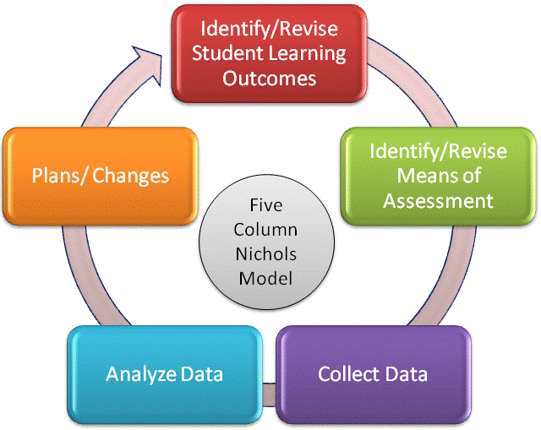

Effective Assessment Processes

For assessment to be truly effective, departments need to engage both faculty and students in the process. Faculty need to have a collective ownership of the entire program by focusing on the curriculum rather than on courses. Students need to be informed about what a program is trying to accomplish. And, programs need to come up with a way to make the process more effective. The assessment process should involve all faculty, regardless of rank or position.

Each participating program/department must have an assessment coordinator who oversees the REAL Curriculum assessment process each year. Departments may choose to designate a faculty member for program assessment, REAL assessment, or both. But assessment should not be the sole responsibility of a single faculty member, the assessment coordinator.

Developing an Effective Assessment Process

Assessment is effective when:
- Assessment is viewed as a comprehensive, systematic, and continuous process;
- Assessment is viewed as a means for self-improvement;
- Assessment measures are meaningful;
- Assessment utilizes multiple measures and multiple sources;
- Assessment is used as a management tool;
- Assessment results are valued and are genuinely used to improve programs and processes;
- Assessment is coordinated by one person and reviewed by a committee (note that this is “coordinated,” not “done”);
- Assessment involves the participation and input of all faculty and staff; and
- Assessment includes students.

Process Tips:
- Make the assessment process more manageable. Come up with timelines and protocols for implementation.
To develop an effective assessment process a program should ask:
- How is the program sharing the assessment results with the faculty?
- How is the program using the assessment results to make improvements in student learning?

- Share the results at faculty meetings. Get assessment on the agenda. Have group discussions on what the data has shown and how the program can make changes to assist student learning.
- Act on the assessment. Use the data the program already has. Don’t file it away.
- Utilize what is already being done in the programs. Streamline assessments by examining what learning activities are already in place and see how these can fit into the assessment planning process.
- Keep in mind that assessment is a collaborative, intentional, and iterative process of gathering and analyzing information. All faculty should help develop a plan for documenting and designating who is responsible, what steps will be taken, and deadlines.
- Treat assessment as a living, dynamic document. Learning outcomes might change and curriculum might change. This should be seen as an improvement process.

The REAL Assessment Process

Developing an Effective REAL Assessment Process

STEP 1: Developing an Assessment Cycle and Assessment Measure Mapping

It is important for programs to develop an assessment cycle and a measure map for the assessment process. These two procedures assist programs in keeping track of the “where” and “when” in the assessment process. The program should identify how often each of the learning outcomes should be assessed and who is responsible for conducting the assessment.
In developing an assessment cycle and assessment measure map the program should ask:
- What student activities / experiences are needed to cover most of the learning outcomes?
- Who would be responsible for collecting the assessment data?
- Who would analyze the data or complete the reports?
- How often would the outcomes be measured?

When the two processes of developing an assessment cycle and a curriculum map are utilized:
- programs can identify time frames and personnel needed to accomplish an assessment plan;
- programs can see where assessment can be streamlined (i.e., utilizing one course or project to effectively measure more than one learning outcome); and
- programs can make the assessment process more manageable.
- Assessment measure map: Programs can chart their measures to determine if one can cover several of the outcomes. This can also be a place where programs can give timelines and responsibilities.
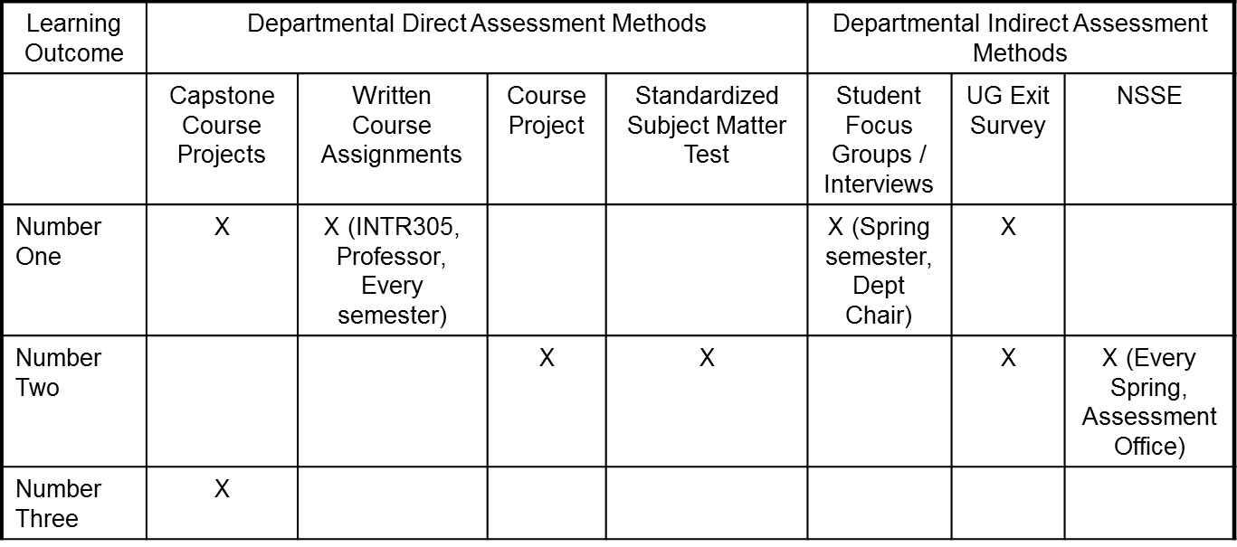

STEP 2: Measures and Data Collection

Once expected outcomes are developed, methods that will be used to measure these outcomes must be determined. While the type of methods used will vary depending on the outcomes, all methods should demonstrate whether students have achieved the expected outcome.

Allen (2008) states that good measures are:
- valid (are directly related to the learning outcome being assessed);
- reliable;
- actionable (results show what students have learned and which outcomes may require some form of action);
- efficient and cost-effective in time and money;
- engaging to students and other respondents (students will be motivated to demonstrate their skills or knowledge);
- acceptable to faculty and other stakeholders (faculty will care about the results of the assessment and will be willing to make changes if necessary); and
- triangulated (multiple lines of evidence point to the same conclusion).

Direct Measures
A direct measure of a learning outcome allows one to directly observe the student performance, usually via student assignment or work embedded in the course. This is an actual measure of the extent to which the student achieved the desired outcome.
In developing measures the program should ask:
- Are there any measures / student activities already in place that could be used to assess the student learning outcomes?
- Will these measures obtain the appropriate knowledge level of the outcome?
- Are there multiple measures to examine the outcomes?

Examples of direct measures of student performance include: capstone projects, portfolios, commercially developed tests, local tests, case studies, student artifacts, written exams, essay questions, presentations or demonstrations, nationally normed testing, discipline-specific tests, external evaluation of exhibitions or performances, juried review of projects, etc.

A direct measure of a program outcome allows for someone to obtain rates or statistics on expected student achievement. Examples include licensure exam scores, retention and graduation rates received from the Office of Institutional Research.

Indirect Measures
An indirect measure of a learning outcome asks students to reflect on their learning or abilities but does not provide a direct piece of evidence regarding the learning; instead it infers student knowledge. Indirect measures are often used to supplement direct measures of student learning and program outcomes. Some examples of indirect measures of student learning include surveys, exit interviews, employer satisfaction studies, course evaluations, and focus groups.
Indirect measures of program outcomes include information obtained from secondary sources or from student perceptions of achievement. Examples would include an alumni survey asking students about their job experiences or about satisfaction with their academic experience.

Using a combination of both the direct and indirect methods is recommended. However, a direct method for each of the learning outcomes is essential and is required for the REAL Curriculum.

Guidelines for Choosing a Measure
An effective assessment plan makes sure that appropriate measures are selected for the intended student learning outcomes. Programs need to have cognitive alignment such that the chosen measures accurately reflect the defined level of the student ability listed in the outcome (i.e., it is not appropriate to use multiple-choice items for a learning outcome asking students to compare and contrast two theories or concepts).

Evaluation of Data Collection Method
After selecting a data-collection method, this checklist can help programs confirm their decisions. A well-chosen method:
- provides specific answers to the assessment question being investigated;
- is feasible to carry out given program resources and amount of time faculty members are willing to invest in assessment activities;
- provides useful, meaningful information that can be used as a basis for decision-making;
- provides results that faculty members and intended users will believe are credible;
- provides results that are actionable (faculty members will be willing to discuss and make changes to the program, as needed, based on the results); and
- takes advantage of existing products (e.g., exams or surveys the faculty/program already use) whenever possible.

STEP 3: Targets / Criteria for Success

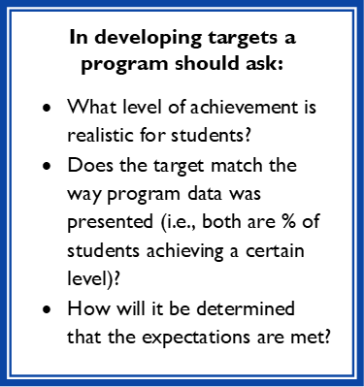
Targets for learning or program outcomes are the desired performance level programs want to see from their majors and graduates.
Performance targets should be:
- specific (what the program plans to achieve is clear);
- measurable (there is a way to determine whether or not the target has been reached);
- achievable; and
- rigorous.

For the REAL Curriculum, the REAL Council is responsible for establishing performance targets. Designating departments then decide criteria or standards for determining whether students have successfully achieved the learning outcomes for courses (including Foundational and Cornerstone courses), majors, minors, and certificates.

The REAL Council has set the following REAL Curriculum performance targets:
- R, E, A, L areas: 75% of Radford University students will be “competent” or above
- Foundational Writing, Foundational Math, writing-intensive, and personal and professional development: 70% of Radford University students will be “competent” or above
The criteria for each of the following levels based on the targets set by REAL Council will be determined by departments and explained in the detailed assessment plan using the following terminology:
- Highly Competent
- Competent
- Below Competent

STEP 4: Results/Findings

Results or findings are obtained by analyzing the data from a chosen measure and comparing it to the target to determine student performance.

Suskie (2009) describes several ways to summarize assessment results. These include:
- percentages (usually the preferred method);
- tallies or frequencies;
In presenting findings or results a program should ask:
- Are the findings reported in terms of the stated targets?
- Do the numbers make sense in relation to the measure?

- averaging results into an overall score;
- averaging results into sub-scores; and
- qualitative summaries (grouped listings, themes, examples).
Results can also look at differences:
- between groups;
- over time; and
- with peers.

How findings should be written:
- The first step in analyzing results is to review the learning or program outcome. The analysis should include all aspects of the outcome. For example, if the outcome is for students to effectively communicate in both written and oral formats, the analysis should include separate findings for written and oral communication measures.
- The second step is to review the target statements for the outcome. If the target is that at least 75% of students will demonstrate proficiency on a particular skill, the findings should be reported as a percentage and not as an average or frequency.

STEP 5: Feedback and Action Plans
In developing action plans a program should ask:
- What actions are necessary from the results?
- What changes will be needed?
- Are additional resources needed to implement the action plan(s)?
- Are faculty involved in the interpretation of the data?

This section of the assessment plan includes the program’s interpretation of the assessment findings and consideration of future plans. Action plans can consist of changes to pedagogy, changes to curriculum or programming, and changes to the allocation of resources. Action plans can also include changes in the assessment process. It is important to be as specific as possible when describing these plans. All faculty should participate in the development and implementation of the action plan.

Step 6: Results of Action Plans (Closing the Loop)

“Closing the Loop” encompasses analyzing the results of action plans by re-assessing outcomes to determine the effect those action plans had on student learning. Because closing the loop is an evaluation of an action plan once it’s implemented, this section of the assessment report cannot be completed until the next assessment cycle.

There are various ways a program can close the loop in assessment:
In closing the loop a program should ask:
- What impact has the action plan had on student learning?
- If there has been no improvement in learning, does the action plan need more time to be effective?
- If there has been no improvement in learning, should a new action plan be implemented?

- Assessment results can be used to show that the program has achieved an academic or program outcome target. To close the loop for this outcome a program will:
  - collect data;
  - report results showing that the criteria of achieving the outcome is met; and
  - continue to measure in future cycles and revise target.

- If the outcome’s target has not been met, the program develops an action plan to address the deficiency. The impact of the action plan is then evaluated by reassessing the outcome. If the action plan still does not help the program achieve the outcome, then further action for improvements is made. To close the loop a program will:
  - collect data;
  - report results showing that the criteria for achieving the outcome is not met;
  - identify an action plan to address the unmet target;
  - implement the action plan;
  - collect data on the impact of the action plan; and
  - report results.

- The program decides that the assessment plan needs revision to better reflect the program (including changes to an outcome, assessment measure, or target) and documents those revisions. To close the loop the program:
  - collects data;
  - reports results; and
  - documents the changes to be made to the assessment plan.

REAL Assessment Documentation

REAL Assessment Documentation
Detailed assessment plans are required for approval of writing intensive courses, personal/professional development courses and engagements, and majors, minors, and certificates that fulfill REAL areas. In order to meet the SACSCOC general education conditions, Radford University’s REAL Council has created assessment policies and guidelines that programs follow as a provision of taking part in the REAL program. To assist programs, the Council has developed detailed assessment plan templates that walk assessment coordinators through the process of creating appropriate assessment plans. Because the institution will be evaluated by SACSCOC on its adherence to these policies, it is important that all programs not deviate from their detailed assessment plans approved by the REAL Council.

Faculty completing these detailed assessment plans must be as specific as possible, including the following:

- Number, type, and content of questions on any tests or quizzes used to assess competency;
- Sample or representative questions; and
- Rubrics, if used to assess competency

Departments and programs must complete detailed action plans related to how results of assessment will be considered by all full-time and part-time faculty. It is important that action plan responses are not the responsibility of a single member of the program or department. Action plans should be developed by the department as a whole.

Relatedly, action plans need to reflect the unique nature of the unit considering the assessment data. Copying and pasting from the sample assessment plan is not acceptable.

Assessment plan templates for each REAL area, foundational courses, writing intensive courses, and personal and professional development can be found here.

REAL Assessment Guidelines

REAL Assessment Guidelines
- Each participating program/department must have a designated assessment coordinator who will oversee the REAL Curriculum assessment process each year. Departments may choose to designate a faculty member to oversee only program assessment, only REAL assessment, or both.
- Assessment should not be the sole responsibility of a single faculty member, the assessment coordinator. The REAL assessment process should involve all faculty, regardless of rank or position.
- The Executive Director of General Education and the Office of Institutional Effectiveness & Quality Improvement must be notified of any changes to the assigned department/program assessment coordinator(s).
- An assessment plan must be submitted for each major/minor/certificate program.
- Departments must assess somewhere in their programs.
- REAL-area assessment must be conducted and reported annually.
- Assessment MUST be required in some way (students cannot avoid the assessment).
- Designating departments may collect REAL data at the course level or at the program level.
- REAL assessment for Foundation, Cornerstone, WI courses, and PPD must be conducted and reported each time such a course is taught.
- Departments do not need to assess every individual course that is designated.
- Departments are not limited to only course-based assessment and can require assessment activities that are not a part of any formal course.
- If course-based assessment is selected as a measure, departments are not limited to conducting assessment in a course that has a particular designation.

REAL Assessment Planning

REAL Assessment Planning
Many departments will find that the implementation of the REAL Curriculum is an opportunity to review, update, and innovate when it comes to assessment practices. When departments or programs claim an area or requirement in the REAL Curriculum, they will need to collect artifacts for assessment purposes. Evaluating the artifacts to ensure students are meeting the learning goals and outcomes is paramount to continued success, so it is important to do it effectively and efficiently.

Many faculty are used to collecting artifacts from activities done within a specific class (task X in class Z covers learning outcome Y, so task X is used for assessment). This option is always available, but other options now also exist with the REAL Curriculum, because programs cover areas and requirements. While covering an area or requirement partially involves declaring a set of relevant courses, assessment artifacts can be collected from many other places in a program (as long as it is done somewhere).

Things to Consider When Planning
- It’s ideal to collect artifacts in required courses to make sure that every student in a program has a chance to be evaluated. Avoid relying on an elective course to collect artifacts.
- Programs should not expect another department to collect artifacts for them (if using external courses to cover areas or requirements). Be careful to consider how you will assess students in your majors, minors, or certificates.
- Collecting artifacts in the 300- or 400-level courses required for REAL area coverage may be efficient. Note that departments can also conduct assessment in some other required course in its program (outside the courses used to claim areas).
- Sampling can help with efficiency, especially if a department has a large number of students to evaluate.
- A ‘signature assignment’ that rarely changes, such as a capstone project, can help with assessment and also establish a shared identity among students.
- Assessment outcomes can be used to drive innovation and program development. The CITL may offer training programs to help with this.
- Programs can consider using or adapting assessment data collected for licensure or accreditation purposes. Double-dipping is encouraged as long as the assessments focus on the designated REAL areas and will clearly meet the REAL learning outcomes.
- Remember that assessment plans can be adapted and changed as REAL is implemented.
- There are many campus resources to assist departments with assessment design, such as the Office of Institutional Effectiveness and Quality Improvement.

REAL Assessment Options

REAL Assessment Options

Departmental Assessment Methods
- Departments can choose to use existing measures and artifacts it is already collecting for REAL assessment. These can be artifacts already a part of its courses, or artifacts it collects for program review or for accreditation purposes. Departments will need to document how these measures and artifacts fulfill the REAL learning outcomes.
- Departments can choose to develop new measures and artifacts to collect. Under this method, departments will create artifacts that map to the REAL learning outcomes and include them somewhere in their programs.

University-Wide Assessment Methods
Faculty Senate has recommended the development of a university-wide assessment tool that includes both direct and indirect measures to assess the REAL Studies minors.

The REAL annual assessment plans must include at least two measures for each student learning outcome; there are two learning outcomes for each REAL area. At least one measure must be a direct measure (measures may come from the same assessment or instrument). The R area, because the learning outcome contains both scientific and quantitative reasoning, requires two direct measures for the scientific area and two direct measures for the quantitative area. A two-prong assessment strategy housed within the D2L learning management system will be developed assess the REAL Studies minors and programs whose departments choose to adopt this tool.

Assessment Administration
All undergraduate students enrolled at Radford University who need to complete general education requirements must complete these assessments to assist in identifying needs and potential areas of support for academic development. Undergraduate students must complete the pre-test or baseline assessments upon entry to the university. Near the end of their academic programs of study, every student will again take the same assessment to identify areas of growth in learning in the REAL areas. The change in scores will help identify the effectiveness of the REAL Curriculum approach to general education. Departments may choose to adopt some or all of these measures to assess their majors, minors, and certificates. Departments would then be required to report their programs’ disaggregated REAL data in their annual assessment report.

Direct Measure of Student Learning in R, E, A, and L
General items assessing the four REAL areas of curriculum will be developed to assess student learning within each of the REAL areas. Questions will be non-discipline specific or include sufficient background information to enable students to answer. Students will receive a random selection of questions from the question library.

Indirect Measure of Student Learning in R, E, A, and L
In addition to the direct measure, students will also be asked a series of Likert-scale items to assess their perception and/or growth of learning of content and skills related to each of the REAL areas. This student perception survey will serve as an indirect assessment that could potentially enrich the data from the direct assessment. The student survey will be assessed prior to the direct measure in D2L.

REAL Assessment Plans

The REAL Assessment Plan
In the appropriate assessment plan template for each major/minor/certificate, Foundation course, Cornerstone course, writing-intensive course, or personal and professional development, each department should detail its plans for initial and ongoing assessment and evaluation. Departments should describe what will be done to assess and evaluate each program and course, what methods will be used, and who will conduct the assessment and evaluation. A detailed assessment plan is required for REAL Council review as part of the course designation and program alignment process. REAL assessment plan documentation is required to be kept by the Office of Institutional Effectiveness and Quality Improvement.

Because Radford University will be evaluated by SACSCOC on its adherence to the policies and guidelines that programs follow as a provision of taking part in the REAL Curriculum, it is important that all programs not deviate from their detailed assessment plans approved by the REAL Council.

General Information
- An assessment plan must be submitted for each major/minor/certificate program seeking a REAL designation.
- Designating departments may collect REAL data at the course level or program level.
- REAL-area assessment must be conducted and reported annually.
- REAL assessment for Foundation, Cornerstone, WI courses, and PPD must be conducted and reported each time such a course is taught.

Measures
- There must be at least (2) measures for each of the REAL area outcomes.
- For the E, A, and L areas, at least one direct measure is required.
- Because the R area includes both scientific and quantitative reasoning, assessment plans for this competency must include 2 measures for the scientific reasoning competency and 2 measures for the quantitative reasoning competency. Both measures each must be direct measures.
- Description of measures must be specific.
- Each measure should be articulated as a single, distinct measure – do NOT combine multiple measures with “and” or “or.”
- The type of measure should be indicated. Each competency should include at least one direct measure:
- Direct measures are those that measure student learning by assessing actual samples of student work (e.g. capstone projects, senior theses, exhibits or performances). Because direct measures capture what students can actually do, they are considered best for measuring levels of achievement of student learning on specific outcomes
- Indirect measures gather information through means other than looking at actual samples of student work and capture student attitudes, perceptions, and feelings, etc. (e.g. survey responses, exit interviews, focus groups). Indirect measures imply student learning through self-reported data. These measures are commonly in conjunction with direct measures of student learning.
- Relevant documentation should be included for each measure:
- Exam questions
- Rubrics
- Surveys (for secondary/indirect measures)
- When each outcome will be measured during each program should be specified: Capstone course, senior year, during a specific course, etc.
- The population that will be assessed should be included (all students, sample, etc.)
- If sampling, a sampling strategy should be included (random sampling, sample from particular sections, etc.

Targets/Criteria for Success
- The REAL Council is responsible for establishing the benchmarks (targets) for students achieving competencies in the REAL areas, Foundation, and Cornerstone courses.
- Designating departments decide criteria or standards for determining whether students have successfully achieved learning outcomes for courses (including Foundational and Cornerstone courses), majors, minors, and certificates.
- Departments can consider the following questions to set the achievement standards for each learning outcome:
- What is acceptable evidence of understanding?
- What is acceptable evidence of demonstration?
- What specific characteristics of mastery do you expect?
- What does mastery look or sound like?
- The criteria for each of the following levels based on the targets set by REAL Council should be explained using the following terminology:
- Highly Competent
- Competent
- Below Competent

Action Plans
- Action Plans will detail the departmental process for reviewing and acting on REAL assessment data results. Without an Action Plan, no one becomes accountable and no actions take place. Determining an action plan provides direction and ensures actions toward improvement.
- Action Plans must include:
- A full departmental process - i.e. should not just be the assessment coordinator’s responsibility – for determining what the assessment data means and what to do moving forward.
- A full departmental process that is specific to that department’s unique culture and includes the faculty teaching the courses; processes may differ slightly between courses/programs within a department.
- SACSCOC requires that departments make a good-faith effort to involve all instructors in the departmental assessment decision-making process. This involves ensuring that adjuncts, NTT faculty, and graduate students (where applicable) are given opportunities to provide feedback and suggestions for improvements to courses or how to better achieve learning outcomes. Departments need to demonstrate that they are making an effort to fulfill this requirement, which should be documented in the Action Plan.
- Action Plans must discuss what will happen – the specific process – if a program does not achieve the learning outcome targets.
- Because the institution is required to demonstrate that it is continuously seeking improvement, after baseline REAL data is collected, programs not meeting learning outcomes will need to include in the annual reports concrete and specific instances of improvement seeking based on REAL assessment results.

REAL Assessment Plan Revision
Over time, departments may wish to revise their assessment plans related to REAL. Minor changes that do not alter the substantive content of the plan may be conducted with notification to the Executive Director of General Education. Changes that entail substantive modifications to the assessment plan require REAL Council review and approval. Substantive modifications/changes include:

- Change in instrument/method
- Initiation or removal of the use of rubrics
- Question type changes (from multiple choice to essay or vice versa)
- Revision of question content
- Increase or decrease in number of questions
- Modification of rubrics: adding criteria, altering content of criteria
- Changes to the sampling frame used for assessment
- Changes to the departmental assessment process and/or action plan

REAL Assessment Reporting
REAL Curriculum assessment data is collected and reported every academic year. REAL annual reports are due by October 1st of each year and are submitted as part of each department’s or program’s annual assessment report.
Radford uses Tk20 as its assessment data reporting system. Examples of how to enter annual REAL assessment data are on the following pages.
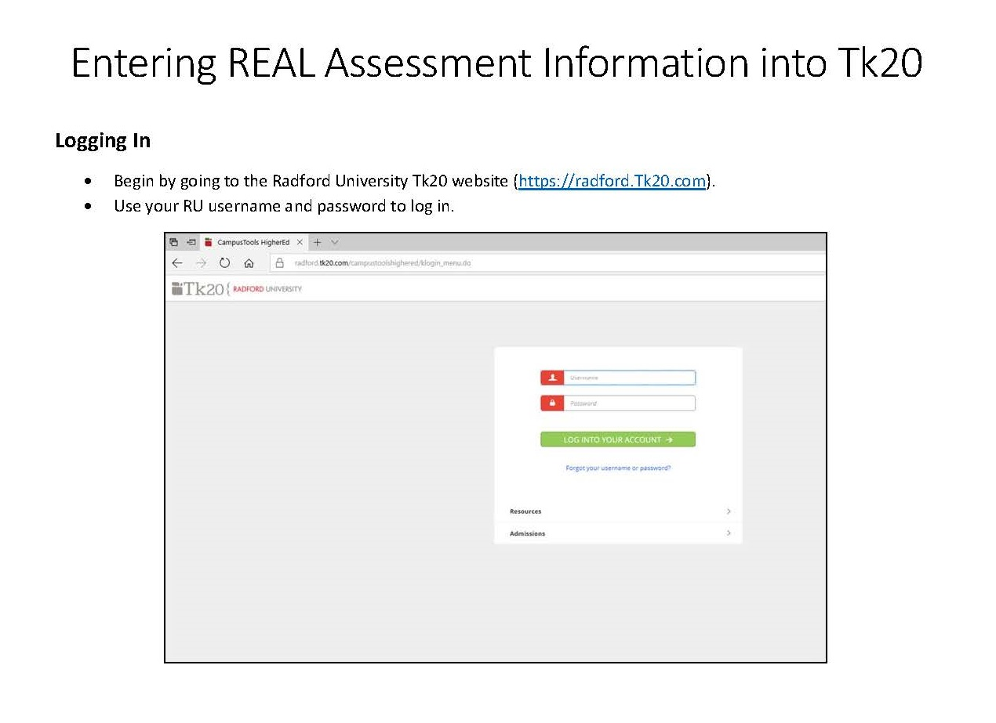

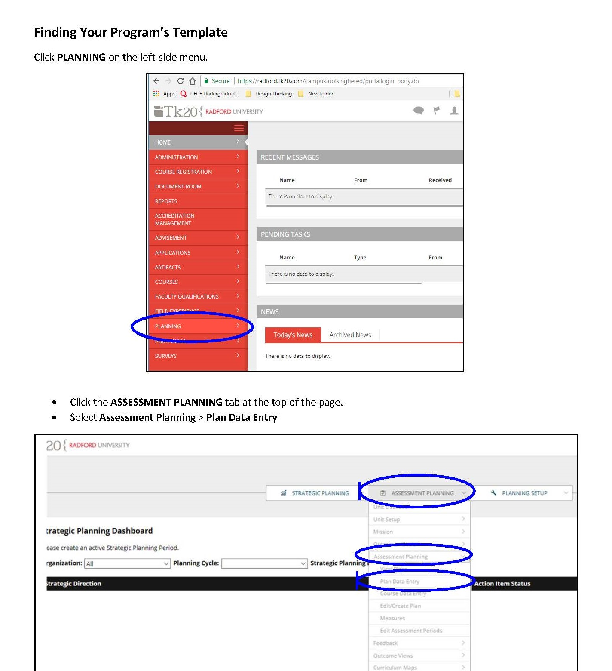
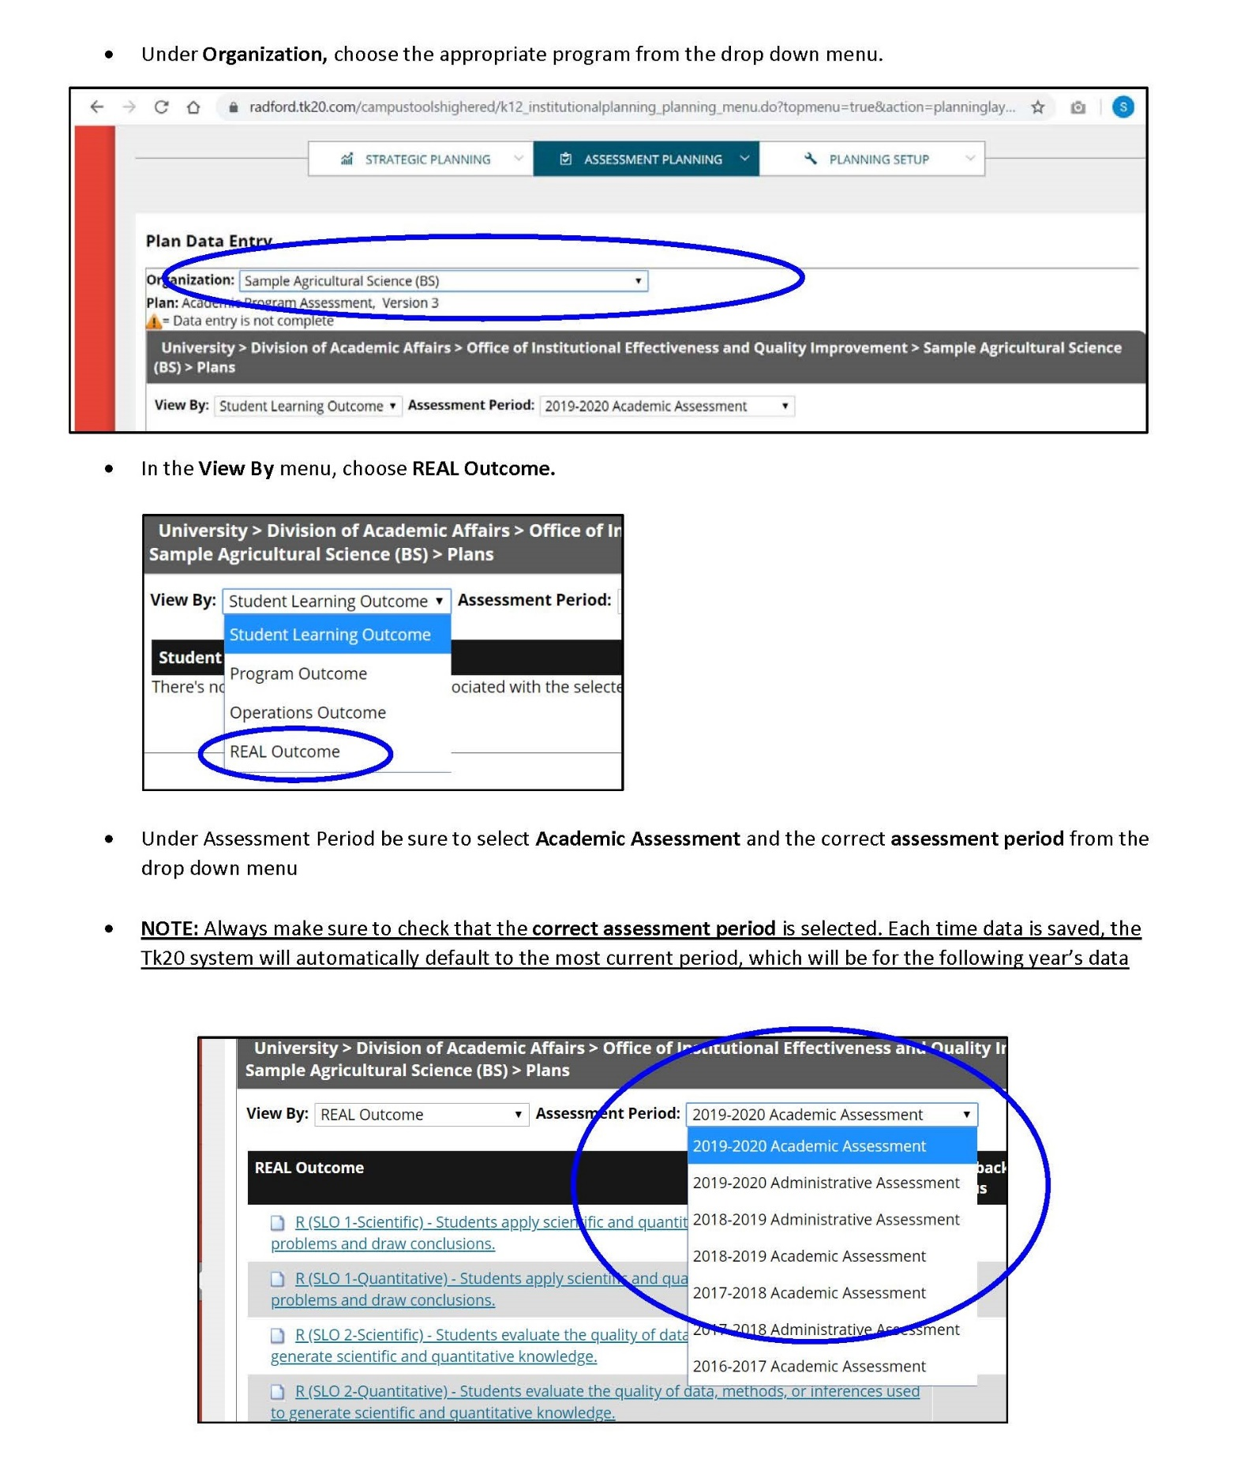

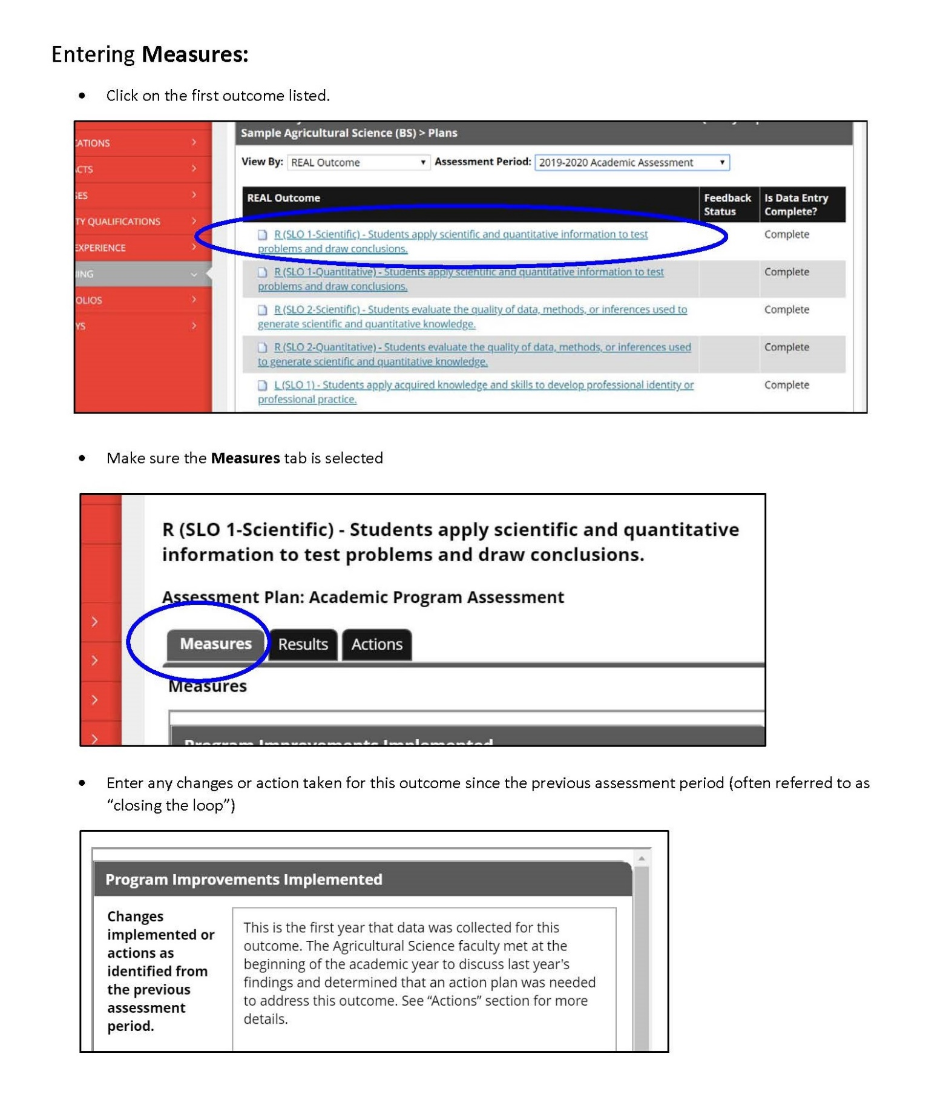
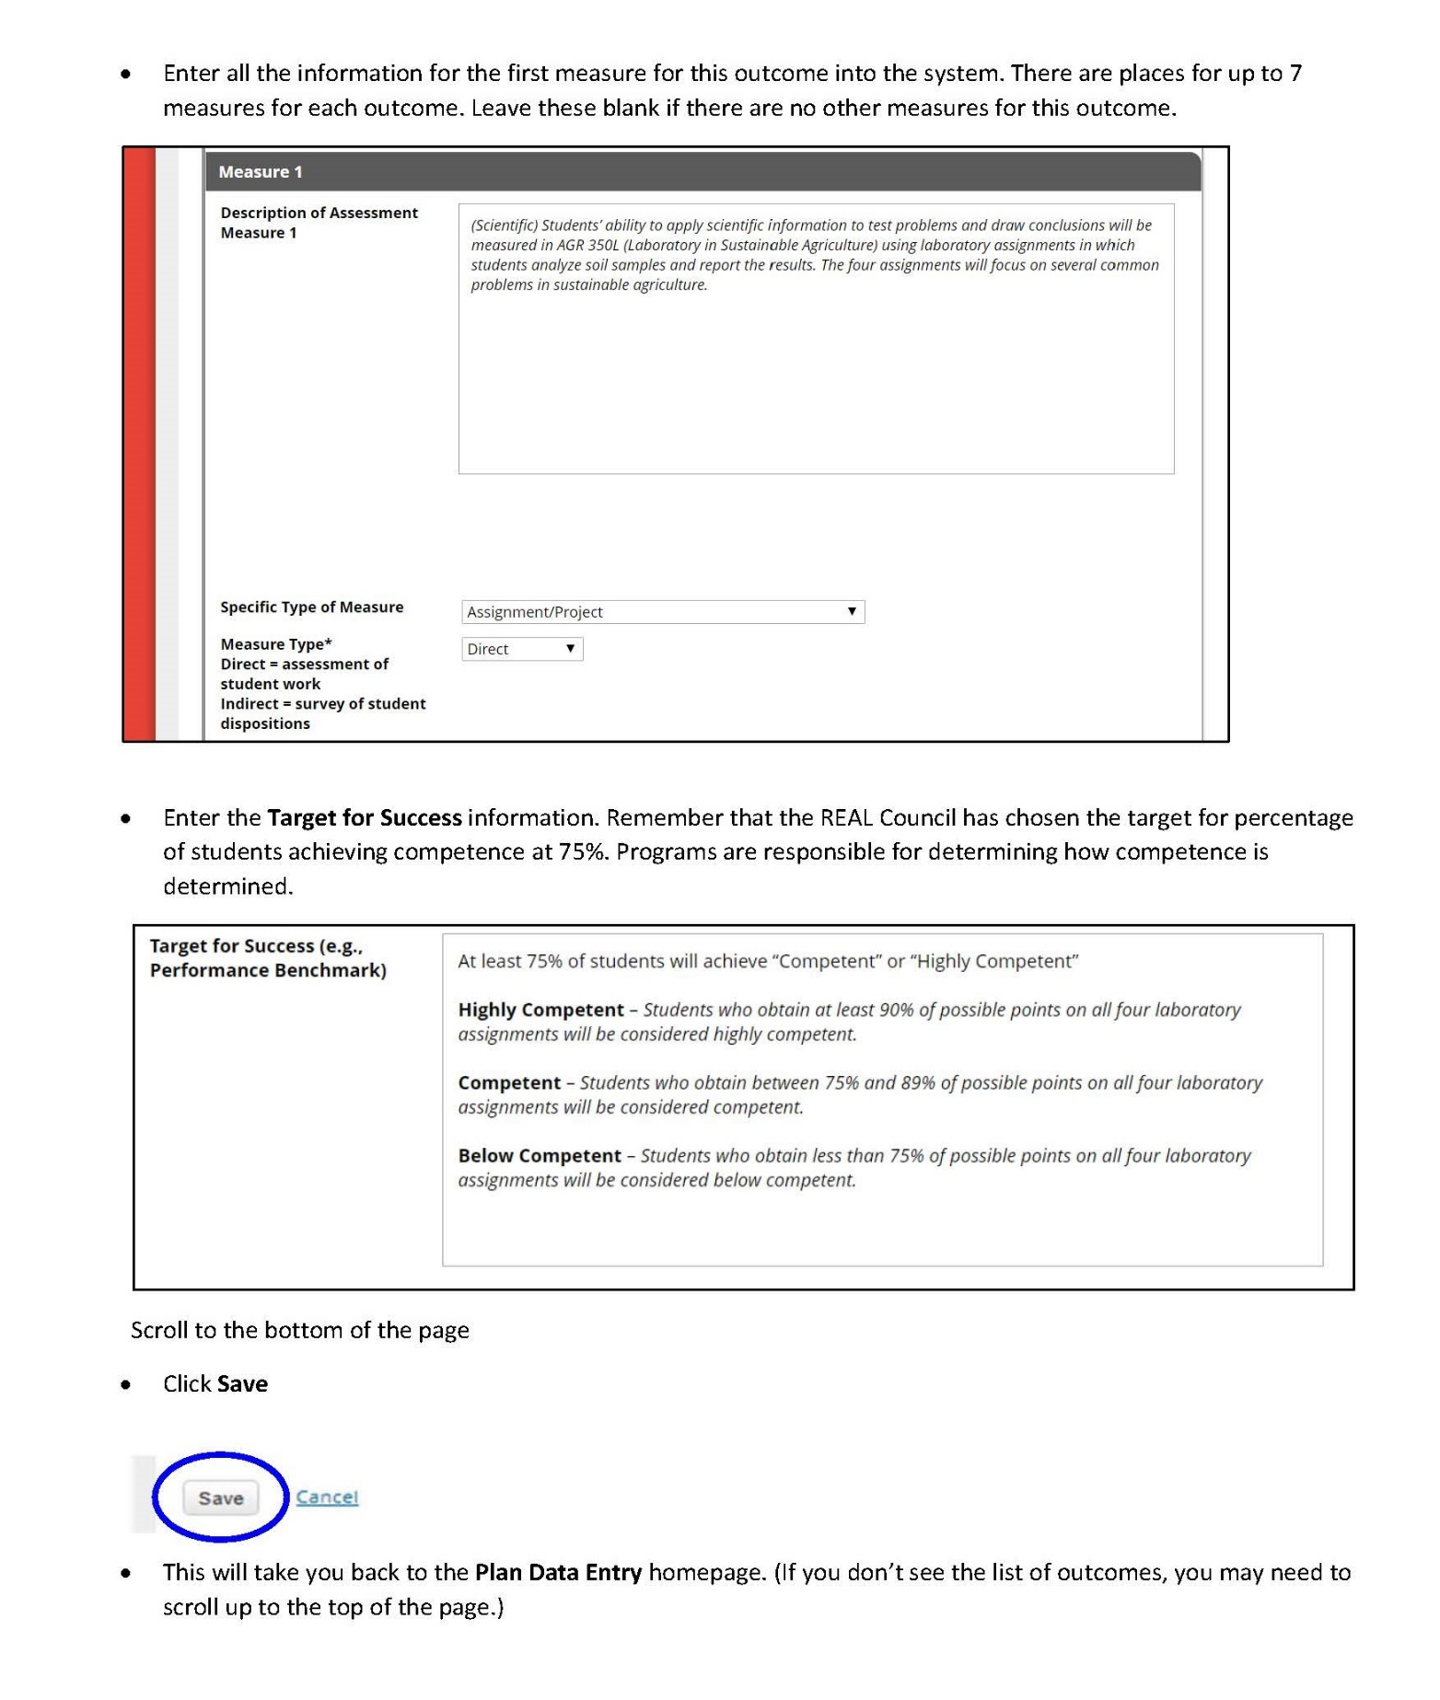
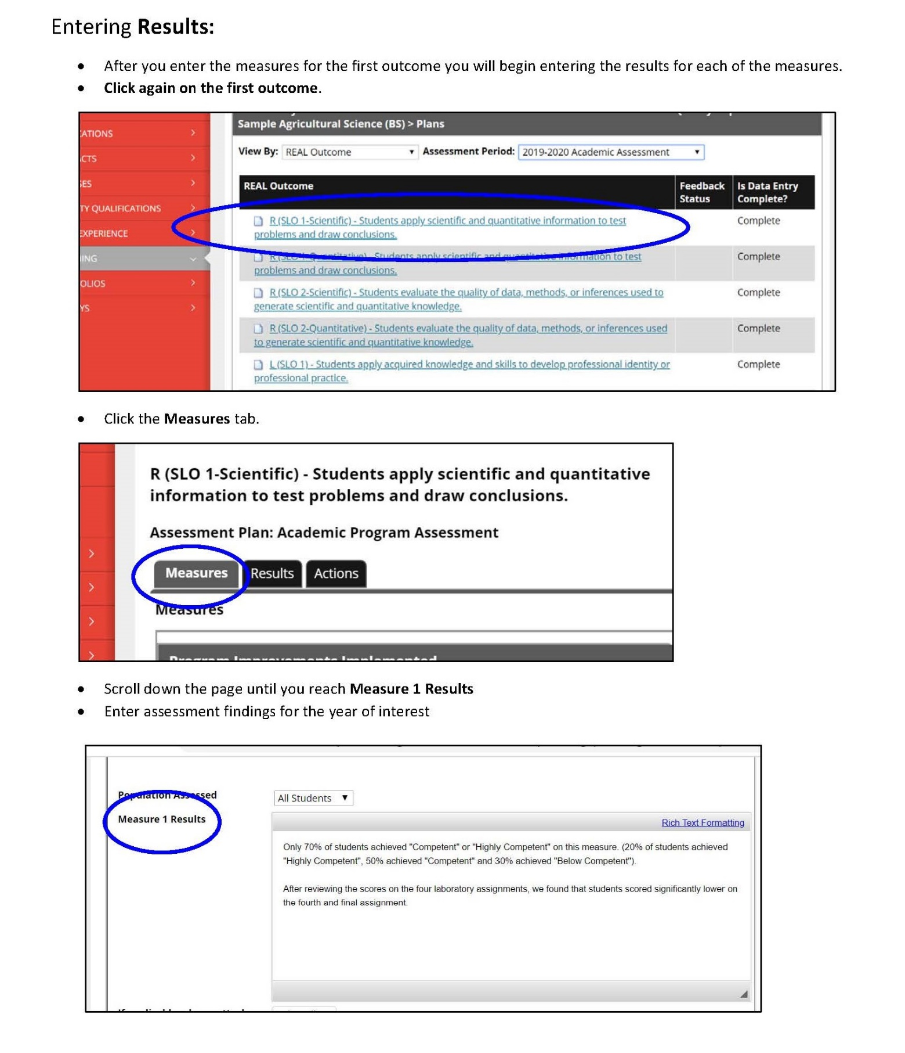
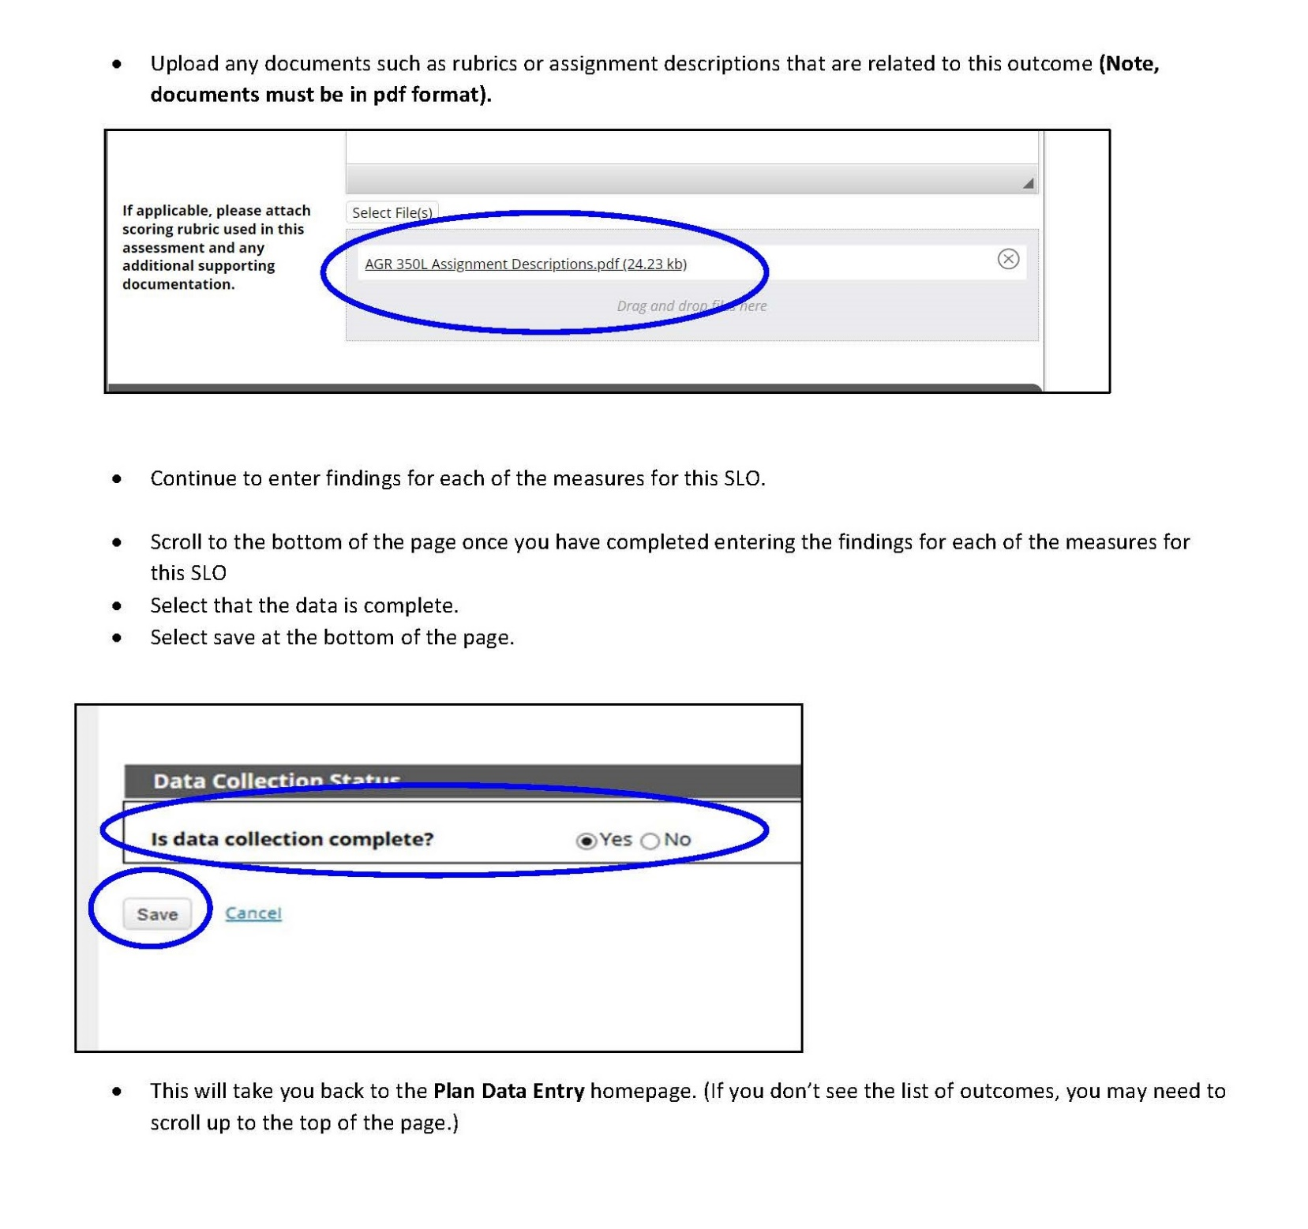

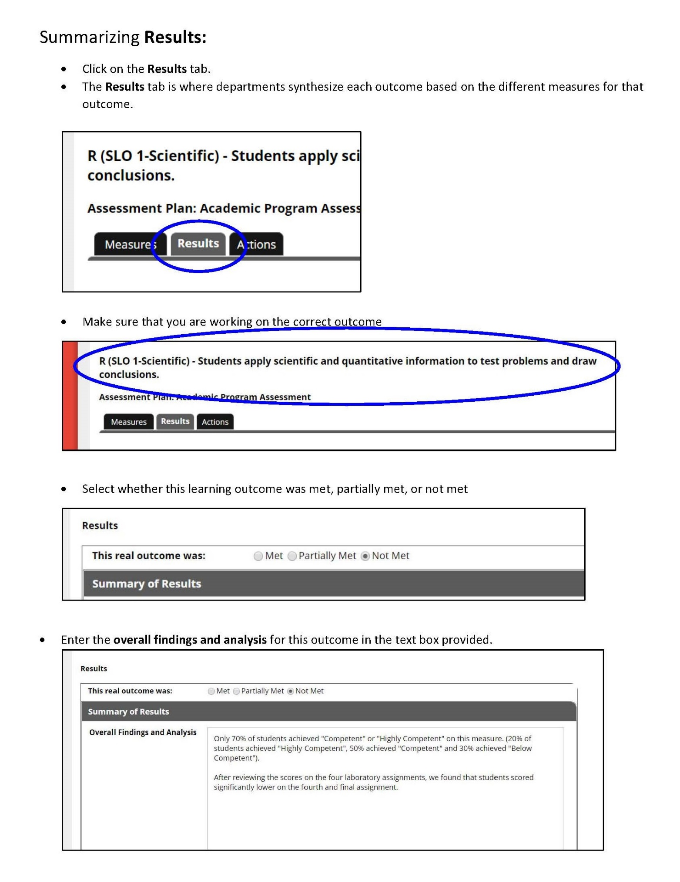
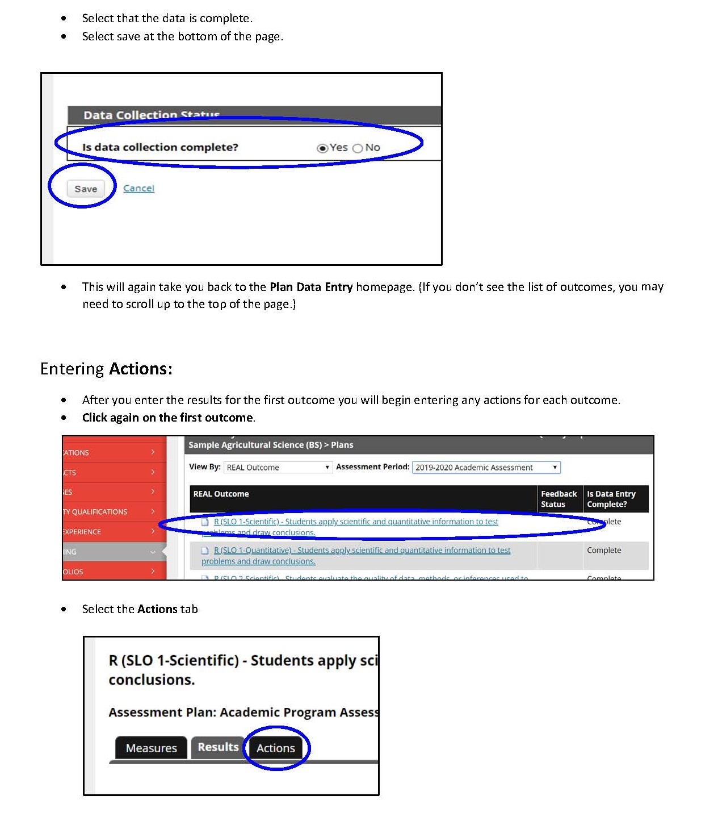
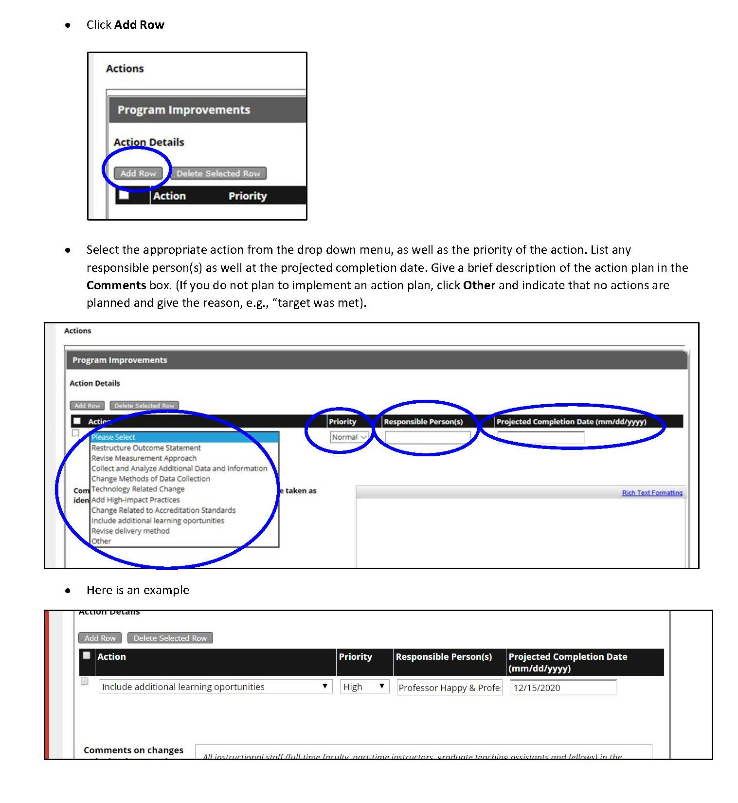

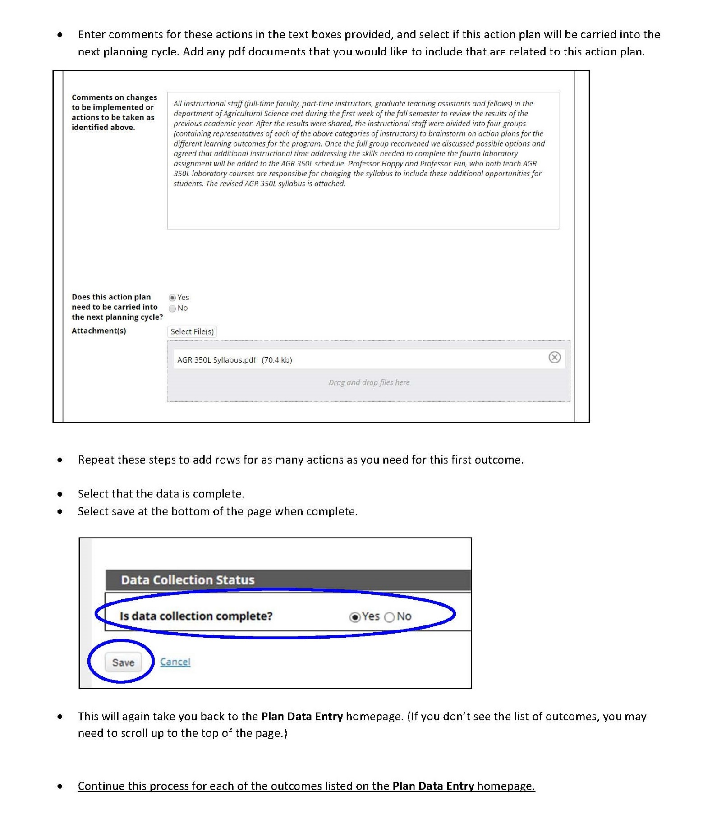
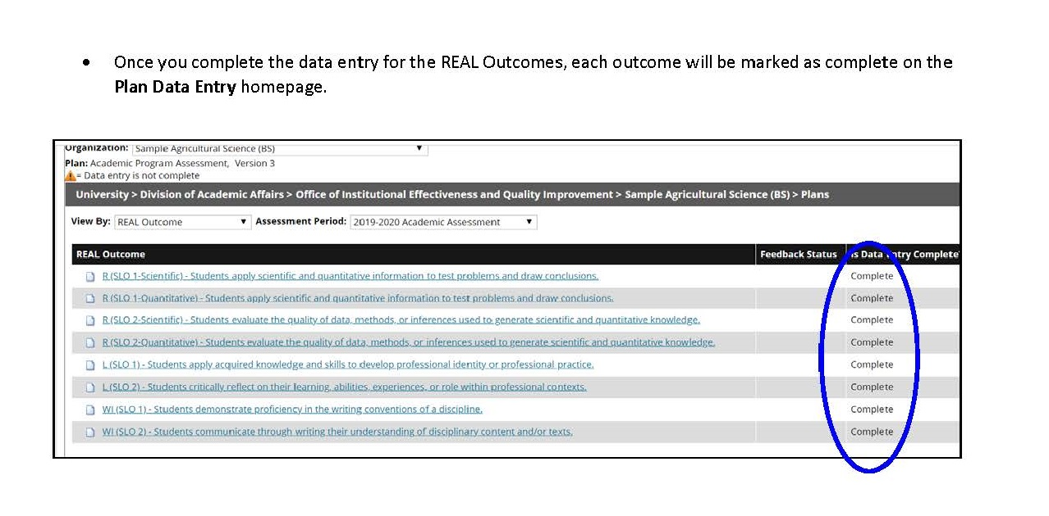
REAL Resources

REAL Curriculum Webpage
https://www.radford.edu/content/real/home.html

REAL Curriculum Assessment Information
https://www.radford.edu/content/real/home/faculty/assessment.html

Tk20 Assessment Reporting System
https://radford.tk20.com/campustoolshighered/start.do

Office of Institutional Effectiveness & Quality Improvement Assessment Resources
https://www.radford.edu/content/institutional-effectiveness/home/resources.html

REAL Curriculum Contact Information
Dr. Nicole Hendrix
Executive Director of General Education
Young 418
Radford VA 24142
Phone: 540-831-6161
Email: pnhendrix@radford.edu

