Financial Aid Office ∙ P.O. Box 6905 ∙ Radford, VA 24142
Phone: (540) 831-5408 ∙ Fax: (540) 831-5138∙
Text: (540) 328-9360 ∙ finaid@radford.edu
Financial Aid Website: http://www.radford.edu/finaid
IRS 2019 FEDERAL TAX TRANSCRIPT INFORMATION
Important Note:
- The instructions below apply to each parent/step-parent included in the household and to the student (and spouse, if applicable).
If each parent/step-parent or a student’s spouse filed separate tax returns, a signed copy of each Federal IRS Tax Transcript will be required. If a copy of the federal IRS tax return transcript cannot be obtained, a signed copy of the federal tax return may be submitted. The FAFSA IRS Data Retrieval (IRS DRT) option of the FAFSA will not work for students or parents filing separate tax returns.
- If neither parent is required to file an IRS Federal tax return, please complete the Parent Non-Filer
Statement located on the Financial Aid Forms page found at
(https://www.radford.edu/content/dam/departments/administrative/financial-aid/ContentFiles/2021Nonfiler-Parent.pdf) and submit a Letter of Verification of Nonfiling for tax year 2019 from the IRS.
- If the student or neither student and spouse, if applicable, are required to file an IRS Federal tax return, please complete the Student Non-filer Statement located on the Financial Aid forms page at
(https://www.radford.edu/content/dam/departments/administrative/financial-aid/ContentFiles/2021Nonfiler-Student.pdf) Independent students will also need to submit a Letter of Verification of Nonfiling for tax year 2019 from the IRS.
Instructions: The best way to verify income is by using the IRS Data Retrieval Tool (IRS DRT) that is part of FAFSA on the Web at FAFSA.gov. In most cases, no further tax documentation is needed to verify 2019 income information that was transferred into the student’s FAFSA using the IRS DRT if that information was not changed. Instructions are included below. If you are unable to use the IRS Data Retrieval Tool with the FAFSA, you will need to request a Federal Tax Return Transcript. Instructions for requesting a transcript is located at the bottom of this document.
In most cases, for electronic tax return filers, 2019 IRS income tax return information for the IRS DRT is available within 2–3 weeks after the 2019 electronic IRS income tax return has been accepted by the IRS. Generally, for filers of 2019 paper IRS income tax returns, the 2019 IRS income tax return information is available for the IRS DRT within 8–11 weeks after the 2019 paper IRS income tax return has been received by the IRS.
If you have questions or need assistance with the data retrieval tool on the FAFSA, please call the Federal Customer Service Center at 1-800-433-3243.
Verification of information reported on this form may be requested. Review of verification documents may take up to four weeks. Additional information may be needed after the review of documents. Awarding will not occur until all documents are received and verified. Students will be considered for funds that are available at the time verification is finalized. Students can monitor documents received, reviewed, or needed through their MY RU Account. Correspondence regarding verification will be sent to the student’s RU e-mail address.
Verification must be finalized prior to the payment date for the semester to receive any deferment or partial deferment of charges. Students who have not received award notifications (or if awards are insufficient to cover balances due) by the time payment is due, they will need to pay university charges by the payment deadline.
Please be sure to include the student’s Radford ID number on all pages of documents sent to the Financial Aid Office.
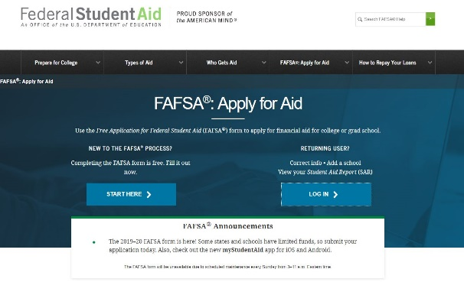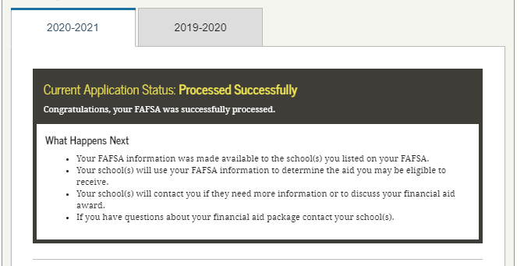
Instructions for using
the IRS Data Retrieval Tool with your FAFSA

If you have questions or need assistance with this tool, please call the Federal Customer Service
Center at 1
-
800
-
433
-
3243.

1.
Go to

https://fafsa.ed.gov

and click “Log
in” button
.
2.
Enter student information and click “next”.
3.
Click on the 2021-2022

tab at the top of the page. At the bottom of the page, click on
“Make FAFSA Correction”.
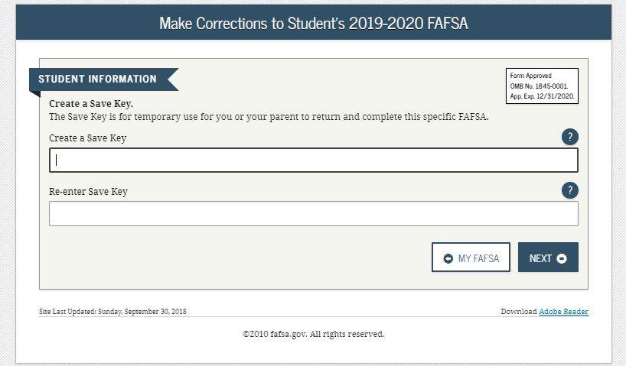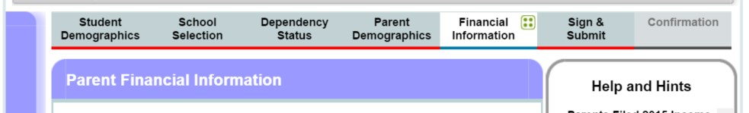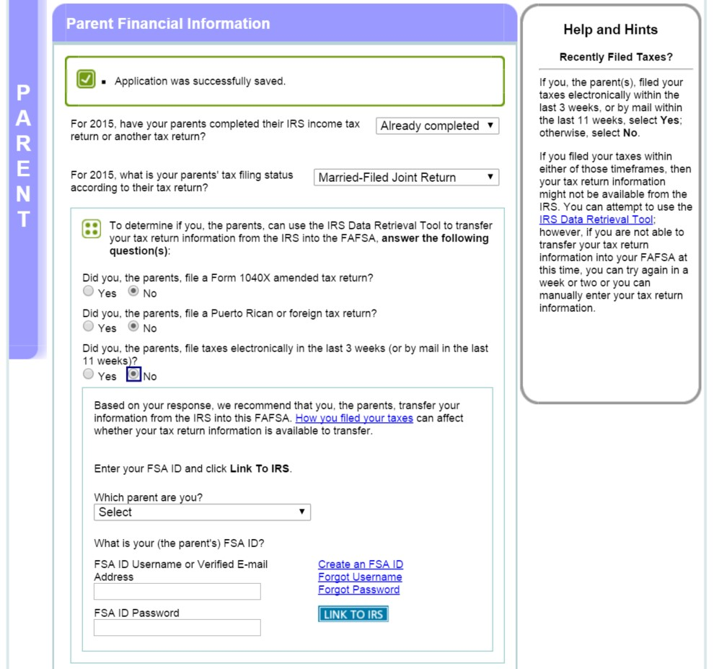
4.
Create a Save Key as indicated below
.
Click next.
5.
Click “Financial
Information” tab located near the top of the page.
6.
Select “already completed” from drop
-
down and select ‘no’ for the next three
questions choices then enter parents
FSA ID
and click “Link to IRS”

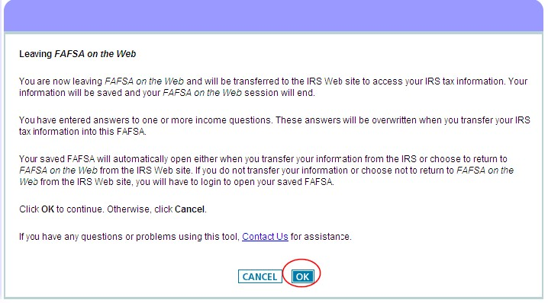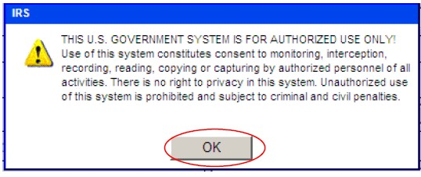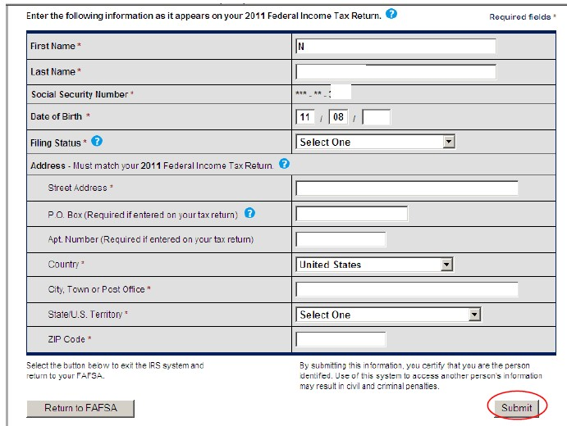
7.
Click ‘OK’ at the page titled ‘Leaving FAFSA on the We
b’.
8.
Click “OK” to close warning, then fill out form and click “submit”.
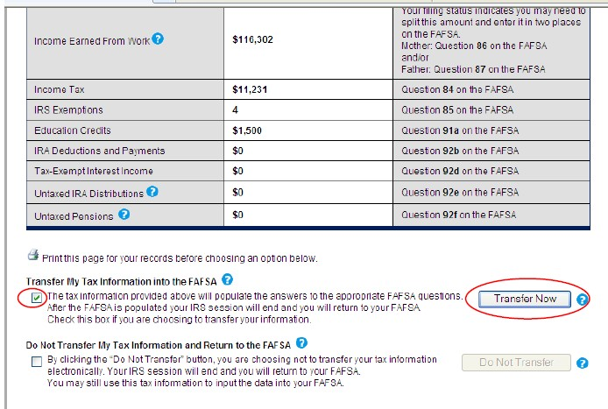
9.
Verify information for accuracy, scroll to the bottom of the page, mark the check box,
and click “Transfer now”.
10.
You will see a confirmation if the transfer was successful.
If you are unable to
transfer the IRS tax information, you will need to obtain a Federal IRS Tax
Transcript. See the instructions below.
IRS Tax Transcript Request Process
Tax filers can request a transcript, free of charge, of their 2019 tax return from the IRS in one of three way:
- Online Request o Available on the IRS Web site at http://www.irs.gov
  - On the IRS homepage select “Get My Tax Record”
  - Click “Get Transcript Online”
  - Enter your Login information or Create Account.
  - Enter the tax filer’s Social Security Number, date of birth, street address, and zip or postal code. Use the address currently on file with the IRS. Generally, this will be the address that was listed on the latest tax return filed. However, if an address change has been completed through the US Postal Service, the IRS may have the updated address on file.
  - Click “Continue”
  - In the Type of Transcript field, select “Return Transcript” and in the Tax Year field, select “2019”.
  - If successfully validated, tax filers can expect to receive a paper IRS Tax Return Transcript at the address included in their online request, within 5 to 10 days from the time the on-line request was successfully transmitted to the IRS.
  - IRS Tax Return Transcripts requested online cannot be sent directly to a third party by the IRS.
- Telephone Request o Available from the IRS by calling 1-800-908-9946
  - Tax filers must follow prompts to enter their social security number and the numbers in their street address. Generally, this will be numbers of the street address that was listed on the latest tax return filed. However, if an address

change has been completed through the US Postal Service, the IRS may have the updated address on file.
- Select “Option 2” to request an IRS Tax Return Transcript and then enter “2019”.
- If successfully validated, tax filers can expect to receive a paper IRS Tax Return Transcript at the address that was used in their telephone request, within 5 to 10 days from the time the IRS receives the request.
- IRS Tax Return Transcripts requested by telephone cannot be sent directly to a third party by the IRS.
• Paper Request Form – IRS Form 4506T-EZ o IRS Form 4506T-EZ should be used instead of IRS Form 4506-T because it is sufficient to request an IRS Tax Return Transcript.
- Download at http://www.irs.gov/pub/irs-pdf/f4506tez.pdf
- Complete lines 1 – 4, following the instructions on page 2 of the form. Note that line 3 should be the most current address as filed with the IRS. It is the address where the IRS Tax Return Transcript will be sent. If the address has recently changed, include the address listed on the latest tax return filed on Line 4. However, if an address change has been completed through the US Postal Service, the IRS may have the updated address on file.
- Line 5 provides tax filers with the option to have their IRS Tax Return Transcript mailed directly to a third party by the IRS.
Institutions are responsible for notifying aid applicants whether to list the institution as the third party to receive the Transcript or not. Some institutions may have difficulty matching a parent’s incoming IRS Tax Return Transcript to the aid applicant, as the two names may be different.
- On line 6, enter “2019” to receive IRS tax information for the 2019 tax year that is required for the 2021-2022 FAFSA.
- The tax filers (or spouse if requesting information from a joint tax return) must sign and date the form and enter their telephone number. Only one signature is required to request a transcript for a joint return. o Mail or fax the completed IRS Form 4506T-EZ to the appropriate address (or FAX number) provided on page 2 of Form 4506T-EZ.
Tax filers can expect to receive their transcript within 5 to 10 days from the time the IRS receives
and processes their signed request. NOTE: Processing form 4506T-EZ means verifying/validating the information provided on the form. If any information does not match the IRS records, the IRS will notify the tax filer that it was not able to provide the transcript.

Verification of 2019 Federal Tax Information for Individuals with Unusual Circumstances

Individuals Granted a Filing Extension by the IRS
If an individual is required to file a 2019 IRS income tax return and has been granted a filing extension by the IRS, provide the following documents:
- A copy of IRS Form 4868, ‘‘Application for Automatic Extension of Time to File U.S. Individual Income Tax Return,’’ that was filed with the IRS for tax year 2019;
- A copy of the IRS's approval of an extension beyond the automatic six-month extension if the individual requested an additional extension of the filing time for tax year 2019; and
- A copy of IRS Form W–2 for each source of employment income received for tax year 2019 and, if self-employed, a signed statement certifying the amount of the individual’s Adjusted Gross Income (AGI) and the U.S. income tax paid for tax year 2019.
- A copy of 2019 Federal Tax Return Transcript.
- A signed IRS Form 4506 T designating Radford University as the 3rd party recipient.

Individuals Who Filed an Amended IRS Income Tax Return
If an individual filed an amended IRS income tax return for tax year 2019, provide both of the following:
- A signed copy of the original 2019 IRS income tax return transcript that was filed with the; and
- A signed copy of the 2019 IRS Form 1040X, “Amended U.S. Individual Income Tax Return,” that was filed with the IRS.

Individuals Who Were Victims of IRS Identity Theft
▪ A victim of IRS identity theft who is not able to obtain a 2019 IRS Tax Return Transcript or use the IRS DRT must contact the IRS at 1-800-908-4490. Upon authentication of the tax filer’s identity, the IRS will provide, by U.S. Postal Service, a printout of the tax filer’s 2019 IRS income tax return information.

Individuals Who Filed Non-IRS Income Tax Returns
An individual filed or will file a 2019 income tax return with Puerto Rico, another U.S. territory (e.g., Guam, American Samoa, the U.S. Virgin Islands, the Northern Marianas Islands), or with a foreign country, must provide a signed copy of that 2019 income tax return(s).

