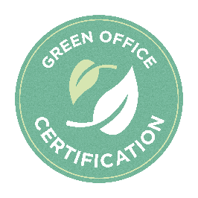

Resources for Green Office Certification
Radford University Office of Sustainability Webpage- Radford University Sustainability

Contacts for assistance with certification:
- Josh Nease, Sustainability Manager- Phone: 540-831-5223
Email: jnease@radford.edu

Contacts for more assistance
- Neal Thompson, Recycling Coordinator- Phone: 540-831-7207
Email: lthompson@radford.edu
- Service request form PP25 (maintenance needs): PP25 Service Request Form
- Facilities Management Information: Facilities Management
- For all HVAC, electrical, plumbing, or facility related-inquiries, call 540-831-7800
- For a pickup from the Surplus Warehouse, call 540-831-5342

Recycling
- Recycling at RU | Radford University – Use this link to request a recycling bin, better understand recycling at RU, stay updated on events like Earth Day and Shred-A-Thon, and more.
- Why is recycling so important? To find out more, click here. Why Recycle?
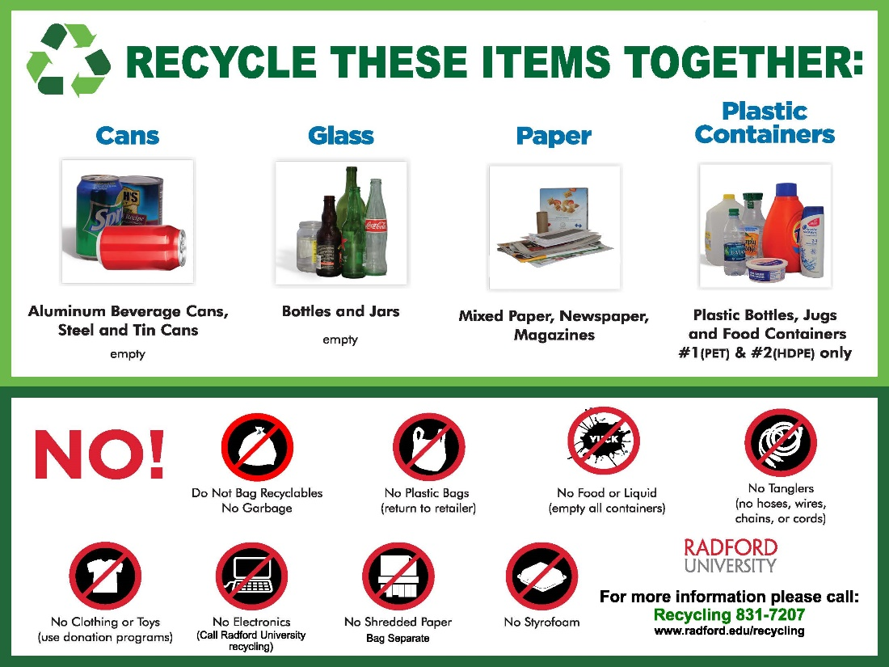
If you would like to display the poster shown above inside of your department office (recommended), please contact the Sustainability Office using the contacts listed above and request one. We will happily print one out and deliver it to you.
- Updated campus recycling guidelines: Recycling Guidelines

Electricity
- Radford University offers a service called “DoIT” (Division of Information Technology). This is a technology support service that can guide you through the troubles you might be having with your electronic technologies used in your office or classroom. This ranges from technical support, field support, knowledge base on your equipment, hardware repair, implementation of new technologies, and assistance with purchasing new equipment.
- DoIT website for more information and assistance – RU DoIT webpage
- Phone support – (540) 831-7500 Monday through Friday 8 a.m. – 5 p.m.
- Walk-in support – Walker 153 Monday through Friday 8 a.m. – 4:45 p.m.

- What is a power strip? These are the electrical devices you will often see around any place using electronics. They don’t all look similar, but they all are beneficial when considering energy use. These devices include power-saving features that make it easy for the user to use less electricity when not needed. Depending on the power strip you have (which may not look like a “strip”) the device can shut off power from your outlet according to the energy use from the devices plugged in to the strip. They use a sensor circuit to detect if the device plugged in is in standby mode (less than 30 watts) and will turn off that specific socket on the strip. This saves money as well!

The Plants
Bringing plants into your office actually has some great benefits. They naturally improve air quality since they filter out harmful pollutants. They also stabilize humidity levels which can make your office much more comfortable, allowing those inside to focus more on their work and leisure time rather than discomfort. “Sick Building Syndrome” is a very real thing, and plants are known to help prevent any such conditions.

Paper Purchasing
- 30% Recycled Content:
-Eagle Office Paper 30% Recycled Content: Supply Room Companies - AME31600501
-American Eagle Office Copy Paper 30% Recycled Content: Supply Room Companies -AME31600503
-Recycled Color Copy Paper: Supply Room Companies - HAM102210
-Great White 30% Recycled Copy Paper: Supply Room Companies - HAMA86700
- 50% Recycled Content:
-Eagle Copy Paper, 50% Recycled Content: Supply Room Companies - AME31500501
-Great White 50 Recycled Paper: Supply Room Companies - HAM86780
- 100% Recycled Content:
-Eagle Office Paper, 8.5X11, 100% Recycled Content: Supply Room Companies - AME31550501
-Great White 100 Recycled Paper, White: Supply Room Companies - HAM86790

Electronics Purchasing

- EPEAT – This is the “Ecolabel” for electronics. An example of an ecolabel is the “Fair Trade” certification you see in the grocery store. This guarantees the benefits of the product being identified, and therefore can beneficial to you. In this case, the ecolabel “provides independent verification of manufacturers’ claims and the EPEAT online registry lists sustainable products from a broader range of manufacturers than any comparable ecolabel.” (“EPEAT Overview”, greenelectronicscouncil.org) this assists in the implementation and practice of creating a more sustainable market for IT products. To learn more, visit More About EPEAT

Transportation
- Visit these websites for more information on Radford’s transportation efforts and opportunities. Here are also websites with information regarding how you can use your fuel more wisely to save gas, time, money, and of course help protect our environment.
-Radford Transportation
-How To Save Gas
-How To Save Gas Pt. 2

2021 - Executive Order 77
In March 2021, Governor Northam signed Executive Order 77 requiring all state institutions to cease buying, selling, and distributing the following plastics: disposable plastic bags, single-use plastic and polystyrene food service containers, plastic straws and cutlery, and single-use plastic water bottles by July 21, 2021. These product cessation efforts are part of a longer-term single-use plastic reduction effort guided by EO77 and align with the work of RU’s President’s Task Force on Sustainability to develop a new RU Sustainability & Climate Action Plan.

