How to Submit a Closure Form

- Log into InfoEd and select the “My Items” tab.
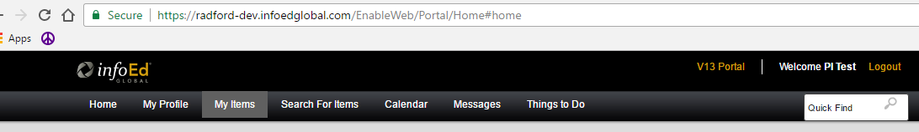

- Hover over the protocol number you wish to submit a closure for and move the mouse to “Create New” and then select “Closure”.
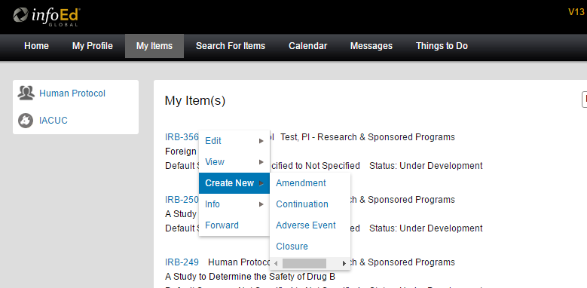

- This creates a closure form in your protocol. You won’t see anything until you move your mouse up to view or edit, and there will be a closure above “Initial Application”

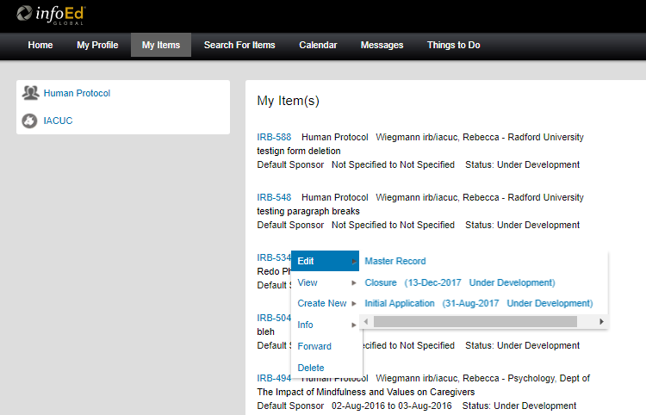

- Now select this and add all latest approved versions of your documents, when the window opens as shown.

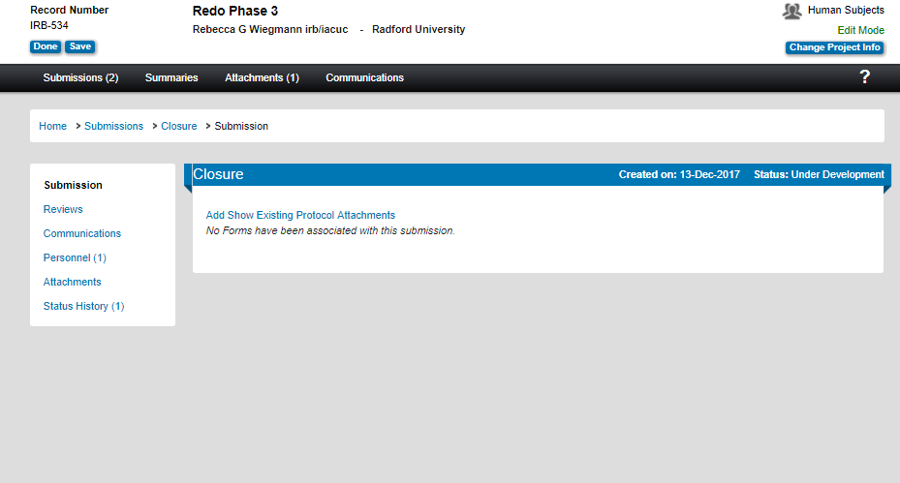
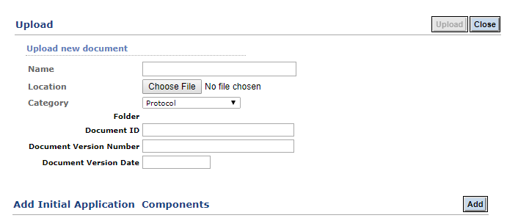

- Once chosen, select upload.
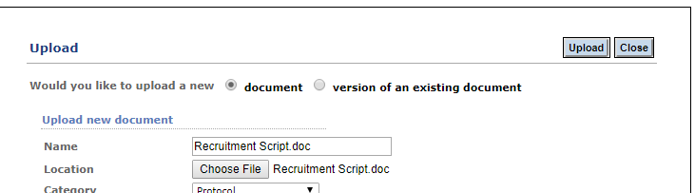

- Then when the system prompts you to close, select the close button to complete your upload.
After adding the closure form to your Closure submission, you may select submit.
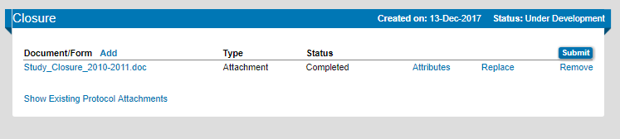
- It will notify you of the Route Path, please select “Submit” again.
