Notetaking Support
Notetaking support is an accommodation intended to support a student’s notetaking process and enhance the learning experience.

CAS can provide students access to notetaking support software, assistive technology, recording devices, and in some cases, assign a peer volunteer notetaker.

Please be aware peer notetaking is not a paid position, it is voluntary, so sometimes CAS is unable to recruit a volunteer and therefore, notes are not available. Students eligible for the notetaking support accommodation are encouraged to always do their best to take notes, so additional notetaking support is supplemental.

Peer notetakers are encouraged to volunteer, as they may receive non-conduct related community service hours, priority registration status for the following semester, add the position to their resume, and gain satisfaction in helping support a fellow Highlander.

Volunteer Note Takers

How to upload and/or view notes
- Note takers log into ACCESS CAS through One Campus Student- Access CAS

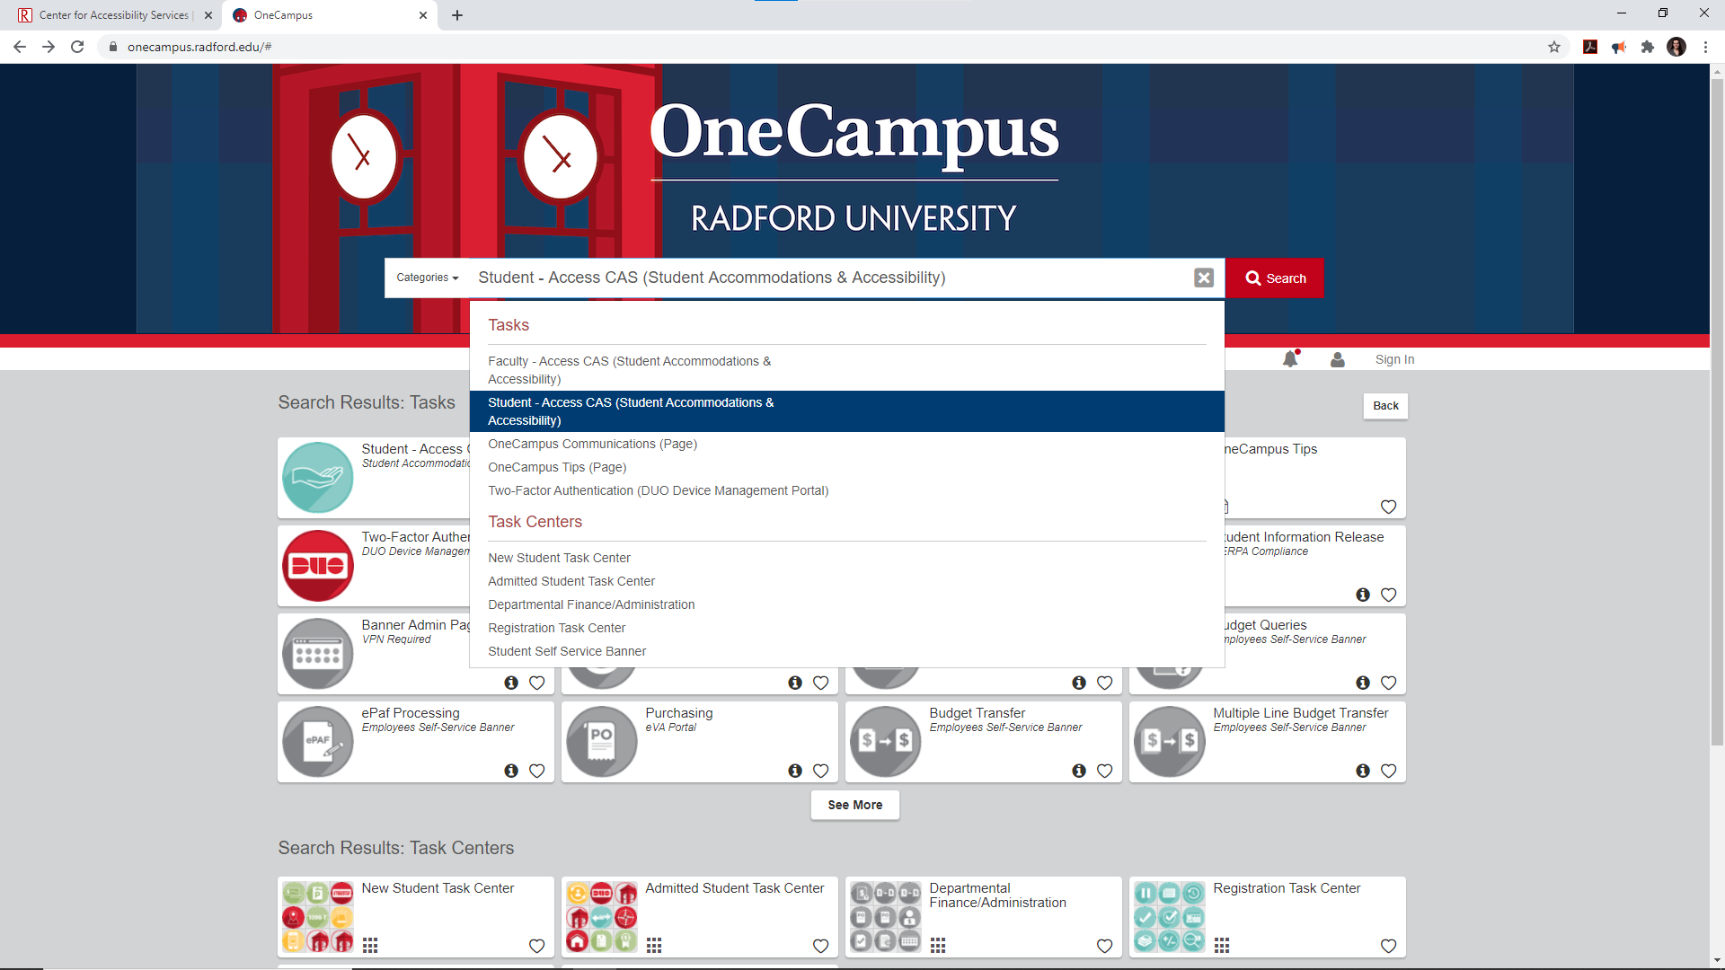

- Click on the "Note Taker Network" tab

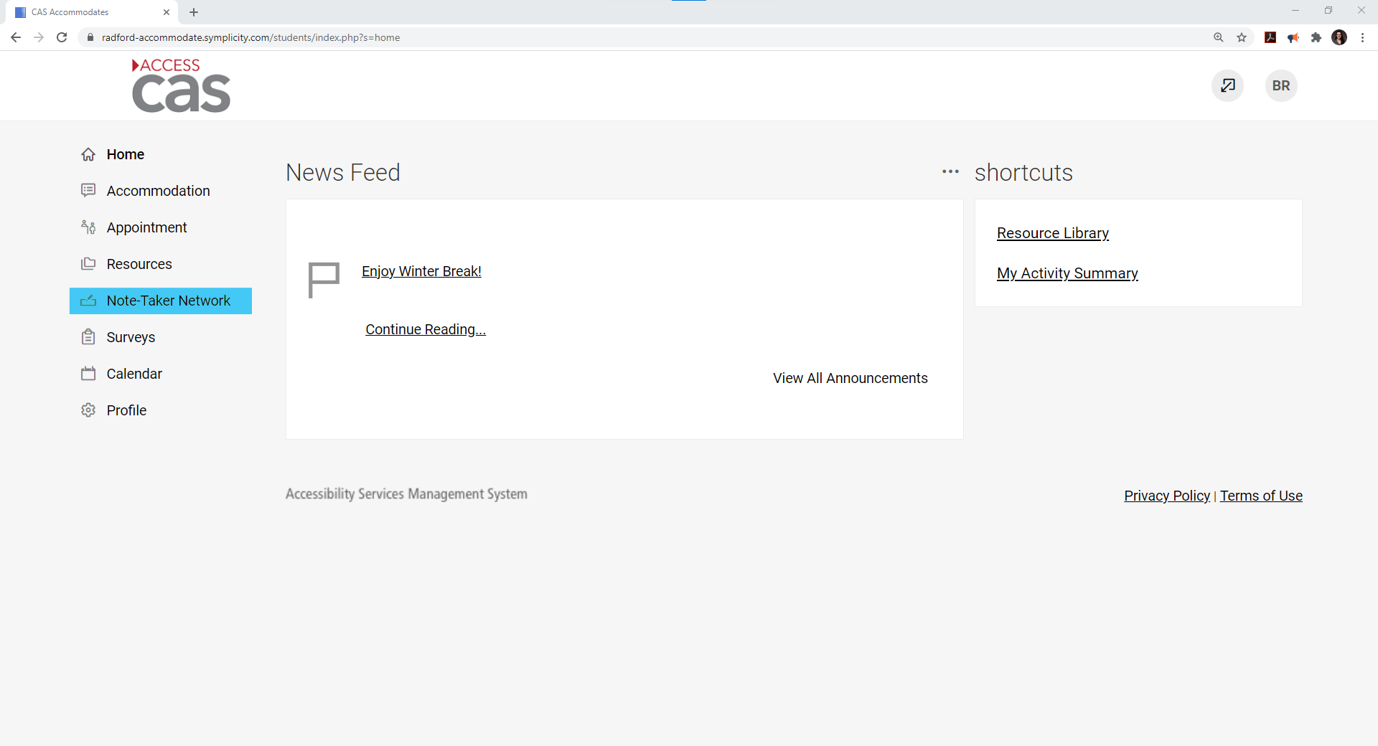

- Make sure you are on the "Note Dropoff" tab

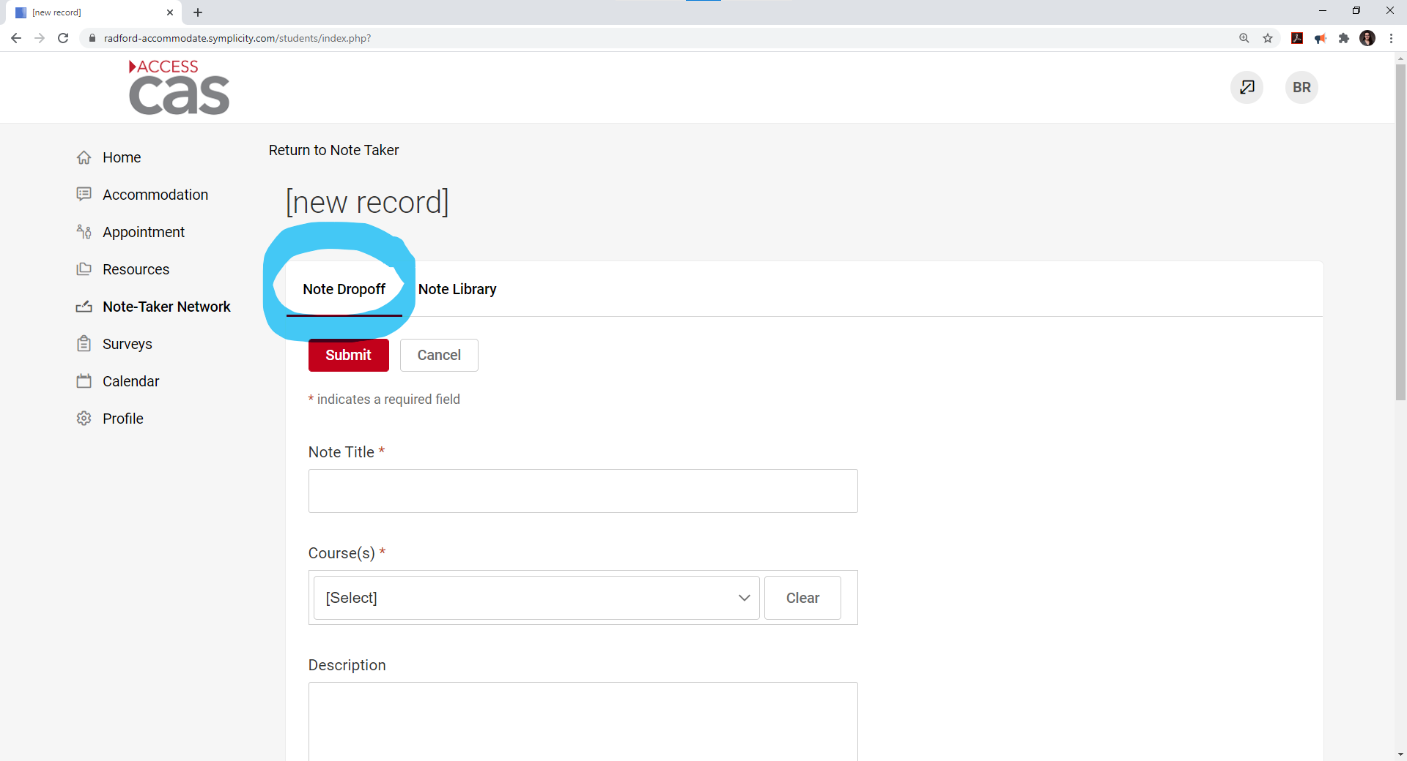

- Complete the following fields:
- Type a title for the notes. Ex. Chapter 6 Photosynthesis
- Select Course from the drop-down menu
- Type a description. Ex. Lecture notes, discussed midterm, and lab #5

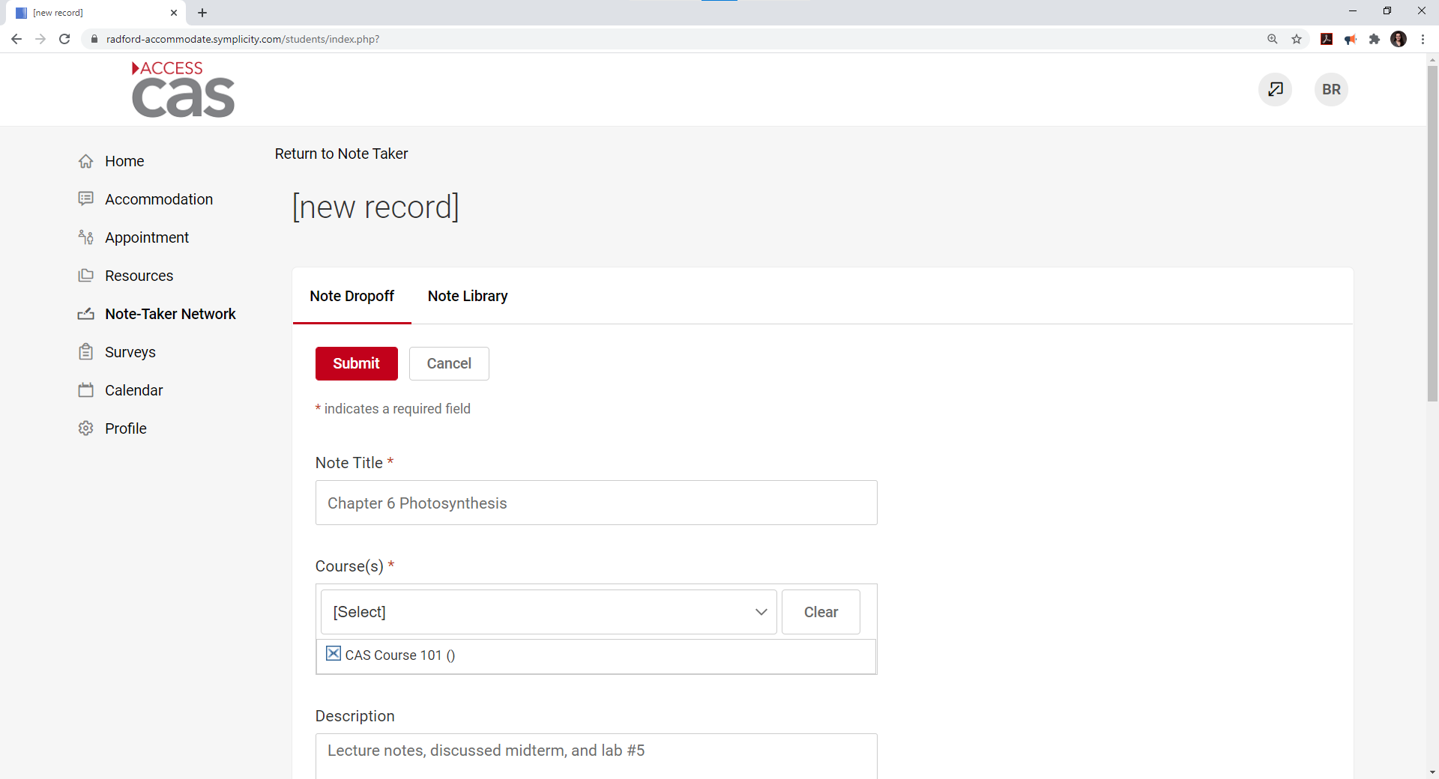

- Upload the notes by clicking Choose File button.
- Select the appropriate date that this set of notes were taken.
- Click SUBMIT

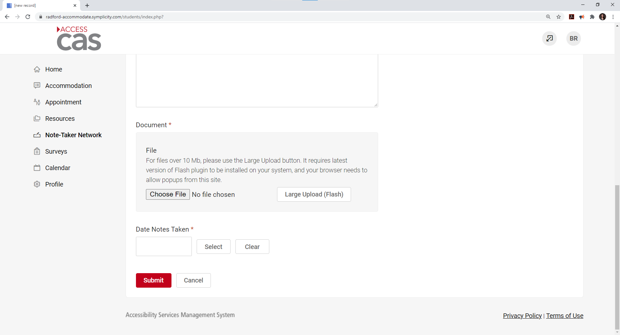

- Once you have clicked SUBMIT, you will see the uploaded notes in the Note Library.

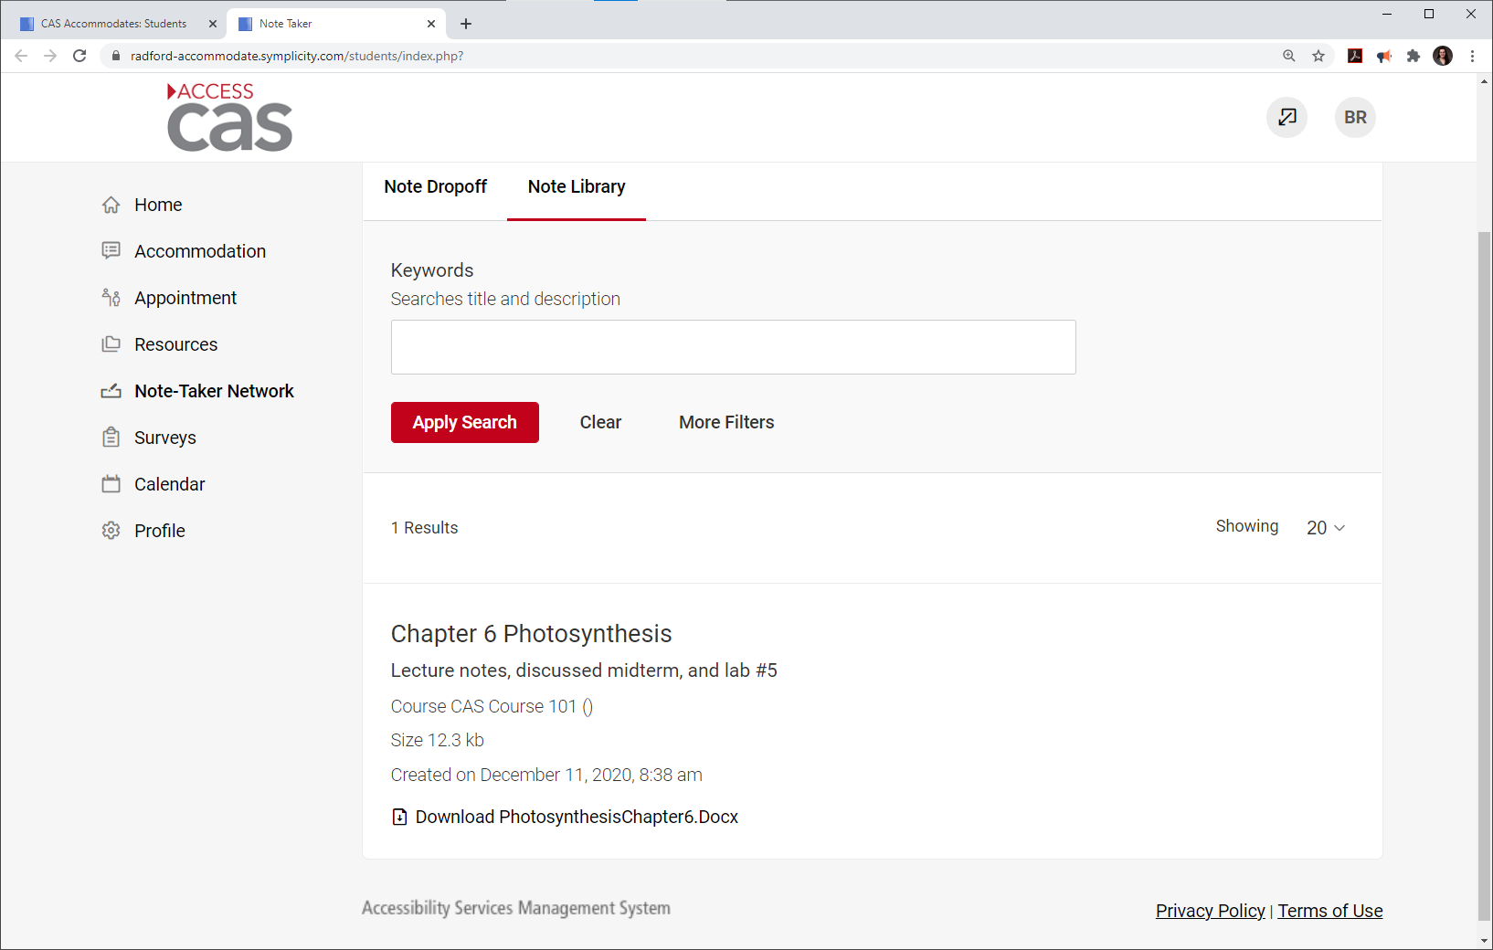

Frequently Asked Questions

How will I know if I was chosen to be a note taker?
- You will receive an email with ACCESS CAS instructions.
How often do I need to upload notes?
- Please keep in mind, one or more of your classmates may be relying on your notetaking support to study, please try to uploaded notes ACCESS CAS at least once a week. Eligibility to receive perks will be determined by history of notes being uploaded throughout the semester.
Where can I upload my notes?
- ACCESS CAS. Please refer to Volunteer Note Takers instruction above.
Can I email my notes?
- No, please upload to ACCESS CAS. Please refer to Volunteer Note Takers instruction above.
Where can I scan my notes?
- There are scanners on main campus in McConnell Library, Hurlburt Student Center (the Bonnie), and Walker Hall computer lab. This is not an extensive list of scanners on main campus. There are also many free apps for snapping a picture of your notes with your phone’s camera to save as PDF, jpeg, etc.
Do I have to make copies of my notes?
- No, an electronic version uploaded to ACCESS CAS is all that is needed.
What if there are no notes for class?
- Then there is no need to upload anything. Be aware you may receive an automated email from the ACCESS CAS system reminding volunteer note takers to upload notes.
What if we watch a movie or have a guest speaker in class?
- Please continue your typical note taking duties. If that means there are no notes to be taken, then no notes will be uploaded to ACCESS CAS.
What if my class has a lab?
- Please continue your typical note taking duties.
What if power point slides are available through the professor and D2L?
- Take notes on what is being said regarding each slide. The student can then use the hand-written notes in conjunction with the power point slides.
What perks do I receive as a volunteer note taker?
- If selected and upon providing notes through ACCESS CAS throughout the semester, you will receive 45 hours of non-conduct-related community service, may put the position on your resume, priority registration for the following semester and the satisfaction of helping a fellow Highlander!

Student receiving Notetaking Support

How to upload and/or view notes

- Log into ACCESS CAS through One Campus Student- Access CAS

- Click on the "Note Taker Network" tab

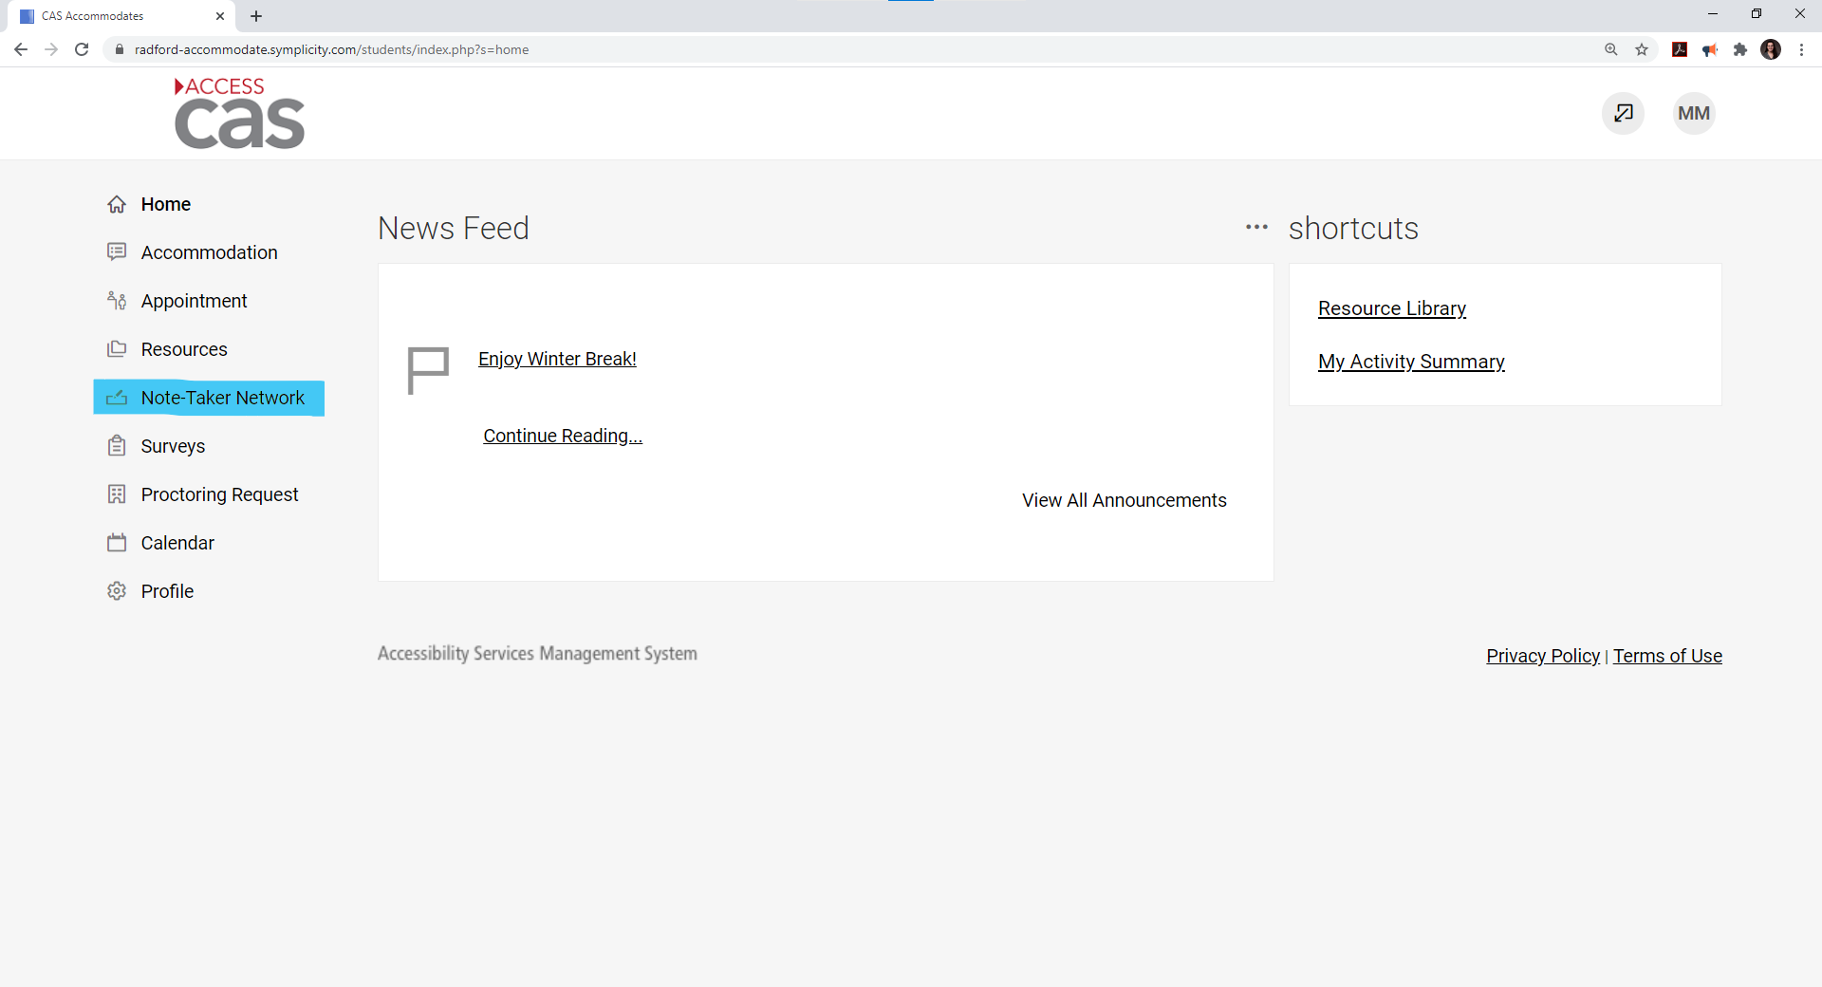

- Notes uploaded by your peers or professor will show under the Note Taker Network.

- Select Download to access the document.
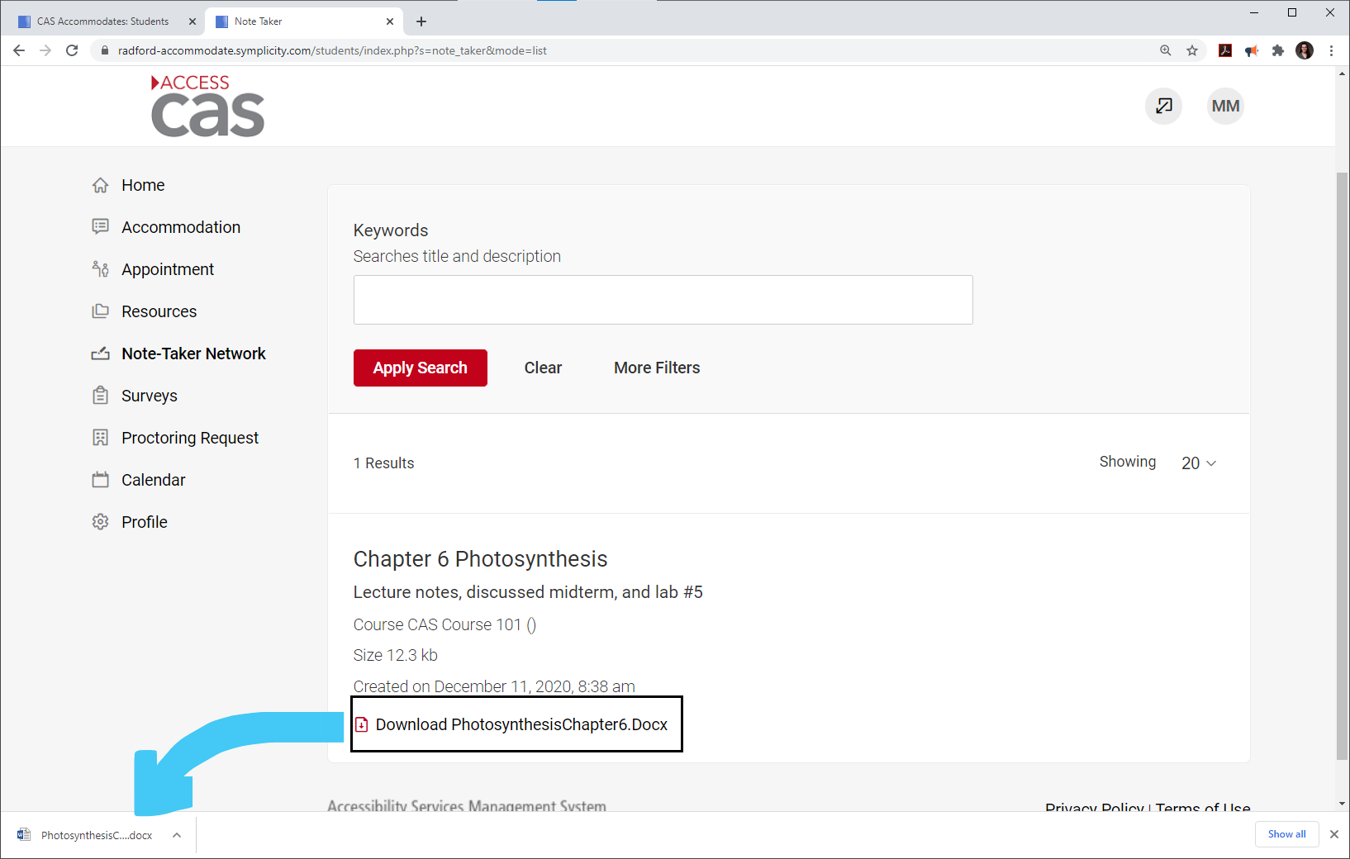

Frequently Asked Questions

What happened to the paper Volunteer Note Taker form?
- As of Spring 2019, we will no longer be using the paper form, a Volunteer Note Taker recruitment email will be sent out by CAS.
What is the process and time frame for assigning my note taker and viewing my notes?
- Once a volunteer receives the recruitment email and accepts the position, CAS will assign them as the note taker for the class and they will be able to immediately start uploading their notes directly to ACCESS CAS. From there, the CAS student will be to log in and view the notes.
How often should I receive notes?
- CAS asks that peer notetakers upload notes at least twice a week and regularly throughout the semester; however, this may vary depending on the schedule of the class.
How will I receive my notes?
- You can receive automated notifications when notes are uploaded to ACCESS CAS. To view the notes, log into ACCESS CAS and click on the Note Taker Network tab. Please be instructions above.
What do I do if I have not received notes in a timely manner?
- Please contact CAS as soon as possible if you are not receiving notes in a timely manner.
What do I do if I have an upcoming exam and need my notes?
- Please contact CAS if you are not receiving notes in a timely manner. If you notify CAS of any upcoming exams at least 2 business days prior to the exam, CAS will reach out to the volunteer note taker and remind them to upload their notes to ACCESS CAS. Please be aware, note taking is on a volunteer basis, so there is no guarantee that notes will be upload in time for your exam.
What if the notes are not legible or adequate?
- Please contact CAS as soon as possible so your note taker can be asked to provide more legible or typed notes, or so another note taker can be selected.
Should I still attempt to take notes?
- Absolutely! We understand that can be difficult at times; however, the notes from your peer note taker should be an additional tool for you to use in conjunction with your own notes. Having a note taker does not mean it is okay to miss class. You still need to attend class regularly.

Faculty Members

How to upload and/or view notes

- First, log into OneCampus, by clicking the OneCampus link on the Radford website.
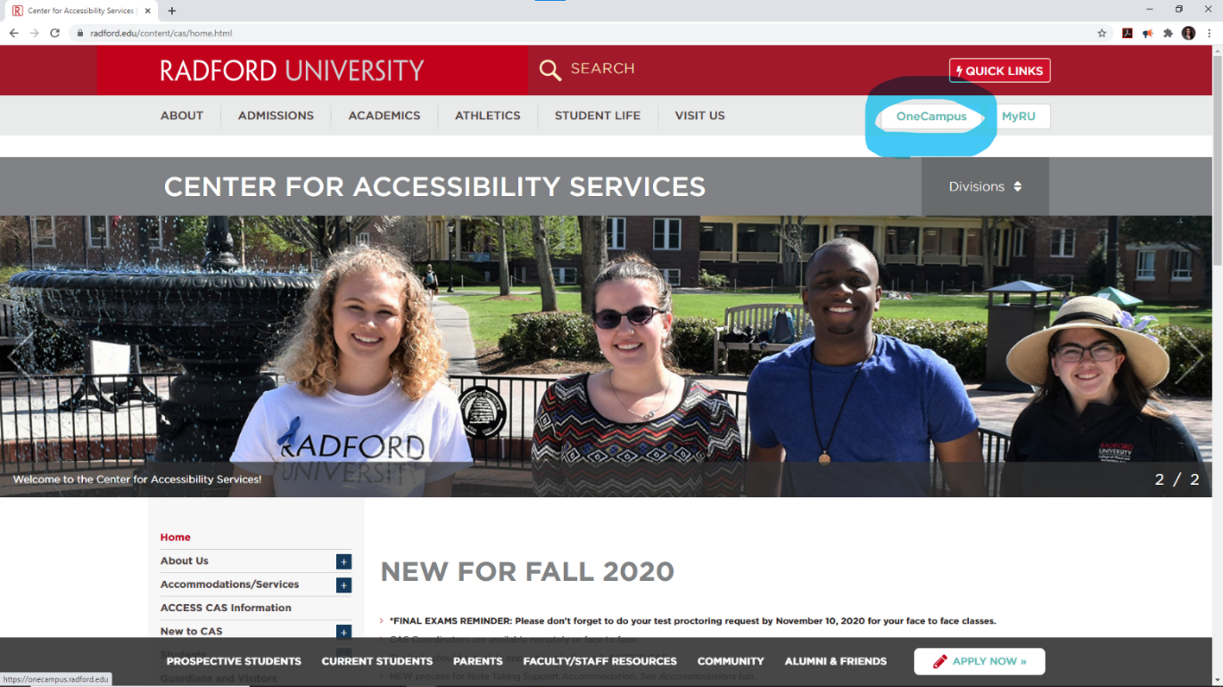
- Type ACCESS CAS in your OneCampus search bar.
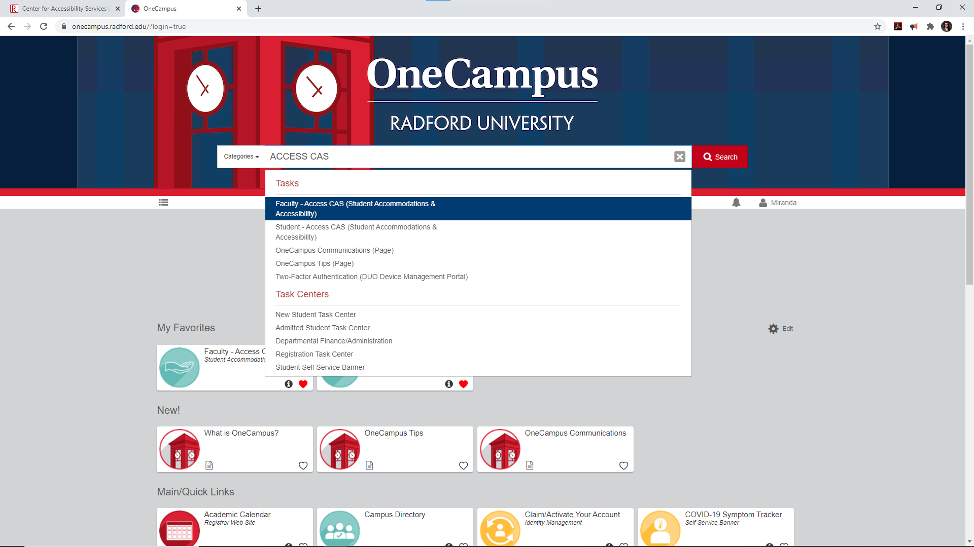
- Select FACULTY ACCESS CAS (Student Accommodations & Accessibility). This will open a new tab.
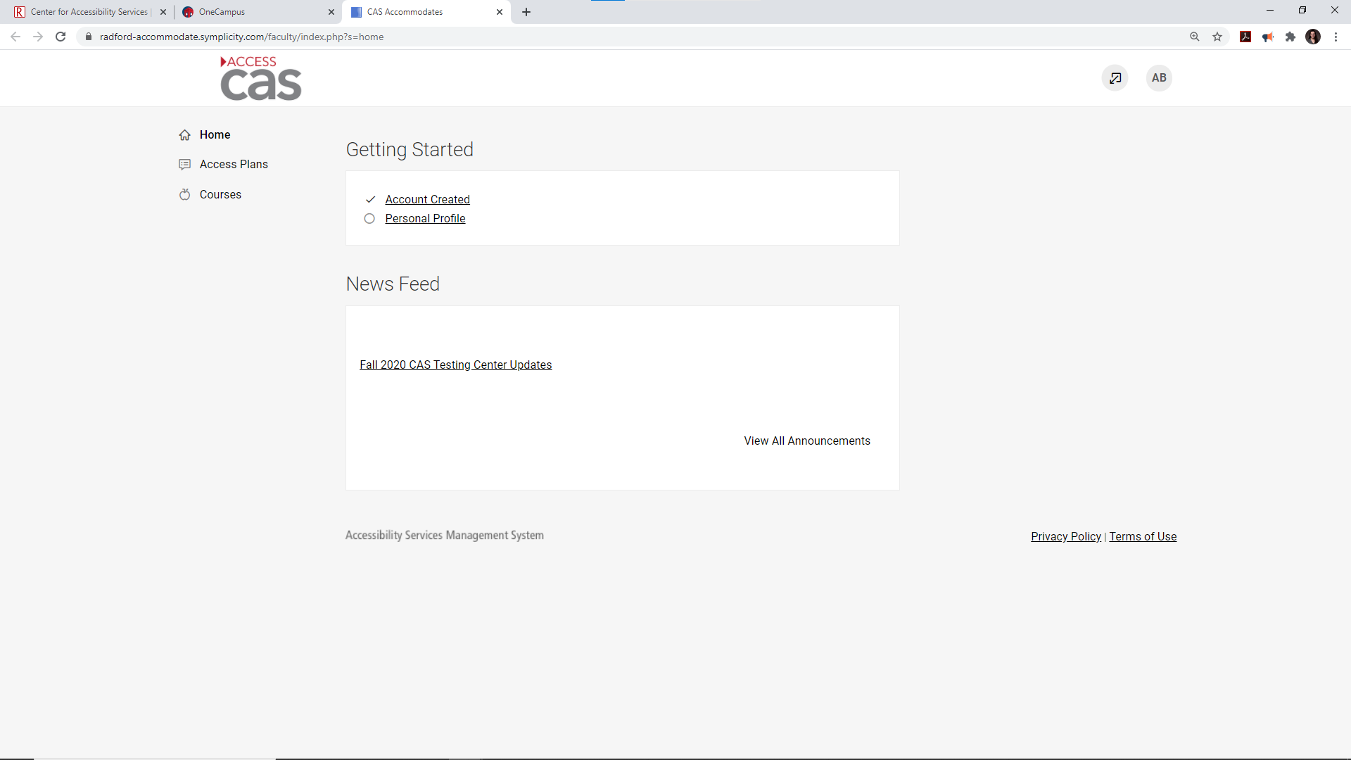
- Select the Courses tab on the left-hand side of the screen.
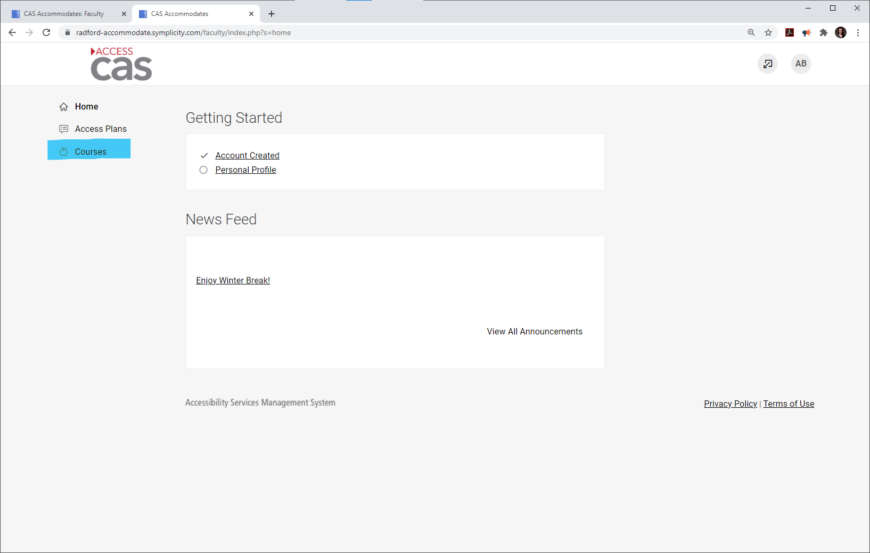
- Scroll and select the appropriate course.
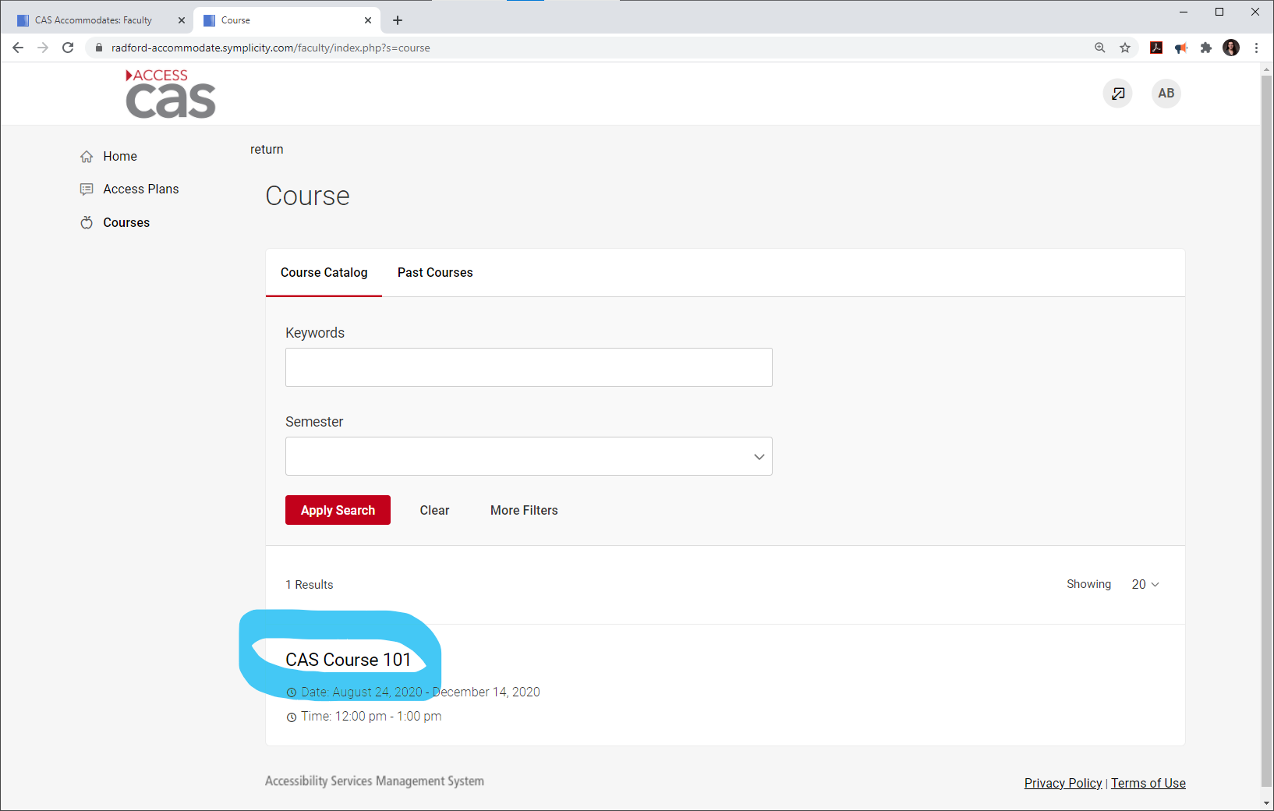
- Select the Course Notes tab.
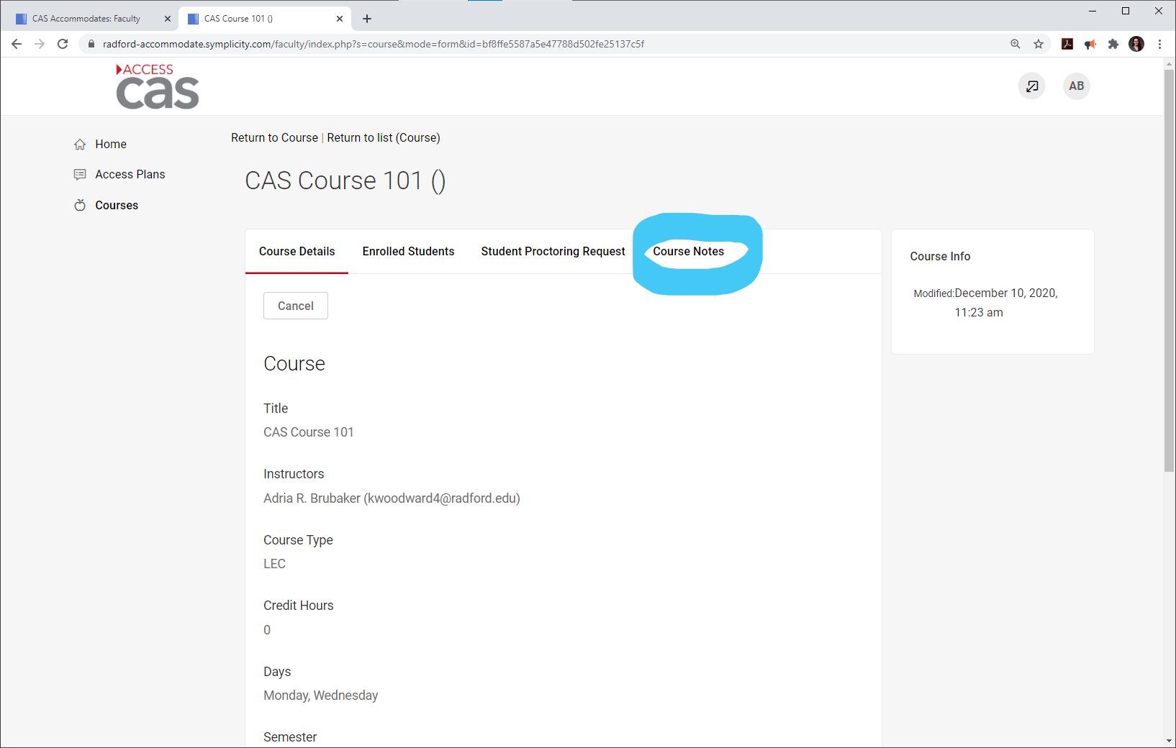
- You will be able to view any course notes uploaded by the volunteer notetaker, or upload notes/handouts, if you would like. Select Download to open the files.
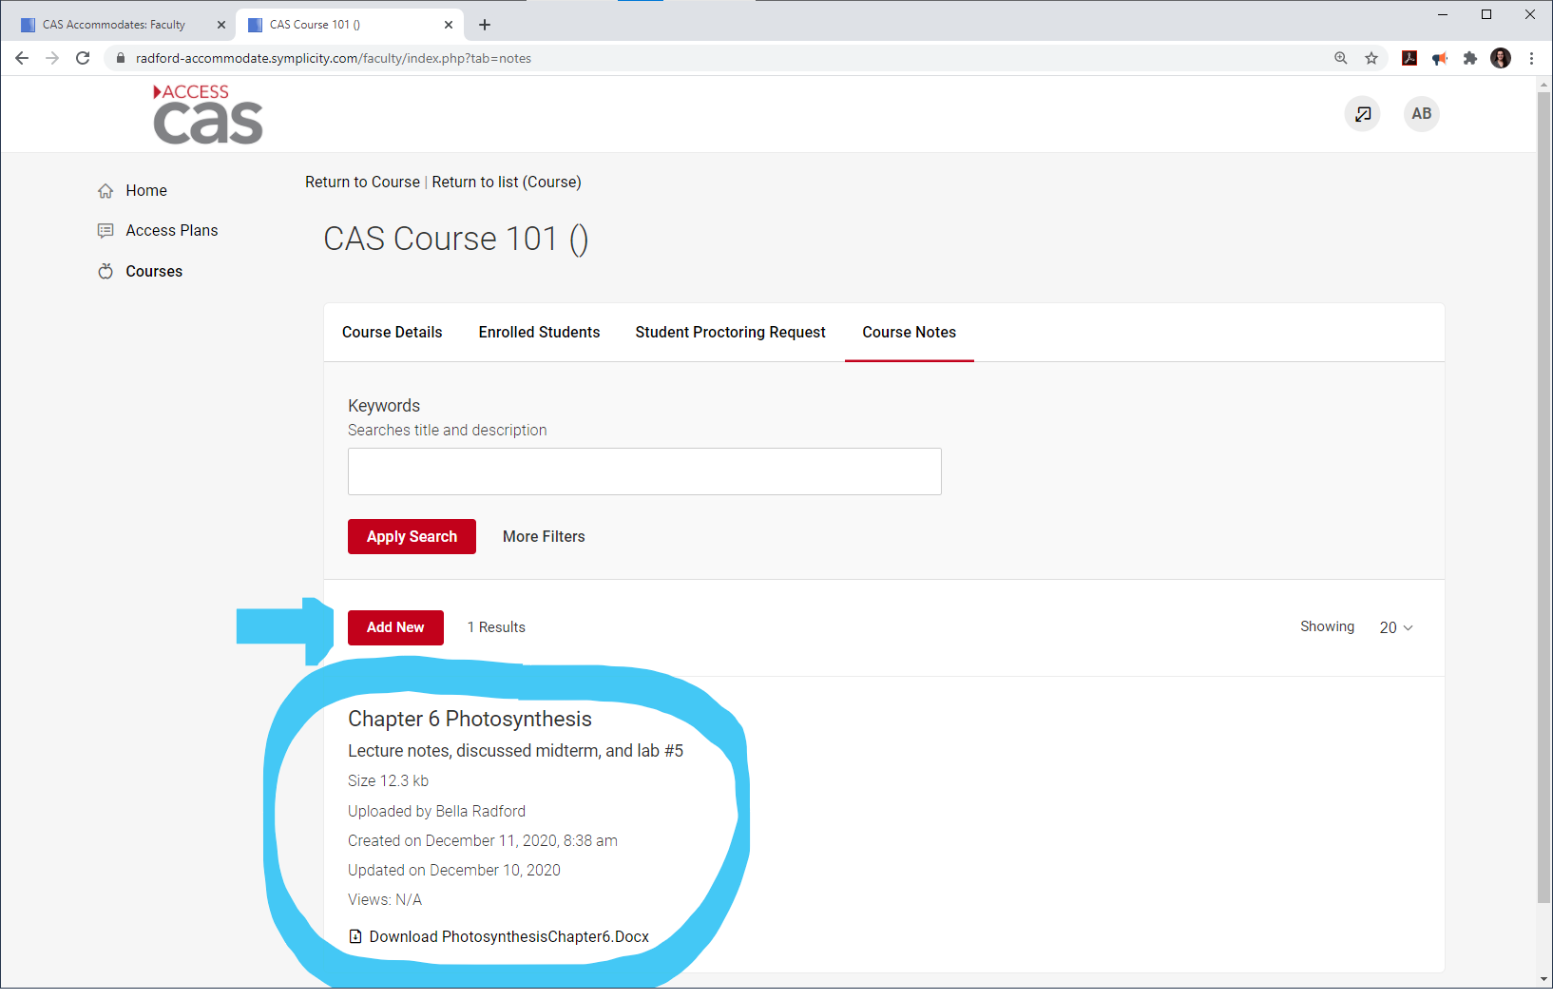

Frequently Asked Questions

What happened to the paper note taker form that I shared with my class in order to find a volunteer?
- As of Spring 2019, we will no longer be using the paper form, a Volunteer Note Taker recruitment email will be sent out by CAS. Once a student accepts the position, CAS will assign them as the note taker for the class and they will be able to upload their notes directly to ACCESS CAS. From there, the CAS student will be responsible for logging in and viewing the notes. If a professor would like to log in to check the notes or upload course materials, they are able to do so through ACCESS CAS. Please see instructions above.

