RESOURCE REPORT C
MBA Student Skills Sought by Employers
The six sources reviewed examined the skills and abilities sought by employers when considering an MBA graduate for employment. The most definitive source is the Corporate Recruiters Survey, a product of the Graduate Management Admission Council® (GMAC®), the owner of the Graduate Management Admission Test® (GMAT®). MBA programs around the world rely on the Council as the premier provider of reliable data about the graduate management education industry. For that reason, GMAC data had the greatest impact on the assessment of employer needs.
Functional Demand by Job Level and Region
The table below displays employer demand for recent graduate business hires by job function and job level placement within each function. In 2015, fifty-four percent of employers indicated they will fill marketing and sales positions with a recent MBA or other specialized business master’s graduate. These companies indicated they will place the majority (80%) of these new hires in mid-level or associate positions. Two areas, data analytics and finance, tied for second place in the list of 2015 job functions employers hope to fill, with 51 percent of employers planning to hire recent graduates to occupy these roles.
Employer Demand for Recent Business School Graduates, by Function, Overall & by Job Level
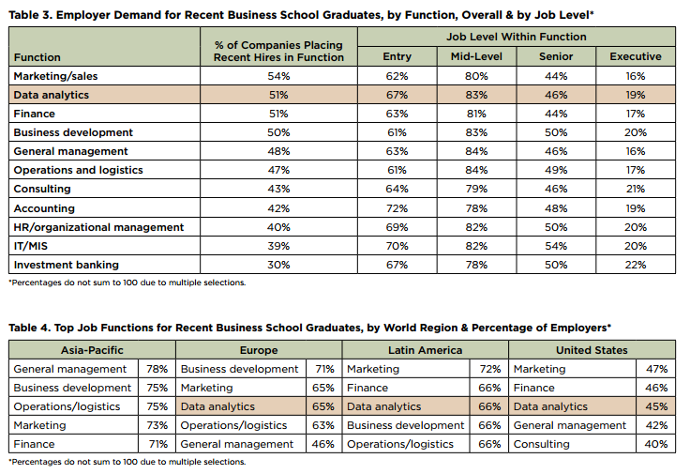
According to the GMAC report, “The demand for new hires skilled in data analytics has grown notably in recent years. The burgeoning interest in a field that has come to be known as ‘big data’ is gaining a strong foothold in companies worldwide as well as in higher education. (See sidebar for deeper analysis.) By region, companies in Asia-Pacific are seeking to fill roles in general management, business development, and operations and logistics, whereas companies in Latin America are more likely to place recent graduate business hires in marketing, finance, and data analytics functions.” (See table below)
Top Job Functions for Recent Business School Graduates, by World Region & Percentage of Employers*
The skill set in Analytics is in such demand that the GMAC added an Integrated Reasoning section to the GMAT to assess students’ aptitude for applying data to real-world problems. According to GMAC vice president for research and development, “the section was developed over four to five years after surveying faculty, businesses, students and graduates about the skills that are ultimately needed in the workplace”.
“The math department, they’ll probably produce better data analysts,” Rudner said, “but the business school is going to produce someone who can see the forest and the trees.”
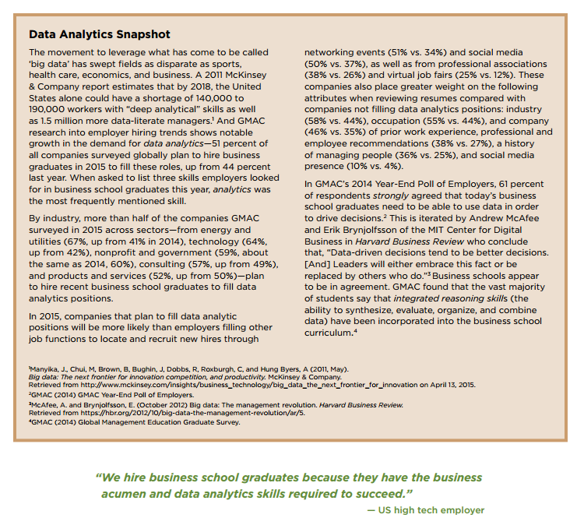
“We hire business school graduates because they have the business acumen and data analytics skills required to succeed.” – US high-tech employer

Summary of Skills Most Sought by Employers in MBA Students
Based on several national surveys and reports focused on the skills sought by employers when considering recent MBA graduates for employment (see Resource Report A) as well as communication with 12 MBA recruiters, below are the skills most often sought by employers.
Skills | Description
Strong Oral, Written Communication Skills and Presentation Skills | Ability to listen, write, and speak effectively. Active listening by giving full attention to what other people are saying, understanding the points being made, and asking clarification questions. Having the ability to interpret what others are saying and organize and express their thoughts clearly. Applicants should also possess the ability to create and edit written reports.
Strong Analytic, Quantitative, Technical, Critical Thinking, Analytical Reasoning and Problem Solving Skills | Having a grasp of Analytics, statistics, and quantitative analysis. Using logic and reasoning to identify strengths, weaknesses, alternative solutions, conclusions or approaches to problems. Ability to Identify problems and reviewing related information to develop and evaluate options and implement solutions. These skills also include an ability to find solutions to problems using creative problem solving, past experiences and available information and resources. Students should also develop the ability to conduct a situational analysis, look at issues from multiple perspectives, gather information if necessary, and determine the priority issues need to be addressed.
Adaptability and Flexibility | Ability to work under pressure, set priorities, adapt to changing conditions, apply knowledge and skills in new setting/situations, manage multiple priorities, and multitask. Employers also want employees who are open to new ideas and concepts and who can work independently or as part of a team.
Work Experience, Internships, Applied Projects, Collaborative Research/Consulting, Professional/Job-Related Certifications | Proven Ability to Perform. Demonstrate skills related to the position sought. Proven ability to deliver on expectations. Proven ability
Teamwork, Collaborative, Ability to Lead Teams, Negotiation Skills | Employers want job candidates to have the ability to work collaboratively, especially with people from diverse backgrounds. Teamwork also is the ability to work with others in a professional manner while attempting to achieve a common goal.
Ability to Manage Decision Making Process | Employers want applicants to possess the ability to analyze a problem to develop workable solutions. Ability to consider the relative costs and benefits of potential actions to choose the most appropriate ones. Having the skills and abilities to manage others in a decision-making situation
Job-Related Degree Specialization/Concentration | Earned degree or supporting coursework, minor, concentration, or certification in the job area
Innovation and Creativity | Ability to make changes in something established, especially by introducing new methods, ideas, or products. Ability to conceive something original or unusual.
Motivation and Drive | Ability to focus on specific goals and gain satisfaction when achieved
Global/Cross-Cultural Understanding/Experience | Understanding the global context in which decision are to be made
Relevant Language Skills | Employers want applicants having fluency in a language other than English
As can be seen, the skills sought by employers in MBA students are similar to those sought by employers when considering students with baccalaureate degrees. According to recruiters, the difference is in the degree to which an MBA student should have mastered, enhanced and be able to show or demonstrate proof that he/she possesses the skills desired.

Corporate Recruiters Survey 2015, GMAC http://www.gmac.com/market-intelligence-and-research/gmac-surveys/corporate-recruiters/corporate-recruiters-survey.aspx and http://www.gmac.com/~/media/Files/gmac/Research/Employment%20Outlook/2015_corporate-recruiters_survey-report_web-release.pdf
Ibid.
As demand for big data analysts grows, schools rush to graduate students with necessary skills, Steven Overly (September 2013) Capital Business, The Washington Post. http://www.washingtonpost.com/business/capitalbusiness/as-demand-for-big-data-analysts-grows-schools-rush-to-graduate-students-with-necessary-skills/2013/09/13/afbafb3e-1a66-11e3-82ef-a059e54c49d0_story.html
Ibid.
Ibid.

