Sociology: Studying People, Society, & Cultures
Classes for Spring 2022

SOCY 110, Introduction to Sociology (3), multiple sections, please see the registration schedule for section days & times. Look for Online Distance Learning; Asynchronous (DLAS) options too.
SOCY 110 helps you understand everything from society’s biggest problems to your individual interactions, all within a social context.

SOCY 121, Understanding Cultures (3), Prof. Will Taggart, two sections:
SOCY 121-01, TR 8:00-9:15 & SOCY 121-02 (Honors), TR 9:30-10:45
SOCY 121 is an introductory course to cultural anthropology. Explore cultural patterns of behavior and belief around the world, and apply cultural anthropology perspectives to understand cultural variations and diversity.

SOCY 210, Social Problems (3), Dr. Elizabeth Lyman, two sections:
SOCY 210-01, MWF 9:00-9:50 & SOCY 210-02, MWF 10:00-10:50
Job insecurity, a “broken” educational system, health care woes: What are the causes? The consequences? And what kinds of action can we take in addressing these pressing social problems? In this class we will examine these issues and more as we take a sociological look at contemporary social problems.

SOCY 213, Social Issues and Healthcare Delivery (3), Dr. Paula Prince. This course is Online Distance Learning; Asynchronous (DLAS).
This course will introduce students to vital social issues affecting healthcare delivery in the United States. Course content will include health related demographics, ethnic and cultural diversity, applied communication methods and skills and an orientation to community healthcare. An experiential learning module will place students in a volunteer role working 20 hours a week with a human service agency.

SOCY 250, Social Inequality (3), Dr. Stephanie Bradley. two sections:
SOCY 250-01, TR 9:30-10:45 & SOCY 250-02, TR 2:00-3:15
Did you know that the richest one percent of U.S. households own more than the combined wealth of the bottom 90%? That the wages of professional women are approximately 80% of those of professional men? And that African Americans and Hispanics are roughly three times as likely to live in poverty as whites? In this course, we will seek to clarify how social institutions contribute to the unequal distribution of valued resources and opportunities, and explore the factors that impact inequality.

SOCY 331, Race and Ethnic Relations (3), two sections:
SOCY 331-01, Dr. Stephanie Bradley, TR 11:00-12:15 & SOCY 331-02, Kathryn Everard-Van Patten, at the Roanoke Higher Ed Center, T 6:00-9:00
This course presents both a comparative historical review and a contemporary understanding of racial and ethnic relationships in the United States. We will explore the effects of historical patterns and societal dynamics on prejudice, discrimination, and inequality as we employ a sociological framework to see race as a social construct with real outcomes.

SOCY 342, Race, Ethnicity, and Healthcare (3), Dr. Paula Prince. This course is Online Distance Learning; Asynchronous (DLAS).
This course will provide students with a fundamental understanding of the dynamics of racial and ethnic relations in American daily life. Students will
get an in-depth look at the history, theory, and methods that inform social science research on pressing social issues that affect health status such as diversity and inequality.

SOCY 365, Society and the Individual (3), Dr. Joanna Hunter, MWF 2:00-2:50
Why are you attracted to certain people and not others? Why do people go along with the crowd even when they know they shouldn’t? Are women really less aggressive than men? Why are we so influenced by others? This class takes a sociological look at social psychology and uses a variety of lectures, class exercises, and other activities to explore these and other questions related to the ways that social interaction affects individual attitudes and behaviors.

SOCY 389, Sociology of the Family (3), Dr. Roby Page, MWF 11:00-11:50
It’s long been said that family is the place where they’ll always take you in. How well are families doing in today’s changing society? We’ll look at the facts about family and consider the many changes that have come and are coming to this core institution. In this class we consider the social, economic, and political context of familial relations.

SOCY 411, Appalachian Cultures (3), Dr. Aysha Bodenhamer, MWF 1:00-1:50
The purpose of this class is to gain a better understanding and appreciation of Appalachia, its beauty, and its mischaracterization. You will learn about different cultural styles and dialects, stereotyping of the region, the history of moonshining, and how powerful actors, particularly in extractive industries, have come to dominate much of the region. We will also discuss Appalachians’ resilience and grassroots efforts to improve the region.

SOCY 443, Deviance (3), Dr. Roby Page, MWF 1:00-1:50
“Why be normal?” some like to ask. We’ve all been deviant now and then, for better or worse. Why do people step outside the boundaries and deviate? From criminals in the streets and criminals in the suites… to drug abusers and sexual deviants… to simply not fitting in, we’ll look at how and why people stray from conformity.

SOCY 480, Survey Research Methods (3), Dr. Allison Wisecup, TR 11:00-12:15
Survey Research Methods, invites students to engage in the world of research by selecting their research question and analyzing the data using a worldwide leading software program, SPSS. This class will give you transferable skills for your resume, so you can hit the job market ahead of your peers.

SOCY 486, Engaging the Community (3), Dr. Aysha Bodenhamer, MWF 11:00-11:50
Have you ever wanted to conduct research with a community partner? Now is your chance to learn more about applied sociology and how we can take sociology to the next level. Students will build a research project from the ground up, gaining valuable skills and experience, while also presenting at the Student Engagement Forum.

SOCY 495, Topical Seminar in Sociology: African Americans in Southwest Virginia (3), Dr. Joanna Hunter, MWF 10:00-10:50
Are you interested in learning more about the past and present African American experience in this region? In this course, we will study the history of African Americans in Southwest Virginia from the Reconstruction to present. This course will be designated as a Citizen Leader course and will involve community-based research.

SOCY 499*, Internship (3-12). Please see Dr. Stephanie Bradley, Internship Coordinator, to discuss opportunities to fulfill the internship requirement. Also please review the Sociology Internship Manual on the Sociology web site, and view internship opportunities at http://www.radford.edu/content/chbs/home/sociology/about/internships.html.
* Satisfies the SOCY major Applied/Practical Experience course requirement
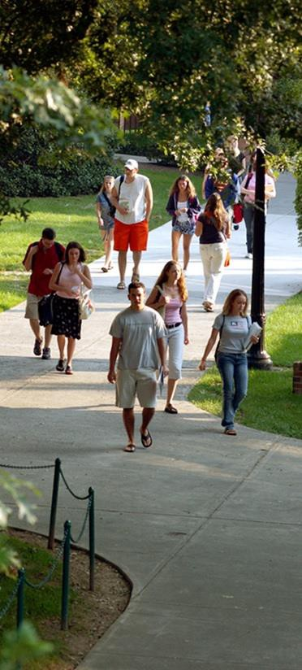
Sociology: Studying People, Society, & Cultures The Department of Sociology, Program in Public Sociology, and Center for Social & Cultural Research
www.radford.edu/sociology; http://www.radford.edu/cscr; (540) 831-5615

THE SOCIOLOGY MAJOR AND MINOR
The Department of Sociology promotes a challenging atmosphere in which students are encouraged to recognize, understand, and think critically about social processes, issues, and cultural diversity. Through rigorous coursework, the program teaches students how to gather, analyze and interpret qualitative and quantitative data. Through research-in-service and internships students learn how to apply their knowledge and skills to problems and needs in businesses, organizations, and communities. A central part of our mission is to provide opportunities for independent student research as well as faculty and student collaborative research. We teach from the philosophy that active engagement in real-world research enhances employment opportunities and opens doors to graduate school. The department engages in sound career planning and preparation with each major.
SOCIOLOGY MAJOR, B.A. OR B.S. DEGREE
(36 semester hours)

Required Courses (21 credit hours)
SOCY 110 Introduction to Sociology (3)
SOCY 250 Social Inequality (3)
SOCY 360 Sociological Theory (3)
SOCY 365 Individual and Society (3)
SOCY 380 Introduction to Social Research Methods (3) SOCY 480 Survey Research Methods (3)
SOCY 497 Senior Seminar in Sociology (3)

STAT 130 Understanding Statistics in Society, or STAT 200 Introduction to Statistics. All majors in the department must successfully complete either of these courses, which is a prerequisite for SOCY 380.

Sociology Electives (15 credit hours)
Five additional elective courses not listed above must include at least four 300-400 level courses. One elective must be satisfied by an approved internship or other designated applied sociology course selected in consultation with your advisor.

GRADUATION REQUIREMENTS
To graduate with a major in Sociology, a student must have a grade point average of 2.0 or higher in all courses taken with a SOCY prefix. Majors must complete all required courses in the major curricula listed above with a grade of “C-” or better (SOCY 110, and 250, 360, 365, 380, 480, 497).

For specific Core Curriculum information and additional B.A or B.S requirements see the Undergraduate Catalog.

SOCIOLOGY MINOR
(18 semester hours)

SOCY 110 Introduction to Sociology (3)
SOCY 210 Social Problems OR SOCY 250 Social Inequality (3) SOCY 365 Society and the Individual (3)
The remaining 9 credits must be SOCY-prefix courses and include at least two courses (6 credits) at the 300- or 400-level.

Sociology Department Advisor: Dr. Roby Page, erpage@radford.edu

