Sociology: Studying People, Society, & Cultures
Classes for Fall 2022
ELAS = Online Distance Learning: Asynchronous

SOCY 110, Introduction to Sociology (3), multiple sections, please see the registration schedule for section days & times. Look for ELAS options too. SOCY 110-10 is an Honors section. SOCY 110 helps you understand everything from society’s biggest problems to your individual interactions, all within a social context.

SOCY 121, Understanding Cultures (3), three sections:
SOCY 121-01, Dr. Hulya Dogan, ELAS & SOCY 121-02, Prof. Will Taggart, TR 9:30-10:45 & SOCY 121-03, Prof. Will Taggart, TR 11:00-12:15
SOCY 121 is an introductory course to cultural anthropology. Explore cultural patterns of behavior and belief around the world, and apply cultural anthropology perspectives to understand cultural variations and diversity.

AAST 200-01, Introduction to African American Studies (3), TBD, TR 12:30-1:45
This course introduces the interdisciplinary field of African American Studies by way of tracing the experience of African people in the Americas, their creation of cultural products such as art and literature, and the ongoing fight for equality and justice.

SOCY 210, Social Problems (3), three sections:
SOCY 210-01, TBD, MWF 3:00-3:50 & SOCY 210-02, Dr. Roby Page, MWF 1:00-1:50.
Job insecurity, a “broken” educational system, health care woes: What are the causes? The consequences? And what kinds of action can we take in addressing these pressing social problems? In this class we will examine these issues and more as we take a sociological look at contemporary social problems.

SOCY 213-01, Social Issues in Healthcare Delivery (3), Dr. Paula Prince, ELAS.
This course will introduce students to vital social issues affecting healthcare delivery in the United States. Course content will include health related demographics, ethnic and cultural diversity, applied communication methods and skills and an orientation to community healthcare. An experiential learning module will place students in a volunteer role working 20 hours a week with a human service agency.

SOCY 250, Social Inequality (3). three sections:
SOCY 250-01, Dr. Stephanie Bradley, TR 9:30-10:45 & SOCY 250-02, Dr. Stephanie Bradley, TR 11:00-12:15 & SOCY 250-03, Dr. Hulya Dogan, ELAS.
Did you know that the richest one percent of U.S. households own more than the combined wealth of the bottom 90%? That the wages of professional women are approximately 80% of those of professional men? And that African Americans and Hispanics are roughly three times as likely to live in poverty as whites? In this course, we will seek to clarify how social institutions contribute to the unequal distribution of valued resources and opportunities, and explore the factors that impact inequality.

SOCY 326-01, Men & Women in Society (3), Dr. Hulya Dogan, ELAS.
How does your gender or gender identity shape the way you learn, love, work, thrive, and suffer? In the US today, why do we call some women "cougars" while there is no corresponding word associated with men looking for younger women? Sociology facilitates an analysis of the cultural and social definitions of masculinity and femininity and with this class, we will look at the consequences of such creations.

SOCY 331-01, Race and Ethnic Relations (3), Dr. Joanna Hunter, MWF 9:00-9:50
This course presents both a comparative historical review and a contemporary understanding of racial and ethnic relationships in the United States. We will explore the effects of historical patterns and societal dynamics on prejudice, discrimination, and inequality as we employ a sociological framework to see race as a social construct with real outcomes.

SOCY 340-01, Appalachian Health Culture (3), Dr. Paula Prince, ELAS.
In this course students are introduced to the history of health and healthcare in the mountains of Appalachia and the engaging interface between Appalachian culture and health. The region’s current health status is discussed with regard to problematic health conditions, leading causes of morbidity and mortality, and access to comprehensive healthcare.

SOCY 360-01, Sociological Theory (3), Dr. Elizabeth Lyman, MWF 10:00-10:50
McDonald's, fashion, social networking, and car shopping: sociological theory comes to life in this course covering both classical and contemporary theory. Come and explore the relationships between theory and our everyday lives.

SOCY 365, Society and the Individual (3), Dr. Joanna Hunter. two sections:
SOCY 365-01, MWF 1:00-1:50 & SOCY 365-02, MWF 2:00-2:50
Why are you attracted to certain people and not others? Why do people go along with the crowd even when they know they shouldn’t? Are women really less aggressive than men? Why are we so influenced by others? This class takes a sociological look at social psychology and uses a variety of lectures, class exercises, and other activities to explore these and other questions related to the ways that social interaction affects individual attitudes and behaviors.

SOCY 380-01, Introduction to Social Research Methods (3), Dr. Allison Wisecup, TR 8:00-9:15
Why do sociologists use scientific methods to research an array of social phenomena? Why are certain research design choices made, what data collection methods do social scientists employ, and how is research carried out? In this course, students will learn the answers to these questions and receive “hands on” training to learn the fundamentals of both doing and writing about quantitative and qualitative research in the social sciences.

SOCY 433-01, Rural Sociology (3), Dr. Aysha Bodenhamer, MWF 11:00-11:50
This course focuses on the unique sub-field of rural sociology including: agriculture and food, natural resources and environment, population change, gender, sexuality, race and ethnicity in rural America, rural economies, community, and quality of life. More broadly, the course will address uneven regional development, the role of space and place, rural poverty, and the struggles of racial, ethnic, and sexual minorities in rural America.

SOCY 444-01, Juvenile Delinquency (3), Dr. Roby Page, MWF 11:00-11:50
Is juvenile delinquency on the rise? What causes delinquency? What can be done about it? We’ll look at such pressing concerns as gangs, drugs, bullying, and shootings. And we’ll examine the persistent question of how juveniles should be treated by the justice system.

SOCY 495-01, Topical Seminar in Sociology: Hip Hop Culture (3), Dr. Stephanie Bradley, TR 2:00-3:15
Originated by New York City teenagers and young adults in the 1970s, Hip Hop is now an outright culture and a global influence. Assessments of hip hop suggest that it both brings awareness to social inequalities and reinforces stereotypes. We will explore Hip Hop culture through a sociological lens as we assess these claims and listen to some dope music.

SOCY 497-01, Senior Seminar in Sociology (3), Dr. Stephanie Bradley, TR 3:30-4:45
“You majored in what? What can you do with that major?” This course prepares you to answer these questions and serves as the capstone experience for sociology majors. We will analyze the disciplinary nature of sociology applied in a contemporary context. In addition, we will prepare you to transition to becoming a professional sociologist. Students will learn to market their skills, explore future opportunities, and prepare for entry into the workplace or graduate school.

SOCY 499*, Internship (3-12). Please see Dr. Stephanie Bradley, Internship Coordinator, to discuss opportunities to fulfill the internship requirement. Also please review the Sociology Internship Manual on the Sociology web site, and view internship opportunities at http://www.radford.edu/content/chbs/home/sociology/about/internships.html.
* Satisfies the SOCY major Applied/Practical Experience course requirement
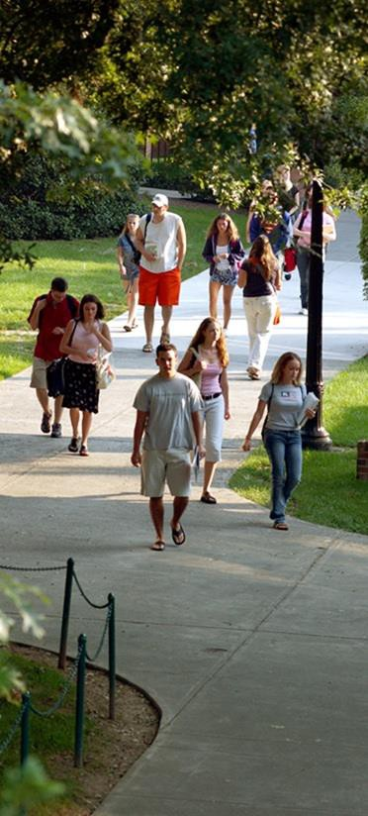
Sociology: Studying People, Society, & Cultures The Department of Sociology
Center for Social & Cultural Research
www.radford.edu/sociology; http://www.radford.edu/cscr; (540) 831-5615

THE SOCIOLOGY MAJOR AND MINOR
The Department of Sociology promotes a challenging atmosphere in which students are encouraged to recognize, understand, and think critically about social processes, issues, and cultural diversity. Through rigorous coursework, the program teaches students how to gather, analyze and interpret qualitative and quantitative data. Through research-in-service and internships students learn how to apply their knowledge and skills to problems and needs in businesses, organizations, and communities. A central part of our mission is to provide opportunities for independent student research as well as faculty and student collaborative research. We teach from the philosophy that active engagement in real-world research enhances employment opportunities and opens doors to graduate school. The department engages in sound career planning and preparation with each major.
SOCIOLOGY MAJOR, B.A. OR B.S. DEGREE
(36 semester hours)

Required Courses (21 credit hours)
SOCY 110 Introduction to Sociology (3)
SOCY 250 Social Inequality (3)
SOCY 360 Sociological Theory (3)
SOCY 365 Individual and Society (3)
SOCY 380 Introduction to Social Research Methods (3) SOCY 480 Survey Research Methods (3)
SOCY 497 Senior Seminar in Sociology (3)

STAT 130 Understanding Statistics in Society, or STAT 200 Introduction to Statistics. All majors in the department must successfully complete either of these courses, which is a prerequisite for SOCY 380.

Sociology Electives (15 credit hours)
Five additional elective courses not listed above must include at least four 300-400 level courses. One elective must be satisfied by an approved internship or other designated applied sociology course selected in consultation with your advisor.

GRADUATION REQUIREMENTS
To graduate with a major in Sociology, a student must have a grade point average of 2.0 or higher in all courses taken with a SOCY prefix. Majors must complete all required courses in the major curricula listed above with a grade of “C-” or better (SOCY 110, and 250, 360, 365, 380, 480, 497).

For specific REAL Curriculum information and additional B.A or B.S requirements see the Undergraduate Catalog.

SOCIOLOGY MINOR
(18 semester hours)

SOCY 110 Introduction to Sociology (3)
SOCY 210 Social Problems OR SOCY 250 Social Inequality (3) SOCY 365 Society and the Individual (3)
The remaining 9 credits must be SOCY-prefix courses and include at least two courses (6 credits) at the 300- or 400-level.

Sociology Department Advisor: Dr. Roby Page, erpage@radford.edu

