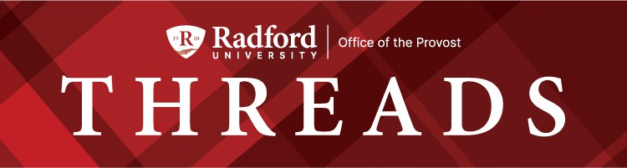

September 29, 2025

Happy fall! With the start of the semester and all the activities, I’ve had less chance for reading and listening to audiobooks. But on my walks, I’ve been listening to the 15th anniversary edition of Start with Why by Simon Sinek. I’m often skeptical about pop management books, but this one really resonates. When the value of student earning college degrees is being challenged, it helps to remember our why. Education matters, not just because it creates ﬁnancial well-being (it does), but because it creates healthier, happier and more engaged communities. Here are a couple of slides that are helpful in explaining that value, from a presentation I gave this summer at a higher education workshop.
College graduates are most likely to vote.
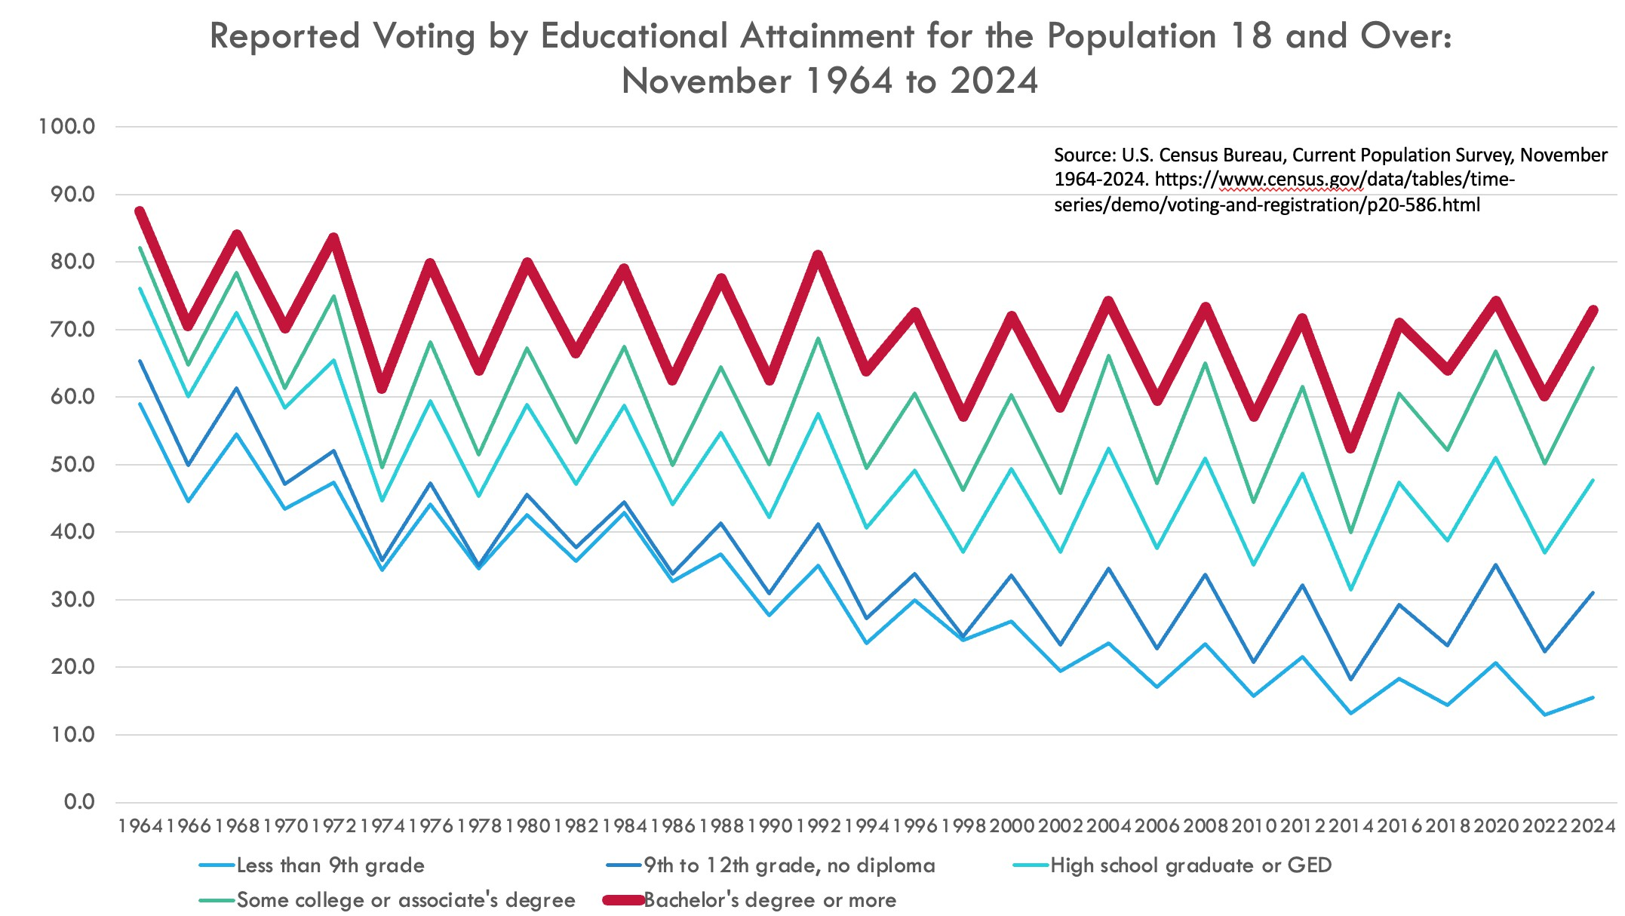

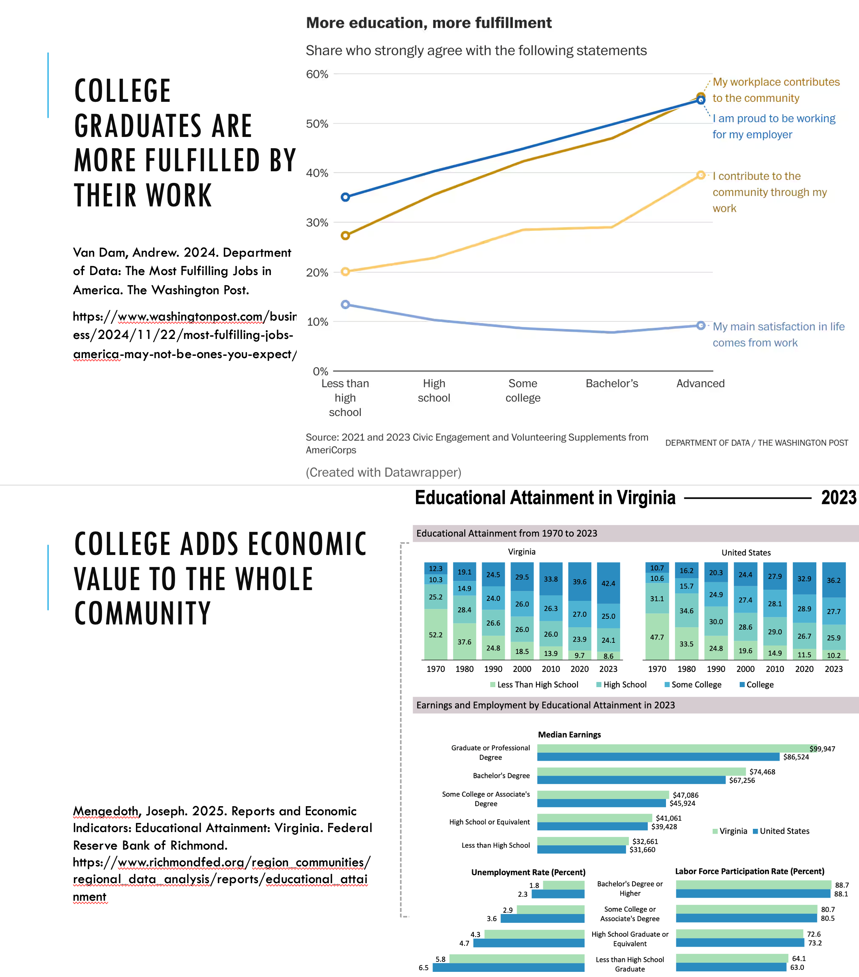
We saw the pride and joy from our students as they showed off their new Radford University home to their Families and Friends (and dogs) over the past weekend. It was great to see them discovering and reinforcing their why - it’s the key to student success. I hope that you remember your why - you all contribute to the value we bring to our students and communities.
As always, I appreciate all that you are doing! Bethany



Free Hearing Screenings for Faculty, Staff, and Students

The Radford University Department of Communication Sciences and Disorders is offering free hearing screenings to faculty, staff, and students during the Fall 2025 semester. Available appointment times are Tuesdays between 11:00 am-12:30 pm and Thursdays between 1:00-2:30 pm. Each appointment will be about 10 minutes long.
Hearing screenings are a shortened form of an evaluation and while they can determine the potential presence of hearing loss, they do not quantify severity of any hearing impairment.
Please Note: These screenings serve as important clinical education experiences and provide student clinicians with mandated hours and experience toward fulﬁlling licensure requirements to practice as speech-language pathologists. Please keep your appointment or notify the clinic as soon as possible if you are unable to do so. Failure to keep an appointment hinders a students' ability to develop necessary clinical skills needed for graduation and licensure.
To schedule your appointment for a hearing screening or to gain more information, please email our referral line at speech@radford.edu.
The Radford University Speech-Language-Hearing Clinic is located on the ﬁrst ﬂoor of Waldron Hall.


Did you know...
that you have access to a collection of digital medical and health sciences books? Included in the Radford University Libraries’ almost 300 databases, AccessMedicine (requires your Radford University login) contains medical textbooks, examination and procedural videos, patient safety modules, practice guidelines, self-assessments, customizable patient education, and many other visual health sciences related tools and resources. This database has applications for a variety of health science ﬁelds, or for just general use and reference.
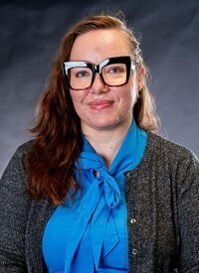

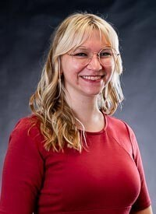

This summer, the Libraries welcomed two new library liaisons (librarians). Our newest Instruction Librarian, Amber Mear, is the new library liaison for Communication Sciences & Disorders, Nursing, Occupational Therapy, and Social Work. Our University Archivist/Head of Archives & Special Collections, Ashley Palazzo, is the new library liaison for Appalachian Studies, History, and Political Science. We are glad they are here, and they will be working with their assigned departments’ faculty library liaisons to ensure the libraries have the materials they need to serve our students.
We also said goodbye to our Serials & Electronic Resources Librarian, Jessica Ireland, after serving as the library liaison for Anthropological Sciences, Biology, Geospatial Sciences, and Information Technology. We appreciate her years serving her departments and are happy to see her off on her next adventure!
Until a new librarian is hired, Alison Armstrong will be serving as the library liaison for most of Jessica’s areas; the Head of Collection and Technical Services, Kay Johnson, will be taking on Geospatial Sciences to go with her long-time liaisonship with Geology.
We greatly appreciate the library liaisons and faculty library liaisons working together throughout the year!
If you have library materials you wish to request such as books, CDs, or DVDs to support your students, please send them to your faculty library liaison to send to your library liaison. If you have a recommendation outside the scope of your department, please submit it using this form. If you have any questions, please contact the Collection Management Librarian, Alison Armstrong.


CVPA Events Make the News:
Reporter Tynisha Jackson, spent time at Radford recently gathering stories and came away with three pieces featuring the College of Visual and Performing Arts. She proﬁled two events that took place on Fri., Sept. 26, doing a piece on the Virginia Watercolor Society and the Ailey II dance concert. On Friday, she also ﬁled a story on junior Leah Bratton, a music therapy major who earned a SURF grant this summer to research one handed piano compositions after Bratton suffered an injury to her own hand. Professor Matt Cataldi, her mentor, was also interviewed.


Did you know? YOUR Center for Innovative Teaching and Learning offers custom workshops to ﬁt your department’s needs—like a recent session for Occupational Therapy on question design, rubrics, and transparent assignments.
□ Interested? Contact us at citl@radford.edu to discuss a custom workshop.

The Highlander Center for Character and Public Impact (funded by a grant from the Educating Character Initiative) is up and running! While we will have an opening for our physical space later this year, our activities are full speed ahead. Please contact us for workshops for classes, clubs, and athletic teams on building character, professional identity, professional ethics, or dialogue across difference. We can offer workshops to your students or train you to do so! Likewise, civil discourse tools, such as the Constructive Dialogue Institute's Perspectives online program, are available to anyone in the RU community. We are also offering a reading group on Cultivating Virtue in the University (register here). Contact hkeith1@radford.edu for more information.
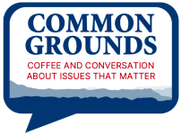

Do you want to have a meaningful conversation about what's happening in the world while enjoying treats from Arabica? Join us for Common Grounds on October 1, 4-5, in McConnell's ILCb classroom (3rd ﬂoor). This month's discussion topic will be "What does safety, belonging, and free expression on campus and beyond mean to you right now?"


New Electronic Forms:
Three new forms are available via the OGA website.
Name: Graduate Course Transfer Request
Purpose: Used by Graduate Students and Advisors to submit course transfer requests from other institutions.
Audience: Graduate Advisors and Students https://radford.kualibuild.com/app/6814c6a75e85670282aef54c/run

Name: Continuous Enrollment Form (GRAD 799)
Purpose: Used to enroll for GRAD 799 for completion of requirements for a graduate class, thesis, or dissertation.
Audience: Graduate Advisors and Students https://radford.kualibuild.com/app/6814c6b05e856702826c995b/run

Name: Graduate Student Academic Forgiveness Request
Purpose: Used to request exclusion of certain grades from the calculation of a student's GPA. Audience: Graduate Students https://radford.kualibuild.com/app/68191b77d18f68027ddbcf33/run

Upcoming Breaks:
- Fall Break: October 17th, 2025
- Thanksgiving Break: November 22nd – November 30th, 2025

Withdrawal Deadlines: (withdraw by the deadline receive "W" on transcript)
- Fall A 2025 University Withdrawal (Fast Track): October 2nd, 2025
- Fall 2025 Course Withdrawal: October 31st, 2025
- Fall 2025 University Withdrawal: November 14th, 2025
- Fall B 2025 Course Withdrawal (Fast Track): November 25th, 2025
- Fall B 2025 University Withdrawal (Fast Track): December 1st, 2025

Degree/Certiﬁcate Deadlines:
- Fall B 2025 (Fast Track): October 27th, 2025

Outstanding Graduate Student Awards
The Ofﬁce of Graduate Affairs is accepting nominations for the Graduate Student Awards, recognizing outstanding achievement in academics, research, teaching, and professional development.

- Nominations Due: November 17th, 2025 [Form Attached Here]

Graduate Research & Scholarly Projects Stories
We are collecting stories of graduate student and faculty conferences, presentations, publications, or new research initiatives. Please email submissions to gradaffairs@radford.edu.

Professional Development
Communication Skills: Mastering Communication Understanding productivity, time management, and much more! Course available on Udemy via Link | Complete by October 1st Welcome to the Library: Getting Started on Your Research October 6th, 2025 | 6:00 PM – 7:00 PM | Zoom
Meet other graduate students and learn about popular library resources!



Academic Advising Celebrates a Successful Major & Minor Fair!

The Academic Advising team in the Highlander Success Center is proud to share the incredible success of the Major and Minor Fair, held on Thursday, September 25th in the Student Recreation and Wellness Center.
This year’s fair welcomed 397 students—more than double last year’s attendance! Of those, 242 students fully engaged by visiting at least 12 department tables, earning them a special prize: a cozy Highlander Success Center Academic Advising picnic blanket.
With the enthusiastic participation of nearly all academic departments across campus, along with many valued campus partners, students had the opportunity to explore programs, connect with faculty and staff, and learn more about the variety of majors, minors, and resources available to them.
Thanks to the collaboration of our academic departments, campus partners, and most importantly, our students, this event was an overwhelming success. We are excited to continue building on this momentum and look forward to another amazing fair next year!
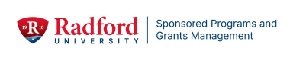

Hanover Webinar: Developing Relationships with Private Foundations
Led by Rob Guroff, a Managing Grants Consultant with Hanover Research

Friday, October 3 @ 11 am on Zoom
In this one-hour session, Cultivating Foundation Relationships, the presenter will discuss key differences between foundation and federal funders, introduce a foundation taxonomy to help participants quickly categorize foundation funders during the prospecting process, and offer a networking strategy to guide outreach to foundations. The presentation will emphasize the importance of internal coordination prior to engaging foundation funders and the beneﬁts of a long-term relational approach. Time will be allotted to consider as a group participants’ planned foundation outreach and existing foundation relationships.
Register Here

Sponsored Programs Seed Grant Program - Interdisciplinary Research Team Project Development Award

The Interdisciplinary Research Team Project Development Award aims to foster collaborative, cross-discipline research and scholarly activity in the following focus areas: Healthcare (e.g., health disparities, rural health, mental health, healthcare education), Artiﬁcial Intelligence (AI), Community workforce training that boosts economic development, as well as Community engagement promoting cultural heritage, tourism, and the arts

The goals of this award are to:
- Support the formation and development of diverse, interdisciplinary teams
- Encourage interdisciplinary collaboration and generation of innovative research.
- Enable teams to conduct smaller projects/studies that may impact the university and/or aid the community, collect preliminary data/ information for external funding proposals, Federal earmarked proposals, or other allied initiatives
- Promote community impact and engagement as a key outcome of funded projects

Request for Proposals

GLOBAL FACULTY FELLOW

The McGlothlin Center for Global Education and Engagement (MCGEE) seek applications for one faculty to serve as a Global Faculty Fellow. The selected faculty will assist with increasing the level of engagement of RU faculty in international initiatives, including promoting faculty-led programs, assisting with the development of institutional partnerships, identifying international research opportunities, and others. The faculty will be designated to serve a 2-year term.
The Global Faculty Fellow will be expected to contribute by:

- Engaging with Deans, Academic Chairs and other faculty members to promote and build awareness of the international initiatives available to the faculty at their respective College.
- Participating in faculty events to create awareness about international opportunities for academic collaborations.
- Delivering at least four (4) workshops during the academic year on how to develop international academic collaborations.
- Researching two (2) grant opportunities and identifying the requirements needed to apply.

The Global Faculty Fellow will become especially involved with international education at Radford University, thus gaining a balanced understanding of (1) the challenges facing international students at Radford University that may affect their retention, (2) the challenges and opportunities in establishing international collaborations, (3) the education abroad opportunities (including research) available for Radford University students and its role in the retention of students, and (4) a general understanding of the most important U.S. immigration regulations that govern international students on campus.
In recognition of their service, the Global Faculty Fellow will receive a $2,500 stipend per year.
All candidates for the Global Faculty Fellow appointment are expected to have the following qualiﬁcations:

- Must be in a 9-month faculty contract.
- Tenured or tenure-track faculty status.
- Strong interest and/or experience with international education.
- Willingness to interact with people from the broad spectrum of the campus community (students, faculty, administration, staff, prospective students and their families, and alumni)

Those interested in applying to be a Global Faculty Fellow are encouraged to review the McGlothlin

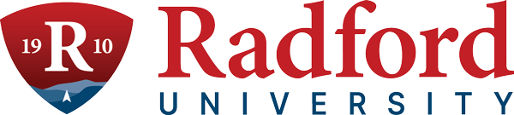
Center for Global Education and Engagement website. Application materials should include the following information:
Subscribe to our email list.

801 East Main Street | Radford, VA 24142 US

A 1-page cover letter that addresses the applicant’s:
experience with or interest in international education. goals for contributing to the international ofﬁce.
Curriculum vitae
Brief memos from one’s department chair and one’s dean that indicate the faculty member would be permitted to serve as a fellow if selected.

Applications should be submitted to ibetancourtvelez@radford.edu no later than November 15, 2025. The appointment is expected to being on January 12, 2026.
Any questions about the position should be directed to: Dr. Ismael J. Betancourt Vélez
Assistant Provost for Global Education and Engagement Cook Hall 105
(540) 831-6575
ibetancourtvelez@radford.edu

Ofﬁce of the Provost Radford University Martin Hall 331
540-831-5404

