

September 2, 2025

To badly misquote TS Eliot’s The Hollow Men, “this is the way the semester begins, not with a whisper but a bang.” At least that’s the way it feels to me - after all the preparation, the students arrive and the semester begins like the pistol at the starting line. We all stand, eager with excitement and bouncing on our toes, and then we are off! The updates below, as well as all the activities and opportunities you can ﬁnd on the Events at Radford University page (https://calendar.radford.edu/), send us off to a busy and exciting fall semester. I hope to see you at the Radford Night at Elmwood, the Fall into the New, and many other events.
From everything I have heard, the semester has started off well. Students found their way to classes (very few lost students), and they appreciated the help tents set up at the Clock Towers and by Young (thanks . IT was present and helpful for faculty and students. Many of you held welcome events in your departments and colleges, and there was a great turn-out for the club fair.
There are some illnesses going around campus, which isn’t surprising given that so many people arrive from their various travels and bring their germs with them. Please remember that a culture of care means caring for yourself and others. If you are ill, please stay home and recover, and do not feel like you need to come and share germs. If you have students who are ill, please give them the grace to recover. Please note that Student Health does not give excuse notes to students for common infectious disease (and sending them there only spreads germs), so if you need a note for several missed classes, you can ask them to submit an Absence Notiﬁcation (https://www.radford.edu/dean-of-students/student-advocacy /absence-notiﬁcation.html).
To better quote another poem that invokes the season of learning, I think about the closing of Mary Oliver’s Wild Geese:
Meanwhile the wild geese, high in the clean blue air, are heading home again.
Whoever you are, no matter how lonely, the world offers itself to your imagination,
calls to you like the wild geese, harsh and exciting --over and over announcing your place
in the family of things.
Thank you for helping all of us ﬁnd our place at Radford and in the "family of things.” Bethany



What are you reading this fall?
Henry Schaefer suggests "The Five Types of Wealth: A Transformational Guide to Design Your Dream Life" by Sahil Bloom. Henry says, "It doesn't have the punch of Stephen Covey's "The 7 Habits of Highly Effective People" but I really liked it, and I think we'll be hearing a lot from Mr. Bloom in the years ahead. I will be incorporating many of his insights into my MKT 360 this Fall."

The Seven Husbands of Evelyn Hugo by Taylor Jenkins Reid
The Lincoln Highway by Amor Towles
Kingmaker: Pamela Harriman's Astonishing Life of Power, Seduction, and Intrigue by Sonia Purnell
Henry and Clara by Thomas Mallon
Naked Lunch by William S. Burroughs
These were all summer reads for Wesley Young

David Beach is reading Lola Shoneyin's The Secret Lives of Baba Segi's Wives and Ayobami Adebayo's Stay With Me, powerful Nigerian novels that explore secrecy, resilience, and the pressures of family and culture. These are novels that a graduate student is analyzing for her master's thesis."


Name that series, win free coffee!
Congratulations Andy Travers!
Andy suggested the name RAD Talks (a play on TED Talks) as the new name for the Provost Speaker Series. Provost Usher will treat Andy to coffee at Arabica soon to celebrate the naming of this exciting series.

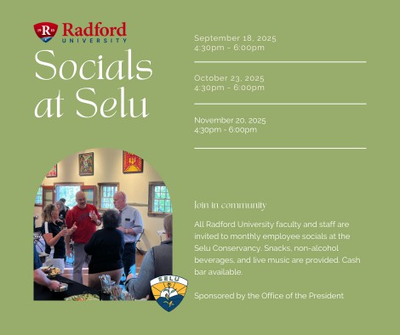
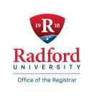

Updates from the Ofﬁce of the Registrar:
Radford University recently completed two major routine federal compliance reviews with exemplary results. The Ofﬁce of the Registrar successfully led both the Department of Defense (DoD) Institutional Compliance Program (ICP) and the Veterans Affairs (VA) Compliance Survey audits. These critical reviews ensure that the university remains compliant with federal requirements and eligible to serve military-afﬁliated students. These rigorous reviews require extensive coordination and documentation, and we thank our campus partners for their collaborative efforts, including Financial Aid, Bursar’s Ofﬁce, Admissions, Marketing and Communications, Controller’s Ofﬁce, Institutional Research, and Internal Audit. This achievement reﬂects the university's commitment to supporting our military-afﬁliated students.


Three art events take place in early September. All events are free and open to the public. Brook Ramsey’s "The Art of Becoming" opens in the Tyler Gallery on Sept. 3. Becca Foster’s "Thimbles in Thread: Embroidered Wonders" exhibition opens in the new gallery in Artis Gallery 302 on Sept. 8. This new gallery will be open 12-4 p.m. Thursday through Saturday through October 22. Finally, on Sept. 9, Charlie Brouwer will speak in the Artis Center Performance Hub at 3:30 p.m. followed by a reception.

The Mid-day Music series of free informal lunchtime concerts returns on September 3 in the Artis Center atrium. Erica Sipes will perform a piano set entitled "Singing through the Piano" from 12:15 - 12:45 p.m. Bring a lunch, bring a friend and enjoy something unique. Everyone is invited.

CVPA and the Department of Theatre and Cinema want to express our sadness at the passing of Monica Weinzapfel who retired from the department in 2019. Monica was always full of positive energy and created remarkable costumes for our theatre productions for more than three decades. She was beloved by students and faculty alike. A celebration of Monica’s life will be held at Radford University on a date yet to be determined. For more on Monica, please click here.



Welcome Our New Archivist!
Radford University Archives & Special Collections welcomes Ashley Palazzo, MA, as the new University Archivist/ Head of Archives & Special Collections. Ashley previously served as the Archivist at Christiansburg Institute, Inc., and before that, she was the Collections Management Technician at Gunston Hall. She is a graduate of George Mason University, where she studied Applied History and specialized in Digital Public Humanities. She is passionate about Appalachian History and creating opportunities to make archives more accessible. When she isn’t on the 5th ﬂoor of McConnell Library you can usually ﬁnd her hiking with her pup on one of the many trails in Southwest Virginia.


OURS: Research Ready Series
The Ofﬁce of Undergraduate Research (OURS) is excited to announce the fall lineup of our regular faculty and student support seminar series. All seminars are open to Radford University students, faculty, and staff. The meeting the ﬁrst week of the month will be focused on faculty support and the meeting the third week of the semester will be focused on providing student support. The meetings will be hybrid through zoom and in person at Career and Talent Development Lab (Russell 348).
https://radford.zoom.us/j/94643267604

Room: 94643267604
Password: ours
Decorative lightbulb with Radford University colors.

September 9th 3:30 – 4:30 pm
Faculty as Mentors: Strategies for Success
This session offers practical, adaptable strategies for guiding students through the research process
—helping them build skills, conﬁdence, and independence.
As a reminder, OURS is happy to meet individually or with groups all across campus and can be contacted at ours@radford.edu, 831-7203, or in Whitt 118-126. OURS can also run workshops on various professional development areas for your class, department, or even research team.

OURS Student Seed Grant: Supporting early-stage student research and creative inquiry projects
OURS is excited to announce the creation of a new way to support student-faculty research across campus in all disciplines! The OURS Student Seed Grant provides up to $500 to help undergraduate students launch new research projects. This small grant is designed to help you take those ﬁrst steps exploring a new creative idea.
Any Radford University or Radford University Carilion (RUC) student working on a new mentored undergraduate research project can apply here. Funding must follow guidelines for the use of E&G funds and can be used in a variety of ways, including:

- Project supplies or materials
- Research-related travel
- Software or access fees
- Equipment not available elsewhere on campus

Note: These grants are not intended for existing projects, conference travel, or class assignments. Timeline Applications will be reviewed on a rolling basis, starting at the end of August. We will continue reviewing until all available funds are awarded or February 28, 2026.


Capturing Research Expenditures at Radford University
Radford University actively participates in several national surveys and reports that track research and development (R&D) expenditures. These efforts help ensure that both internally and externally funded research is properly recognized and counted. Research and development is a vital part of supporting innovation, enhancing teaching, and preparing students to meet today’s workforce needs. Participating in these surveys not only allows us to benchmark our performance against peer institutions, but also highlights program achievements. To qualify as a research expenditure, the activity must stem from creative and systematic work undertaken with the goal of acquiring new knowledge or applying existing knowledge to develop or improve products, processes, or

systems. With your help, we can ensure that all qualifying activities—whether it's research-related travel, student stipends, or internally funded projects—are accurately captured.
Here’s how you can help assist:

- Properly code research expenditures in the Enburse travel system when faculty or students are traveling for research related purposes – this includes presenting at conferences.
- If students (undergraduate or graduate) are being paid for participating in research activities, please communicate with the Ofﬁce of Sponsored Programs at tcruise@radford.edu so that their ofﬁce has this information on ﬁle.

Call for Faculty Participation: Institutional Review Board (IRB) – SoTL Expertise Needed
Radford University, like many institutions across the U.S., actively supports and engages in the Scholarship of Teaching and Learning (SoTL)—a systemic inquiry into teaching and learning in higher education. These research efforts often yield valuable insights, leading to scholarly publications and contributing to the broader academic community. Because SoTL research frequently involves human participants (e.g., students), it requires approval from the Institutional Review Board (IRB) to ensure ethical and responsible research practices.
The IRB is currently seeking a faculty member—either tenure-track (T/R) or administrative/professional (AP)—with experience in SoTL research to join the committee. This individual would provide valuable insights and help guide the review of SoTL-related protocols, sharing best practices to support the ethical conduct of educational research.
If you are interested in serving on the IRB and contributing your expertise in SoTL, please contact Ricky Calderon at irb-iacuc@radford.edu


The Fulbright U.S. Scholar Program's 2026-2027 competition is now open! Consider advancing your faculty professional development by applying to one of the many prestigious Fulbright opportunities. Types of awards include:

- Fulbright Scholar Awards
- Fulbright Distinguished Scholar Awards
- Fulbright Postdoctoral Awards (for recently graduated scholars)
- Fulbright International Education Administrator Awards

The Fulbright U.S. Scholar Program offers over 400 awards in more than 135 countries for U.S. citizens to teach, conduct research and carry out professional projects around the world. College and university faculty, as well as artists and professionals from a wide range of ﬁelds can join over 400,000 Fulbrighters who have come away with enhanced skills, new connections, and greater mutual understanding.
Please contact Dr. Ismael Betancourt, Assistant Provost for Global Education and Engagement, at ibetancourtvelez@radford.edu with any questions.

International Student Welcome

The McGlothlin Center for Global Education and Engagement invites the campus community to welcome new and returning international students to campus. Come delight yourself with a delicious cup of coffee or tea at the Highlander Hotel lobby on Thursday, September 4th, from 12-2pm while meeting our global Highlanders!


Grad Affairs: By the Numbers
Out of the 2,027 active graduate students in Fall 2025

| 99% are in good academic standing

Degree/Certiﬁcate Deadlines:
- Fall 2025: September 8th, 2025
- Fall B 2025 (Fast Track): October 27th, 2025

Celebrating Graduate Faculty & Students
- Highlander Blitz – 3-Minute Research Competition
Students (graduate & undergraduate) showcase their work with just one slide in 3 minutes.
  - Interest Meeting: November 5th, 2025 [Join via Link]
  - Applications Due: February 20th, 2026
  - Event Date: April 1st, 2026

Graduate Research & Scholarly Projects Stories
We are collecting stories of graduate student and faculty conferences, presentations, publications, or new research initiatives. Please email submissions to gradaffairs@radford.edu.

Professional Development
- Managing Chronic Pain and Stress with Dr. Angela Mickle
September 11, 2025, 6:00 PM – [Join via Link]

Leadership Summit – Rooted in Values, Rising in Vision
Hosted by Omicron Delta Kappa (ODK), a National Honors Leadership Society open to graduate students. Contact: Dr. Jean Mistele (jmistele@radford.edu)

Community Building
- Graduate Student Coffee Hour
Tuesday, September 9th, 2025 | 12:00 – 1:00 PM | Highlander Hotel
Meet peers & connect with Graduate Affairs! (Complimentary coffee provided)

Truist Emerging Leaders Certiﬁcation

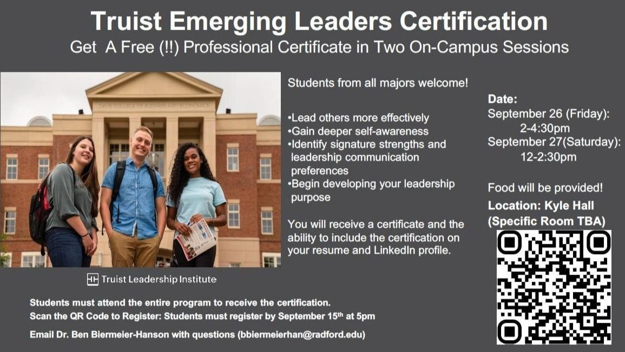

Date:
Subscribe to our email list.

801 East Main Street | Radford, VA 24142 US
September 26 (Friday): 2-4:30pm September 27 (Saturday): 12-2:30pm

Ofﬁce of the Provost Radford University Martin Hall 331
540-831-5404

