

October 27, 2025

Message from Provost Usher

We are past the mid-point of the semester! I love the energy on campus that is really showing how you are helping our students learn in a scholarly environment that is connected to the community. Just last week, I was awed by the Fall Dance Festival, watched Jenny Hall give the second RADTalk, welcomed our nine VCCS partners for the Tartan Transfer Summit, listened to a candidate speak at the Radford Votes Candidate Town Hall, and talked to students about their summer research. I am impressed and proud every day.
Rob Hoover and I wanted to give you an update on the planning for the new Health Sciences Academic Building in Roanoke. The ﬁrst caveat is that we have state support to plan for the building, and we will still have to go back to the state to get the support to actually build. My goal is to have a new building that embodies our approach to supporting a healthy and thriving community by Fall 2030, but realistically, we will likely celebrate a 2031 opening. But, we are making progress.
Facilities Management is taking the lead on the ﬁrst steps, and we are forming two committees to guide the process. The Steering Committee will be small, and will be primarily responsible for setting up meetings and agendas, and serving as the liaison to the University President and the Board of Visitors for major decisions and updates. We will have a larger, representative Building Design Committee that we will be naming soon. The Building Design Committee is "charged with shaping a bold, innovative vision for the Health Sciences Academic Building—one that meets the evolving needs of faculty, staff, and students across academics, research, and operations. With a focus on functionality and future readiness, the committee will ensure the ﬁnal design reﬂects the University’s strategic goals and brings its mission to life through thoughtful, purpose-driven spaces."
Facilities Management has contracted RRMM Architects to evaluate the two possible sites for the Roanoke Health Sciences Building (one on Jefferson and one on Williamson, both close to the current RUC location). The geotechnical drilling has been completed and will inform us about the ability to place a large building on the sites. The surveying of the sites is happening now. The survey study is due in mid-November. Once this study is completed, the Steering Committee will convene with leadership to determine the best location, in consultation with the City of Roanoke and Carilion.
We are in the process of scheduling a meeting with the City of Roanoke, to introduce city ofﬁcials to the project, establish a good relationship, and learn about impactful ordnances. Additionally, we plan to learn about utilities and any related challenges.
Facilities has issued a request for proposals (RFP) from interested architect engineering (AE) ﬁrms, with proposals due in mid-November. Once we have an understanding of the Roanoke perspective

and the complete study mentioned above, we will be able to provide all of that related information to the short-listed AE’s that we plan to interview for the project. The selection of the AE ﬁrm should occur in November/December with contracts awarded before the beginning of the new year.
Starting in the spring with the contracted AE ﬁrm, the Building Design Committee will launch a design process that will include broad stakeholder and community input through a variety of focus groups, interviews, speciﬁc space planning sessions and surveys along with other avenues.
It’s exciting to imagine the future of our impact in Roanoke and the whole region! Thanks for all you are doing!
Bethany

Winter Commencement RSVP and Regalia
Faculty can rent regalia through the Bookstore or purchase custom regalia. The deadline to submit an order for faculty rental regalia is Nov. 1, 2025.
Information about regalia rental

Please let us know if you plan to attend 2025 Winter Commencement on December 12th and 13th. The deadline to RSVP is Friday, November 21.

Winter commencement overview
Please RSVP
Website: Winter Commencement
Schedule of Events: Schedule of Events | Winter Commencement | Radford University

News from the Registrars Ofﬁce

Fall Final Grading Deadline Extended to 5 p.m. on December 15
The fall ﬁnal grading deadline has been extended to 5 p.m. on Monday, December 15th. Please ensure that all ﬁnal grades are submitted by this deadline.
Timely grade submission plays a vital role in ensuring students receive ﬁnancial aid, maintain accurate academic standing, graduate on schedule, and can access ofﬁcial transcripts without delay.
Thank you for your continued effort and diligence in submitting grades on time and helping ensure a smooth ﬁnish to the semester for our students.
Contact registrar@radford.edu with questions.

More information about grading


Final Reminder
Honors Faculty Fellows
The Honors College invites applications from tenured or tenure-track faculty to serve 3-year terms as Honors Faculty Fellows. Two appointments are anticipated to begin in May 2026. These faculty invest additional time with honors students through teaching (typically one honors course per year), honors advising, and participating in honors events. Fellows are supported with funds for one-course reassigned time and a $2500 stipend per year. Additional details can be found at the link below. Inquiries are welcome and should be directed to Niels Christensen, Director of the Honors College (pchristen@radford.edu, x6125).
Application deadline November 1st, 2025
New Fellow terms begin May, 2026

Honors Faculty Fellow Information and Application

Radford’s Mariachi band making news: Radford University's Mariachi ensemble was recently featured on WFXR in a story by Hazelmarie Anderson. Professor Robert Trent and student Wilson Purdue are interviewed here and it is a great look at both the music and the musicians.
See Story Here

The Halloween Spooktacular returns Oct. 30: One of the most anticipated events of the year comes skulking out of the dark forest again, this time with a very hairy attitude. We celebrate werewolves this year, and all sorts of things that go bump in the night. You can check out the trailer here or go to www.radford.edu/spooktacular for more info. The show is FREE and open to the public, but tickets are limited to 325 and it ﬁlls up fast. Doors open at 6:45 p.m., seating begins at 7:00 p.m. and the music begins at 7:30 p.m. There’s trivia, spooky artwork, displays and maybe a few roaming werewolves! (Advisory: The intention is to have fun and the material is generally light, but we do recommend you use PG 13 as a guideline.)

Mid-day Music features Ed Knoeckel on Nov. 5: Join us in the Artis Center atrium for a little mid-day piano music from Ed Knoeckel. The 30-minute concert starts at 12:15 pm. The performance is free, open to everyone and we encourage you to bring your lunch and enjoy.

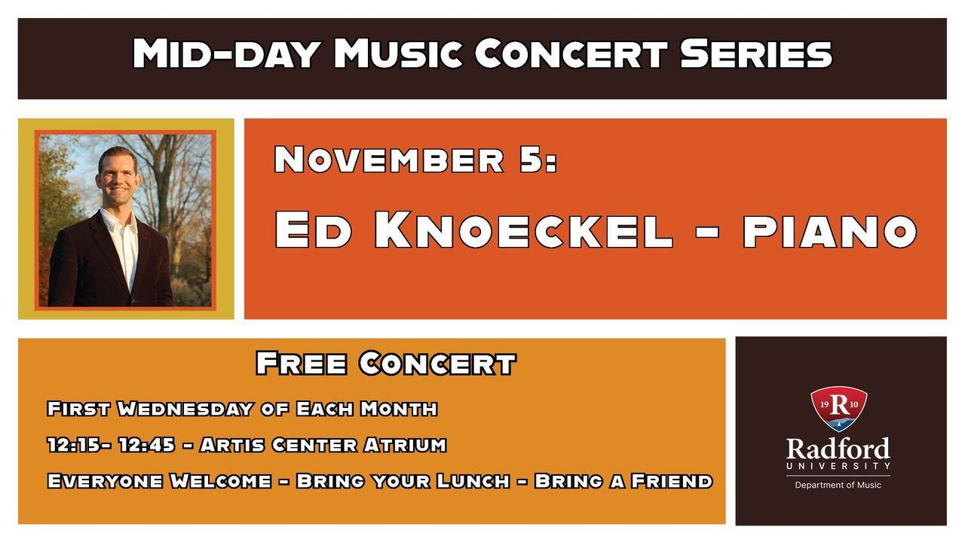


“Stepping Safe: Fall Prevention in Older Adults”
Free Webinar for Students, Faculty, Staff, and Community Members

Panel Guests from MaineHealth's Center for Health Improvement:
Jessica J. Bolduc, DrOT, MSOTR/L, FAOTA | National Fall Prevention Fellow, National Council on Aging Maureen Higgins, MSW, Healthy Aging Project Manager

Session Topics:
- 2025 National Falls Prevention Action Plan
- Community resources that help reduce fall risks
- Evidence-based strategies for assessing and preventing falls in both clinical and community settings

Participants will gain valuable insights into assessing fall risks, promoting safety, and applying practical, research-informed interventions to improve outcomes for older adults.
Date and Time: November 6th, 12pm – 1pm
Link to register: https://radford.zoom.us/meeting/register/hJFCRydkSteL4-vEkPRLYA
This event is part of the Radford University Series on Public Health and Healthcare Leadership.

Find out more about Waldron College of Health and Human Services


Global Faculty Fellow
The McGlothlin Center for Global Education and Engagement (MCGEE) seek applications for one faculty to serve as a Global Faculty Fellow. The selected faculty will assist with increasing the level of engagement of RU faculty in international initiatives, including promoting faculty-led programs, assisting with the development of institutional partnerships, identifying international research opportunities, and others. The faculty will be designated to serve a 2-year term.
The Global Faculty Fellow will be expected to contribute by:

- Engaging with Deans, Academic Chairs and other faculty members to promote and build awareness of the international initiatives available to the faculty at their respective College.
- Participating in faculty events to create awareness about international opportunities for academic collaborations.
- Delivering at least four (4) workshops during the academic year on how to develop international academic collaborations.
- Researching two (2) grant opportunities and identifying the requirements needed to apply.

The Global Faculty Fellow will become especially involved with international education at Radford University, thus gaining a balanced understanding of (1) the challenges facing international students at Radford University that may affect their retention, (2) the challenges and opportunities in establishing international collaborations, (3) the education abroad opportunities (including research) available for Radford University students and its role in the retention of students, and (4) a general understanding of the most important U.S. immigration regulations that govern international students on campus.
In recognition of their service, the Global Faculty Fellow will receive a $2,500 stipend per year.
All candidates for the Global Faculty Fellow appointment are expected to have the following qualiﬁcations:

- Must be in a 9-month faculty contract.
- Tenured or tenure-track faculty status.
- Strong interest and/or experience with international education.
- Willingness to interact with people from the broad spectrum of the campus community (students, faculty, administration, staff, prospective students and their families, and alumni)

Those interested in applying to be a Global Faculty Fellow are encouraged to review the McGlothlin Center for Global Education and Engagement website. Application materials should include the following information:

- A 1-page cover letter that addresses the applicant’s:
- experience with or interest in international education.
- goals for contributing to the international ofﬁce.
- Curriculum vitae
- Brief memos from one’s department chair and one’s dean that indicate the faculty member would be permitted to serve as a fellow if selected.

Applications should be submitted to ibetancourtvelez@radford.edu no later than November 15, 2025. The appointment is expected to being on January 12, 2026.
Any questions about the position should be directed to: Dr. Ismael J. Betancourt Vélez
Assistant Provost for Global Education and Engagement Cook Hall 105
(540) 831-6575


Radford University is excited to offer the Highlander Works Grant Program in Spring 2026. The program offers undergraduate students an opportunity to apply for funding to help reduce the ﬁnancial barriers associated with work-based learning opportunities, including internships, ﬁeld placements, clinicals, etc. Please see the website for eligibility and details.
Application submission for Spring 2026 begins November 1 and closes November 30.

Highlander Works Application

Please visit our training page @ https://www.radford.edu/sponsored-programs/training-and-resources.html, for access to grant writing training materials and additional content provided by the Sponsored Programs team.
SPGM is pleased to offer a series of training modules designed to support you throughout the grant-seeking and grant-writing process. If you would prefer individual training, we welcome you to contact our ofﬁce to schedule a one-on-one appointment.
We hope you ﬁnd these resources helpful. As always, we appreciate your feedback and are committed to providing the support you need to succeed.
The Ofﬁce of Sponsored Programs & Grants Management 232 Cook Hall
831-5479
tcruise@radford.edu



Ask a Librarian 24/7 Research Help via Chat
Make your life easier by getting personalized, one-on-one assistance from a *real human* who is a credentialed librarian! This service is available 24/7 from the comfort of your own ofﬁce (or home, coffee shop, or park bench). Chat is offered by Radford University librarians on weekdays; at other times, including nights and weekends, a librarian from our co-op will be online. If it’s a Radford-speciﬁc question that our co-op librarians can’t help with, they’ll ask for your contact information so that we can get in touch with you the following day.
Click the Ask a Librarian button anywhere on the University Libraries’ website, and you'll get the support you need right away. Please encourage students to try out the service, too!
Some recent reviews of our chat service:
- First time using this service and it was great! Thank you!
- Fantastic Feedback and help!!! Very fast.
- Very helpful and patient.
- Fast, knowledgeable, and super supportive help as always!
- She was super helpful!
- Awesome experience

You can also ﬁnd research help in person at McConnell Library in Radford or the Radford University Carilion Library in Roanoke; by setting up a consultation via Zoom or email; or through our FAQs and LibGuides (Research Skills and Subject Guides). Find all the options on the Libraries’ Research webpage.
Help can include ﬁnding access to a paywalled article, developing a research topic, evaluating sources, ﬁnding an open access textbook or journal, and so much more. Reach out to see if we can offer support for the question that you’ve been thinking about!

We might have your textbook!
You can search for it in the SuperSearch catalog on Radford University Libraries webpage: https://www.radford.edu/libraries/.
Other places to look include the e-Textbooks
webpage: https://www.radford.edu/libraries/collections/e-textbooks.html; and the Course Reserves list quick link on the main
webpage: https://radforduniversity .on.worldcat.org/courseReserves/landing.
And did you know some e-resources in SuperSearch have access notes? In SuperSearch, choose the Notes & License Terms circled on the included screenshot to discover this book has an unlimited number of simultaneous users and perpetual access.

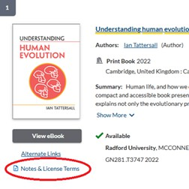


Graduation:
- Ceremony: December 12th, 2025 at 5:00 PM, Bondurant Auditorium
- Graduates & Hooders: Please arrive at 4:00 PM

Celebrating Graduate Faculty & Students
Coves Fellowship
The COVES Policy Fellowship program enables selected fellows to spend 12 weeks advising policymakers and organizations on science and technology issues through placements in Virginia’s various legislative ofﬁces, agencies, and leading companies.

- Nominations Due: November 10th, 2025 [Email Nominations to amanizade@radford.edu]

Outstanding Graduate Student Awards
The Ofﬁce of Graduate Affairs is accepting nominations for the Graduate Student Awards, recognizing outstanding achievement in academics, research, teaching, and professional development.

- Nominations Due: November 17th, 2025
Nominate an Outstanding Graduate Student

Highlander Research Blitz – 3-Minute Research Competition
Students (graduate & undergraduate) showcase their work with just one slide in 3 minutes.
- Interest Meeting: November 5th, 2025 [Meeting via Zoom]

Graduate Research & Scholarly Projects Stories
We are collecting stories of graduate student and faculty conferences, presentations, publications,


or new research initiatives. Please email submissions to gradaffairs@radford.edu.
Subscribe to our email list.

801 East Main Street | Radford, VA 24142 US

Social at Selu - November
Please join us for the last Social at Selu for this semester. November 20, 2025 | 4:30pm - 6:00pm
Snacks, Non-alcoholic beverages, and live music. (Cash bar available) 3215 Dry Valley Road | Radford, VA 24141

Ofﬁce of the Provost Radford University Martin Hall 331
540-831-5404

