

November 10, 2025

Message from Provost Usher

Happy November!
It’s hard to believe that we are already moving into ﬁnal weeks of the semester, and beginning to the culmination of projects. Last week, I was thrilled to attend the largest WickedFest ever, and the ﬁrst that included students from all seven colleges. From a totally subjective perspective, they were also the most professional set of posters I’ve seen. The future of higher education is really about addressing societal challenges, and we are teaching our students to do that. Thanks go to the whole team, including Paige Tan, Joe Wirgau, and Heather Keith, who continue to champion this approach.
I love to see that there are so many things happening in Academic Affairs and across the university. Please star or favorite both the Threads Newsletter on Mondays and the Radford Connected Newsletter on Friday. Consistently, we have heard that communication is a concern, and the President and I, along with the cabinet and Faculty Senate, want to make sure that you are getting the information you need to be informed and participate in the life of our Radford community. We try not to unnecessarily duplicate information across the two so we hope that you are taking the time to review both (and not get bombarded with other “ofﬁcial” emails).
One of the reasons I love working in higher education is that we are scholarly communities with a wealth of activities - and I love learning from you and our students. I try to attend as many things as possible, knowing that there are always events I will have to miss because I cannot create more than 24 hours in a day (that would be my superpower, if I had the opportunity). Please know that I value and see the work of you and your students, even if I can’t get to everything. I know that you face this challenge, too - between classes, and research, and students, and your busy lives beyond Radford, you have to choose what to participate in. As long as everyone picks the opportunities and activities that ﬁts with their individual situation, we will thrive.
My reading has mostly slowed to the Chronicle and the Times, along with my email and policy documents. But, I’ve had to be in the car for a few hours recently, so had the chance to listen to Notes on Inﬁnity, a debut novel by Austin Taylor. The author is a recent graduate of Harvard who participated in research herself, and makes an undergraduate biochemistry project that moves to commercialization central to the plot.
Best of luck for the next few weeks! Because of the Thanksgiving holiday, the next Threads will be published December 1. I hope to see you at many events between now and then - and know that I am thankful for all of you!
Bethany

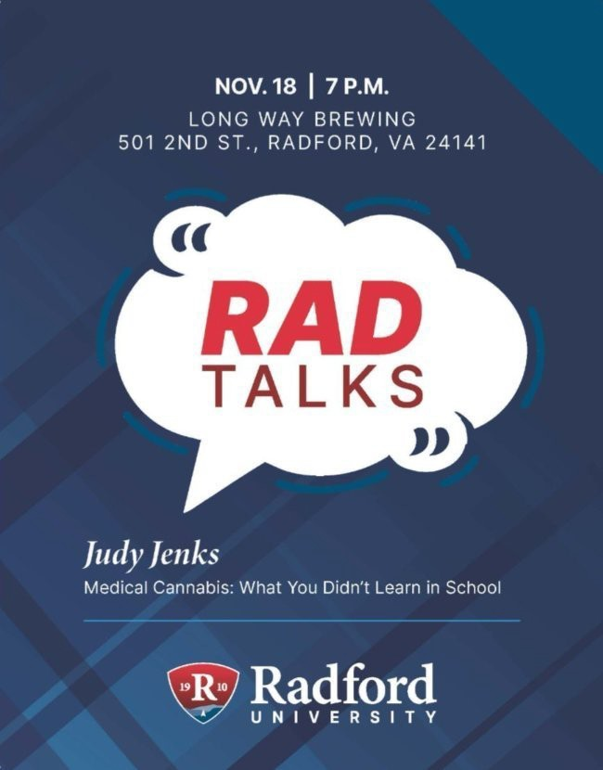
Please join us for RADTalks on November 18, 2025, 7PM, at Long Way Brewing in Radford. Judy Jenks will be our speaker and her talk will be about Medical Cannabis: What You Didn't Learn in School.

RSVP for Commencement
Please let us know if you plan to attend 2025 Winter Commencement on December 12th and
13th. The deadline to RSVP is Friday, November 21.

Winter commencement overview
Please RSVP
Website: Winter Commencement
Schedule of Events: Schedule of Events | Winter Commencement | Radford University


Updates from the Ofﬁce of the Registrar

Graduation application review process and timeline Spring 2026 Graduation Application Preliminary Review:
- Following the graduation application deadline, degree audits are reviewed by the Ofﬁce of the Registrar for each undergraduate student who has applied to graduate to assess whether they are on track to meet graduation requirements or if any potential issues exist.
- Lists of students who are missing requirements or do not appear on track to complete are forwarded to departments and faculty advisors for review and advising intervention. For Spring 2026 graduation, departments and advisors can expect to receive the reviewed lists prior to the end of Fall Semester.
- Graduate Affairs completes graduation applications review and follow-up for Graduate Students.

This timeline is intended to provide sufﬁcient opportunity for advising interventions and to make any necessary schedule adjustments.

Fall 2025 Graduation Application Final Review and Degree Conferral:

- Final review and conferral begins for undergraduate and graduate students immediately after ﬁnal grading and end of term processes are completed.
- Lists of students who are missing requirements are forwarded to departments and faculty advisors for review and advising interventions. For Fall 2025 graduation, departments and advisors can expect to receive lists by the end of January.
- Graduate Affairs completes graduation applications review and follow-up with departments for Graduate Students.

Please contact graduation@radford.edu with questions.

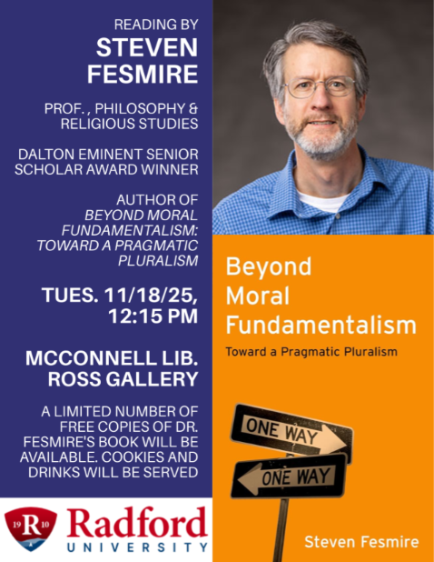
Please join us at McConnell Library's Ross Art Gallery on Tuesday, November 18 at 12:15PM for a presentation from Professor Steven Fesmire. There will be a limited number of free copies of Fesmire's Beyond Moral Fundamentalism (Oxford University Press, 2024) available, thanks to the generosity of the Radford University Foundation and a Dalton Eminent Senior Scholar Award.
The presentation will be about 45 minutes and will include time for questions. Light refreshments will be served.

Learn more about Dr. Fesmire and his book

Free Hearing Screenings for Faculty, Staff, and Students
The Radford University Department of Communication Sciences and Disorders is offering free hearing screenings to faculty, staff, and students during the Fall 2025 semester. Available

appointment times are Tuesdays between 11:00 am-12:30 pm and Thursdays between 1:00-2:30 pm. Each appointment will be about 10 minutes long.
Hearing screenings are a shortened form of an evaluation and while they can determine the potential presence of hearing loss, they do not quantify severity of any hearing impairment.
Please Note: These screenings serve as important clinical education experiences and provide student clinicians with mandated hours and experience toward fulﬁlling licensure requirements to practice as speech-language pathologists. Please keep your appointment or notify the clinic as soon as possible if you are unable to do so. Failure to keep an appointment hinders a students' ability to develop necessary clinical skills needed for graduation and licensure.
To schedule your appointment for a hearing screening or to gain more information, please email our referral line at speech@radford.edu.
The Radford University Speech-Language-Hearing Clinic is located on the ﬁrst ﬂoor of Waldron Hall.

The Dr. Raymond N. Linville Center for Interprofessional Education and Practice and the Waldron College Health Advocacy Committee invite you to join regional health
discussions with Carilion Clinic this week to learn about the latest community health needs assessment results and discuss opportunities for collaboration to improve health and well-being across our region.
Students, faculty, staff, administrators, and community partners are invited to participate in these hybrid events, where Carilion Clinic leaders will highlight priority areas from the Roanoke Valley and New River Valley Community Health Needs Assessments (CHNAs).
We welcome your participation and perspectives as we discuss how interprofessional collaboration, research, community service, and community partnerships can help address key health priorities identiﬁed in these assessments.

Event Details
- Tuesday, November 11, 2025 – Roanoke Valley CHNA Discussion
  - Radford University Carilion (RUC) 3rd Floor Board Room, 12:00–1:30 p.m. EST
  - Zoom Link: https://radford.zoom.us/j/94944383957
  - Password: RValley

Wednesday, November 12, 2025 – New River Valley CHNA Discussion
  - Artis Center Room 312 at Radford University, 12:00–1:30 p.m. EST
  - Zoom Link: https://radford.zoom.us/j/91709338618
  - Password: NRValley
Both sessions will be offered in hybrid format, where you can attend in person or online.

Contact Dr. Jenny Hall with questions

International Education Week

International Education Week (November 17 to 20, 2025) is a national week of the U.S. Department of State and U.S. Department of Education that celebrates the beneﬁts of international education and exchange worldwide.
The McGlothlin Center for Global Education and Engagement invite proposals for events and workshops from students, faculty and staff interested in celebrating International Education week this upcoming November. There are many events that are welcome, including cultural performances, global art exhibitions, guest speakers, global trivia night, and more!
If you would like to participate, please complete the International Education Week Interest Form. If you have any questions regarding International Education Week, please contact:

Adam Russell
International Student and Scholar Services Coordinator Azrussell@radford.edu
Phone: (+1) (540) 831-6574
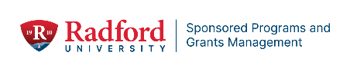

Upcoming Professional Development Opportunities
SAVE THE DATE!
We’re excited to announce two upcoming Zoom webinars presented by Hanover Research on

Friday, January 9, 2026.
These sessions will provide valuable insights into successful grant writing, including:
- How to identify and pursue funding opportunities
- How to communicate effectively with potential sponsors
- Networking strategies and other insider tips of the trade

Registration details and session times are below — you won’t want to miss these informative events!

Webinar #1: The Art of Prospecting
Presented by Hanover Grants Consultant Dr. Joyce Belcher

Friday, January 9, 2026 @ 11 a.m. Eastern
This one-hour session will focus on the art of “prospecting,” or identifying funding opportunities that align with your project. We will include an overview of funding entities and their grant-making programs in addition to a discussion of the different resources available to ﬁnd opportunities.
Register to attend Webinar #1

Webinar #2: Program Ofﬁcer Engagement Presented by Hanover Grants Consultant Paul Tuttle Friday, January 9, 2026 @ 1 p.m. Eastern
Program Ofﬁcers (POs) can act as assets and resources throughout your grant-seeking career. This one-hour training will provide you with information and resources to help you navigate PO outreach and the feedback process more effectively, helping you to develop relationships that will last throughout your research career.
Register to attend Webinar #2

Sponsored Programs & Grants Management Update!
We are pleased to announce, effective 11/1/2025, all new SPGM Seed grant applications will now be submitted using Kuali. SPGM has partnered with IT to create a Kuali form that will hopefully provide a better, streamlined submission process.

SPGM’s Kuali form can be found at: SEED Grant Proposal form [Kuali]
All other requirements of the Seed Grant remain unchanged! However, if you have question concerning this change please contact Tom Cruise, Director of Sponsored Programs, at tcruise@radford.edu


Faculty: Did you assign a project to your students, for which they used University Libraries resources? Each Spring, the Libraries host the Winesett Awards, to recognize creative and original library research completed by Radford University students. Over $5,000 will be awarded in three divisions: lower (freshmen/sophomores), upper (juniors/seniors), and graduate! Class projects completed in Spring 2025 and Fall 2025 are eligible! Submissions will open in Spring 2026.
Meanwhile, interested candidates are encouraged to track their research process for current projects to help with their application.
Save these dates:
- Applications will be due by Monday, March 30, 2026, at 11:59 p.m.
- Awards Luncheon and Ceremony: Friday, April 17, 2026, from Noon-1:30 p.m.
Email Co-Chairs Tony Pepper and Barbara Tait with any questions.

Explore Internship Opportunities with Archives & Special Collections!
Are you passionate about history, storytelling, or digital media? Archives & Special Collections at Radford University offers hands-on internships for students of all degree programs. Gain valuable experience in:

- Digital Archiving: Digitize archival materials and create metadata for the RU Digital Archive.
- Archival Processing: Rehouse historic documents, create inventories, and learn arrangement & description techniques.
- Audio/Visual Projects: Transcribe recordings, edit videos, and contribute to social media outreach.

Whether you're studying history, media, museum studies, or just curious about archival work, this is a great opportunity to build skills and contribute to preserving university heritage.

Learn more about the University Libraries

Outstanding Graduate Student Awards
The Ofﬁce of Graduate Affairs is accepting nominations for the Graduate Student Awards, recognizing outstanding achievement in academics, research, teaching, and professional development.

- Nominations Due: November 17th, 2025
Nominate an Outstanding Graduate Student

Professional Development
Ofﬁce of Graduate Affairs Student Newsletter
Please share our full list of professional development opportunities, community-building events, with your graduate students. For a complete list, direct them to our LinkedIn, or the Professional Development and Events website.

Join OGA and Graduate Students for:
Book Club
Wednesday, November 12th, 2025 | 7:00 PM | Whitt 116 & Zoom [Join via Link] Enjoy discussing How to Take Smart Notes by Sonke Ahrens

Graduate Student Coffee Hour
Tuesday, November 18th, 2025 | 12:00 PM – 1:00 PM | Highlander Hotel
Meet graduate students, program coordinators, and Graduate Affairs with complimentary coffee!

Social at Selu - November
Please join us for the last Social at Selu for this semester. November 20, 2025 | 4:30pm - 6:00pm
Snacks, Non-alcoholic beverages, and live music. (Cash bar available) 3215 Dry Valley Road | Radford, VA 24141
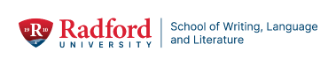


Mark your calendars for the "What is a Veteran?" panel on Monday, November 10th @ 7:00-8:30pm in Hemphill 3012. This particular event—which is a collaboration between the School of Writing, Language and Literature and the Military Resource Center as part of Veterans Week—will feature panelists from the MRC, English, History, etc. We'll explore representation of military service / veterans in popular media (e.g. ﬁlm, television, video games, etc.). Please join us for a timely and thoughtful discussion!
Contact mmarberry@radford.edu for more information.

A Conversation with Ripley Johnson: “Deﬁning Yourself While Being Deﬁned by Others”
Navy veteran, voiceover artist, and writer Ripley Johnson will share his story of navigating identity and self-deﬁnition across gendered expectations. His talk reﬂects on living much of life as a woman in a man’s world—with a man’s mind—and later transitioning to live authentically as a man who wasn’t raised within masculine norms. Ripley explores what it means to adapt, to be perceived, and to hold onto one’s sense of self in a world eager to deﬁne it for you, all without ever losing sight of who you truly are.
The talk will take place in the Andrew Ross Art Gallery of McConnell Library on 11/13 (TH), 3:30 - 5 pm. The sponsoring programs will provide light refreshments.


The talk is sponsored by the Program in Women’s and Gender Studies; the School of Writing, Language, and Literature; the Center for Gender Studies; Connected Communities; and the Military Resource Center.

Institutional Research joins IEQI
After moving into the Division of Finance and Administration 13 years ago, the Ofﬁce of Institutional Research is returning to Academic Affairs. This summer IR merged into Institutional Effectiveness and Quality Improvement, a move that promotes university-wide, strategic use of data.
IR is a team of three skilled and experienced professionals: Eric Lovik, Director; Damien Allen, Associate Director; and Timothy Millard, Assistant Director.
Eric came to Radford in 2015 after serving in IR and IE positions in public and private colleges outside Virginia. His years in the dean’s ofﬁce of the College of Health and Human Development at Penn State focused his interest on IR related work, where he also earned a PhD in Higher Education and a graduate certiﬁcate in Institutional Research.
Damien is a Highlander alum, having earned his bachelor’s degree in Computer Science and Technology here in 2007, so he is “all in” with RU. Damien developed the Electronic Fact Book that is frequently used internally and beyond. He is widely respected as the go-to guy for university data.
Tim joined Radford University as a result of our merger with Jefferson College of Health Sciences in 2019, where he had served as IR director. Prior to that he ﬁlled various IR roles in public and private institutions including George Mason. Tim completed an EdD from the University of Virginia.
We are pleased that the Institutional Research (IR) team has ofﬁcially become part of Academic Affairs at Radford University! This transition strengthens our commitment to data-informed decision-making and continuous improvement across the university.
The IR team provides critical support by collecting, analyzing, and reporting institutional data to guide strategic planning, ensure compliance, and promote transparency. Their expertise will play an essential role in advancing academic quality and student success.
Please join us in welcoming the Institutional Research team to Academic Affairs!

Faculty and staff are welcome to submit data requests with speciﬁc details and expected deadlines by emailing irpa@radford.edu or contacting a speciﬁc IR member.


Recently, students in many lower-division courses were invited to take surveys about their sense of belonging in their classrooms and in Radford University as a whole. Despite some hiccups in the process—apologies to everyone who received more than 5 reminder emails!—we had a stellar response rate of 45%. Belongingness is one of two key goals for RISE. Through intentional engagement in events like Food For Thought-Highlander Pride (CEHD), a chili cookoff (ACSAT), a community art project (CVPA), lunch with your professor (Waldron) and Settle in September (DCOBE), we are sending the message to every student: You are welcome. You're part of our community. You've found your place.
We've heard you about the excessive reminder emails and there will be an improved process for the next round of surveys in Spring 2026. Data will be reported out through your Deans and the Faculty Senate periodically, but you can always reach out to Susan Schoppelrey if you have questions. Thank you to everyone who encouraged their students to take part in this important assessment.
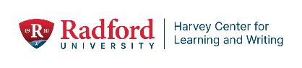

Recommend a student to become a tutor!
The Harvey Center for Learning and Writing is seeking recommendations for tutors! If you have
a student you think would make an excellent tutor, please let us know! Tutors earn $15.00 an hour and receive training, mentorship, and development as they support students.
Visit our website and ﬁll out a quick Qualtrics form with the student’s info and a short note about why you recommend them: https://radford.co1.qualtrics.com/jfe/form/SV_51hﬂW0YNPly Bue
What we look for in our tutors:
Students who make great tutors usually have these traits:
- Have experienced challenges or failure and were willing to learn and improve
- Have a positive orientation towards learning—they are usually excited to learn and excited to help other students learn
- Good social and communication skills—they easily connect with other students and feel comfortable talking about their subject to others

When we are seeking applications for tutors in the subject area you recommended, we will contact the student and invite them to apply. We are sure to let them know that you thought they would make an excellent tutor—this is a conﬁdence boost for so many students!
We anticipate a few openings for the spring and lots more for the fall semester!



Ofﬁce of the Provost Radford University Martin Hall 331
540-831-5404
Subscribe to our email list.

801 East Main Street | Radford, VA 24142 US

