

May 5, 2025

Message from Provost Usher
I am so proud to be at Radford, to have you as my colleagues, and of the education and opportunities we give our students. These past weeks have shown the culmination of the year’s work, and it has been inspiring.
This semester, our Strategic Communications ofﬁce conducted a Brand Perception Research study, following up on one done in 2023*. The goal was to test the effectiveness the two year plan that President Bret put into place to address critical issues, including the re-branding with the "Find Your Place. Here." logo and tagline. It was a well-done, reliable survey and differentiated between several constituent groups. I was heartened to see that over that span, being an affordable college option that focuses on hands-on learning and having a supportive community with small classes outpaced the perception that we are a party school. Maybe we're just redeﬁning fun as experiential learning!
I was a little concerned to see the data about Faculty perception of Radford's quality. As you see here, we've deﬁnitely improved since 2023. But faculty still lag between every other group in recognizing what an excellent university we are. On reﬂection, though, I realized that it's a kind of imposter syndrome that makes it hard to identify that others perceive you are excellent.

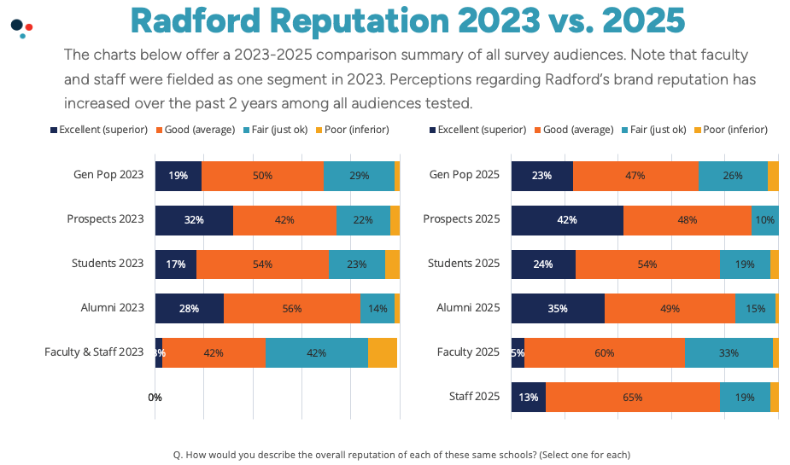
We need to change that mindset, and have you see what the alumni, the students, and the community see in us. My privileged view shows me how you all are excelling according to your own strengths and in ways appropriate to your roles and disciplines. This newsletter highlights the breadth of successes, for faculty and our students.
As you charge on through exams (and I see you working to keep students here and active through exam week), and then get to celebrate graduation at the end of next week, look around to recognize the strengths of your colleagues and students. Celebrate how we have come together to teach and support these students, and to improve Radford.
And, be thinking forward to our bumper crop of eager new Highlanders in the fall. Late breaking data shows we exceeded last year's number of deposited students at the May 1 deadline, and retention is trending high, too!
In appreciation for all you do, Bethany
*Note that the extensive slide deck report is available from your deans and from Faculty Senate, if you want to see all the details. It isn’t published on the web because it is proprietary brand and marketing information, and we appreciate your upholding that integrity by not sharing or posting.



Faculty Award Winners Named
The Faculty Awards Ceremony was held on April 30. We would like to congratulate all of our award winner for 2025!
Distinguished Service Award - Dr. Luke Liska, Assistant Professor of Marketing
Distinguished Faculty Advising Award - Dr. Stockton Maxwell, Professor of Geospatial Science
Distinguished Creative Scholar Award - Ms. Amy VanKirk, Associate Professor of Dance
Award for Administrative and Professional Excellence - Ms. Elizabeth Costa, Associate Director for Student Engagement in Roanoke
Anna Lee Stewart Award for Contributions to Faculty Development - Dr. Samantha Blevins, Instructional Designer and Architect in the Center for Teaching and Learning
Donald N. Dedmon Distinguished Teaching Professional Award - Dr. Karen Powers, Professor of Biology
Dalton Eminent Scholars, Rising Star - Dr. Lindsay Semprevivo, Assistant Professor of Criminal Justice
Dalton Eminent Scholars, Senior Scholar - Dr. Sarah Capello, Associate Professor in the School of Teacher Education and Leadership
Dalton Eminent Scholars, Senior Scholar - Dr. Eunyoung Lee, Professor of Nursing
Dalton Eminent Scholars, Senior Scholar - Dr. Jennifer McDonel, Associate Professor of Music and Associate Director of OURS

Faculty Professional Development Leave Program participants for 2025-26

David Anderson Shala Cunningham Zehui Dai | Karen Douglas Thomas Duncan Tiesha Martin | Michael Meindl Tara Pelletier Paul Thomas
Karen Douglas | Million Dollar Circle Awardees | Darren Minarik

 | Seed Grant Awardees
Andrea Barrick | Jamie Lau | Tara Pelletier
Melissa DeBiasse | Michelle Lenhart | George Philippi
Anthony Guidone | Tiesha Martin | Mengyang Zheng
Naveen Jospeh | Michael Meindl
 | External Grant Awardees
Elizabeth Altieri | Anthony Graham | Karen Powers
Krystina Angelini | Diane Hodge | Allison Pratt
Jeff Aspelmeier | Annemarie Horn | Carrie Sanders
Guy Axtell | David Horton | Ryan Sincavage
Kim Baskette | Whitney Idol | Sarah Smidl
Dannette Beane | Charlie Jewell | Matthew Smith
Tom Bennett | Sallie Beth Johnson | Shawn Smith
Virginia Bussey | Richard Joyce | Karen Stinson
Jared Caughron | Heather Keith | Lee Svete
Tim Channell | Solitaire Kelley | Paige Tan
Joseph Chase | Nancy Loosle | Tay Tan
John Steve Childers | Brian Lusk | Cora Taylor
Brandon Cohen | Stockton Maxwell | Erica Thornton
Melinda Cruz | Glen Mayhew | Tim Thornton
Shala Cunningham | Leslie McArthur-Fox | Prem Uppuluri
Jason Davis | Steven McBride | Tamara Wallace
Melissa DeBiasse | Peter McCann | Chester Watts
Karen Douglas | Michael Meindl | Eric Williams
Emily Dove | Jeanne Mekolichick | Sam Williams*
Matt Dunleavy | Peter Meulenbroek | Joseph Wirgau
Andrew Foy | Darren Minarik | Mingyang Zheng
Pam Fraiser Sharon Gilbert | Kathleen Pierson Jeff Pittges | *Student Awardee
Faculty Awards Ceremony Program

Radford Advances to the Championship for Blue Ridge Outdoors' Top Adventure College

Tournament!

Championship: April 30-May 6
FINAL ROUND IS LIVE...VOTE NOW!

Spring 2025 Undergraduate Commencement Ceremony

Please help us celebrate our graduates by participating in the upcoming Undergraduate Commencement Ceremony on Saturday, May 10, at 10 a.m. on Moffett Lawn.

Visit the Commencement webpage to learn more about the ceremony. In particular, please see the Commencement Map for entry points into Moffett Lawn.
NEW Commencement Security Measures Including the university's clear-bag policy

Thank you for all your work in supporting our students’ academic journeys and getting them to this important milestone.

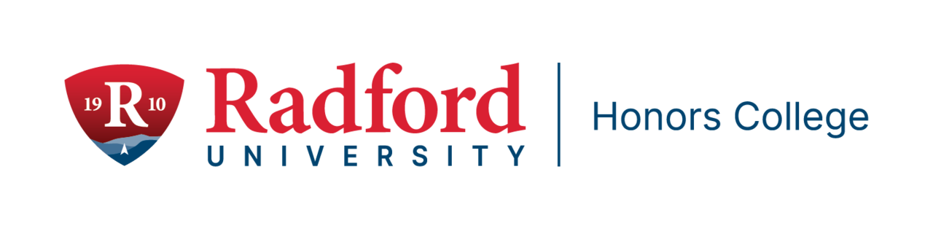

2025 Honors College Medallion Ceremony
Forty-eight graduating seniors will be recognized at the 2025 Honors College Medallion Ceremony on Friday, April 9th at 11am in the Davis Performance Hall of Covington Center. These students completed either 27 credit hours of honors work (Highlander Honors Scholar) or 15 credits of hours (Highlander Honors Distinction), including the execution and presentation of an honors capstone project in their major. Family, friends, faculty, and the campus community are invited. Reception to follow in the Scartelli Atrium.

Sponsored Programs and Grant Management
Are you interested in writing a grant? The federal government is not the only entity that provides grant opportunities supporting research, scholarship, or creative activities. With the uncertainty of the federal grant funding, it is really important to understand other avenues of funding. Our colleagues at Hanover have launched a Non-Federal Funding Resource Site that will equip you with tools to thrive in this ever changing environment. Non-Federal Funding Resource
Site features recorded webinars, practical guides, as well as prospecting resources for non-federal funders. To login, please contact Tom Cruise in Sponsored Programs at tcruise@radford.edu

Faculty Professional Development Leave Program
For tenured faculty who are eligible,
The Radford University Faculty Professional Development Leave Program (FPDL) is an opportunity for you to broaden your professional horizons and develop new teaching and research perspectives. The University has supported numerous faculty over the years, so we would like to encourage you to explore this option. More information about the application form and instructions for the 2025-2026 program will be posted on SPGM’s website very soon! Until then, if you are eligible to submit and have questions about the program please feel free to reach out to Jeanne Mekolichick or Tom Cruise.

Research Compliance Ofﬁce
Are you planning your next research project that involves either Human Subjects or Animals and need help submitting your protocol on IRBManager? Please reach out to Ricky Calderon our




Research Compliance Coordinator and she will help guide you through the process. Ricky can be reached at irb-iacuc@radford.edu or by extension 5290.
Subscribe to our email list.

801 East Main Street | Radford, VA 24142 US

Graduation Hooding Ceremony Events

Thursday May 8th 3:00 pm. Dedmon Center – Practice Day

Hooding Faculty Walk-Through. We encourage all hooding faculty to attend the practice session as we prepare for the Graduate graduation ceremony on May 9th. We will show you where you and your students will be lining up and we will practice the hooding process. Please reach out with any concerns you may have.

Friday May 9th 5:00 pm. Dedmon Center – Graduation Day

We request that graduating students and the hooding faculty arrive at the Dedmon Center at 4:00 pm to line up. We will have signs to help you navigate the site and people available to help you. We are happy to support you and your students on this celebratory occasion.

Building Our Community

Graduate Student Coffee Hour – FREE Coffee
May 5th Graduate Student Coffee Hour at the Highlander Hotel, 12 – 1. Come and Join Us!

Ofﬁce of the Provost Radford University Martin Hall 331
540-831-5404

