

March 9, 2026

Message from Provost Usher

Welcome back from Spring Break! Last week started with snow and ended with me literally watching the redbud outside my ofﬁce (on Main between Center for the Sciences and Martin) bloom on Thursday. I hope that you had the chance for some rejuvenation over the break, whether that was leading students on one of the fabulous spring break research and service trips or just catching up on grading and prep for the second half of the semester.
I spent part of the week at a seminar on AI for provosts at regional universities. It was fascinating and a little mind-blowing. What I learned is that most people know about “AI” in concept but don’t fully understand it or know about its positive or negative potential. I came away realizing that as a university, we have a responsibility to a) learn how AI and other emerging technology can be a tool to augment and support teaching, learning, and research; b) continue to use the liberal arts, humanities, inquiry, critical thinking, and information literacy as the basis of judiciously and humanely implementing AI tools.
Because most of us began our scholarly work before these tools were available, and we need to prepare our students for a world where most employers are expecting students to “use AI” (even if the employer doesn’t exactly know what that means), we’ll continue to work (through the AI Task Force) to offer professional development opportunities to you. In fact, if you want to test our trial of Boodlebox, please reply to this email and we will send you a registration link and some training materials.
Tomorrow, on March 10, Radford University will celebrate our 116th anniversary. I think it’s terriﬁc day to eat a cupcake, blow up balloons, or raise a toast!
I look forward to seeing you all in these brighter, warmer days and at all the events that are coming up as we celebrate our community through the end of the semester!
Thanks, as always, for all you do. Bethany

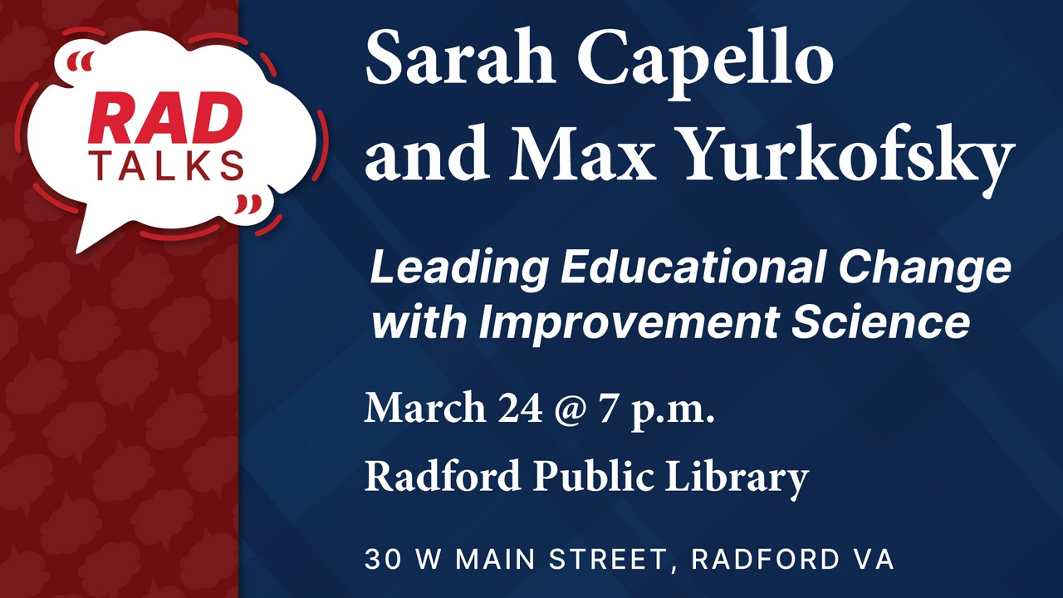
Join us for RAD Talks
With Sarah Capello and Max Yurkofsky
Leading Educational Change with Improvement Science
March 24, 2026 at 7pm Radford Public Library


Streamlined Transfer Credit Evaluations
The Ofﬁce of the Registrar is now the central point of contact for all transfer credit evaluations for new and continuing students. To support Radford
University’s commitment to being transfer-friendly, the Ofﬁce of
the Registrar has implemented new software to streamline and expedite transfer credit evaluations. Registrar staff continue to review each transcript and apply existing policies and equivalencies; credit policies and equivalency approval process remain unchanged. Centralizing evaluations in the Ofﬁce of the Registrar helps to create a more seamless transfer evaluation experience for students.
For questions about how your transfer credits were evaluated, contact transcripts@radford.edu. For questions about transcript receipt or submission, contact the Ofﬁce of Admissions.
Find out more about Transfer Credit Policies



Maker Mondays: Lunch, Craft, and Connect
Looking for a creative start to your week? Join us for Maker Mondays, a lunchtime make-and-take meet-up for Radford faculty, staff, and students. Bring your lunch, work on a craft, and enjoy relaxed conversation with fellow makers while learning something new. During the month of March, we’ll be creating a SPRING BASKET made from a cardboard box and two upcycled t-shirts—a fun project that combines creativity and sustainability. Our sessions will be from 12pm - 1pm in the CITL ilab (McConnell 231).
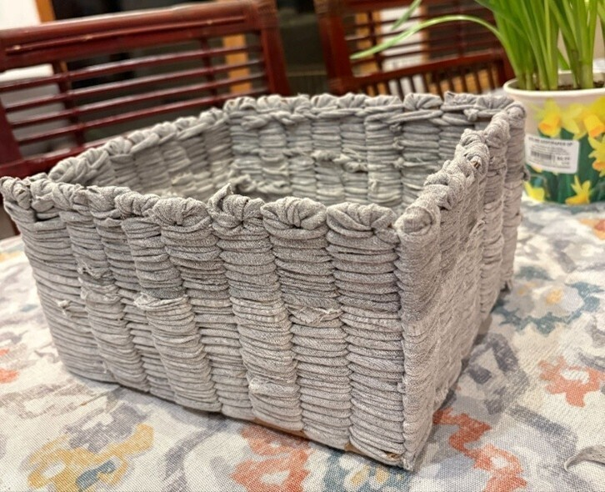
- March 16 (making t-shirt yarn)
- March 23 (preparing the box loom and beginning the weaving)
- March 30 (weaving and ﬁnal touches).

Attending all three sessions is encouraged, but video instructions will be available so you can catch up if you miss a session. Registration is required and space is limited, so sign up and join us for a creative lunchtime community!

Radford University faculty are invited to join a four-session Professional Learning Community (PLC), Supporting Neurodiverse Learners in Higher Education. This lunchtime series will explore how evolving understandings of neurodivergence can inform inclusive teaching practices while maintaining academic rigor. Through guided dialogue and reﬂection, participants will examine these topics:

- Understanding neurodivergence and dysregulation in higher education (March 20, 12–1pm, Young Hall 221 or Zoom);
- Designing classroom structures that reduce dysregulation before it occurs (April 3, 12–1pm, Young Hall 221 or Zoom);
- Responding to dysregulation through de-escalation and co-regulation strategies (April 10, 12–1pm, Young Hall 221 or Zoom); and,
- Supporting diverse learners across learning environments such as labs, clinics, and internships (April 23, 12:30–1:30pm, CITL iLab McConnell Library 270 or Zoom).

Each session is anchored by a short article, podcast, or video that participants engage with between meetings, allowing our time together to focus on application to your own courses and policies. This is a bring-your-own-lunch series designed to foster thoughtful, collegial conversation. Registration is now open—join us to explore practical strategies for supporting neurodiverse students while strengthening learning environments for all. Click here to register. Contact Tracy Kwock (tkwock1@radford.edu) with questions.



Free Textbook Savings
Radford students saved $83,000 on textbooks during the Spring 2026 semester by utilizing 94 new and repeat e-textbooks purchased by Virginia’s Academic Library Consortium, VIVA. This partnership with Radford University Libraries and the Highlander Bookstore continues to expand affordable access to course materials.
Explore Radford University Libraries e-textbook options

College Life in Virginia During World War II
Join the Radford University Libraries on Thursday, March 26 from noon to 1:00 p.m. in the 3rd Floor Board Room at RUC as we welcome Jim Triesler, Director of Education at the Virginia War Memorial in Richmond to College Life in Virginia During World War II. During the weeks following the attack on Pearl Harbor, Radford College adapted to war. As food rationing was instituted, students created a cookbook featuring sugarless desserts made with sugar substitutes. Under the leadership of Radford’s librarian, they participated in the national Victory Book Campaign to collect ten million books for military personnel. All the while, students studied, attended movies and dances, volunteered in hospitals, got married, wrote letters, entered the workforce, and strived to preserve our way of life. Lunch will be provided.


JOIN US FOR
International Culture Night
March 12th 2026 at 5:30PM - Kyle Hall 340

Passport Ofﬁce on Campus
The McGlothlin Center for Global Education and Engagement is an approved passport acceptance facility by the U.S. Department of State. We accept applications for new passports (no renewals) and

offer passport photos. For more information on how to obtain your passport, please visit our website. You can also contact us at globaled@radford.edu.

Faculty-Led Study Abroad Program Applications Now Open
Applications are now open for faculty interested in developing a faculty-led study abroad program for Spring 2027 or Summer 2027. The McGlothlin Center for Global Education and Engagement will have an information session via Zoom on Tuesday, March 24th at 3:00pm. The Zoom link is: https://radford.zoom.us/j/94721427198. Those unable to attend are encouraged to contact Dr. Ismael Betancourt for an appointment.
Leading a group of students abroad is a great experience for professional development for faculty. It also helps students by developing critical skills like adaptability, intercultural competence, and independence. Students often gain a global perspective, broaden their career networks, and experience academic, cultural, and social development that prepares them for a globalized world.

Fulbright Program – Faculty/Scholar Opportunities
The Fulbright U.S. Scholar Program's 2027-2028 competition is now open! Consider advancing your faculty professional development by applying to one of the many prestigious Fulbright opportunities. Types of awards include:

- Fulbright Scholar Awards
- Fulbright Distinguished Scholar Awards
- Fulbright Postdoctoral Awards (for recently graduated scholars)
- Fulbright International Education Administrator Awards

From March to August the Fulbright ofﬁce will be offering a suite of webinars and ofﬁce hours to showcase country and discipline-speciﬁc awards while answering applicant questions. They have consolidated and updated the application steps and requirements and recommend bookmarking this page for easy reference. The deadline is Tuesday, September 15, at 5pm Eastern Time.
The Fulbright U.S. Scholar Program offers over 400 awards in more than 135 countries for U.S. citizens to teach, conduct research and carry out professional projects around the world. College and university faculty, as well as artists and professionals from a wide range of ﬁelds can join over 400,000 Fulbrighters who have come away with enhanced skills, new connections, and greater mutual understanding.
Please contact Dr. Ismael Betancourt, Assistant Provost for Global Education and Engagement, at ibetancourtvelez@radford.edu with any questions.

Highlander Center for Character and Public Impact
VA250 Public Square Debate at Radford University! Join us for this "Braver Angels" style debate on Monday, March 16 at 6:30 in the Bonnie Auditorium. Radford is one of a few colleges across the Commonwealth hosting a Public Square Debate in which audience members will debate the resolution "The American Dream is Alive and Well." This event is open to the public and is co-hosted by the Political Science Department, New River Community College, and the Highlander Center for Character and Public Impact. A dessert reception will follow. Please invite students to this leadership opportunity!

Join us as an Elevate Research Faculty Fellow!
Are you interested in incorporating an undergraduate research or creative inquiry project in one of your 26-27 courses? Would you like to partner with a talented undergraduate student to be a research mentor for students in your classes? Are you looking to decrease DWF rates in a class?
Seeking to infuse develop career competences in a particular course? Join the Elevate Research Program!

- Receive $1,000 stipend or budget transfer to your department for your professional development
- Participate in a four-week (mostly asynchronous) summer institute on redesigning your course for a career-connected undergraduate research project
- Learn how to implement an evidence-based pedagogical approach to decrease DWF rates
- Partner with a paid student who will act as a mentor to students in your course (in either fall 2026 or spring 2027)
- Meet other faculty passionate about undergraduate research

State your interest here by March 12. Contact Heather Keith (hkeith1@radford.edu) for more information.

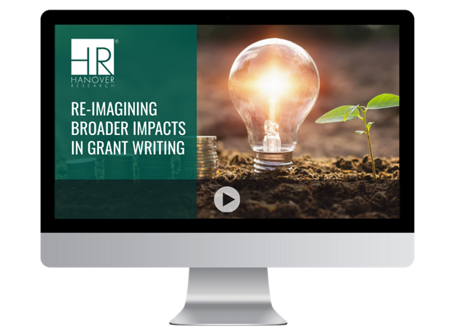

*UPCOMING* Re-Imagining Broader Impacts in Grant Writing
March 26, 2026
The articulation of broader impacts remains a critical component of federal grant proposals, but recent policy changes have signiﬁcantly reshaped how applicants should approach this aspect of their proposals. This session will present strategies for designing and communicating broader impacts that align with current federal priorities, including practical ways to demonstrate project relevance and impact for a wide audience.

Registration Link

Abstract Deadline Extended - 2026 Waldron College Interprofessional Symposium
The deadline to submit abstracts for the 2026 Waldron College Interprofessional Symposium has been extended to Wednesday, March 11th at 11:59 PM (EST).
The Symposium will take place on Thursday, April 9th at the Artis Center and will bring together students, faculty, and staff from across disciplines to share research, teaching innovations, community engagement initiatives, and emerging ideas related to health and human services.
Abstract submissions are welcome for poster presentations, roundtables, and workshops. Interprofessional and interdisciplinary projects are encouraged.
For questions or more information, please contact Dr. Jenny Hall at jlhall2@radford.edu

Submission Information

Important Dates & Opportunities – Spring 2026
- Fast Track Spring B:
  - Last Day to Add/Drop: March 13, 2026

Graduation:
  - Application Due: March 16, 2026

Celebrating Graduate Faculty & Students
Outstanding Student Award Applicant Information
Applications for the Outstanding Graduate Student Award are now closed. Winners will be announced on March 20, 2026, with additional information about the award ceremony to follow. For more information, please contact OGA Graduate Assistant Adriana
Garcia at agarcia37@radford.edu.

Highlander Research Blitz – A 3-Minute Thesis Competition
Students (graduate & undergraduate) showcase their work with just one slide in three minutes. The HRB application has closed. The event will take place from 5:00 PM to 7:30 PM on April 1, 2026, in 1016 Hemphill Hall. For more information on this event, please check out the HRB website or contact OGA Faculty Fellow Dr. Paige Tan at etan3@radford.edu.

Professional Development Graduate Student Travel Funds
OGA has funds available to support students traveling to present research at conferences. Direct your students to apply here.

Graduate Research & Scholarly Projects Stories
We are collecting stories of faculty and graduate student conferences, presentations, publications, and new research initiatives. Please email submissions to gradaffairs@radford.edu.

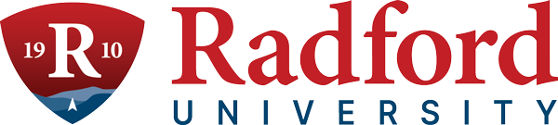
Ofﬁce of Graduate Affairs Student Newsletter
Please share our professional development opportunities and community-building events with your graduate students. For a complete list, direct them to our Graduate Student
Newsletter, LinkedIn, or the Professional Development and Events website.
Ofﬁce of the Provost Radford University Martin Hall 331
540-831-5404
Subscribe to our email list.

801 East Main Street | Radford, VA 24142 US

