

March 24, 2025

Message from Provost Usher
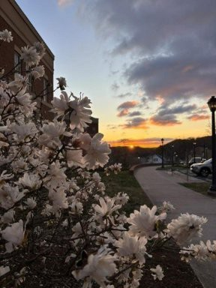
Dawn by Davis College

Happy Spring!
On Thursday and Friday, the Board of Visitors held our Spring meeting, and I wanted to update you on several important Academic Affairs items from that meeting. But ﬁrst, I wanted to give you all kudos. Academic Affairs was the star of the show. We started the meeting with a tour of the Artis College of Science and Technology, with faculty and students showing off their projects. The BOV members were so impressed! During our presentation, every one of the metrics we are using to talk about improvement in Academic Affairs and Student Success from the President’s two year plan is moving in a positive direction, from retention to success in lower division classes to the percent of classes meeting enrollment targets.
I don’t want to bury the lede. The board unanimously approved our items! The ﬁrst, academic promotions, is a “notiﬁcation item,” but they commended the promoted faculty (listed below). The BOV approved tenure for the thirteen recommended faculty(also listed below). Tenure is a shared commitment by faculty to Radford University, and by Radford to our exemplary faculty, and I am

proud of the newly tenured faculty and their investment in our community of scholars! The BOV also approved submitting the new MS in Clinical Psychology for SCHEV approval.
I thank the entire Academic Affairs community, from the faculty who put together excellent promotion and tenure packages, to the Personal Committees, and to Chairs and Deans who do all the reviews and letter writing. Thanks, too, to the curriculum committees and Faculty Senate for their work.
Two other important items were passed by the BOV. They voted to increase tuition and fees by a modest amount that helps us maintain affordability while essentially allowing us to keep pace with inﬂation (and cover the 3% raise and proposed 1.5% state bonus for employees).
We discussed raising the credit window from 15 to 18 credits for undergraduate students, and the board was supportive. However, because of the substantial cost, this will be offered starting in Fall 2026 so that we can build it into our next budget.
The BOV also passed a resolution that afﬁrmed our commitment to being an inclusive university community, while recognizing our support for offering an “environment free from discrimination for every student.”
Note that you can access all the board materials, including the Academic Excellence and Student Success and the Business Affairs presentations. The minutes, including the resolutions, should be posted soon.
I know that the academic world, both at Radford and nationally, is unsettled right now. I will be holding several Lunch and Learns sponsored by CITL (see below for dates in Radford and Roanoke). Please note that these are informal, in-person events with no reservations needed. Please feel free to bring your lunch and ask me anything (I may or may not have answers). And if you don’t have any questions, please just come and keep me company!
I appreciate that as an academic community, we are working together to make Radford shine. Bethany

Congratulations Faculty!!

Information Item: 2025-2026 Faculty Promotions

Artis College of Science and Technology Christopher Monceaux (Chemistry), Professor Sandra Liss (Physics), Associate Professor Andrew Ray (Computing/Info Science), Professor Jobriath Kauffman (Mathematics & Statistics),
Assistant Professor
Matthew Close (Biology), Professor
Laura Gruss (Biology), Professor

College of Humanities and Behavioral Sciences Laura Vernon (Writing, Language & Lit), Professor Justine Jackson Stone (Writing, Language & Lit), Senior Instructor
Roberto Santos (Criminal Justice), Professor Riane Bolin (Criminal Justice), Professor Dayna Hayes (Psychology), Professor
Daniel Berry (Psychology), Associate Professor
Samuel Jennings (Communication), Professor

College of Education and Human Development Darren Minarik (Teacher Education and Leadership), Professor
Bethany Lanier (Counselor Ed), Associate Professor

College of Visual and Performing Arts Amy VanKirk (Dance), Professor Jennifer McDonel (Music), Professor Jimmy Ward (Theatre), Professor
Bruce Parsons (Design), Associate Professor

Davis College of Business and Economics Thomas Duncan (Economics), Professor Michael Chatham (Accounting, Finance & Information Systems), Professor
Yiwen Li (Accounting, Finance & Information Systems), Associate Professor
Benjamin Biermeier-Hanson (Management), Associate Professor

Waldron College of Health and Human Services Kimberly Baskette (RUC Public Health & Healthcare Ldshp), Associate Professor
Thomas Castor (RUC Public Health & Healthcare Ldshp), Associate Professor
Rebecca McIntyre (RUC Public Health & Healthcare Ldshp), Associate Professor

Carey Peerman (RUC Public Health & Healthcare Ldshp), Associate Professor
Jacob Elias (RUC Public Health & Healthcare Ldshp), Associate Professor
Philip Mongan (Social Work), Professor
Sarah Rakes (Social Work), Associate Professor Stephen Glass (RUC Physical Therapy), Associate Professor
Renee Huth, (RUC Physical Therapy), Associate Professor
Kevin Parcetich (RUC Physical Therapy), Associate Professor
Kenneth Gentry (Occupational Therapy), Associate Professor
Chase Poulsen (RUC Respiratory Therapy), Professor
Sara Nicely (RUC Physician Assistant). Professor

Board Action Item: 2025-2026 Tenure Recommendations

Artis College of Science and Technology
Sandra Liss (Physics)

College of Nursing Sara Brown(Nursing) Carey Cole (Nursing)
Davis College of Business and Healthcare Leadership)
Economics Sarah Rakes (Social Work)
Yiwen Li (Accounting, Finance & Info Stephan Glass (Physical Therapy) Systems) Kevin Parcetich (Physical Therapy)
Kenneth Gentry (Occupational
Waldron College of Health and Therapy)
Human Services Chase Poulsen (Respiratory Therapy)

College of Visual and Performing Arts
Bruce Parsons (Design)
Kimberly Baskette(Health & Healthcare Leadership) Thomas Castor (Health & Healthcare Leadership) Rebecca McIntyre (Health &
Sara Nicely (RUC Physician Assistant)


Radford
UNIVERSITY
Center for Innovative Teaching and Learning

Lunch and Learn
with Provost Bethany Usher
Drop in to ask questions and engage in conversation about University initiatives and national conversations.
Feel free to bring your own lunch. No registration or RSVP needed.
Main Campus McConnell ILCB (3rd ﬂoor) | April 7 | Noon Main Campus McConnell ILCB (3rd ﬂoor) | April 22 | Noon RHEC Room 501E | April 16 | Noon
RUC Board Room | May 1 | Noon

Provost's Speaker Series with Sallie Beth Johnson
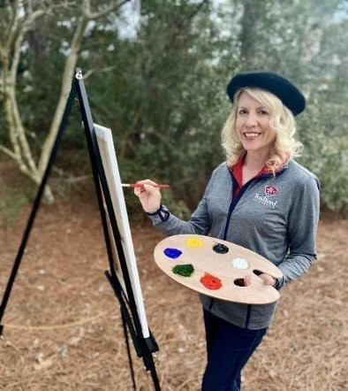
A Picture of Health: How We Create Thriving Communities Together

What makes a community healthy? It’s more than healthcare—it’s shaped by many factors, such as the air we breathe, food we eat, places we live and work, and relationships we nurture. Everyday forces shape our well-being, determining whether we thrive or struggle with chronic disease—a leading cause of death and disability in the United States.

On Earth Day, please join Dr. Sallie Beth Johnson, Chair of Radford University’s Department of Public Health and Healthcare Leadership, at the Taubman Museum of Art, for an engaging talk on the art and science of health behavior change. Drawing on her 25 years in community health, she will share insights from research and real-world examples of how communities in Virginia are improving health through programs, policy, and partnerships.
Included with the talk will be a faculty and student photo exhibit showcasing the often-overlooked ways our surroundings promote health. Whether you're a student, professional, or community member, take this opportunity to connect, collaborate, and paint a healthier, thriving future together.

April 22, 2025 7:30pm
Taubman Museum

The AI Community of Practice...
...invites you to four presentation/discussion sessions in March and April to help you navigate the complexities of AI use in your research and teaching. Each presenter/facilitator will discuss an AI topic for 20 minutes and then will open the rest of the time for questions and discussion. The purpose of these sessions is to share knowledge and experiences, learn new things that can improve your practice, and discuss timely issues and support one another. All sessions will take place in Zoom and will be recorded.
March 25, 12:00 p.m.: Diana Willeman-Buckelew (Associate Professor, RUC-Public Health/Healthcare Leadership) will share what she learned at a recent Online Learning Consortium conference about the use of AI in online teaching and learning environments and what she is implementing and experiencing in her own online classroom.
April 2, 2:00 p.m.: Joanna Hunter (Associate Professor, Sociology) will discuss the various AI detectors available for our use; share her experiences using them; and offer recommendations, tips, and cautions.
April 8, 3:00 p.m.: Amelie Smucker (Assistant Professor, Teacher Education & Leadership) will discuss how to leverage AI in our teaching through case studies, simulations, and lesson planning.


Please join students, staff, and faculty for an open discussion at RUC of: “Are social assistance programs like Medicaid a human right? Are they serving everyone equally?“

Tuesday, March 25, 11-12
RUC classroom 617
Coffee, tea, and bakery snacks will be served!

Common Grounds events are aimed at building our community's capacity to converse and collaborate across differences. This series is sponsored by the Civil Discourse and Freedom of Expression Working Group and hosted by the Healthcare Ethics class.

Common Grounds events are open to anyone in the Radford University community.


ACSAT - Radford University Scholarships

Waiting for Christine Hermann to give me more information...

As part of the registration for the Blue Ridge Highlands Science Fair, students got to select if they would like to be considered for a Radford University scholarship. This Science Fair encompasses 16 counties in Southwest Virginia. The judges select the award winners by looking at the students research and their in-person interviews.
The two top projects get an all expense paid trip to the International Science and Engineering Fair, which is held in Columbus, Ohio in May.
The winners of this years scholarship are:

Larah Clemons
The Effect of Mass Distribution in a Rotating Mass Wave Energy Converter Southwest Virginia Governor’s School
Sponsor: Matt Frazier

Sage Lahmers
Symbiotic Strength: Evaluating Mycorrhizal & Nitrogen-Fixing Inﬂuences on Plant Fitness Blacksburg High School
Sponsor: Katharine Davis

Learn more about Radford University's Science Fair

Explore Exciting Science Fiction and Fantasy Books at the Radford University Libraries!
The Radford University Libraries are making it easier than ever to explore our collection to ﬁnd your next exciting science ﬁction or fantasy read!

You can browse our online catalog to discover a selection of science ﬁction and fantasy books available to check out at McConnell and Radford University Carilion libraries. We have also added stickers to the spine of each book, so you can easily ﬁnd these books in our collections.
Dive into beloved classics like Suzanne Collins’ Hunger Games series, or get lost in the latest releases from Cassandra Clare, Ta-Nehisi Coates, and many more. You will ﬁnd books for adult readers at Radford University Carilion Library, and books for everyone from juvenile and young adults through adult readers at McConnell Library.
Visit our libraries online or in person and let your next great adventure begin!
Online Catalog

Graduate Affairs

Award Celebrations

Second Annual Highlander Research Blitz Competition
Date: April 2, 2025
Time: 5 – 7:30
Location: 125 Russell Hall
Graduate student awards: 1st place $750, 2nd Place $500, 3rd Place $350.
The Graduate Affairs Ofﬁce with OURS is hosting the Highlander Research Blitz. Two separate categories: Undergraduates and Graduates.

We hope to see you there!
Outstanding Graduate Student Awards Celebration
Date: April 18, 2025
Time: 11 am – 1 pm Location: The HUB
One award of $750 will be presented in each of the following ﬁve categories:
- Graduate Student
- Doctoral Student
- Graduate Assistant
- Graduate Teaching Assistant
- Graduate Teaching Fellow

Join us as we celebrate our outstanding graduate students!

Professional Development Opportunities
Self-Care Book Club Series: Daring Greatly by Brene Brown
Led by Dr. Nadine Hartig, nhartig@radford.edu.
Wednesday, March 26, 2025; 12:00–1:00 p.m. (In-Person)

Whitt Hall 116 (In-Person)
Wednesday, March 26, 2025; 4:00–5:00 p.m. (Online)
Zoom Link: https://radford.zoom.us/j/93597982444 Password: 314660

Pizza Party! Hold the Date!
April 16, 12-1 Pizza party for all who can join us!


March 27, 2025
Travel to Greensboro, NC Charted Bus, Free Lunch Maximum Capacity: 40 students
Hosted by African American Studies,
Register: Dr. Fredrick Douglas Dixon, fddixon@radford.edu

Building Our Community
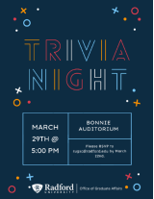

March 29, 2025, Graduate Student Council Hosts: Trivia Night Bonnie Auditorium
5PM
RSVP to rugsc@radford.edu or Contact Kalyn Stiles, kmstiles@radford.edu or Kira Glander, kglander@radford.edu for more information.

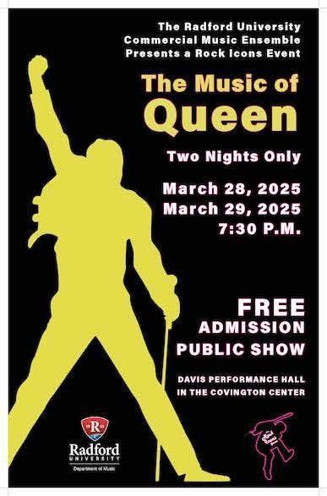

COMMERCIAL MUSIC ENSEMBLE

March 28, Friday & March 29, Saturday @ 7:30pm Davis Performance Hall in the Covington Center

OURS news - Research Scholars
If you mentor students on research and creative projects we need your help in letting graduating seniors know about being recognized as a Research Scholar for their diploma and resume!
Students qualify that have:

- Completed a minimum of two semesters of research, scholarship, or creative inquiry supervised by a faculty mentor
- Presented or displayed their work on or off campus or published it?

If the answer is “Yes” to these two questions, then we want to celebrate your accomplishments! You can apply for a Radford University Research Scholar transcript designation on your diploma by ﬁlling out the Undergraduate Research Scholar Transcript Designation application. You will need to:

- Submit how your work contributed to a ﬁeld of study (this can be your abstract from a conference, such as the Student Engagement Forum) and how the experience has impacted your intellectual and professional growth.
- be endorsed by your faculty mentor(s)—they will be contacted to ﬁll out a form when you submit your application.

Please submit your form by April 4th for possible inclusion in the program for Spring Commencement and to receive the designation on your transcript.
The Radford University Research Scholar transcript designation is in recognition of the accomplishment of undergraduate students who have contributed to the knowledge base within a ﬁeld of study through active research outside the classroom. The Undergraduate Research Scholar designation will be speciﬁc to the ﬁeld in which the student conducted research. For instance, if a student meets the requirements for URSCI in Dance, the designation would read, “Dance Research Scholar.” The designation is determined by the nature of the project and the department of the faculty mentor.
Click here for a more detailed explanation of the requirements for the Research Scholar designation and to apply. Questions can be directed to ours@radford.edu


Ofﬁce of Sponsored Programs Training Page
We are pleased to offer training resources to all faculty, students and staff who are interested in grant writing, as well as managing grants. Please take advantage of our videos and other resources by going to: https://www.radford.edu/sponsored-programs/training-and-resources.htmlAs always, if you have any questions please reach out to Tom Cruise, Director of Sponsored Programs, at tcruise@radford.edu or by calling 831-5479.

Ofﬁce of Sponsored Programs Funding Page
Do you have an idea for a project but ﬁnd funding? Please reach out to the Ofﬁce of Sponsored Programs at tcruise@radofrd.edu and we will gladly help you! In the meantime, please check out our Funding Page on our website at https://www.radford.edu/sponsored-programs/ﬁnd-funding.html to learn more about other resources.
We will work with you each step of the way to a successful proposal submission. Our services include, but are not limited to:

- Finding Funding Opportunities
- Preparing Budgets
- Providing Templates (if applicable)
- Editing Proposals
- Connecting you with a Hanover Research Consultant to help with Methodology Design
- Providing assistance with the Internal Routing Process
- Completing and submitting the applications (via mail or electronically)

We try to help alleviate the administrative burden of proposal preparation so you can focus on the technical aspects of the proposal. Please contact our ofﬁce to schedule an appointment today to begin the proposal process!


Career and Talent Development
Subscribe to our email list.

801 East Main Street | Radford, VA 24142 US

V-TOP Highlander Works Internship Grant Program Continues!

Radford University is excited to offer the V-TOP Highlander Works Internship Grant program in Summer 2025. The program supports students participating in internships and will be administered through the Center for Career and Talent Development Ofﬁce. Grant funds will go directly toward removing ﬁnancial barriers to student participation. Requests can be funded in part or in full up to $4,000 per student.

Deadline for application submission is March 31, 2025.

Apply and ﬁnd out more information

Ofﬁce of the Provost Radford University Martin Hall 331
540-831-5404

