

March 23, 2026
Message from Provost Usher

Spring is really teasing us this year - but regardless of the temperature, everything continues to bloom and our semester is ﬂying by! So many good opportunities for being engaged in the Radford University community are listed below. I’ll highlight some updates from my perspective before you get to the good parts.
I wanted to start by thanking everyone in Academic Affairs for shining for the BOV this week. I presented the updated (and ﬁnal) version of the Academic Affairs strategic priorities, with points of pride and data supporting our strengths in each area. The BOV continues to be very supportive of our central mission and our faculty. They also successful awarded tenure to ten faculty - congrats to them all for, to paraphrase what we say at graduation, continuing to strengthen our community of scholars.
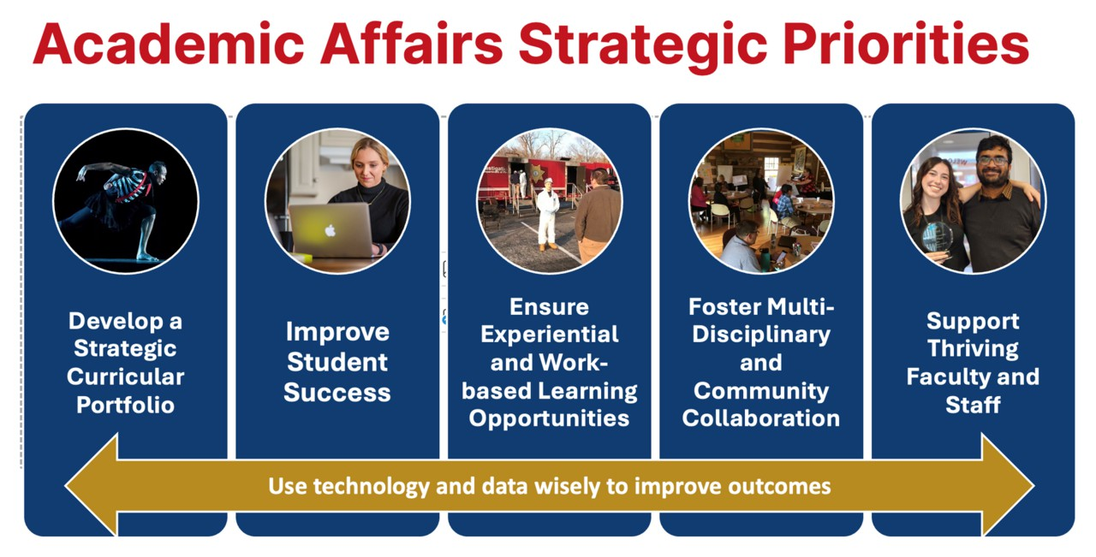
Academic Affairs Strategic Priorities: Develop a strategic curricular portfolio; Improve student success; Ensure experiential and work-based learning opportunities; Foster multi-disciplinary and community collaboration; Support thriving faculty and staff; Using technology and data wisely to improve outcomes.

Heather Keith has been leading a book group (you knew we would be talking about what we are reading!) discussing Beth Macy’s Paper Girl, ahead of the formal opening of the Highlander Center for Character and Public Impact. Talking with faculty emphasized how a loss of Pell funding for educational access and the signiﬁcant loss of local news media have contributed our regional and

national polarized conversations, and the impact in our classrooms. After reading Paper Girl, I have turned back to read her earlier book, Factory Man. Together, her works have helped me better understand the impact of shifting industry and demographics over the last century (and the recent decades). That context gives more insight into our students, and Radford University’s past, present, and future impact on the region. On March 31, the Center will hold a grand opening in the morning in Radford, and in the evening, Beth Macy will be headlining the grand opening in Roanoke.
Thanks, as always, for your contributions to our community! Bethany

2026-2027 Faculty Promotions
Artis College of Science and Technology
Sarah Kennedy (Chemistry), Professor

Nathaniel Lahn (Computing/Info Science), Associate Professor

Miodrag Lovric (Mathematics & Statistics), Professor

College of Humanities and Behavioral Sciences
Lindsay Semprevivo (Criminal Justice), Professor

College of Education and Human Development
Melissa Lisanti (Teacher Education and Leadership), Professor

College of Nursing
Samantha Wilkinson (Graduate Nursing), Associate Professor Tara Chitwood (Undergraduate Nursing), Associate Professor Sarah Knoeckel (Undergraduate Nursing), Associate Professor Karen Valcheff (Undergraduate Nursing), Associate Professor
Davis College of Business and Economics
Jennifer Elias (Economics), Senior Instructor

Robert Warren (Accounting, Finance & Information Systems), Associate Professor

Zachary Collier (Management), Associate Professor

University Libraries
Alyssa Archer (McConnell), Professor
Anthony Pepper (McConnell), Assistant Professor Jennifer Resor-Whicker (McConnell), Professor Barbara Tait (McConnell), Assistant Professor Christina Manzo (RUC Library), Associate Professor Jamie Price (RUC Library), Associate Professor
Mary Catherine Santoro (RUC Library), Associate Professor

Waldron College of Health and Human Services
Diana Willeman-Buckelew (RUC Public Health & Healthcare Ldshp), Associate Professor

Andrea Barrick (Social Work), Associate Professor

Jason Browning (RUC Occupational Therapy), Associate Professor

2026-2027 Tenured Faculty
Artis College of Science and Technology Nathaniel Lahn (Computing & Information Science) College of Education and Human Development David Brock (Health & Human Development)
College of Humanities and Behavioral Sciences

Lindsay Semprevivo (Criminal Justice)

College of Nursing

Sarah Knoeckel (Undergraduate Nursing)

Karen Valcheff (Undergraduate Nursing)

Davis College of Business and Economics

Robert Warren (Accounting, Finance & Info Systems)

Zachary Collier (Management)

Waldron College of Health and Human Services

Diana Willeman-Buckelew (Health & Healthcare Leadership)

Andrea Barrick (Social Work)
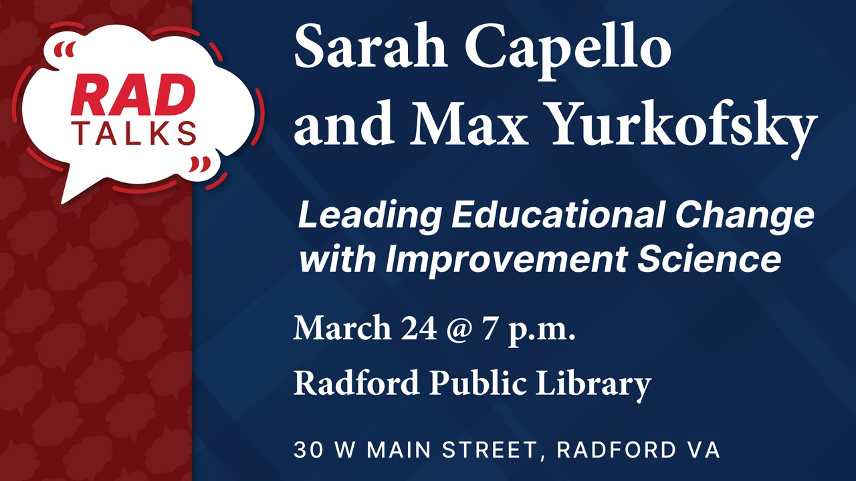

Join us for RAD Talks
With Sarah Capello and Max Yurkofsky

Leading Educational Change with Improvement Science
March 24, 2026 at 7pm Radford Public Library


Graduation application review process and timeline Spring 2026 Final Review and Degree Conferral:
- Final review and conferral begins for undergraduate and graduate students immediately after ﬁnal grading and end of term processes are completed.
- Lists of students who are missing requirements are forwarded to departments and faculty advisors for review and advising interventions. For Spring 2026 graduation, departments and advisors can expect to receive lists by the end of May.
- Graduate Affairs completes graduation applications review and follow-up with departments for Graduate Students.

Fall 2026 Graduation Application Preliminary Review:

- Fall Registration Opens on April 6. Graduating students are encouraged to register as soon as possible.
- Beginning April 13, Degree audits are reviewed by the Ofﬁce of the Registrar for each undergraduate student who has applied to graduate to assess whether they are on track to meet graduation requirements.
- Lists of students who are missing requirements or do not appear on track to complete are forwarded to departments and faculty advisors for review and advising intervention. For Fall 2026 graduation, departments and advisors can expect to receive the reviewed lists prior to the end of June.
- Graduate Affairs completes graduation applications review and follow-up for Graduate Students.

This timeline is intended to provide sufﬁcient opportunity for advising interventions and to make any necessary schedule adjustments.
Please contact graduation@radford.edu with questions.


Take a Second Look at the McConnell Library Reading Room
Almost everyone who visits McConnell Library walks through the beautiful Reading Room on their way to their ultimate destination. The Reading Room offers the Front Desk and its friendly staff, gorgeous architecture, and portraits of former university presidents and other administrators, but there’s more. Have you ever stopped to examine some of the library materials on the shelves in the Reading Room? Some of these collections are permanent, and some have rotating themes throughout the year.

You may already be familiar with our Popular Reading collection, which contains both ﬁction and nonﬁction books – often bestsellers that you’d also ﬁnd in a bookstore or a public library. Next to Popular Reading you’ll ﬁnd a display of horror-themed materials, including ﬁction and nonﬁction books, and DVDs of tv shows and movies; following that section is a display of some of the newest additions to the physical library collection. There are many more new titles shelved elsewhere in the library and, of course, available online.
On the other side of the Reading Room, near the Bird Room, the shelves are ﬁlled with books and DVDs on fascism. Adjacent to that area you’ll ﬁnd a selection of The Beehive, Radford University’s yearbook. Warning -- it’s easy to lose track of time once you sit in a lounge chair and start perusing these old annuals.
Finally, centered under the portrait of Dr. John Preston McConnell is the Radford Authors collection. Publications by current faculty members are showcased there. These, and all other displayed materials in the Reading Room are available for checkout! If you see something that catches your eye, take it over to the Front Desk and we’ll be happy to check it out to your account.

Your Students Can Win Cash: The Winesett Awards For Library Research (apply by Mar 30!)
Did you assign a paper or project to your students in which they used library resources? Each Spring, the Libraries host the Winesett Awards, to recognize creative and original library research by RU students. Over $5,000 will be awarded in three divisions: lower (freshmen/sophomores), upper (juniors/seniors), and graduate! Class projects completed in Spring 2025 through Fall 2025, as well as in-process Spring 2026 are eligible!
Save these dates: Applications due by Monday, March 30th at 11:59 p.m. Awards Luncheon and Ceremony: Friday, April 17th from Noon-1:30 p.m. Questions? Email Tony Pepper at tjpepper@radford.edu or Barbara Tait at btait@radford.edu.


The McGlothlin Center for Global Education and Engagement will be holding the following virtual workshops for faculty interested in learning more about engaging in international initiatives.
Title: Developing your own faculty-led program When: Monday, March 30th, 2026 at 12:00 noon Where:https://radford.zoom.us/j/98229546421
Title: Overview of the Fulbright Scholars program When: Thursday, April 2nd, 2026 at 12:00noon Where: https://radford.zoom.us/j/94327557875

Title: Developing international academic collaborations
When: Wednesday, April 8th, 2026 at 12:00 noon Where: https://radford.zoom.us/j/93940386301
Please contact Dr. Ismael Betancourt Velez at ibetancourtvelez@ radford.edu with any questions.




*UPCOMING* Re-Imagining Broader Impacts in Grant Writing
March 26, 2026
The articulation of broader impacts remains a critical component of federal grant proposals, but recent policy changes have signiﬁcantly reshaped how applicants should approach this aspect of their proposals. This session will present strategies for designing and communicating broader impacts that align with current federal priorities, including practical ways to demonstrate project relevance and impact for a wide audience.

Registration Link

The Department of Public Health and Healthcare Leadership presents “Solutions Through Empowerment: Why Health and Education Matter to Climate Change,” a free webinar taking place on April 8 at 12:00 p.m. via Zoom. This presentation explores how worldwide population pressures contribute to challenges such as food insecurity, natural resource scarcity, inequality, and climate-changing emissions, using a climate justice framework to examine the interconnected impacts of demographic trends and climate change while emphasizing the importance of integrating gender equality into global climate solutions. The webinar will be presented by Hannah Evans, Senior Analyst at Population Connection, and is part of programming occurring April 6–12 in recognition of National Public Health Week. Pre-registration is required.
For additional information, participants may contact Dr. Diana Willeman-Buckelew at dlwilleman@radford.edu
Pre-Register Here

Radford University Carilion’s Department of Public Health and Healthcare Leadership is partnering with Blue Ridge Literacy to host a Hygiene Product Drive from April 6–10, 2026. In celebration of National Public Health Week and Blue Ridge Literacy’s 41st anniversary, the community is invited to donate essential hygiene items to support local English Language Learners. Donation boxes will be available at RUC and RHEC campus locations, helping ensure that every contribution directly supports neighbors working hard to build new beginnings. Items needed are feminine hygiene

products, deodorant, shampoo & conditioner, body wash, soap bar and travel case, toothbrush & toothpaste, dental ﬂoss, comb/brush, hand sanitizer, and lotion.

Waldron College Interprofessional Symposium April 9th | Artis Center | 9:00 AM – 3:30 PM
Join us for the Waldron College Interprofessional Symposium at Radford University, hosted by the Dr. Raymond N. Linville Center for Interprofessional Education and Practice. This full-day event will feature presentations, discussions, and collaboration highlighting innovative teaching, research, and community engagement across the health professions.


We are honored to welcome Sarah Parker, Chair of Health Systems and Implementation Science at Virginia Tech Carilion School of Medicine, as our keynote speaker.
Dr. Parker’s research focuses on human performance in healthcare systems and developing practical, human-centered solutions to improve individual and team performance. With more than 15 years of experience applying human factors and industrial/organizational psychology to healthcare, she has led over $7 million in funded research from organizations including the Agency for Healthcare Research and Quality, the Robert Wood Johnson Foundation, the CDC, and the National Science Foundation. She also oversees the health systems science and interprofessional practice curriculum at the school, helping prepare future clinicians for collaborative practice.

Event Highlights
- Keynote address by Dr. Sarah Parker
- 90 in-person and virtual presentations, including posters, workshops, and roundtables
- Lunch roundtable session on the Radford CARES Mobile Health Initiative
- Participation from students and faculty representing ﬁve Radford colleges and Edward Via College of Osteopathic Medicine
View Preliminary Agenda
Register to attend by March 31, 2026

For additional information, contact: Dr. Jenny Hall at jlhall2@radford.edu


Important Dates & Opportunities – Spring 2026 Withdrawal Dates (Full Semester):

- Partial Withdrawal (Not All Classes): March 27, 2026
- From All Classes: April 10, 2026

Withdrawal Dates (Fast Track B):
- Partial Withdrawal (Not All Classes): April 10, 2026
- From All Classes: April 16, 2026

Thesis/Dissertation Submission (Required Programs):
- Format Review Deadline: April 20, 2026
- Final Deadline: April 8, 2026

Celebrating Graduate Faculty & Students
Outstanding Student Award Applicant Information
Applications for the Outstanding Graduate Student Award are now closed. Winners will be announced on March 20, 2026, with additional information about the award ceremony to follow. For more information, please contact OGA Graduate Assistant Adriana
Garcia at agarcia37@radford.edu.

Highlander Research Blitz – A 3-Minute Thesis Competition
Students (graduate & undergraduate) showcase their work with just one slide in three minutes. The HRB application has closed. The event will take place from 5:00 PM to 7:30 PM on April 1, 2026, in 1016 Hemphill Hall. For more information on this event, please check out the HRB website or contact OGA Faculty Fellow Dr. Paige Tan at etan3@radford.edu.

Professional Development
Graduate Assistantships
Please direct interested students to apply for Graduate Assistantships (GA) for the Summer and Fall 2026 semesters. Eligible applicants must be enrolled in a degree-seeking graduate program, be in good academic standing, and be registered full-time (3 Credits Summer, 9 Credits Fall). Graduate Assistantship opportunities can be found here. If you are interested in requesting a GA for the Summer 2026 semester, please contact OGA at gradaffairs@radford.edu.

Graduate Student Travel Funds
OGA has funds available to support students traveling to present research at conferences. Direct your students to apply here.

Graduate Research & Scholarly Projects Stories
We are collecting stories of faculty and graduate student conferences, presentations, publications, and new research initiatives. Please email submissions to gradaffairs@radford.edu.

Ofﬁce of Graduate Affairs Student Newsletter
Please share our professional development opportunities and community-building events with your graduate students. For a complete list, direct them to our LinkedIn, or the Professional Development and Events website, but also keep an eye out for the Graduate Affairs Newsletter sent out weekly.

Community Building

Join OGA, faculty, and graduate students for:
Coffee Hour
Tuesday, March 24, 2026 | 12:00 PM – 1:00 PM | Red Provisions Café, Highlander Hotel
Meet our staff, connect with students, and enjoy coffee with us at our biweekly gathering. Our treat!

Coffee Hour
Thursday, April 2, 2026 | 12:00 PM – 1:00 PM | City View Cafe, RUC Campus
Join our ﬁrst RUC Coffee Hour to meet students and staff—come connect and unwind!


Women's History Month is here, and the Women's and Gender Studies Program is proud to present a full month of events celebrating the stories, scholarship, creativity, and voices of women
— on our campus and beyond.
From March 10 through April 1, we have something for everyone: live music, academic presentations, artist talks, a craft break, a tea party, and more. This year's programming spans disciplines and departments across campus, and we're grateful to the many students, faculty, staff, and community partners who helped make it happen.
Highlights include:

- A panel with six women who helped create The Magic School Bus, available in person and via Zoom (March 23)
- Grammy-nominated singer-songwriter Amythyst Kiah performing and taking questions live (March 27)
- Presentations on gender complexity, intersex identity, environmental governance, contemporary art, and more
- A closing Celebration on April 1 honoring our Lifetime Achievement Award recipient and spring graduates

See the full program

Ofﬁce of Undergraduate Research Welcomes Dr. Tiesha Martin as Associate Director
The Ofﬁce of Undergraduate Research (OURS) at Radford University is pleased to announce that Dr. Tiesha Martin will serve the ofﬁce as Associate Director.
Dr. Martin is an associate professor in the Department of Health and Human Performance and brings extensive experience mentoring students and integrating research and community engagement into undergraduate education. Her work focuses on the role of sport in community and social development.



In her new role, Dr. Martin will help expand opportunities for Radford students to participate in undergraduate research and creative inquiry, working with faculty across campus to support student projects, mentorship, and professional development.
“I’m eager to collaborate with faculty and campus partners to expand undergraduate research and support faculty development in mentoring student researchers, particularly given the meaningful role OURS has played in my own professional development as a faculty mentor,” said Dr. Martin

“We’re excited to have Tiesha joining OURS and bringing leadership experience from a range of roles in sport management. Her teaching, research, and service have always been centered on students and often connect academic and student affairs. She already has deep experience working with OURS through Elevate Research, the SURF program, and the Highlander Research Rookie program,” said OURS Director Joe Wirgau.
Learn more about undergraduate research at Radford by attending upcoming events such as the Highlander Research Blitz and the Student Engagement Forum.


After 37 years of dedicated service to students and the university, the Radford University Department of Music announces the retirement of Dr. Bruce Mahin, esteemed composer and eminent scholar, effective August 1, 2026. Throughout his distinguished career, Dr. Mahin made a profound impact as a teacher, mentor, and creative artist, shaping generations of musicians while contributing signiﬁcantly to the ﬁeld of composition. His commitment to excellence and intellectual curiosity have left an enduring legacy within our department and beyond. The Radford community extends its deepest gratitude to Dr. Mahin for his remarkable contributions and wishes him all the best in his well-earned retirement. A celebration of Dr. Mahin will be held on Thursday, April 23rdat 12:00pm-2:00pm in ARTIS CENTER 301. Students, Faculty, and the campus community are invited to attend this special event in honor or Dr. Mahin!

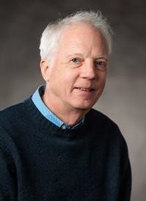
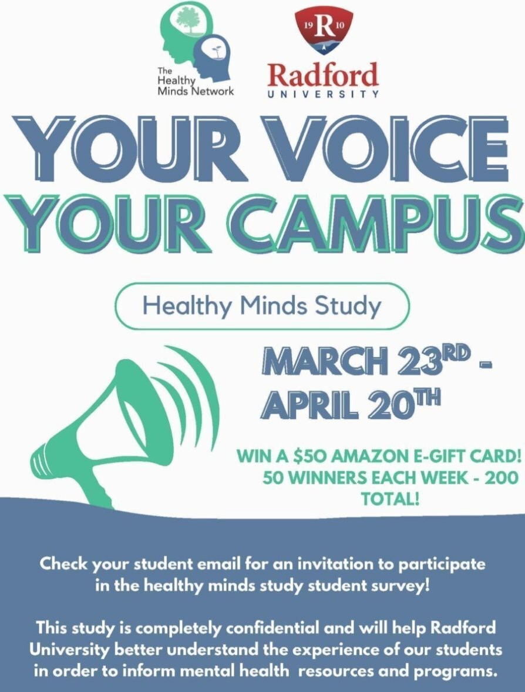

"Students will soon have an opportunity to share their experiences and perspectives through the Healthy Minds Study, a campus-wide survey focused on student health and well-being. Beginning March 23rd, students will receive a personalized email invitation with a link to complete the survey, which will remain open for four weeks, until April 20th. The survey takes approximately 20-25 minutes to complete.
The insights gathered from this survey will help our institution better understand the needs of our students and advocate for programs, services, and resources that support student success and well-being across campus.

Faculty and staff play an important role in encouraging student participation. Simple reminders in class, during meetings with students, allowing a few minutes for them to complete the study, or sharing the information through departmental communications can make a signiﬁcant difference. If you can encourage your department, colleagues, student workers, and instructors/faculty to assist with this effort, it would be greatly appreciated.



Navigate360 Implementation Update
Subscribe to our email list.

801 East Main Street | Radford, VA 24142 US
The implementation of Navigate360 continues to move forward as the University builds a more coordinated and connected approach to student success. The platform is designed to support collaboration across academic and administrative areas, strengthening outreach, communication, and support in alignment with institutional priorities outlined in the strategic plan, including fostering a culture of care.
With a planned launch date of April 6, there will be a phased rollout to new students, continuing students, faculty, and staff throughout the spring and summer. In preparation, the implementation team is working closely with faculty and campus partners to conﬁgure the system, integrate institutional data, and establish care units.
Faculty and staff will have an opportunity to engage with Navigate360 during May and August Our Turn sessions, which will include system demonstrations and training. Additional training opportunities will also be announced. Website and resource guides are in development.
As part of this transition, Starﬁsh will be discontinued over the summer. All existing notes will be retained and transferred to Navigate360. Continued system development and reﬁnement will take place throughout the summer, with a full launch anticipated by August 2026.
For questions about Navigate360, please contact Susan Hudson, Director of Student Success and Retention, at smhill@radford.edu.

Ofﬁce of the Provost Radford University Martin Hall 331
540-831-5404

