

June 23, 2025

Message from Provost Usher
Happy ofﬁcial summer, as the we enjoy the lightest (and apparently hottest) days of the year.
Quest is in full swing. I love meeting the excited new students and their supportive but anxious families and friends, while I give them my tips for success. I know the students are half paying attention to the academic planning, while much of their attention is focused on meeting the other incoming students and imagining themselves here in the fall.
My main tip for students and families is to have the families and friends practice saying, sympathetically, “What are you going to do about that?” As a faculty member and a parent, I know that students will call/Facetime/text home, sad or frustrated with some glitch or failure. I tell them that growth happens when the students are empowered to solve the challenge, knowing that they have a community of care both on campus and home. And then, as a parent, I have to remind myself of the same thing…
We appreciate everyone who is coming out to welcome and support these new students. Your role is crucial to creating that positive experience and ensuring that they arrive in fall, engage and learn, and eventually graduate.
Bethany


What’s new at McConnell Library? The New Materials Shelf, beside the Front Desk, features a changing selection of new items added to the library’s physical collection. We’d love to have you visit us this summer and ﬁnd some new reads.
Library summer hours:

Monday through Thursday 8am – 7pm; Friday 8 am – 5pm.


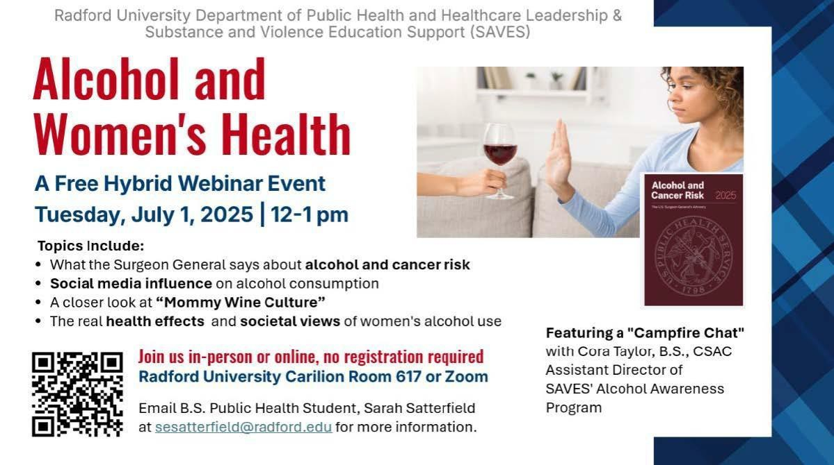

Topic: Alcohol Use and Women's Health
Time: Jul 1, 2025 12:00 PM-1:00PM EST
Location: Radford University Carilion Room 617 or Zoom (no registration/password required)
Join from PC, Mac, Linux, iOS or Android: https://radford.zoom.us/j/99339648723

Join from a Telephone：
Dial +1 408 638 0968
Enter Meeting ID 99339648723
International numbers available: https://radford.zoom.us/u/abmopFe4eq Join from a Room Systems: 99339648723@zoomcrc.com
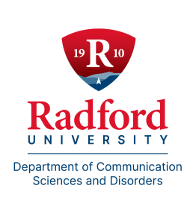

Graduate Students Lead Summer Speech and Language Program
This summer between June 9th and July 3rd, graduate students from the Department of Communication Sciences and Disorders are welcoming approximately 40 children to campus for a four-week intensive clinical program. In addition to on-campus services, students are also providing speech and language therapy at the Radford Early Learning Center. Across both locations, participating children receive more than 60 hours of individualized therapy. This impactful program is made possible through the generous support of the Scottish Rite Masons of Virginia. To celebrate this ongoing partnership, the Department will host a luncheon honoring their contributions on June 26th. Dr. Corey Cassidy, Ms. Rachel Green, Ms. Brandi Holland, Ms. Katherine Leeper, and Ms.
Maggie Turner serve as faculty supervisors.
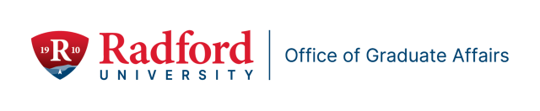

Graduate Affairs: By the Numbers
- 6% overall retention and graduation rate across both semesters
- 21% decrease in academic probations from Fall 2024 to Spring 2025
- 25 professional development and engagement events hosted by the Ofﬁce of Graduate Affairs
- 6% of graduate students participated in at least one event

In-Progress

- 2025-2026 Catalogue Merging Support: The Graduate Affairs Ofﬁce is supporting the Registrar’s Ofﬁce with the merging of the Undergraduate and Graduate Catalogs. The Graduate Affairs portion is nearing completion.
- Updating Graduate Program Contact Information: The Graduate Affairs Ofﬁce sent the survey form to all Deans to update the Graduate Programs Contact Information. June 25, 2025, is the due date to complete the survey.

Celebrating Graduate Faculty and Graduate Students

Contact Jean Mistele, jmistele@radford.edu if you have accomplishment or interesting experiences to share about your professional work and/or your students’ professional growth.

Recruitment Support

- Program coordinators: Schedule your Graduate Recruitment 2025-2026 Strategy Meeting with Cris Thompson from Graduate Admissions. Calendar link: (https://doodle.com/bp/cristhompson1/gradrecstrat2526
- Program coordinators: Fund your Recruitment Strategy with funding! Proposals due August 9, 2025. Awards up to $2000 for innovative ideas that lead to sustained student engagement. Proposal Link: Proposal: https://radford.co1.qualtrics.com/jfe/form/SV_4JkbGPfPRVGUGCG
Recruitment Funding Proposal Toolkit contains proposal requirements and evaluation rubric. Toolkit link: Graduate Recruitment
Funding Proposal Toolkit 2025-2026.docx

Retention Planning for 2025 – 2026 Professional Development Planning 2025-2026
Udemy: Graduate Affairs is partnered with Davis College to extend access to all students for the wide array of certiﬁcate courses to students.
Leadership Summit: September 17 – 20. Omicron Delta Kappa Society is partnered with Graduate Affairs, Emerging Leaders Certiﬁcate Training offered by the Truist Leadership Institute housed in the Davis College of Business and Economics, and with the Leadership minor in the College of Humanities and Behavioral Sciences to extend leadership development opportunities to graduate students for the ﬁrst time.
Book Clubs/Workshop/Other: If you are interested in supporting a professional development opportunity for graduate students during the 2025-2026 academic year, please contact Jean Mistele, jmistele@radford.edu. We can help you promote your event.


New Data Management and Sharing Resource Page on Sponsored Programs’ Website

Sponsored Programs is pleased to announce updates to our website. We have added an additional resource to our webpage that will assist your efforts in the collection and management of research data. Many external sponsors require data management plans as part of their proposal requirements, so this resource page will help guide you in developing your plan while adhering to compliance requirements from our sponsors. Successful management and protection of information and data are critical to the administrative, clinical, educational, and research functions

of Radford University. The sharing of research data at the preliminary phase of the proposed research project, as well as the sharing of collected research data after publication or with the sponsor, are situations that require effective data management planning. Please visit our website for more information and resources.
Please visit our website

As always, please reach out to our ofﬁce by emailing Tom Cruise (tcruise@radford.edu) or Pam Frasier (pfrasier2@radford.edu) if you have questions about data management.

New Training Tutorials Added to Sponsored Programs’ Training Page

Sponsored Programs is happy to announce three new training tutorials have been added to our YouTube channel. https://www.y outube.com/@RU-SPGM
New videos that have been added:
- Developing Objectives, Hypothesis, and Concept Papers
- From Publication to Proposals: Making the Shift from Academic Writing to Grant Writing
- Working with Hanover Grants Consultants

Please visit our YouTube channel, as well as our website training page @ https://www.radford.edu/sponsored-programs/training-and-resources.html, for additional training resources offered by the Sponsored Programs team. We hope our training page provides helpful information, but as always, we are open to feedback from you on how we can best serve your grant-writing needs.


Radford student wins national advertising award

Congratulations to Jenna Repass, recent graduate of the Art Department's graphic design concentration. Jenna garnered a national gold ADDY Award at the American Advertising Awards in Pittsburgh this past weekend. She is the ﬁrst Radford student to take a gold at this level.

Three University Performance Series events announced

A pair of University Performance Series events for the 2025-26 season has been announced. The dance company Ailey II (founded by the legendary Alvin Ailey) will perform in the Bondurant Auditorium on Friday, September 26 at 7:30 p.m. On Tuesday, January 20 at 7:30 p.m., The Acting Company will perform “Great Expectations” in the Main Stage Theater in the Artis Center. We will also bring a concert from the Three Italian Tenors od Davis Performance Hall in the Covington Center on March 12 at 7:30 p.m. For more information, please visit www.radford.edu/ups.

Radford Theatre alums at the Tony Awards
Congratulations go to Faye Armon-Troncoso, Radford Theatre alumna who worked as the prop


supervisor and did all the set dressing for "Purpose," which won Best Play at the 2025 Tony Awards. Incidentally, Faye is also the ﬁrst set designer/prop master to ever win an Obie. Radford alum Raphael Reagan had a show nominated as well. Reagan works with Dede Ayite in costume design and their work was nominated for Best Costume Design in a Musical.
Ofﬁce of the Provost Radford University Martin Hall 331
540-831-5404
Subscribe to our email list.

801 East Main Street | Radford, VA 24142 US

