

June 2, 2025

Message from Provost Usher
After last week’s November weather, it’s nice to see June appear as the most gorgeous early summer days! I hope that you are enjoying some time to do something enriching and hopefully relaxing.

General Education Updates

Thank you to everyone who has poured your heart and soul in to updating our REAL/General Education program. The curriculum approved in April by Faculty Senate will serve our students, provide a strong liberal arts basis for all undergraduates, and help them Find Their Place Here.
Faculty Senate Executive Committee and the Academic Affairs Leadership Team met together after Commencement in May to consider whether to implement the new General Education Program for students entering Radford in Fall 2026 or Fall 2027. We considered two timelines for designating courses, developing and piloting RADF101, implementing Banner and Degreeworks updates, and creating new assessment rubrics and processes. We together determined that starting in Fall 2027 would give us the time to ensure that the General Education implementation would be successful, and allow the most time for faculty to be fully involved. David Beach, Matt Close, Jessica Stowell, Katie Piper, and Jerel Benton are working together this summer on planning. I expect that an early Fall step will be having Faculty Senate recommend updating the REAL University Governance Committee’s name and charge, and then having this new General Education committee leading the transitional activities with support from the Academic Affairs team. We are committed to the success of this roll-out.
In the meantime, the streamlined REAL program, dubbed REALx, will be in place for students entering starting this year. New students are being advised with this guidance:

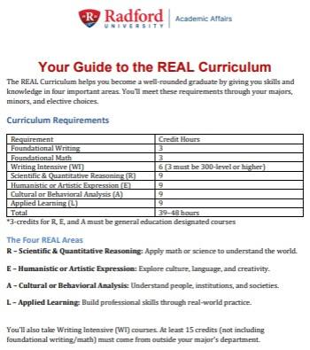
Our goal, over the next few years, is to have a single General Education curriculum that we support for a generation of students, and that we work together put our heart and soul into having the best foundational learning experiences within this new program.

Summer Reading

For me, summer is a time of reading. If you are interested, please share what you are reading and we will include short recommendations in later Threads.
I am catching up on all the Science magazines that come every week and I lose track of mid-semester. Our Libraries offer everyone on campus free access to the New York Times and the Chronicle of Higher Education through our own logins (so you can set up the app on your phone or browser). They also have a Popular Book section, so feel free to stop by and check one out. I also have a library card from Radford Public Library and use the Libby app to download free Kindle and Audiobooks. I read The 272 by Rachel Swarns, which follows the history of the families of the 272 people enslaved by Georgetown University starting in 1838. For a lighter listen, I loved hearing Meryl Streep read Ann Patchett’s Tom Lake.
Thank you for everything you are doing! Bethany

Public Safety Information Sessions
Public Safety Information Sessions for faculty ahead of the fall semester:
- August 11 at 11:00 a.m.
- August 12 at 11:00 a.m.
- August 20 at 1:00 p.m.
Locations for these sessions will be coming soon.


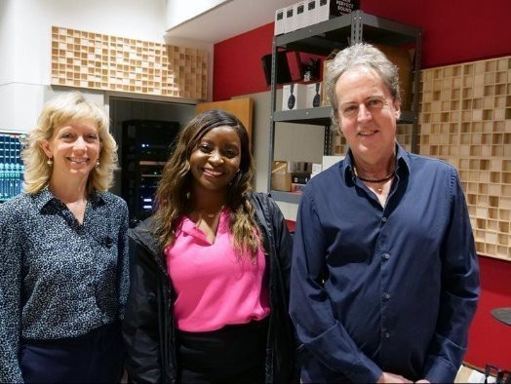

Congratulations to Jennifer McDonel and Dave Rivers in the music department. Their recent story on WDBJ7 was adapted for the national CBS News roundup podcast this weekend. It's the wrap up story and begins at 43:50 in the podcast:
https://ow.ly /OjXk50VV0BJ
Watch the original television broadcast

Graduate Affairs News

Graduate Affairs: By the Numbers
- Awarded $164,000 to 82 Graduate Assistants and Graduate Research Assistants for Summer I.
- Implemented a new end-of-term process to monitor student academic progress for timely outreach. Reviewed and processed 286 student petitions (Fall and Spring) with individualized academic support.
- We recently implemented a comprehensive retention initiative that resulted in:
  - 21.05% reduction in the number of students on academic probation from Fall 2024 to Spring 2025.
  - fewer than 2.4% of all graduate students are on probation (excluding the three Risepoint programs). 21.05% reduction in the number of students on probation from Fall 2024 to Spring 2025

Recruitment Support

- Program coordinators – Schedule your Graduate Recruitment 2025-2026 Strategy Meeting with Cris Thompson from Graduate Admissions. Calendar link: (https://doodle.com/bp/cristhompson1/gradrecstrat2526
- Program coordinators – Fund your Recruitment Strategy with funding! Proposals due August 9, 2025. Awards up to $2000 for innovative ideas that lead to sustained student engagement. Proposal Link: Proposal https://radford.co1.qualtrics.com/jfe/form/SV_4JkbGPfPRVGUGCG Recruitment Funding Proposal Toolkit contains proposal requirements and evaluation rubric.
Graduate Recruitment Funding Proposal Toolkit

Building Our Community
Graduate Student Ice Coffee Hour – Free COFFEE
June 16th Graduate Student Ice Coffee Hour at the Highlander Hotel, 12 - 1

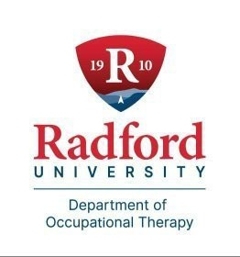

Radford University's Department of Occupational Therapy did a 12-Day Study Abroad Trip to Germany. This was the 3rd such trip and they did amazing things!

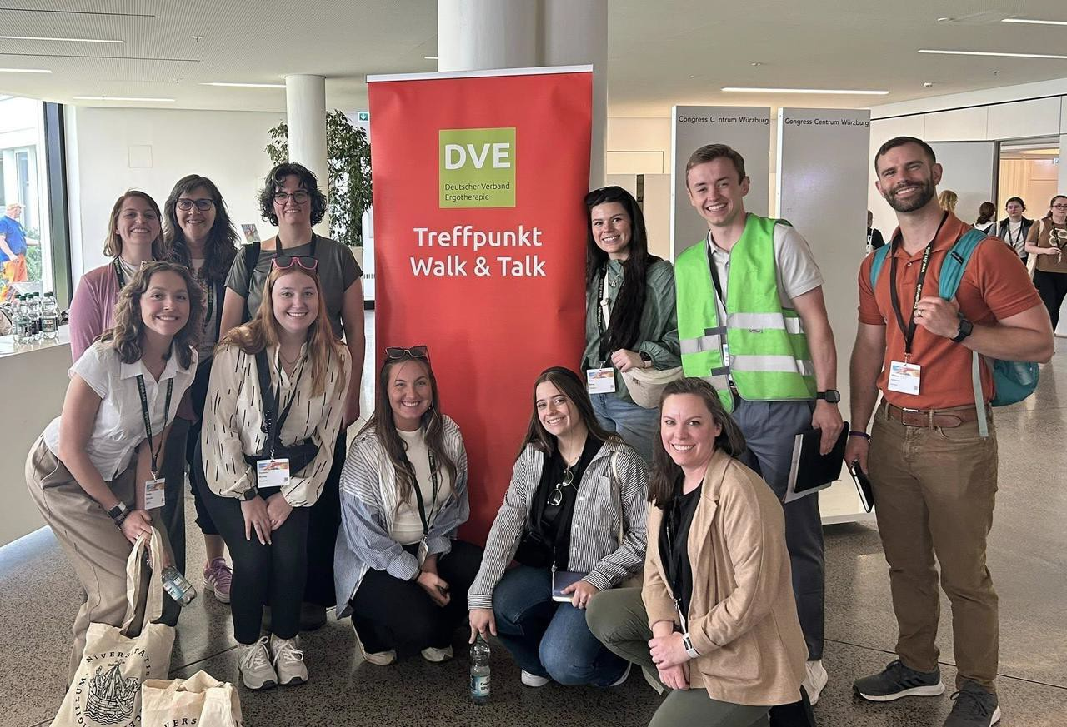
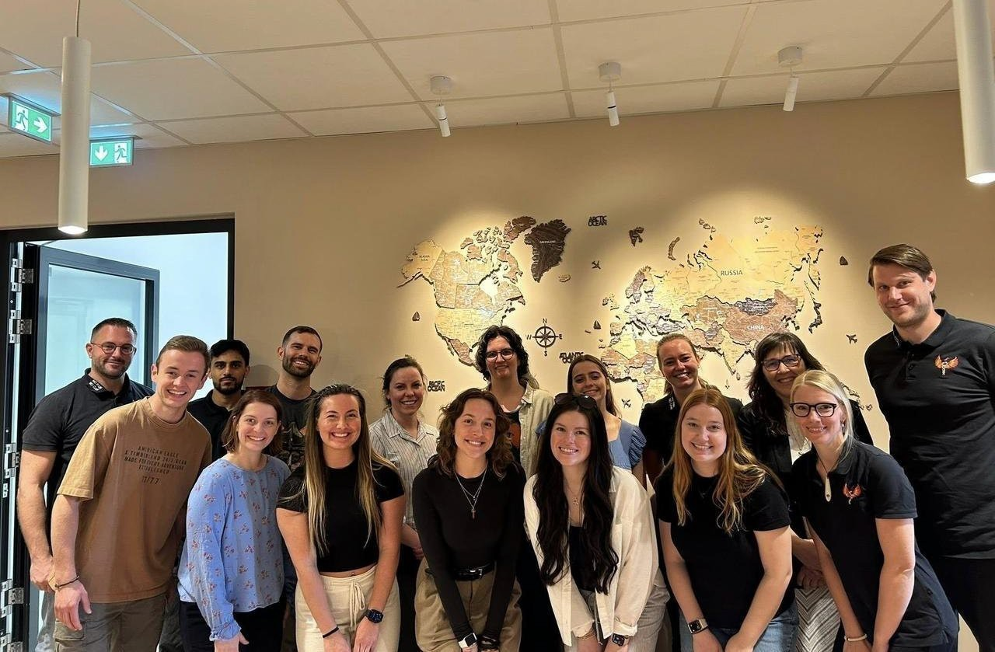
- 9 First year OT Students (from both campuses)
- 2 Faculty
- 12-Day Trip
- https://www.facebook.com/Dept.of.Occupational.Therapy

The exciting things they did while they were there:
Hamburg
- visited a former concentration camp
  - learned about events leading up to WWII
  - explored the way the Nazi ideology took hold and how the subsequent discrimination of a variety of people lead to the holocaust
- visited an outpatient OT clinic
  - met with the entire therapy staff, toured their facility, and discussed OT services in the German context
- visited a hospital
  - met with the lead OT who described the specialized geriatric ﬂoor services they provide
  - toured the integrated dementia unit
- visited a Medical History Museum on the grounds of the University Hospital System
  - learned about the horriﬁc experiments conducted during the Nazi regime
- visited the Dialogue in the Dark house
  - participated in a tour led by people who are blind in a completed darkened environment
  - experienced how a blind person may navigate various environments
  - had a drink with our guide in complete darkness and discussed the challenges he faces in the city as a blind person, but also the many technological advances that make life easier

Wuerzburg
- faculty and students presented at the German OT Association congress
  - Walk & Talk format
    - walked to the river with conference participants in small groups
    - our students lead small groups of 4 people using 3 global themes
    - successful presentation with lots of positive feedback from participants
- attended the German OT association congress & met up with German OT students from the University of Applied Science
  - they served as translators during the conference
  - they met up with our students for a student-led evening event

- US OT faculty met up with German OT faculty and introduced ourselves to the German OT Association Board

Nuremberg
- visited and toured the former Nazi Rally grounds
- met up with a US OT who works in Germany
- met up with several OT students and current OT practitioners and faculty for additional exchange and a historic tour of the city
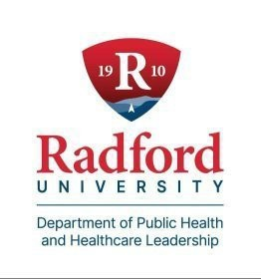

Tick Safety Adventures...
Dr. Jenny Hall, Department of Public Health and Healthcare Leadership, has just released Tick Safety Adventures Activity Book, which turns tick safety into an adventure and features over 40 kid-friendly activities. Children learn how to identify ticks, where ticks like to hide, signs and symptoms of common tick-borne diseases, and ways to prevent tick bites. Activities include mazes, coloring pages, I-See-A-Tick games, word puzzles, Tick-Not-A-Tick Challenges, and more. This is just in time for summer, when ticks are most active.
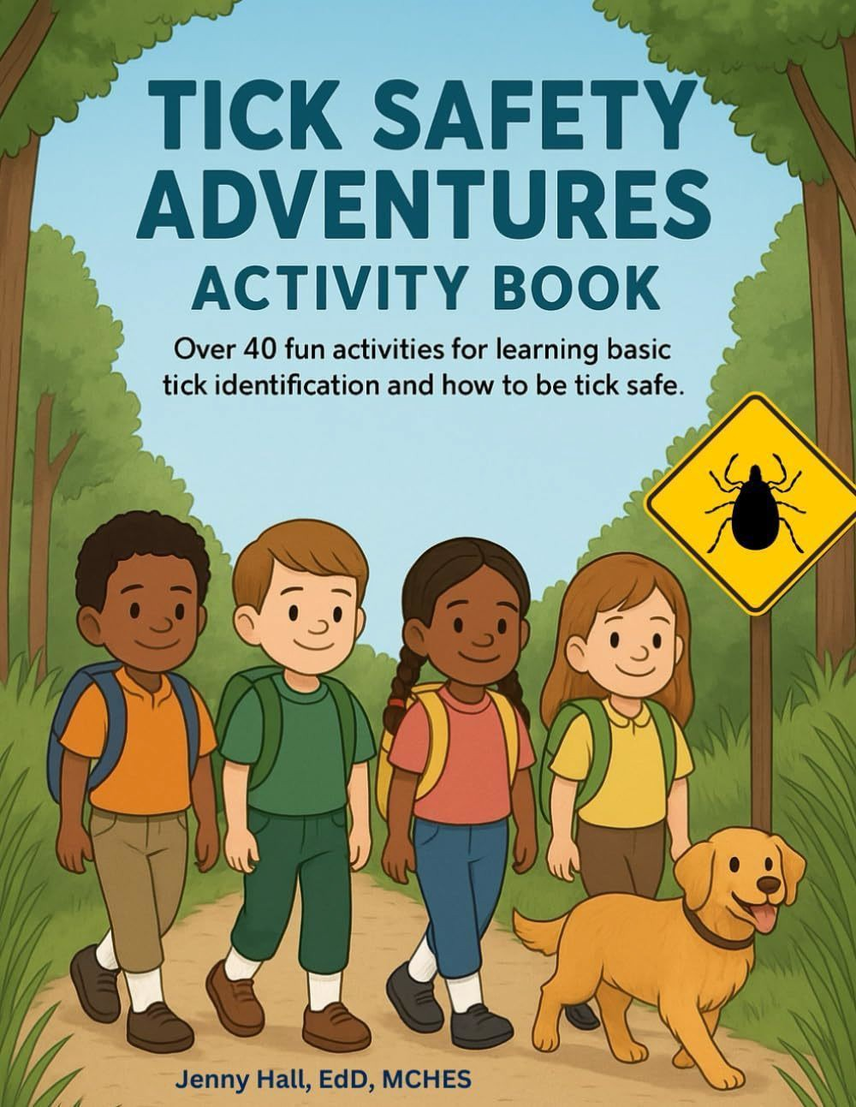
Please contact Dr. Hall for more information. jhall2@radford.edu



New Data Management and Sharing Resource Page on Sponsored Programs’ Website

Sponsored Programs is pleased to announce updates to our website. We have added an additional resource to our webpage that will assist your efforts in the collection and management of research data. Many external sponsors require data management plans as part of their proposal requirements, so this resource page will help guide you in developing your plan while adhering to compliance requirements from our sponsors. Successful management and protection of information and data are critical to the administrative, clinical, educational, and research functions of Radford University. The sharing of research data at the preliminary phase of the proposed research project, as well as the sharing of collected research data after publication or with the sponsor, are situations that require effective data management planning.
As always, please reach out to our ofﬁce by emailing Tom Cruise (tcruise@radford.edu) or Pam Frasier (pfrasier2@radford.edu) if you have questions about data management.
For more information and resources

New Training Tutorials Added to Sponsored Programs’ Training Page

Sponsored Programs is happy to announce three new training tutorials have been added to our YouTube channel. https://www.y outube.com/@RU-SPGM
New videos that have been added:
- Developing Objectives, Hypothesis, and Concept Papers
- From Publication to Proposals: Making the Shift from Academic Writing to Grant Writing
- Working with Hanover Grants Consultants

Please visit our YouTube channel, as well as our website training page @ https://www.radford.edu/sponsored-programs/training-and-resources.html, for additional training resources offered by the Sponsored Programs team. We hope our training page provides helpful information, but as always, we are open to feedback from you on how we can best serve your grant-writing needs.

Faculty Professional Development Leave Program
For tenured faculty who are eligible,
The Radford University Faculty Professional Development Leave Program (FPDL) is an opportunity for you to broaden your professional horizons and develop new teaching and research perspectives. The University has supported numerous faculty over the years, so we would like to encourage you to explore this option. More information about the application form and instructions for the 2025-2026 program will be posted on SPGM’s website very soon! Until then, if you are eligible to submit and have questions about the program please feel free to reach out to Jeanne Mekolichick or Tom Cruise.



OURS Research Ready Summer Programming
Tuesday June 3rd at noon. Welcome to Summer Research: Starting Strong
In this session, you’ll connect with fellow researchers, set goals for a successful summer, and learn tips to stay organized, motivated, and ready for whatever challenges—or surprises—come your way.

Tuesday June 10th at noon. Ethical Conduct of Research
Ethical research is fundamental to academic success—but it requires navigating complex issues like authorship, fraud, and the guidelines of IRB and IACUC. In this workshop, you'll explore how to address these challenges and important questions about authorship and credit.

Tuesday June 24th at noon. Storytelling Starts Here: Collecting Research Media for Impact
Great presentations begin in the ﬁeld, lab, or studio. Whether it’s striking images, revealing quotes, ambient sounds, or drone footage, the materials you gather while researching shape how others experience your work. In this session, you’ll explore how to intentionally collect media that enhances posters, talks, videos, and more—so your research doesn't just inform, it resonates.

Tuesday July 15th at noon. Next Steps: Turning Research into What’s Next
Whether you're eyeing grad school, preparing for job interviews, or polishing your resume, this session will help you connect your research experience to future opportunities. Learn how to talk about your skills, stand out on applications, and take conﬁdent steps toward what’s next.

Tuesday July 22nd at noon. Telling Your Story, Crafting Compelling Elevate Pitches
Make your research unforgettable with a story that sticks! Gain tips and tricks to craft clear, engaging pitches that capture attention and spark curiosity.

Tuesday August 5th at noon. Creating Audience-Centered Posters and Oral Presentations
Your research presentation should be memorable, be it a poster that stops people in their tracks or an oral presentation that engages the audience to remember it months later! Learn how to communicate your work to any audience.

For more information contact ours@radford.edu, 831-7203, or in Whitt 118-126. Session descriptions were developed and adapted with assistance from ChatGPT.
Zoom access for ALL meetings

Ofﬁce of the Provost


Radford University Martin Hall 331
540-831-5404
Subscribe to our email list.

801 East Main Street | Radford, VA 24142 US

