

July 7, 2025

Message from Provost Usher
Happy Summer! Every two years, SCHEV asks the public universities to submit a plan for the next six years (it’s always been confusing to me - but I just think of it as a rolling 6 year window). We just wrote and submitted ours, and it gave me a chance to reﬂect on the past two years. The last one was due just a couple of weeks after I started in this position, and it felt like it took some hubris for the brand-new leadership team to write such a plan. Back then, we emphasized deﬁning our identity while prioritizing enrollment and ﬁnancial stabilization. This year’s submission was much different, as we were able to say that we had met those goals (and Found our Place Here). Now, we continue to plan for stabilized enrollment, a curriculum lifecycle to continue to adapt our programs, a focus on student success, and exciting plans for Roanoke (among many other items). While it felt like writing a very long exam with 27 essay questions, it was much more fun this year than the last time, and the whole leadership team felt very proud of where we are. And it reminded me of how much I appreciate our entire Radford community. The report will be available soon on the SCHEV website, and I’ll post a link.
For other reading, I’ve enjoyed three books recently: The Berry Pickers (by Amanda Peters), a novel about the consequences of a Mi’kmaq child disappearance in Maine, set close to the town where my daughters and I spent a week in June. Eve (by Cat Bohannon) tells the story of human evolution from a female perspective- answering the question about how we would understand human biology and history differently if we assumed that major features were adapted for female survival and reproduction. Finally, I listened to Sayz Who? (by Anne Curran), a guide modern, inclusive English grammar that means that I am just full of fascinating trivia about words now. Dr Curran is an English professor at the University of Michigan and has a weekly podcast, That’s What They Say, if you want to geek out on linguistics with me.
Send in your summer reading recommendations by replying to this newsletter! We’ll publish them in the next Threads.
I know that many of you are taking advantage of the time to do research, plan for classes, teach summer classes, and visit family and friends. No matter what you are doing, I hope that you are enjoying it, before the rush of the fall semester happens!
Bethany



Did you know?
McConnell Library has a Craft Corner in the McConnell Lounge! Take a break and let your inner artist out.



SAVE THE DATE!
Appalachian Translational Research Network 2025 Annual Health Summit, "Navigating the Changing Health Landscape in Appalachia", will be held in Abingdon, VA on Monday, October 13th - Tuesday, October 14th
Abstract Submission Deadline is Friday, July 18, 2025 at 11:59pm

Find out more and submit your Abstract

"Bringing Death Back Into Life"
The Palliative Care Partnership of Roanoke Valley presents "Bringing Death Back Into Life" featuring Dr. Aditi Sethi-Brown on Thursday, September 18, 6:30-8:00pm. Cost is $5.00

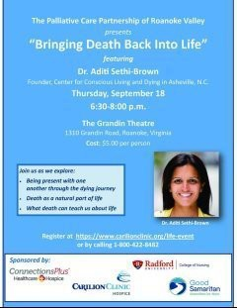

Register Here

Save the Date

August 22, 2025, 9 am – 3 pm, Graduate Teaching Assistant, Teaching Fellow, and Research Assistant Training.

In-Progress
Retention Initiatives: Implementation by Ofﬁce of Graduate Affairs

Celebrating Graduate Faculty and Graduate Students

Contact Jean Mistele, jmistele@radford.edu if you have accomplishment or interesting experiences to share about your professional work and/or your students’ professional growth.

Recruitment Support

- Program coordinators: Schedule your Graduate Recruitment 2025-2026 Strategy Meeting with Cris Thompson from Graduate Admissions. Calendar link: (https://doodle.com/bp/cristhompson1/gradrecstrat2526
- Program coordinators: Fund your Recruitment Strategy with funding! Proposals due August 9, 2025. Awards up to $2000 for innovative ideas that lead to sustained student engagement. Proposal Link: Proposal: https://radford.co1.qualtrics.com/jfe/form/SV_4JkbGPfPRVGUGCG
Recruitment Funding Proposal Toolkit contains proposal requirements and evaluation rubric. Toolkit link: Graduate Recruitment
Funding Proposal Toolkit 2025-2026.docx

Professional Development Planning 2025-2026

Book Clubs/Workshop/Other: If you are interested in supporting a professional development opportunity for graduate students during the 2025-2026 academic year, please contact Jean Mistele, jmistele@radford.edu. We can help you promote your event.


CVPA's New Dean Arrives
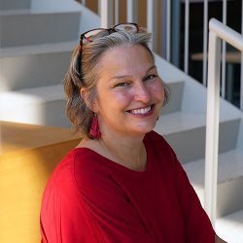
Dr. Rachel Williams stepped into her role as the new dean of the College of Visual and Performing Arts on July 1. She comes to Radford from the University of North Carolina School of the Arts, where she served since 2022 as dean of the Division of Liberal Arts. Dean Williams says she's still moving in box by box but has already started meeting with staff and faculty and is very excited about working with students.
Welcome aboard.

Tickets now available for Ailey II, UPS shows
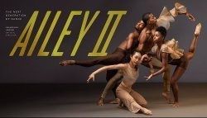
Tickets are now on sale for all three University Performance Series events of the 2025-26 season. Ailey II, the dance company founded in 1974 by Alvin Ailey, will perform in Bondurant Hall on Friday, September 26. In spring, you can enjoy a stage production of Great Expectations by The Acting Company on January 20, 2026 and direct from Rome, Italy, the Three Italian Tenors perform on March 12. To get your tickets, go to https://rutheatretickets.universitytickets.com/

Art alum opens Richmond boutique

Congratulations to Sophie Smith, class of '21 in Graphic Design. She made the RVA news last week, when her new store, Hiss Off, opened in Richmond at 3122 W. Cary St. Hiss Off is a goth and

Harajuku-inspired clothing and vintage décor store that has its origins when Sophie ﬁrst started selling vintage items and clothing online while at Radford. You can learn more here.



Staff Accessibility Bootcamp
Thurs., July 31, 8:30 AM-12:00 PM, Walker Hall 215 and via Zoom
This 3.5-hour bootcamp will give you the nuts and bolts of document accessibility. We will discuss Word, PowerPoint, and PDF accessibility. We will also touch on accessibility technologies and platforms for creating forms. This training is geared towards staff and AP faculty who have responsibilities for creating documents that will be housed in digital formats (on web pages, in D2L, in social media).
Bring a laptop and a few documents to work on—a Word document, a PowerPoint presentation, and a PDF.
This training is a collaboration of the Center for Innovative Teaching and Learning (CITL), Academic Technologies, and the Center for Accessibility Services (CAS).
Breakfast provided by CITL. This bootcamp is limited to the ﬁrst 50 registrants.
Register for the event

Faculty Professional Development Leave Program
For tenured faculty who are eligible,
The Radford University Faculty Professional Development Leave Program (FPDL) is an opportunity for you to broaden your professional horizons and develop new teaching and research perspectives. The University has supported numerous faculty over the years, so we would like to encourage you to explore this option. More information about the application form and instructions for the 2025-2026 program will be posted on SPGM’s website very soon! Until then, if you are eligible to submit and have questions about the program please feel free to reach out to Jeanne Mekolichick or Tom Cruise.

Students are now included in Udemy!

Udemy offers unlimited access to 30,000+ fresh courses across tech, business, leadership, and wellness. While faculty and staff have had access 2024-25, ALL students will have access beginning August 1st. Check out the vast array of training modules by entering "Udemy" in One Campus.
Training and additional details to come!


This past week and the coming two weeks Waldron College of Health and Human Services, the College of Nursing, Virginia Tech Carilion School of Medicine, Roanoke College, Virginia Tech Graduate College, Fralin Biomedical Research Institute, and Carilion faculty are engaged with the Governor’s School for Medicine and Health Sciences students in Roanoke. The 20 high school juniors and seniors, from across the Commonwealth, are getting an immersive curricular experience in medicine and health sciences with a public health theme woven through. Students have been able to see research in progress, learn about many different health professions, and get hand-on experiences in labs. The students are also working in groups developing a poster presentation on a public health issue using the Wicked Problem methodology. Pictured below are the students immediately following their White Coat Ceremony.
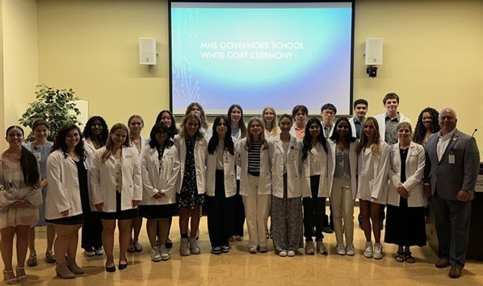

Ofﬁce of the Provost Radford University Martin Hall 331
540-831-5404


Subscribe to our email list.

801 East Main Street | Radford, VA 24142 US

