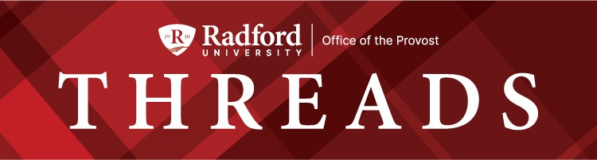

July 22, 2025

Message from Provost Usher
The past week, the BOV held their annual retreat at Berry Hill Retreat near Danville. The President’s Cabinet joined them to lead a workshop focused on Enrollment Management - essentially, how everyone at Radford University is involved in recruiting, teaching, supporting, and launching our students into the world. We focused on how our goal is not just stability for RU, but sustainability.
While almost every college has leveraged their future goals on growth, given the demographics of the state and a national conversation that is not lauding the beneﬁts of higher education, it is a new approach to plan for sustainability. While stability may have a connotation of stagnation, sustainability implies a regular adaptation that serves our mission. The academic affairs presentation was focused on how our portfolio of academic programs attracts, supports, and prepares students to lead thriving communities - and to sustain that, we will focus on the Curriculum Lifecycle (the slide I used is below). We had a good conversation. The Board had a better understanding of their responsibility in approving changes to academic programs, why thoughtful academic program design supports student success, the context of why programs adapt, and how shared governance works in the process.
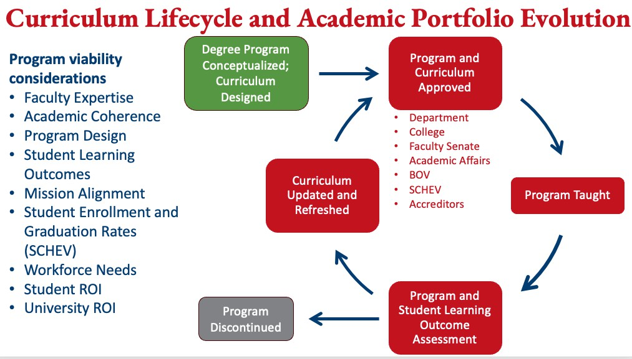

My reading list continues to grow. On my drive, I was listening to The Life Cycle of the Common Octopus (Emma Knight), a lighter novel describing a ﬁrst-year college student's coming-of-age attending the University of Edinburgh. Alexandra Horowitz is a research professor who runs the Dog Cognition Lab at Barnard College, and her popular science book, The Year of the Puppy, compared the fascinating development of puppies with humans as they learn to interact with their worlds. It convinced me I wasn’t ready to raise another puppy right now - Harper will stay an only dog for a while!
Enjoy the other book recommendations below, as you start ﬁlling in your schedule with the back to college events highlighted in the newsletter and please keep sending us your suggestions.
Bethany


What are you reading this summer?

Jessica Stowell:
I read The Personal Librarian which is a fascinating read. It is about a black woman who passes as white and serves as the personal librarian of JP Morgan.
I have also listened to a series called the Glass Library which is set just after WWI and is part mystery, part fantasy, part historical ﬁction.
Sandy French:
My favorite book read of the summer was The Anxious Generation. I think it really deepened my understanding of our students, their concerns, and their needs. I highly recommend it!
Amanda Bozack:
I’ve just read Abundance by Ezra Klein and Derek Thompson. Abundance explains that our problems today are not the results of yesteryear’s villains. Rather, one generation’s solutions have become the next generation’s problems. Rules and regulations designed to solve the problems of the 1970s often prevent urban-density and green-energy projects that would help solve the problems of the 2020s. Laws meant to ensure that government considers the consequences of its actions have made it too difﬁcult for government to act consequentially. In the last few decades, our capacity to see problems has sharpened while our ability to solve them has diminished.
I’m just about to start Reset: How to change what’s not working, by Dan Heath. In Reset, Heath explores a framework for getting unstuck and making the changes that matter. The secret is to ﬁnd “leverage points”: places where a little bit of effort can yield a disproportionate return. Then, we can thoughtfully rearrange our resources to push on those points.
Dan is a New York Times best-selling author and was also the keynote speaker at STEL’s summer convening for local education leaders and teachers: Moving from Surviving to Thriving: Finding

the Right Leverage Points to Impact Current Challenges in Education. Over 100 participants from local school divisions received a free copy of this book. His talk was fantastic! Dr. Max Yurkofsky organized the event and I was so impressed by the whole day.
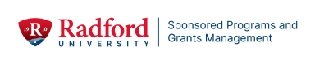

Unlock Your Research Potential: Find Colleagues and Form an Interdisciplinary Research Team on Campus
Are you a faculty member eager to secure funding for your innovative research ideas but unsure where to begin with proposal development or grant writing? Would you like to begin this journey with colleagues who may have like-minded interests? We understand that navigating the grant proposal landscape can be challenging, so Sponsored Programs is here to provide the essential support you need to get started.
We are excited to invite you to participate in our dedicated Interdisciplinary Grant Proposal Program for the 2025-2026 academic year. This initiative is speciﬁcally designed to empower promising faculty like yourself to develop compelling and successful grant applications.

Why Participate?

- Expert Guidance: Receive one-on-one mentorship from experienced faculty who have a proven track record of securing signiﬁcant grant funding.
- Strategic Insights: Learn the nuances of crafting competitive proposals, from identifying suitable funding opportunities to developing robust research plans and impactful narratives.
- Tailored Feedback: Beneﬁt from personalized feedback on your proposal drafts, helping you reﬁne your ideas and strengthen your arguments.
- Enhanced Success Rate: Increase your chances of securing external funding, which is crucial for advancing your research, building your career, and elevating the university's research proﬁle.
- Community & Collaboration: Connect with peers and build a supportive network within our research community.

What to expect:

This year-long program will guide you through the entire grant writing process, offering workshops, individual consultations, and peer review sessions focused on practical strategies and best practices. Our goal is to demystify grant writing and equip you and your team with the skills and conﬁdence to pursue your research ambitions.

Take the Next Step:

To express your interest and/or learn more about how this initiative can beneﬁt you, please sign up for our kick-off session at Our Turn on August 14th at 2:00 PM.. You may ﬁnd colleagues from other disciplines/programs who are interested in the same or similar topic and you will leave this 50 minute session with a new research team!



Graduate Affairs by the Numbers

24% of graduate students returned to good academic standing following suspension or dismissal. Great support provided by all who are dedicated to student success.

Save the Date

August 22, 2025, 9 am – 3 pm, Graduate Teaching Assistant, Teaching Fellow, and Research Assistant Training.

In-Progress
- Retention Initiatives: Implementation by Ofﬁce of Graduate Affairs

Celebrating Graduate Faculty and Graduate Students

Contact Jean Mistele, jmistele@radford.edu if you have accomplishment or interesting experiences to share about your professional work and/or your students’ professional growth.

Recruitment Support

- Program coordinators: Schedule your Graduate Recruitment 2025-2026 Strategy Meeting with Cris Thompson from Graduate Admissions. Calendar link: (https://doodle.com/bp/cristhompson1/gradrecstrat2526
- Program coordinators: Fund your Recruitment Strategy with funding! Proposals due August 9, 2025. Awards up to $2000 for innovative ideas that lead to sustained student engagement. Proposal Link: Proposal: https://radford.co1.qualtrics.com/jfe/form/SV_4JkbGPfPRVGUGCG
Recruitment Funding Proposal Toolkit contains proposal requirements and evaluation rubric. Toolkit link: Graduate Recruitment
Funding Proposal Toolkit 2025-2026.docx

Professional Development Planning 2025-2026
Book Clubs/Workshop/Other: If you are interested in supporting a professional development opportunity for graduate students during the 2025-2026 academic year, please contact Jean Mistele, jmistele@radford.edu. We can help you promote your event.


Virginia Governor's School for the Arts and Humanities Achieves Record Success at Radford University

The Virginia Governor's School for the Arts and Humanities concluded its most successful session to date, drawing over 300 of the Commonwealth's most talented students to Radford University for an intensive three-week program that transforms young artists and scholars.

Under the exceptional leadership of Director Dr. Tay Keong Tan and Associate/Assistant Directors Dr. Meredith Bowen, Maja Anderson, and Dr. Luke Liska, this year's program delivered an unparalleled educational experience that will shape the next generation of Virginia's creative leaders.
The Governor’s School Arts and Humanities Summer Program represents the pinnacle of pre-collegiate arts and humanities education. Our program offers exceptional students from across Virginia an opportunity to push the boundaries of their artistic and intellectual capabilities while forming lifelong connections with peers, staff and professors who share their passion for creative excellence.
The program's comprehensive curriculum, delivered by distinguished faculty and supported by expert residential life coordinators, provided students with intensive artistic training in their chosen disciplines, advanced academic coursework designed to challenge and inspire, collaborative opportunities with like-minded peers from across the state and full immersion in university life and Radford's vibrant campus culture.
The Governor's School Arts and Humanities Summer Program serves as a powerful recruitment pipeline, introducing Virginia's brightest students to Radford University's world-class facilities and academic programs. The program's success reinforces Radford University's position as a premier destination for arts and humanities education in Southwestern Virginia, while strengthening its vital role in developing Virginia's cultural and intellectual future.


Staff Accessibility Bootcamp
Thurs., July 31, 8:30 AM-12:00 PM, Walker Hall 215 and via Zoom
This 3.5-hour bootcamp will give you the nuts and bolts of document accessibility. We will discuss Word, PowerPoint, and PDF accessibility. We will also touch on accessibility technologies and platforms for creating forms. This training is geared towards staff and AP faculty who have responsibilities for creating documents that will be housed in digital formats (on web pages, in D2L, in social media).
Bring a laptop and a few documents to work on—a Word document, a PowerPoint presentation, and a PDF.
This training is a collaboration of the Center for Innovative Teaching and Learning (CITL), Academic Technologies, and the Center for Accessibility Services (CAS).
Breakfast provided by CITL. This bootcamp is limited to the ﬁrst 50 registrants.
Register for the event

Faculty Professional Development Leave Program
For tenured faculty who are eligible,
The Radford University Faculty Professional Development Leave Program (FPDL) is an opportunity for you to broaden your professional horizons and develop new teaching and research perspectives. The University has supported numerous faculty over the years, so we would like to

encourage you to explore this option. More information about the application form and instructions for the 2025-2026 program will be posted on SPGM’s website very soon! Until then, if you are eligible to submit and have questions about the program please feel free to reach out to Jeanne Mekolichick or Tom Cruise.

Get Involved!

In partnership with faculty from Philosophy and Religious Studies and Political Science, Faculty Development is excited to report that Radford University is the recipient of a $604,000 grant from the Educating Character Initiative, administered by Wake Forest's Program for Leadership and Character and funded by the Lilly Endowment. This three-year grant will include a new center for public impact and several opportunities for faculty across the disciplines to do research and course development on character, including professional identity of students in your ﬁeld, community-engaged and wicked problems pedagogies, utilizing values and dispositional goals in your courses, engaging in discourse across political differences, positively impacting social and ecological communities, and exploring what character traits we would like to see all our graduates have as they walk across our Commencement stage. Watch for an Our Turn session in August on how to get involved with the grant. For more information or to suggest a great campus-wide speaker on character/ethics, civil discourse, and/or leadership for public impact, please contact Heather Keith.


D2L Accessibility Tool: Anthology Ally

Ally is a new tool that will be available in D2L starting in August 2025. Ally provides guidance on how to correct accessibility issues with digital course content, which means learning materials will work better on mobile phones and tablets as well as with assistive technologies. Students will also be able to download “alternative formats” of ﬁles by clicking the dropdown icon next to the ﬁle name and choosing a version of the ﬁle most appropriate for their device and need.
Preview Dates Registration Link: July 30, August 1
Training Dates Registration Link: August 5, August 7
*Additional in-depth training will be available during Fall Our Turn and throughout the Fall Semester of 2025.

Ofﬁce of the Provost Radford University Martin Hall 331
540-831-5404

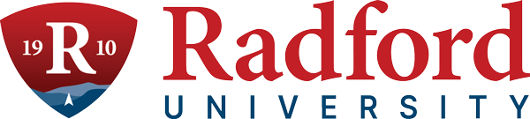
Subscribe to our email list.

801 East Main Street | Radford, VA 24142 US

