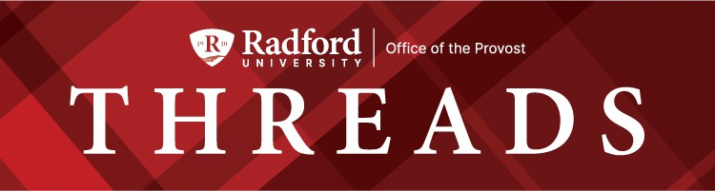

January 27, 2025

A Message from Provost Usher

Message from Provost Usher Provost Speaker Series Library News
Women's History Month
Sponsored Programs and Grant Management OURS News
Honors College Event Graduate Affairs
General Education Taskforce Update Waldron College Events
Citizen Leader Update Wicked Festival Invitation
I joined Radford University as we were going through the process of updating our “brand.” While usually skeptical of this type of corporate activity at a university, what I found was our partner did an excellent ethnography of Radford University. And the characteristics that they identiﬁed aligned with my values, making me proud to join the Radford Community:
Genuine Kind Inclusive Unexpected Curious Motivated

The Radford Code of Ethics echos these principles:
Respect

Honesty and Integrity Communication Stewardship Excellence
Responsibility and Accountability
With guidance from the community and the Strategic Planning Committee, I’m happy to see that our nascent strategic plan is building on these qualities to dedicate us over the next years to serving our students, with a commitment to the well-being of our communities (students, faculty, staff, and regional and state constituents). While we will evolve, the on-going work shows a commitment to these values.
If you have been thrown off balance by the national news in recent weeks, take heart in remembering that we have a strong culture of care for our Radford Community
members. Together, we can continue to support each other and embrace the differences that make us stronger as a university. We dedicate ourselves to our values, encouraging free speech and debate, teaching critical thinking and information literacy, and creating a community
where everyone feels like they belong.
Last Monday, VP Susan Trageser and her Student Affairs team led the student Advocacy Day training. Several members of the Cabinet were cast as state legislators for the student teams to practice their skills. Our students were amazing! It was such a joy to act like a skeptical Senator and have the students convince me of the value of supporting Radford University through their personal stories. They each emphasized how much they had learned from their caring, smart, and dedicated faculty. You should be proud!
Congratulations on getting the semester started well, despite the cold, for our over 7000 students this semester. Thanks to the many of you who attended the Our Turn sessions, modeling the lifelong learning (the curiosity and motivation) we want to instill in our students.

The semester will be busy, as seen in the all the items below. Two additional items I want to draw your attention to:

- Please join us for the Provost’s Speaker Series this semester, starting with Luke Liska tomorrow night. The goal of these talks is to highlight the faculty and student impactful work in an accessible format that brings students, faculty, and community members together on campus.
- Encourage your students from all disciplines to apply for the SURF program. We have increased the award to $6000 for students for the summer, aligned with National Science Foundation best practice, which will hopefully give students more access to devote their summer to their undergraduate research projects.

My best to you- graduation will be here before we know it! Bethany

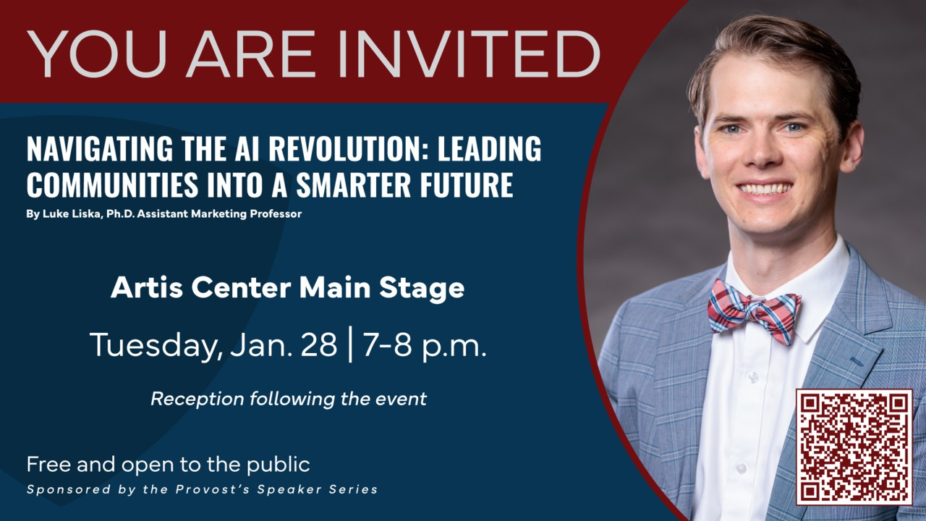
Discover how Artiﬁcial Intelligence (AI) is revolutionizing the way we live, work, and connect. Explore actionable strategies to harness AI, empowering you to make an impact in your community and beyond.
Whether you're a student, business leader, or engaged citizen, this conversation will equip you to leverage AI for meaningful change.
Artis Main Stage | Tuesday, Jan 28 | 7-8pm Reception will follow this event.

Library News

Celebrate National Hot Chocolate Day with McConnell Library! On Friday, January 31, stop by to make your own delicious cocoa mix to take home and enjoy.
Starting at 10am.

Come check out McConnell Library's CD collection! This collection covers a wide variety of genres, including folk/Americana. From traditional bluegrass to contemporary folk, you will ﬁnd artists such as Amythyst Kiah, Rhiannon Giddens, Billy Strings, Molly Tuttle, and Béla Fleck, all who have shaped the Appalachian music scene. Browse these as well as other popular and classic CDs on the 4th ﬂoor of McConnell Library.


Women’s History Month 2025 Call for Proposals
The Women’s and Gender Studies Program at Radford University is excited to host the Women’s History Month events for March 4 (Tuesday afternoon), March 5 (Wednesday all day), and 6 (Thursday morning), at Andrew W. Ross Student Art Gallery in McConnell Library.

Please submit y our proposals via Women’s History Month Proposal 2025 Form by February 19 (Wednesday), 2025.
Please note that all presentations, creative works, posters will be scheduled for these three days. The only exceptions are month-long activities, book clubs, and special events. Thanks for your submission. We appreciate your submission and look forward to celebrating Women’s History Month with you this March.
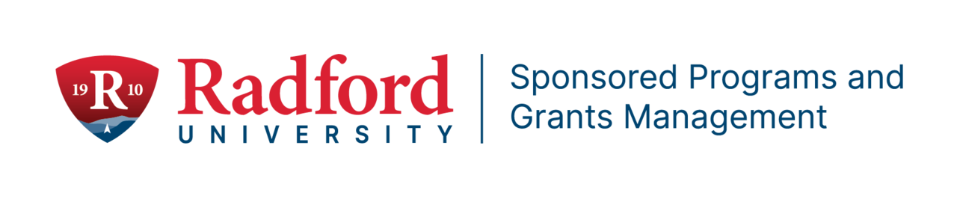

Upcoming Grant Writing Professional Development Opportunities
SAVE the DATE!!!
This will be an all-day Grant Writing Workshop present by Hanover Research for faculty and staff who are interested in writing external grants to either the National Science Foundation or the National Institutes of Health.
When: February 7, 2025

Where: Heth 014 Topics Covered:
Developing a Competitive AREA R15 Proposals.
Developing a Competitive NIH Proposal Developing a Competitive NSF Proposal

If you are interested in attending any of the workshops, please contact Tom Cruise at tcruise@radford.edu for the complete schedule (breakfast and lunch is included!)

Ofﬁce of Undergraduate Research & Scholarship

Ofﬁce of Undergraduate Research & Scholarship Invites Student Summer Research and Creative Inquiry Proposals
The Ofﬁce of Undergraduate Research & Scholarship (OURS) is now inviting proposals from Radford University and RUC students in all disciplines for the Summer Undergraduate Research Fellowship (SURF) program. All currently enrolled, degree seeking undergraduate students who will graduate after the fall 2025 semester are eligible to apply. Awards are for a $6,000 stipend to the student recipient, $1500 stipend to the faculty mentor and a small supply budget.
Applications must be completed and submitted by midnight Wednesday, February 19, 2025. The expectation is that students will work under a faculty mentor to complete the proposed project for 10 weeks during the summer. The faculty mentor should help plan the project, assist with proposal development, and actively participate in the implementation of a student’s project. Biweekly professional development meetings will be held virtually to support and celebrate the participating students.
Students are encouraged to make an appointment or visit the OURS ofﬁce during normal business hours in Whitt 118 for guidance and direction on their proposal drafts. For more on the program and the proposal process, visit:
http://www.radford.edu/surf or contact OURS at ours@radford.edu or 540-831-7203.

Student Engagement Forum April 29-30, 2025
The Ofﬁce of Undergraduate Research & Scholarship (OURS) is pleased to announce dates for the 34th Student Engagement Forum. Ideas for discipline or course-based sessions are welcome, and we would be happy to plan those sessions as requested. Oral presentations, poster sessions, visual arts exhibitions, e-portfolios, panels, performing arts presentations, and other ideas are invited from all disciplines. Presentations accepted at other conferences are also welcome. Please save the dates below to ensure timely submission of your projects.
March 21 – Title and author submission deadline for all presentations April 14 - Poster printing submission deadline

Posters will primarily be on Tuesday April 29th and oral presentations Wednesday April 30th.
We look forward to working with you to create an exceptional opportunity for students to share their scholarly and creative contributions with the Radford campus and the community.
Faculty, staff, and students are encouraged to reach out to the OURS ofﬁce in Whitt
118, www.radford.edu/sef, ours@radford.edu, or 540-831-7203 with their ideas for disseminating their work in April.

Honors College

2025 Honors Lecture
The Honors College invites the entire campus and community to the 2025 Honors Lecture on Tuesday, February 4th at 4pm in the Bonnie Auditorium. Science journalist and author Jason Bittel will speak on “From Star Stuff to Snow Leopards: The Science of How You Are Connected to Literally Everything.” Jason has been funded as a Knight Science Journalism Project Fellow at M.I.T. and a National Geographic Society Explorer. Appearing in numerous outlets including the New York Times and the Washington Post, he is also the author of three books and the forthcoming Sort of Funny Field Guides in 2026. A reception with Jason will follow the talk. This event is free and open to the community.

Graduate Affairs News

Outstanding Graduate Student Awards Nominations due date: Wednesday, January 29, 2025.
Eligibility:
- A nominee must be a degree-seeking graduate student at Radford University.
- They should possess a record of superior accomplishment that strongly reﬂects the mission and vision of the Ofﬁce of Graduate Affairs.

Awards:
- One award of $750 will be presented in each of the following ﬁve categories:
  - Graduate Student
  - Doctoral Student
  - Graduate Assistant
  - Graduate Teaching Assistant
  - Graduate Teaching Fellow
More information about Awards

Electronic Graduate Academic Petition and Program Change Request Form
The Graduate Academic Petition and Program Change Request form is now fully online. This form

can be located via a link on the Graduate Affairs website (https://www.radford.edu/graduate-affairs/forms.html) as well as through a OneCampus tile. A brief tutorial for creating and reviewing the Undergraduate Academic Petition form, which is similar to the Graduate form, is available through the OneCampus platform.

Professional Development Opportunities:

- Tracking the Literature: Identifying and Tuning into Scholarly Conversations: Tuesday, January 28, 6:00–7:00 PM
- Inclusive Citation Practices: Amplifying Marginalized Voices: Monday, February 24, 6:00–7:00 PM
- Dr. Richard Benson's Presentation: The Legacy of Malcolm X After 100 Years: Tuesday, February 25, 2025,12:30–2:30 PM
- Mr. Dale Long's Presentation: Cinematic Realism: Surviving the 1963 16th Street Baptist Church Bombing in Birmingham, Alabama: Thursday, February 27, 2025, 12:30–2:30 PM
Information about Professional Development Opportunities

Graduate Student Book Club:

Come join Dr. Nadine Hartig, nhartig@radford.edu, to explore and learn how to Dare Greatly, by Brene Brown, Ph.D., MSW. This powerful phrase comes from Theodore Rosevelt’s speech, “Citizenship in a Republic” given in 1910. Dr. Brene Brown is a research professor at the University of Houston Graduate College of Social Work and founder and CEO of The Daring Way – a teaching and certiﬁcation program. Meetings are virtual and face-to-face. We hope to see you!

- January 29, 4-5pm (Introduction to Chapter 2)
- February 26, 4-5pm (Chapter 3-5)
- March 26, 4-5pm (Chapter 6-ﬁnal thoughts)
Virtual meetings: Zoom Link: https://radford.zoom.us/j/93597982444 Password: 314660
Join from a Telephone：
Dial +1 408 638 0968
Enter Meeting ID 93597982444 Password: 314660
Face to Face meetings: Location: Graduate Affairs lounge or conference room (across the hall from each other, ﬁrst ﬂoor Whitt)

- January 29, 12-1pm (Introduction - Chapter 2)
- February 26, 12-1pm (Chapter 3-5)
- March 26, 12-1pm (Chapter 6-ﬁnal thoughts) April 16, 12-1 Pizza party for all who can join us!

Citizen Leader Program – Restructure Spring 2025
The Citizen Leader Program begins its restructuring process this semester. We hope elements of Citizen Leader will be integrated into a new general education program which will provide greater institutional support. This would better serve our students as they develop into engaged
citizens upon graduation. Since the COVID-19 pandemic, students have shown waning interest in the program even though we have implemented changes designed to engage students and
to help them succeed. There were several students over the last six years who were deeply engaged in the program and beneﬁtted from it while at Radford and beyond.
The transition, starting this semester will be led by Dr. David Beach, dbeach6@radford.edu, the Director of Undergraduate Curriculum. Dr. Jean Mistele, long-time director of the program, has been consulting with him, and the Citizen Leader board members may continue in their role as
advisors if they so choose.
Dr. Mistele will ﬁll the recently vacated Faculty Fellow position in the Graduate Affairs Ofﬁce. From Dr. Mistele: “I want everyone who has worked with me across campus to know how much I appreciate each of you for your support. Most of all, I appreciate all the new friendships that developed over the last 6 years, which were most enjoyable.”

Update from the General Education Improvement Task Force
The General Education Improvement Task Force continues to work on a draft model for a GE program. Last week, faculty should have received the draft mission and values statements, program goals and learning outcomes, and structure. Last week, the Task Force developed an architecture for assessment, and next week will develop an implementation timeline. Earlier this week, representatives from the Registrar’s Ofﬁce, Advising, IT, and the Provost’s Ofﬁce met to start discussing details of implementation and budgetary implications.
Thanks to those who have provided feedback on the structure which can be found at https://www.radford.edu/faculty -senate/_documents/task-force/gen-ed-draft-structure.pdf. If you would like to provide feedback, please use this Qualtrics survey link: https://radford.co1.qualtrics.com/jfe/form/SV_e4LyMjMbMY9mSIm.
The Task Force will meet on the following dates to accomplish various tasks:
- Jan 27 – implementation timeline
- Jan 31 – review structure, assessment, and implementation considering feedback from faculty
- Feb 10 – prepare ﬁnal recommendations

All information on general education improvement can be found on the Faculty Senate’s web page, https://www.radford.edu/faculty -senate/gen-ed-improvement.html.
David Beach, Chair, General Education Improvement Task Force

Waldron College of Health and Human Services

Social Determinants of Health Lunch and Learn Series

On behalf of the Waldron College Equity Committee, I invite you to participate in our upcoming Lunch-and-Learn session, Social Determinants of Health for Older Women. The session will be led by Dr. Diane Hodge of the School of Social Work and held via Zoom on Thursday, January 30 from 12:00 – 1:00 pm. No advance registration is required. Students are also welcomed, so please share this invitation with anyone who may be interested.

Event Summary:
In the context of social determinants of health (economic stability, education, healthcare, environment, social context, physical environment, etc.), we will discuss unique and speciﬁc social factors that affect older women’s mental/physical health through statistics and information available. Social factors are often interwoven and complex. For example, the historical gender bias and lack of funding in research has left post-menopausal women with little information on chronic conditions and treatments. How do we break this cycle? The majority of our time will be spent discussing what healthcare professionals can do to support better health outcomes for older women.

Spring 2025 Interprofessional Case Study Event

The 2025 Waldron Interprofessional Case Study event will bring together students from various health and human services disciplines to foster collaboration and enhance interprofessional communication. Participants will work in small groups to tackle a ﬁctional yet realistic scenario, discussing the roles and responsibilities of each profession involved in the care of a complex patient case. The event promotes critical skills such as teamwork, empathy, and cultural competence, with the goal of preparing students to work effectively in interdisciplinary teams to improve patient outcomes. This bi-annual activity is an integral part of Waldron College's commitment to interprofessional education and helps students understand how their diverse skill sets contribute to comprehensive, patient-centered care.

Friday, February 28, 2025
8:30 am – 12:00 pm
Radford University

Questions? Contact Dr. Laura Jacobsen, Interim Associate Dean for Interprofessional Education, Waldron College of Health and Human Services
Email: Ljacobsen@radford.edu

Invitation: Join Wicked Festival
Dear Radford Faculty:
In Fall of 2021, faculty in Philosophy and Political Science started the Wicked Festival. In the intervening years, it has grown from 100 to 500+ students per semester, showcasing faculty and students from six of Radford's colleges.
The Festival's secret sauce is that students make themselves experts on complex (wicked) public problems, they work to ﬁnd solutions to the problems, and they present their solutions in public

where they are the authorities on their issue. Students report their conversations with other students are empowering. The feedback they receive at the festival from faculty and fellow students enables them to improve their ﬁnal solutions.

801 East Main Street | Radford, VA 24142 US
Over the last few years, we have found the Festival builds important skills like teamwork, communication, leadership, and critical thinking. Unbeknownst to me when we started, it was also building conﬁdence, hope, empathy, and public-mindedness too. Further, the Wicked initiative points us in new directions for the future of higher education. If "the answer" is freely available on ChatGPT, where is the university's value added? We have found wicked teaching is a great way to add value to our students' undergraduate experience and their career/citizen futures.
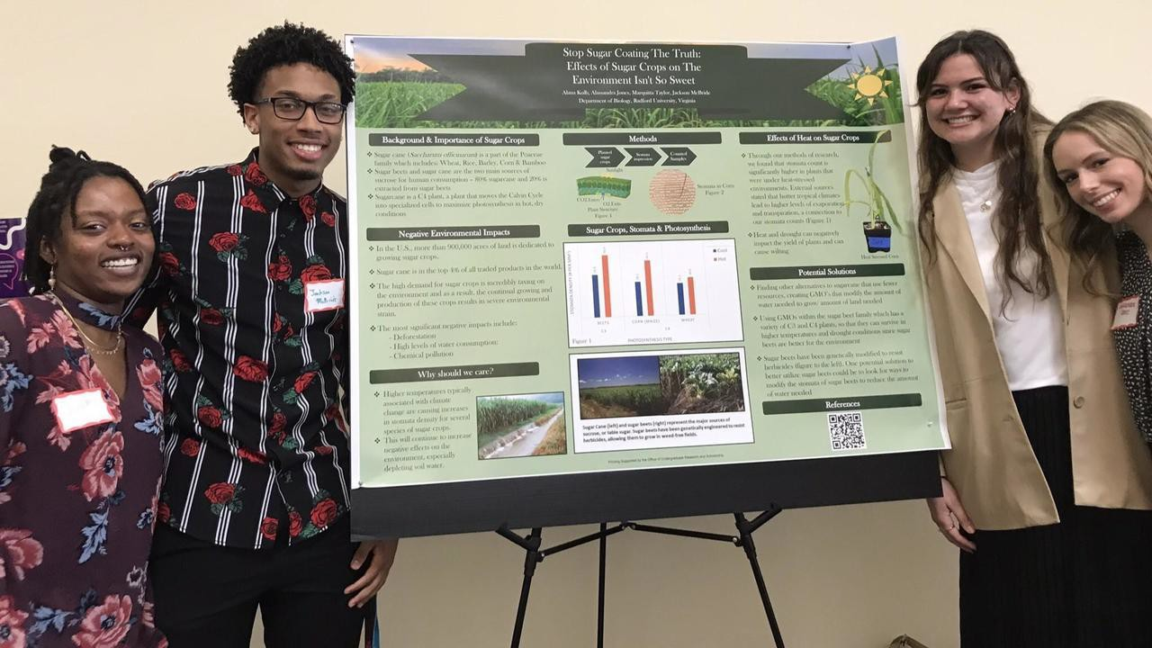
If getting students to ﬁnd solutions to complex public problems might ﬁt with your teaching, I invite you to join the Wicked Festival this semester or this year. Classes join the festival under their instructor. All students in the class can participate in the festival or a selected group. The festival exists to support faculty and their learning goals for their students.

If you'd like to learn more about the festival, please check out the website at: https://www.radford.edu/humanities-behavioral-sciences/wicked/festival.html. To learn more about the campus' broader Wicked Initiative, check out: https://www.radford.edu/humanities-behavioral-sciences/wicked/.
If you'd like to join the festival this semester, please reach out to me as soon as possible at etan3@radford.edu. If there is interest, I'll set up an informational meeting for new faculty early in the spring semester.
If you haven't seen the festival, please put it on your calendar. This semester, the festival will be held Tuesday April 15 5-8pm in the Artis Center.
The Wicked Festival was launched by the College of Humanities and Behavioral Sciences. It is supported by CITL, Citizen Leader, and OURS and hosted by the College of Visual and Performing Arts in the Artis Center.

Ofﬁce of the Provost Radford University Martin Hall 331
540-831-5404



Subscribe to our email list.

