

January 12, 2026

Message from Provost Usher

Welcome to the ﬁrst day of Spring 2026 classes! I was so excited to see the over 7250 students back today - more than 100 more than started classes on the ﬁrst day of the Spring 2025 semester.
For many of you, this isn’t your ﬁrst day back. Many of you organized, presented, or attended the spring Our Turn - I love how that has become an opportunity for the Radford community to share your expertise with each other across teaching and other academic and program areas. I also know the Registrar and Advising teams (as well as Student Affairs) has been busy before and after break supporting our students. Thanks to everyone involved.
We continue to make progress on curriculum. The new General Education Steering Committee (co-chaired by Matt Close, Faculty Senate President, and me, and managed under David Beach, Director of Undergraduate Curriculum) met on Friday to report on progress and make plans for the semester. As this general education program develops, I get more excited about it. I’m also impressed by the work to bridge through REALx that is serving our students and helping us meet state and accreditation requirements. We also continue to advocate with SCHEV on the Program Productivity policy - edits will be considered at the January meeting but I am not expecting action yet. I’ll keep you updated. In good news, according to a new analy sis by the Chronicle of Higher Education based on the Education Department’s data, all of our programs “pass” a student return-on-investment test. We all know that earning a college degree has many beneﬁts to students and communities beyond simple individual earnings, this is a good sign for the value of the education we offer. [Note that everyone on campus can get free accounts for the Chronicle and New York Times through the University Libraries]
During the break, I helped my parents prepare to move to a senior community. It’s a hard transition for them, emotionally and physically, but will be positive once they are settled. Relatedly, I listened to The Correspondent by Virginia Evans on the drive, which tells the life story of an older woman through the letters she writes. The book was a lovely reﬂection of grief and joy at the far end of a life.
Best of luck - have fun this week meeting your new students! Bethany

Good News!
Starting this academic year with the new bookstore contract, funds are available to give to students

in need of a book or supplies. Please direct any students to the ofﬁce of ﬁnancial aid ﬁnaid@radford.edu and have them request bookstore support and the staff will take these request case-by-case.
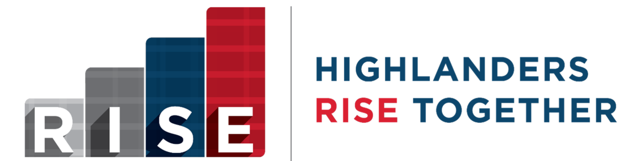

The RISE QEP program is celebrating a year of connection and renewal and making plans for the future! Our second cohort of Faculty Fellows (class of 2025), representing 6 out of 7 colleges, have completed their year of professional development and are implementing inclusive and active pedagogy strategies with their students. Some are developing new ways to build professional relationships with their students, others are making group work more meaningful, and many are allowing more student voice and choice in their classrooms. And, our new 2026 Faculty Fellows just kicked off their work together on January 9th. The RISE College Action Teams (RCAT) had a fall semester of growth and student-centered discussions, while tailoring their events to their students’ needs. The RISE Advisory Board is reviewing progress and reﬁning our vision: Radford University is a community providing support and fostering engagement for all students. If you are interested in getting involved in RISE, reach out to us at rise@radford.edu.


Graduate Affairs by the Numbers:
Radford conferred 171 graduate degrees in December 2025.
Out of 1,698 active graduate students in spring 2026, 98% are in good academic standing.

Dates to Know:
Classes Begin: January 12, 2026
Application to Graduate Opens: January 12, 2026 Martin Luther King, Jr. Day: No Classes
Full Semester:
Last Day to Add/Drop Graduate Students: January 26, 2026 Census Date: January 26, 2026
Fast Track Spring A:
Last Day to Add/Drop: January 16, 2026 Census Date: January 19, 2026

Fast Track Spring B:
Last Day to Add/Drop: March 13, 2026 Census Date: March 16, 2026

Professional Development:
Leadership Academy (free) - 5-Session Training Seminar
Graduate students learn leadership from Harvard Kennedy School-trained faculty, engage in real world cases, and reﬁne their leadership style. Apply soon at QR code on slide below.

Highlander Research Blitz - 3-Minute Research Competition
Students (graduate & undergraduate) showcase their work with just one slide in three minutes.
Information session Tuesday, January 20th (REVISED DATE) 5:30pm Whitt 116/Zoom (password GRAD). Highlander Research Blitz applications due 2/20/26. Information and applications Contact Dr. Paige Tan at etan3@radford.edu for more information.

Graduate Student Research Travel Funds are still available: APPLY HERE

Upcoming Events:
Ofﬁce of Graduate Affairs Coffee Hour: January 20, 2026
Join the Ofﬁce of Graduate Affairs for coffee and conversation every other Tuesday from noon to 1:00pm at the Highlander Hotel coffee shop, Red Provisions. Meet our staff, connect with fellow students, and enjoy a cup of coffee and lunch with us. Our treat!

The Ofﬁce of Graduate Affairs Faculty Fellow, Dr. Paige Tan is looking to enhance programming on careers for graduate students. Please get in touch with ideas for general or program-speciﬁc sessions that would help your students achieve their career goals.
Reach Dr. Tan at etan3@radford.edu/540-831-5752.


Academic Petitions: Earlier Updates for In-Progress Coursework

Good news! The Registrar’s Ofﬁce can now code many approved petitions in the degree audit sooner, even when the relevant course is still in progress (or pre-registered). We’re using an updated coding approach in DegreeWorks that allows exceptions for in-progress classes to be entered, without incorrectly counting if a student later fails to meet minimum requirements. Please note that some petition types still require a posted ﬁnal grade before they can be entered, depending on the nature of the exception.

Please submit petitions for approval in Kuali as soon as possible to help with timely degree audit updates, support accurate academic planning, and streamline graduation review.
If you have any questions on this updated process, please contact the Ofﬁce of the Registrar at registrar@radford.edu.

Spring 2026 Undergraduate Graduation Applications Reviews

Review of Spring 2026 undergraduate graduation applications is complete, and all departments have been notiﬁed. Faculty and advisors should carefully review graduation application information and degree audits for students who anticipate graduating in Spring 2026. If petitions for missing requirements are needed, please submit the petitions for approval in Kuali asap.
If a student is missing from the list provided, this indicates they have not applied to graduate. Please advise them to contact the Registrar’s Ofﬁce immediately to submit their application. Graduation application information is available at radford.edu/graduation. Please contact graduation@radford.edu for information.

Spring Final Exam Schedule
Spring ﬁnal exams are Tuesday, April 28 – Friday, May 1. The academic calendar and ﬁnal exam schedules are available on the Ofﬁce of the Registrar webpage.

Spring Final Grading Deadline Extended
The spring ﬁnal grading deadline has been extended to 5 p.m. on Monday, May 4th. More information about grading is available online. Contact registrar@radford.edu with questions.
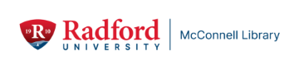

McConnell Library will offer a free camp for elementary-aged children on Monday, Jan. 19, from 7:45 a.m. to 4:30 p.m. in honor of the Martin Luther King, Jr. holiday and as part of Radford University’s MLK Day of Service.
Parents can sign up their children to participate online or by calling 540-831-5688. There are parent/guardian release forms to complete after registration. Please note that space is limited.

Activities will include programming by students in the Schoolhouse Living-Learning Community for future teachers, a trip to the Radford University Planetarium, games at the Student Recreation and Wellness Center and a free lunch at Dalton Hall for all campers, courtesy of Chartwells Dining Services.
This one-day camp is sponsored by McConnell Library, the Schoolhouse Living-Learning Community with Brian Kitts, the Radford University Planetarium, Chartwells Dining Services, the Radford University Museum of the Earth Sciences and the Student Recreation and Wellness Center.
For more information, contact Alyssa Archer at aarcher2@radford.edu or 540-831-5688.

If a parent wants to participate in Radford University’s MLK Day of Service but has childcare concerns, this camp can provide them with support. However, parents are not required to volunteer to sign up their children for the camp.

CRAFT CORNER

Feeling crafty? Want to reduce stress and improve your mood? McConnell Library’s Craft Corner is waiting for you. Located in the McConnell Lounge on Level 3 near the Front Desk, the Craft Corner has an ever-changing collection of craft supplies that are free for in-house use by all library patrons. You might ﬁnd different papers, markers, crayons, pencils, and coloring sheets; scissors and stickers; adhesives and stamps; and maybe yarn or pipe cleaners. Even the most unusual items can be turned into art – such as egg carton ﬂowers.
Shelves are stocked with new supplies from time to time, and contributions are always welcome. The Craft Corner is available anytime the Library is open. Happy crafting!
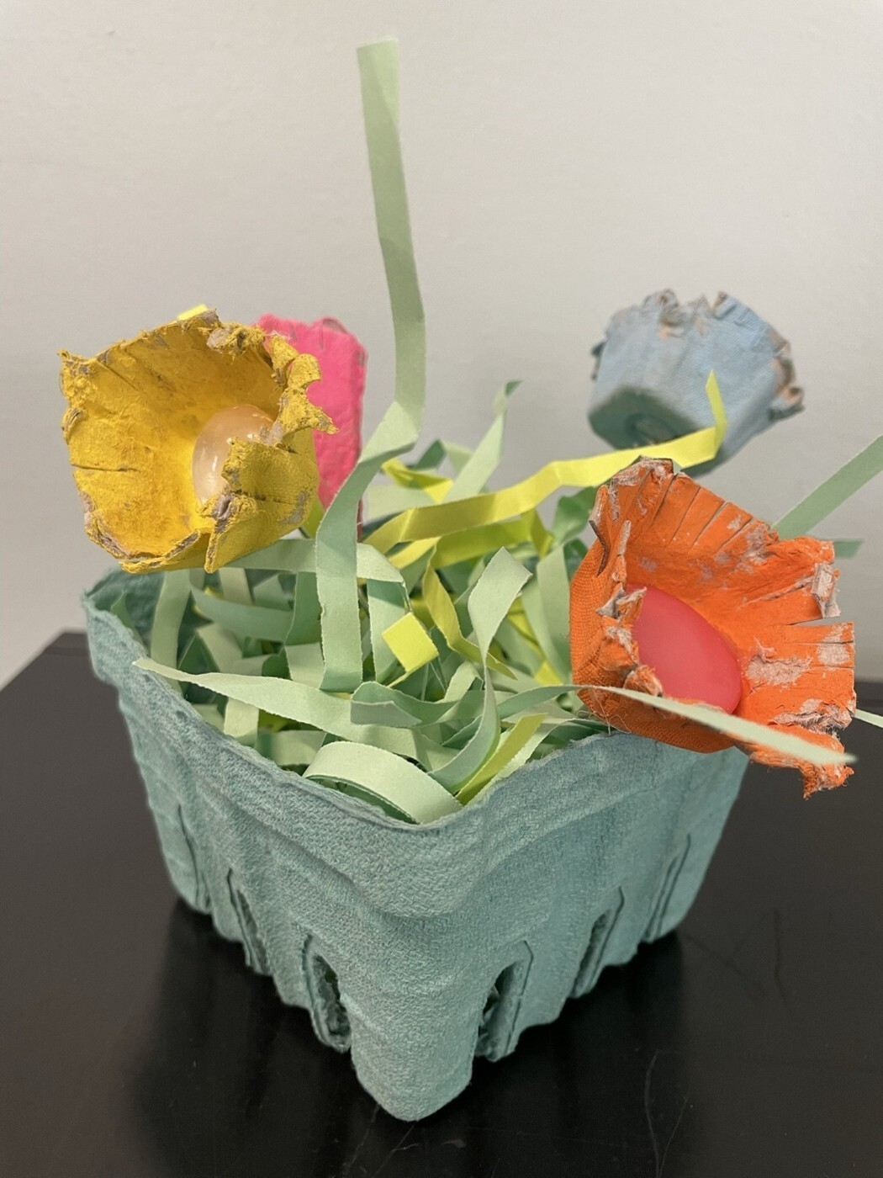

LIBRARY INSTRUCTION
Make Your Job Easier (By Helping Us Do Ours)

- Main campus faculty: please ﬁll out the online form to request a workshop for y our course. We offer in-person, online synchronous, and asynchronous workshops tailored to your courses’ information literacy and library research learning outcomes. Contact Alyssa Archer, Head of Research Services, at aarcher2@radford.edu with questions or to discuss ideas to help your students learn research skills to improve their course performance, and to demonstrate to students the value of the Libraries to their academic and lifelong learning.
- If you’re at Radford University Carilion or the Roanoke Higher Education Center, please email our Clinical Instruction and Outreach Librarian, Mary Catherine Santoro, at msantoro@radford.edu. Be sure to include information about your class, the topics to cover, and preferred format, date, and time.
- The University Libraries also offer self-paced D2L modules in avoiding plagiarism, APA, evaluating sources, SuperSearch search strategy , and other research skills.

Support Course Material Affordability

Main campus faculty: use the Course Reserves Request Form for library or personally-owned physical materials that you’d like students to access whenever the library is open. Have you picked up a class last-minute? Find no-cost library and OER course materials and learn how to add library sources into D2L. And thinking ahead to future semester course schedules, inform the Bookstore and the Registrar if you are keeping a course’s materials free or under $40. This lets students know in advance that they can anticipate low materials costs for a speciﬁc course, removing some anxiety as they budget.

Include the Library in Your Syllabi as a Resource
The University Libraries supports students in ﬁnding, evaluating, and citing sources
through Research Help services, including 24/7 ‘Ask a Librarian’ live chat. The libraries offer a wide range of spaces, events, and services, including AV equipment checkout and Course Reserves.

HOURS OF OPERATION

McConnell Library hours, Radford University Carilion Library hours, and McConnell Library Research Help Desk hours are available here: https://www.radford.edu/libraries/about/visit.html.
Ask a Librarian live chat operates 24/7. Contact the Research Help Desk at refdesk@radford.edu or through Microsoft Bookings to set up a consultation during or outside of regular hours.
Archives & Special Collections Reading Room has drop-in hours on Tuesdays and Thursdays:
- 9:00 AM – 11:00 AM
- 2:00 PM – 4:00 PM
And by appointment:
Email archives@radford.edu to schedule a time.


Need to ﬁnd funding for next big idea?
With an increasing number of applicants competing for fewer grant dollars, every higher education institution is looking for an edge in its grant strategy. Our research consultants at Hanover supports colleges and universities with expert research development, grant writing, and strategic advising. Their professionals deliver customized proposal review, revision, and production support, while also helping to align strategic priorities to funding trends and opportunities across the grants landscape.
Hanover also supports faculty by providing an avenue to ﬁnd potential funders who may be interested in your idea. Whether that be through their prospecting reports, forecast of upcoming grant opportunities, or through their funding opportunity database, they offer a wealth of resources to help you get started. If you are interested in learning more about these opportunities and to get signed up, please contact Tom Cruise in Sponsored Programs at tcruise@radford.edu

Funding Opportunity for Undergraduate Research

The National Institutes of Health (NIH) is now accepting proposal applications to strengthen research training environments and develop a pool of well-trained students who complete their baccalaureate degrees in biomedically-related ﬁelds, and transition into and complete biomedical, research-focused higher degree programs. Speciﬁcally, this funding announcement provides support for evidence-informed approaches to biomedical undergraduate training and mentoring to help build a strong biomedical research workforce for the nation.
Proposals are accepted on: May 25, 2026 and September 25, 2026.

Find out more about Sponsored Programs

Engaging with Industry Partners
Thursday, January 29th
12-12:45 pm ET / 9-9:45 am PT
Register Now

Building strong relationships with industry partners can open new avenues for funding and collaborative research.
In this webinar, we offer practical strategies for building successful industry partnerships, emphasizing the importance of understanding cultural differences and aligning goals for mutual beneﬁt.
Attendees will learn how to communicate effectively, initiate collaborations, and leverage a wide range of engagement opportunities.
Webinar: Engaging with Industry Partners Date: Thursday, January 29th
Time: 12pm ET / 9am PT

Speakers:
Rob Guroff — Managing Grants Consultant, Hanover Research
Clinton Doggett — Senior Grants Advisor, Hanover Research

Unable to attend? Register and we will send a copy of the recording and slides after the webinar.


Happening Tonight!

Cool Blue Grass, and Hot Cocoa January 12, 2026
6pm - 9pm Artis Hub, CVPA

Each year, the College of Visual and Performing Arts carefully selects world-class professional individuals or companies to perform for the campus and surrounding communities. We are proud to present internationally renowned performers at Radford University. This year is no exception.

The Acting Company presents Great Expectations
Wednesday, January 21, 2026
7:30 p.m. in the Bondurant Auditorium Preston Hall
Get Tickets Here

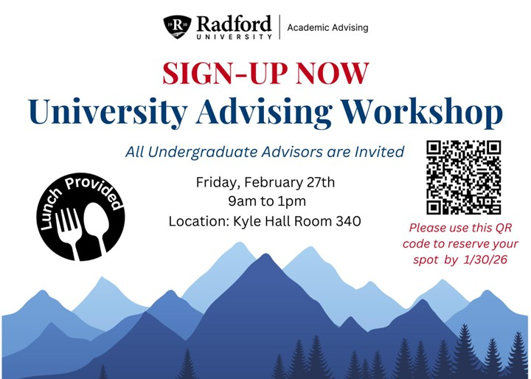
We are excited to announce the ﬁrst annual University Advising Workshop on Friday, Feb. 27th, designed for all faculty and professional advisors at Radford University. Based on feedback from the fall 2024 faculty advisor survey, this grant-funded workshop was created to provide all advisors with updates and training from campus partners on university technologies, policies, processes/procedures, and general education curriculum ensuring consistent academic support to all undergraduate students. Please sign-up by clicking here or using the QR provided, by Friday, Jan. 30th.

Navigate 360 Implementation Update
Implementation of Navigate 360 is underway as the University advances a coordinated, institution-wide approach to student success. Navigate 360 will support student success efforts across academic and administrative areas, enabling more coordinated outreach and support.
Current efforts are focused on conﬁguring the system and integrating institutional data within the test environment, a process that remains ongoing, as well as collaborating with functional areas to begin the development of care units. We are working closely with departments across campus to address implementation considerations and to engage in broader discussions regarding processes that impact students, faculty, and staff.
To ensure that instructional and faculty perspectives are meaningfully incorporated, Dr. Riane Bolen has joined the implementation team to help develop feedback loops to inform decisions related to teaching, learning, and academic engagement.
A soft launch is planned for April 6, with continued development throughout the summer and a full institutional launch of Phase I anticipated by August 2026. We will continue to provide updates and


information as it becomes available.
For questions about Navigate 360, please contact Susan Hudson, Director of Student Success and Retention, at smhill@radford.edu.
Ofﬁce of the Provost Radford University Martin Hall 331
540-831-5404
Subscribe to our email list.

801 East Main Street | Radford, VA 24142 US

