

February 9, 2026

Message from Provost Usher

Colleagues,
Just a brief update today, as many of us are still catching up from the onslaught of winter weather over the past few weeks. The forecast calls for season warmth (above freezing!) this week, so let's hope for some melting. That will allow us to partake of the myriad of activities listed below, including RadTalks, CVPA performances, visiting lectures, etc. The semester is now in full swing!
Thank you all for your work and patience during all that weather. I appreciate the switch to the alternative modes of classes last Monday. Given our tight academic schedule, we don't have much opportunity to give in person make-up days, so doing more remote learning is a good option to keep learning happening. As a reminder, if you need to schedule an in-person make-up time, please contact scheduling@radford.edu.
Have a great week! Bethany


Join us on Feb 17 at 7pm for RAD Talks | Investigating Tax Fraud and Financial Crimes with Rob Warren | Radford Public Library


April 29, 2026
Please Save the Date for the Faculty Awards Ceremony, celebrating the outstanding achievements of our colleagues! This special event will honor T&R and AP faculty members who this year were awarded external funding, internal SEED grants, Faculty Professional Development Leave, University Awards, Dalton Eminent Scholars, as well as folks who submitted external awards.
This ceremony will take place on April 24, 2026 in Kyle 340 from 3-5pm.

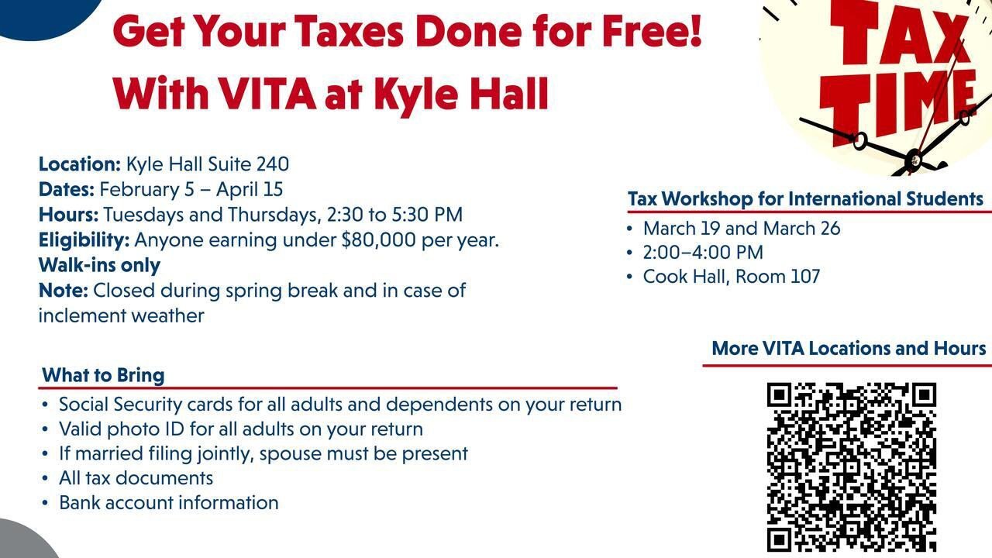
Need help with your taxes? We've got you covered!
Have your taxes done for free with VITA at Kyle Hall (Suite 240). Services are available from Feb 5 - April 15 on Tuesdays and Thursdays, 2:30pm to 5:30pm. Walk-ins only. Anyone earning under $80,000 per year qualifies.
What to bring:

- Social Security cards for all adults and dependents on your return
- Valid photo ID for all adults on your return
- If married filing jointly, spouse must be present
- All tax documents
- Bank account information


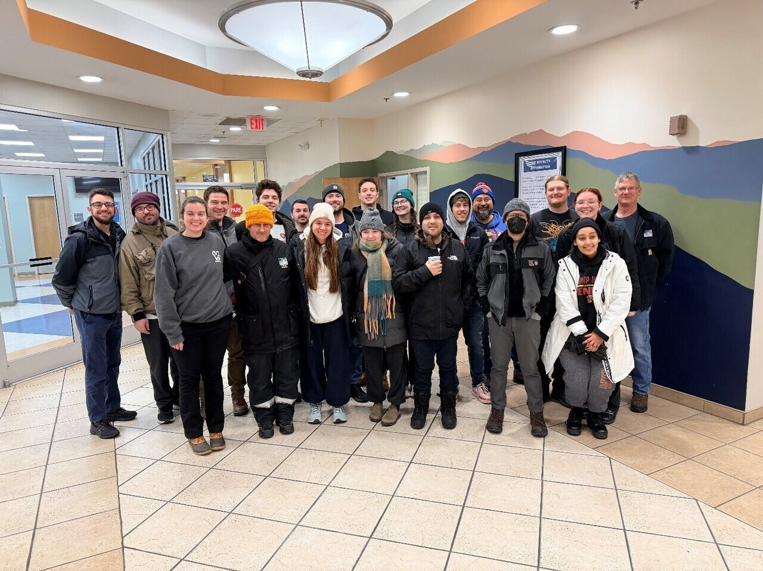

Point-In-Time (PIT) counts of sheltered and unsheltered people experiencing homelessness occur yearly in Roanoke and across the country. The counts provide a snapshot of homelessness on a single night and takes place yearly in January. The Radford University Physician Assistant (PA) students have been helping with the count for 14 years. The data collected provide important information to area service providers, regional and federal policy makers, and enables the Blue Ridge Continuum of Care Region of Virginia to qualify for federal homeless assistance funds.

Organized by PA faculty member Judy Smith, PhD each year, the PA students volunteer with the Blue Ridge Interagency Council on Homelessness to complete this task. They partner with the Homeless Assistance Team and other community organizations to administer a survey to individuals experiencing homelessness and to assess their immediate healthcare needs. They go in the early hours of the morning, before sunup, and search the streets, under bridges, in doorways, and at encampments to interview the unsheltered individuals. This year, with faculty member Luke Swatzyna, MS, they braved icy sidewalks and temperatures in the teens to complete this task. We are grateful they have been participating for 14 years.

The Symposium brings together students and faculty from across disciplines to share scholarship around health, healthcare, and community well-being. Students and faculty are invited to showcase innovative health-focused work through posters, roundtables, and workshop sessions. Submissions may include research, educational innovations, service initiatives, and community or practice-based projects. Interprofessional and interdisciplinary submissions are encouraged, including on emerging rural and regional health issues.
Abstracts are due March 8. Check out the 2026 Call for Abstracts for more information and a link to submit.
For more information on the Rural Healthcare Access Presentation or the Interprofessional Symposium, contact jlhall2@radford.edu

Join Dr. Morgan Montañez, Director of the Center for Social and Cultural Research, for an overview of current research on rural healthcare access and its community impacts. The session will highlight recent projects from the Center and explore opportunities for collaboration to advance regional health.
Feb. 10 | 12:00–1:00 PM EST | Linville Center (415C Artis Center) or via Zoom Password: RurHealth Sponsored by the Waldron College Health Advocacy Committee and the Linville Center for Interprofessional Education & Practice.

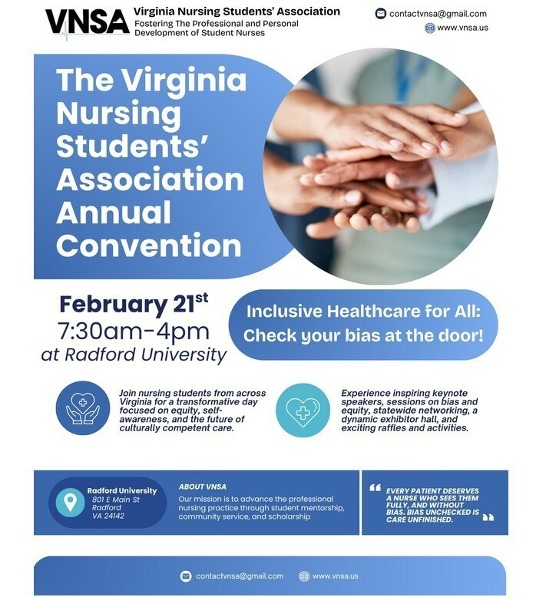

We have several things you can apply for or submit an application in at this year's convention! NSNA Poster Presentation (due 2/14 11:59pm)
VNSA Constituent (due 1/10 11:59pm) Scholarships and Awards (due 2/14 11:59pm)
Vacant Board Member Positions (due 2/14 11:59pm)
House of Delegates (must be a member of NSNA as of 1/4/2026)

We will welcome the Virginia Nursing Students' Association Annual Convention to the Radford University Campus on Saturday, Feb 21, 7:30am - 4pm.
Join the nursing students from across Virginia for a transformative day focused on equity, self-awareness, and the future of culturally competent care.

For more information and to register

CHBS Spring Series
Featured Speaker: Dr. Guy Axtell
Professor in Philosophy and Religious Studies

Wednesday February 18, Noon in Hemphill Hall 4700

Title: David Hume, Cooperation, and Active Hope
This talk will highlight the relevance of Scottish Enlightenment thinker David Hume (1711-1776) for social amelioration in our own time. Civil political oratory, a "progress of the sentiments," and social cooperation are difficult to motivate even in the best of times, and the more so in times of growing factionalism and affective polarization. This research talk utilizes ideas from Hume to illustrate the value of civic virtue, and in particular the virtue of active hope.



FINGERPRINTS OF HISTORY:
REMEMBERING THE ENSLAVED

Learn the ways that fingerprints tell the history of enslaved people. Historian Ben Jackson shares the hidden secrets of bricks, displaying how they become archives of history.
Thursday, February 19 | 1-3pm | Hemphill Hall 4700

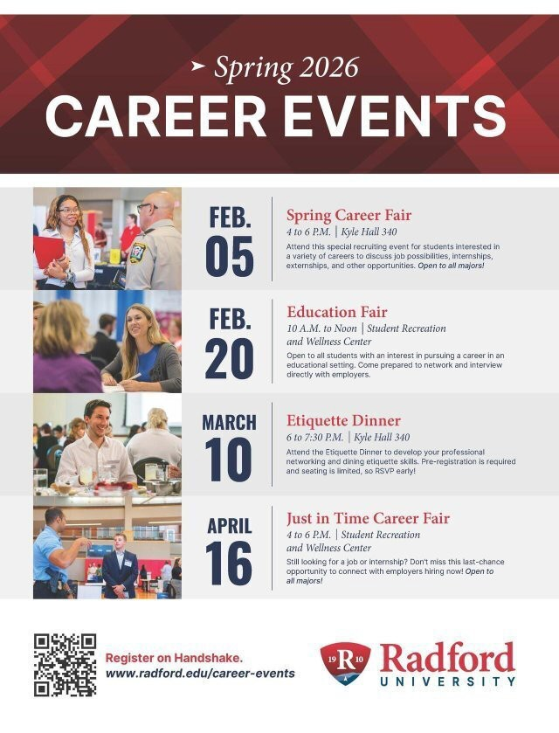
Upcoming Career Events:

- Education Fair, Feb 20 | 10am - Noon | Student Recreation and Wellness Center
  - Open to all students with an interest in pursuing a career in an educational setting. Come prepared to network and interview directly with employers.
- Etiquette Dinner, March 10 | 6pm - 7:30pm | Kyle Hall 340
  - Attend the Etiquette Dinner to develop your professional networking and dining etiquette skills. Pre-registration is required and seating is limited, so RSVP early!
- Just in Time Career Fair, April 16 | 4pm - 6pm | Student Recreation and Wellness Center

  - Still looking for a job or internship? Don't miss the last-chance opportunity to connect with employers hiring now! Open to all majors!
Register on Handshake



Hope is happening at Radford University! The Highlander Center for Character and Public Impact has dropped a podcast called "Hope Happenings," and we are interested in featuring acts of great character and service on campus. If you are involved in (or witness) activities that have a positive impact, please let us know. Click here for the first episode, which gives an introduction to the Center's activities. Contact hkeith1@radford.edu for more information or to report acts of hope and character.


University Libraries User Satisfaction Survey
The University Libraries want to give you an iPad. No, really.
We need your help. Please take a moment to take our brief (we promise!) User Satisfaction Survey and tell us what you think about your experiences with your library. You’ll be entered into a drawing for an 11th Generation iPad as our way of thanking you.
The survey will be open from February 9-20. You can fill it out at www.radford.edu/library -survey or by visiting McConnell Library or the RUC Library in person.
For questions or more information, please contact User Experience and Assessment Librarian Christina Manzo at cmanzo4@radford.edu.

Join the University Libraries for an Author Talk with Mills Kelly
Radford University Libraries is excited to host historian and author Mills Kelly for a special talk on his book A Hiker’s History of the Appalachian Trail. Kelly will explore the rich past of the iconic trail, share stories from his research, and discuss how the Appalachian Trail has evolved into a cultural landmark for generations of hikers.

- Thursday, February 19th
- 3:00 PM
- McConnell Library, Ross Gallery
Whether you're an outdoor enthusiast, a history lover, or simply curious about one of America’s most storied trails, this event offers a unique opportunity to learn from a leading scholar in Appalachian Trail history.
Copies of A Hiker's History of the Appalachian Trail will be available for purchase at the event. All are welcome and light refreshments will be served!
Learn more about the author at: https://millskelly.net/


Celebrate McConnell Day 2026!
Radford University Archives & Special Collections invites the campus and community to join us on February 25th at 10 a.m. for McConnell Day 2026, a special celebration honoring the 160th birthday of Radford University’s founding president, John Preston McConnell.
This year’s program is filled with meaningful moments that highlight McConnell’s lasting legacy. Festivities will begin with a lively performance by the Radford University Highlanders Pipes and Drums, followed by opening remarks from President Bret Danilowicz. Guests will gather on the McConnell Library steps for the christening ceremony, and then enjoy a special presentation from Mayor David Horton.
Additional highlights include:

- Brunch refreshments (10:45–11:45 a.m.)
- Birthday cake cutting at noon
- Exhibit tours and mingling beginning at 12:30 p.m.
- Closing remarks at 3 p.m.

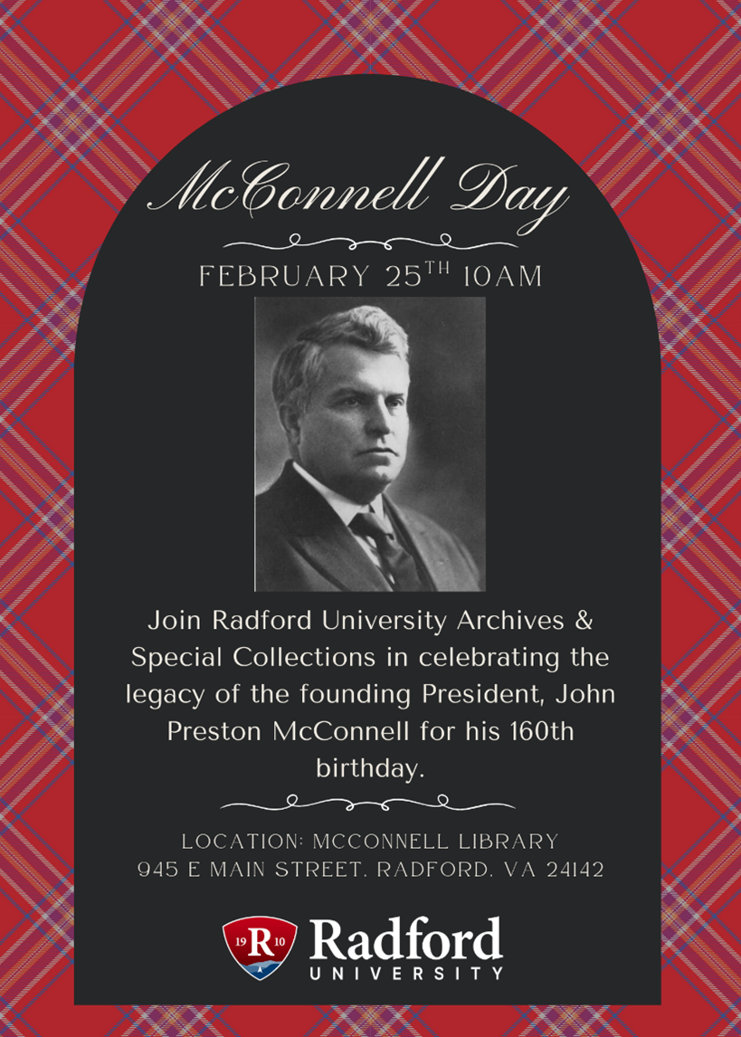
Parking is free in Lot GG, and all are welcome to attend.
Location: McConnell Library, 945 E Main Street, Radford, VA 24142
Join us as we honor a visionary leader and the enduring spirit of Radford University!



VASG 2026 Undergraduate Internships
Learn the Professional Skills You Need to be a Leader in Your Field

Application Deadline: February 20, 2026

Virginia Sea Grant's Summer Internship Program offers motivated students a unique opportunity to gain real-world experience in coastal and marine science, policy, outreach, and resource management. Each summer, interns work alongside graduate students and professionals on meaningful projects that support Virginia's coastal communities, ecosystems, and industries.
Eligibility: Students must be enrolled in an undergraduate program at a Virginia college or university. The student must have completed at least one year of study prior to the start of the internship and must be enrolled as a student throughout the duration of the project. Recent graduates (graduating May 2026 or earlier) are not eligible for this opportunity.

Available Positions:
Blue Crabs and Disease Ecology Research Intern
Virginia Institute of Marine Science
Gloucester Point, VA

Contaminants of Emerging Concern Research Intern
Virginia Tech Hampton Roads Agricultural Research and Extension Center
Virginia Beach, VA
Aquaculture Program Research Intern Virginia State University, Randolph Farms Petersburg, VA

Shellfish Aquaculture Technology Intern
George Mason University, Potomac Science Center
Woodbridge, VA
Marine Outreach and Engagement Intern Virginia Institute of Marine Science Gloucester Point, VA

Plastic Pollution Prevention Intern
Clean Virginia Waterways
Virginia Beach, VA

Aquaculture Ambassador Research Intern
Virginia Tech Virginia Seafood Agricultural Research and Extension Center
Hampton, VA
LEARN MORE AND APPLY

Need to find funding for next big idea?
With an increasing number of applicants competing for fewer grant dollars, every higher education institution is looking for an edge in its grant strategy. Our research consultants at Hanover supports colleges and universities with expert research development, grant writing, and strategic advising. Their professionals deliver customized proposal review, revision, and production support, while also helping to align strategic priorities to funding trends and opportunities across the grants landscape.
Hanover also supports faculty by providing an avenue to find potential funders who may be interested in your idea. Whether that be through their prospecting reports, forecast of upcoming grant opportunities, or through their funding opportunity database, they offer a wealth of resources to help you get started. If you are interested in learning more about these opportunities and to get signed up, please contact Tom Cruise in Sponsored Programs at tcruise@radford.edu


SURF Deadlines Extended until February 18

The Office of Undergraduate Research (OURS) understands the disruption the winter weather has had across campus and in response is extending the SURF deadlines a week. We hope this helps relieve a bit of stress for everyone.
OURS is now inviting proposals from Radford University and RUC students in all disciplines for the Summer Undergraduate Research Fellowship (SURF) program. All currently enrolled, seeking undergraduate students

who will graduate after the fall 2026 semester are eligible to apply. Awards are for a $6,000 stipend to the student recipient, $1500 stipend to the faculty mentor and a small supply budget.
Applications must be completed and submitted by midnight Wednesday, February 18, 2026. The expectation is that students will work under a faculty mentor to complete the proposed project for 30 hours a week for 10 weeks during the summer. The faculty mentor should help plan the project, assist with proposal development, and actively participate in the implementation of a student’s project. Biweekly professional development meetings will be held virtually to support and celebrate the participating students.
Students are encouraged to make an appointment or visit the OURS office during normal business hours in Whitt 118 for guidance and direction on their proposal drafts. For more on the program and the proposal process, visit: www.radford.edu/ours-support or contact OURS at ours@radford.edu or 540-831-7203.


In an effort to improve employee morale and overall experience at Radford University, we request that members of the esteemed staff complete the brief survey. The survey is anonymous, voluntary, and there are no ramifications if you choose not to complete it. It should take no longer than 10-15 minutes to complete and will remain open until 2/14/2026 12:15 AM. We want to stress that the information provided will only be reported in summary format. No information will be collected to link your response to you or your department unless you optionally provide that specific information at the end of the survey. Your feedback is invaluable and will contribute to enhancing the cumulative experience at Radford University.
If you have any questions or concerns regarding this survey, you can either reply to this message or contact Fallon Kreye, at fkreye@radford.edu
All staff were emailed a link for the survey. If you do not have access to a computer and would like to complete the survey, please message or contact Fallon Kreye, at fkreye@radford.edu

Looking ahead:

- Meet and Greet Lunch: February 11th from 11:30am-1:00pm Bonnie Combo Room 248 or Conference Room 302 via Zoom for RUC
- Coffee with the President: February 12th at 9:00am
- Staff Senate Survey closes February 14th
- Next Staff Senate Meeting: February 19th at 9:00am (Provost Usher will be the guest speaker)

Office of the Provost Radford University Martin Hall 331
540-831-5404



801 East Main Street | Radford, VA 24142 US
Subscribe to our email list.

