

February 24, 2025

College of Nursing Announcement
The College of Nursing is thrilled to announce as of February 1, 2025, we have been operating with two ofﬁcial departments, the Department of Graduate Nursing and the Department of Undergraduate Nursing. With the establishment of these two departments, the following individuals have begun serving in their new leadership roles:

- Associate Dean: Dr. Christi Callahan
- Assistant Dean of Graduate Nursing: Dr. Carey Cole
- Graduate Department Chair: Dr. Marjorie Young
- Assistant Dean of Undergraduate Nursing: Dr. Meagan Arthur
- Co- Chair of Undergraduate Nursing (Prelicensure): Dr. Shannon Souther
- Co- Chair of Undergraduate Nursing (Post-Licensure): Dr. Deidra Pennington

The development of these departments has been ongoing since the transition from the School of Nursing to the College of Nursing, which became effective on January 15, 2024. We are excited to continue making signiﬁcant strides as we grow and evolve, setting the standard for other nursing programs as the only College of Nursing in Virginia.

Schedule McConnell Library Instruction for your Spring Classes

Complete the online request form to schedule McConnell Library instruction for y our Spring 2025 classes! We are here to help you and your students with your research goals, from getting started (one of the most difﬁcult parts of the process for undergrads), to ﬁnding relevant sources, synthesizing, and citing/using information ethically. If you’d like to schedule a meeting with a librarian to discuss ideas prior to submitting your request, a member of the McConnell Library instruction team can meet with y ou to reﬁne your library workshop’s outcomes.



Grant Writing Support
Hanover Research Grant Consultants
Are you interested in ﬁnding a potential sponsor to support your research, scholarship or creative activity, or have you found an opportunity but need help writing your grant? Please reach out Tom Cruise in Sponsored Programs to learn more about the support you can receive from Hanover on building your grant application. For more information, contact Tom at 831-5479 or by email at tcruise@radford.edu

Graduate Affairs - Award Opportunities

Outstanding Graduate Student Awards
Faculty Nominate your Awesome Graduate Students for One of Five Categories!! Extended - Nomination Forms Due: February 26, 2025
Student Application Package Due Date: March 5, 2025
Please remind your students who were nominated (by a faculty member or self-nomination) to work on assembling their package.
Apply and ﬁnd out more

Graduate Affairs - Professional Development Opportunities
Self-Care Book Club Series: Daring Greatly by Brene Brown Led by Dr. Nadine Hartig, mhartig@radford.edu.
Wednesday, February 26, 2025; 12:00–1:00 p.m. (In-Person) Whitt Hall 116 (In-Person)
Wednesday, February 26, 2025; 4:00–5:00 p.m. (Online)
Zoom Link: https://radford.zoom.us/j/93597982444 Password: 314660

Graduate Student Lounge


Don't forget about our great student lounge!
Hang out, Relax, Meet Friends over coffee Located on the ﬁrst ﬂoor of Whitt Hall

Graduate Affairs New Electronic Forms
The Graduate Academic Petition and Program Change Request form is now fully online. This form can be located via a link on the Graduate Affairs website (https://www.radford.edu/graduate-affairs/forms.html) as well as through a OneCampus tile. A brief tutorial for creating and reviewing the Undergraduate Academic Petition form, which is like the Graduate form, is available through the OneCampus platform.

Community Building


Time to Meet for Coffee at the Highlander Hotel
Monday February 24 from 12 -1 All graduate students invited We will save you a seat!

Highlander Blitz Research Competition
Extended - Application Due Date Extended to: February 26, 2025
The Graduate Affairs Ofﬁce is hosting with OURS the Highlander Blitz Research Competition. Two separate categories: Undergraduates and Graduates.
Encourage your graduate students to share their research/scholarly project in this 3-minute elevator speech format. Click here for the application form: HB2025 Application
Event: April 2, 2025; Russell Hall 125

Service Opportunity
Graduate Faculty, Program Directors/Chairs can serve as a judge to evaluate the Awesome Graduate Students Awards or the Highlander Blitz.

Please email Jean Mistele, jmistele@radford.edu if you wish to serve.


International Culture Night
The McGlothlin Center for Global Education and Engagement will be hosting its annual International Culture Night on Thursday, March 6th, 2025, at 5:30pm in Kyle Hall 340. The event is free and open to anyone at Radford and the community but requires an RSVP. We would love to have you and your family attend if you’re available! To RSVP, please go to the RU Tickets website or scan the QR code in the ﬂyer below.
For any questions, please contact Emily Jerves at ejerves@radford.edu.




Summer Institute in Research and Creativity, May 15-16
Join us for two relaxing days at Selu meant to launch your summer research, writing, or creative project! This two-day in-person retreat will feature structured writing time (on the deck!), optional hiking and other relaxing activities, resources to support your work, food, and goal-setting activities. Whether you are writing a grant, an article, planning an artistic project, or organizing a professional leave project, this retreat is designed to help you get your project underway!
Note: Breakfast and Lunch will be provided. You are also encouraged to bring your own lawn chair so you can comfortably write outside (weather permitting).
All faculty and staff members are welcome to register (seats are limited)

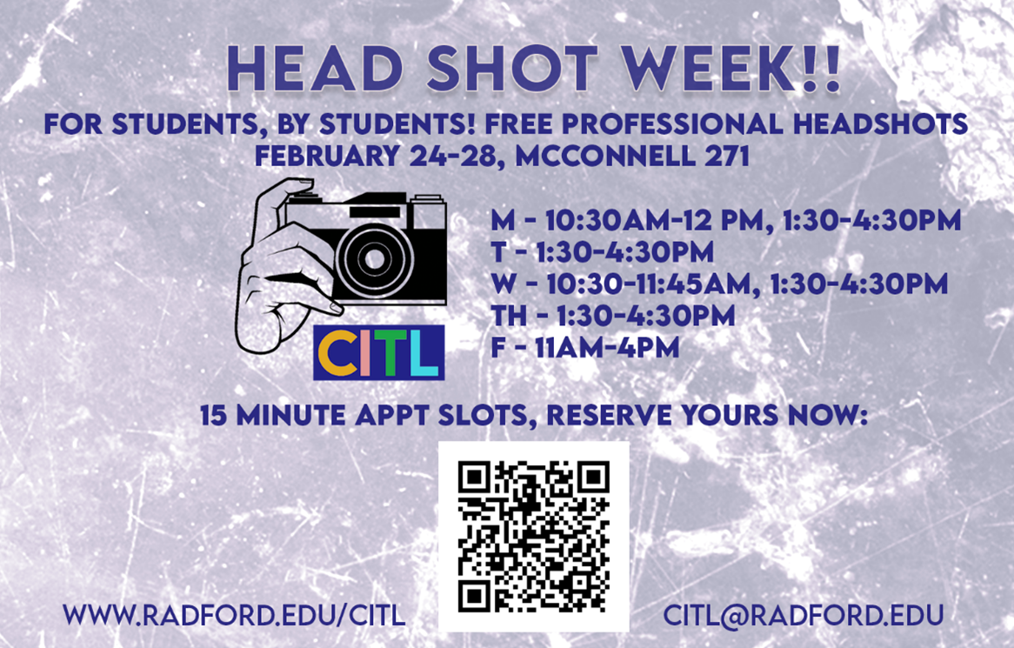

Day of Calm - Sponsored by CITL
Wednesday, February 26, 10am-2pm CITL Activities
RU CITL, McConnell 271
- Quiet atmosphere
- Live music noon-1pm
- Mandala rock painting
- Button making

Women's History Month Events
The 2025 Women's History Month theme established by The National Women’s History Alliance is titled: "Moving Forward Together! Women Educating & Inspiring Generations." The theme celebrates the collective strength and inﬂuence of women who have dedicated their lives to education, mentorship, and leadership. Through their efforts, they have served as an inspiration for all generations — both past and present.
This year also marks the 24th anniversary of Women's Studies (now Women's and Gender Studies - WGST) at Radford University and will offer the opportunity for us to celebrate the history and accomplishments of Women's and Gender Studies.

Our celebration will take places from March 4 (Tuesday) to March 6 (Thursday) at McConnell Library's Andrew W. Ross Student Art Gallery.
We warmly invite you to join us for two signature events in celebration of Women’s History Month:

Keynote Presentation – March 4 (Thursday), 5-6:30 p.m.
Title: Inventing a Space to Speak: Ethos, Agency and United States’ Woman Suffrage Cookbooks (1886-1916)
Presenter: Dr. Danielle Nielsen, Professor of English, Murray State University
This is event organized by Women’s and Gender Studies and Center for Gender Studies.

Women’s History Month Celebration and Lifetime Achievement Awards – March 5 (Wednesday), 3-4:30 p.m.
For the full events schedule, please check our program webpage Women’s History Month Event 2025

Radford Roanoke Hosts New Horizons Healthcare Leadership
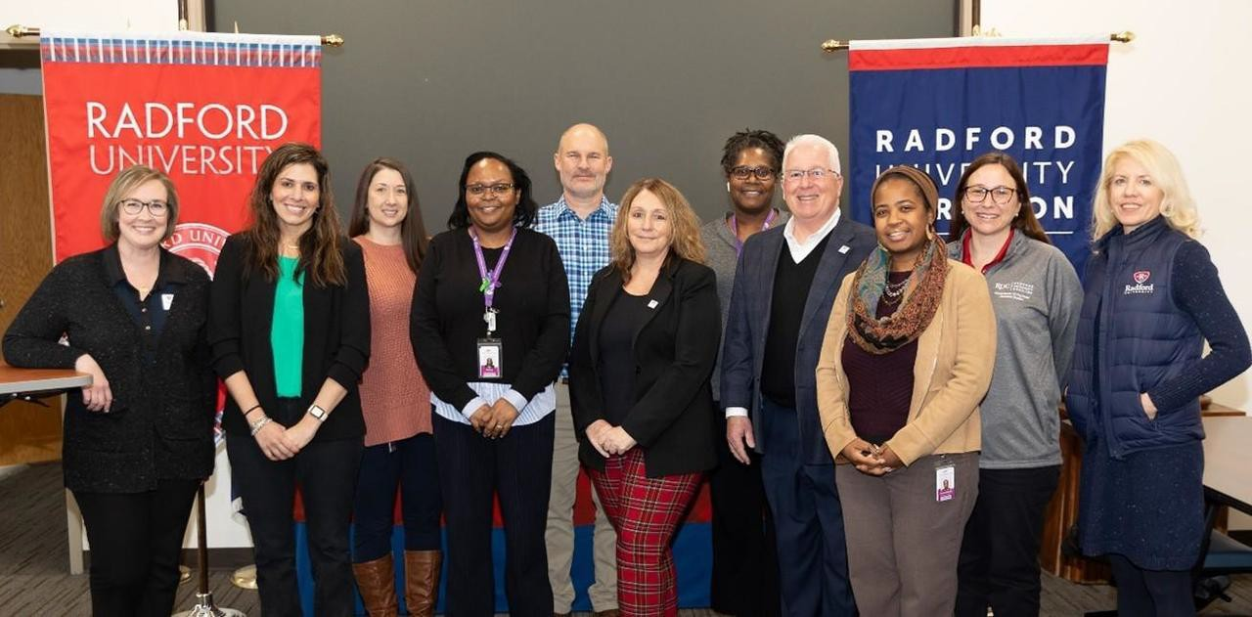
Pictured L-R: Meg Arthur, Sani Widener (PA Alum), Heather Crane, Patricia Spangler, Keith Wilken, Carey Cole, Cynthia Harris, Glen Mayhew, Corinne Bostic, Sara Nicely, Sallie Beth Johnson. Not Pictured: Phil Mongan. Photo by: Mark Lambert

A group of senior leaders from New Horizons Healthcare was hosted in Roanoke on Thursday (20th) for a discussion and tour with leadership from Waldron College and the College of Nursing. Their leadership team included their CFO, COO, Nursing Director, Behavioral Health Director, Dental Director, and their Medical Director who is an alum of the Physician Assistant program. New Horizons Healthcare is a not-for-proﬁt community-based family health center committed to

improving access to affordable, high quality, comprehensive health care for all, including the uninsured and underserved. This growing clinic includes pediatrics, family medicine, an on-site pharmacy with medication assistance program, behavioral health services, and a sliding fee discount program for those who are eligible, based on income.
The group had a robust discussion about New Horizons service offerings, their employment needs, educational needs, clinical rotations, community-based health education, and internships opportunities. The group agreed there were multiple areas of partnership opportunities and more discussion would follow. After the discussion Glen Mayhew took the group on a tour of Radford University Carilion.


Tuesday is a BIG day for Art!
On Tuesday, February 25, successful diesel punk artist, Tony Snipes, will visit art classrooms and deliver an open discussion at noon in the Performance Hub to explore building a brand and making a living as an artist.
At 4 p.m. in the Davis Performance Hall in the Covington Center, Artist-in-Residence Margaret LeJeune's exhibition will discuss "Thirteen Hours to Fall," her exhibition in the Covington Gallery. A reception follows.
Finally, Artrageous comes to the Main Stage Theater in the Artis Center. It’s a fantastic experience you won’t want to miss. Check out more about Artrageous. $15 General Admission; $7.50 children 12 and under; Free with Radford University ID. Tickets available here.

Midday Music Concert Celebration of Black History Month:
A chamber quartet featuring Matt Cataldi, Erica Sipes, Robert Trent and Sheldon Johnson will honor Black History Month with a Midday Music concert in the Performance Hub of Artis Center. This free 30 minute concert is from 12:15 - 12:45 p.m. The public is invited to bring a lunch and enjoy the music.

Rescheduled events:
The reception for the spring Juried Student Art Show will take place in the Tyler Gallery next to BT's on Wednesday, February 26 from 5-7 p.m. Refreshments will be served. The event is free and open to the public. Dayl Burnett’s Midday Music Concert in the Performance Hub has been rescheduled for 12:15 pm on March 5.

Born to Run:
Were you born to run? For two nights only, the Radford University Commercial Music Ensemble and Dept. of Dance will present a live performance of Bruce Springsteen's entire landmark album to celebrate its 50th anniversary--and its absolutely FREE! Come join us in the new Artis Center Main Stage Theater on Feb. 28 and March 1. Show starts at 7:30. Everyone welcome.

RISE Announcement
The RISE program is thrilled to announce our new RISE Faculty Institute Director, Dr. Tracy Kwock.
Tracy is excited to join the Realizing Inclusive Student Excellence (RISE) program because she strongly believes that "the entire Radford University community beneﬁts learning with and from a diverse body of peers and teachers; all learners can reach the same high expectations with the right supports; and instructional practices are more effective when they capitalize
on those diverse strengths and backgrounds. The RISE faculty institute is a catalyst for sparking instructional change which works to mitigate the barriers or challenges our students face
and utilizes their strengths for optimal success and growth."
Dr. Kwock joined Radford University in 2014 through the Training and Technical Assistance Center (TTAC) where she supported K-12 school divisions establishing and implementing systems change initiatives to best meet the needs of all learners. She continues to adjunct classes in RU’s School for Teaching and Learning (STEL) and was a member of the inaugural cohort through Radford’s EdD program in Educational Leadership. She is excited to bring her passion for teaching excellence and student success into the RISE program, and continue supporting the incredible faculty and students of Radford University in this new role.

The School of Writing, Language, and Literature will be hosting a conference in September 2025:

5th Annual Corridors: Blue Ridge Writing & Rhetoric Conference Saturday, September 27, 2025
Radford University | Radford, Virginia Conference Theme
A Voice That Carries: Embracing Authenticity in an Artiﬁcial Age

Description
Writing and rhetoric graduate students, instructors, and scholars in the Appalachian region are invited to submit a proposal for the Corridors: Blue Ridge Writing and Rhetoric Conference to be held on September 27, 2025, at Radford University in Virginia. The conference theme (A Voice That Carries: Embracing Authenticity in an Artiﬁcial Age) focuses on pedagogy, practices, and research that help students and faculty alike reconnect to, re-engage with, and celebrate their authentic voices. As a new age of artiﬁciality sets in, this conference’s purpose is to embrace authenticity by providing a space where real voices can be heard in rhetorically meaningful, creative, and intellectual ways. These voices can, then, engage with others in authentic ways that inspire real action and change within our classrooms, across our campuses, and throughout our communities.
“A voice that carries” is an idiom that expresses the physical ability of sound to travel distances as well as a person’s voice to be impactful, inﬂuential, or inspirational to listeners and readers. Its dual literal and ﬁgurative meanings can have lasting positive effects on audiences, sometimes in surprising ways not anticipated by speakers and writers. Communication that can be both clearly


heard and humanly understood is what leaves a mark, makes a connection, and testiﬁes of the power of words on the human spirit. Therefore, the goal of this conference is to bring together writing and rhetoric humans who desire to carry their voices in presentation rooms and during hallway conversations in the name of authenticity.
Subscribe to our email list.

801 East Main Street | Radford, VA 24142 US

About the Conference
Corridors is a free, in-person, one-day (8:00 a.m. to 5:00 p.m.) regional conference; however, registration is required to attend. Breakfast nibbles will be provided on the day of the conference, but attendees will be on their own for lunch, dinner, beverages, snacks, travel, and lodging. An opportunity to gather in groups for dinner will be available and will be hosted by a faculty member or graduate student from Radford University’s School of Writing, Language, and Literature. Free on-campus parking will be available.

Conference Website
Visit the conference website for information about the keynote speaker, lunch and dinner options, lodging options, schedule-at-a-glance, and directions to Radford.

Contact
Have questions? Please contact Laura Vernon at lvernon@radford.edu.

Sponsors
The 2025 Corridors: Blue Ridge Writing & Rhetoric Conference is sponsored by Radford University’s School of Writing, Language, and Literature and College of Humanities and Behavioral Sciences.

Ofﬁce of the Provost Radford University Martin Hall 331
540-831-5404

