

February 23, 2026
Message from Provost Usher

Last night I was unpacking a box of CDs, which I haven’t touched since I moved here 3 years ago, and was being reminded of my favorite music growing up (shameless plug that it made me more excited for the Commercial Music Ensemble’s 1985 Rock and Roll Time Machine concert coming up March 20-21).
I started listening to David’s Bowie’s Changes (because that was going to be theme of my note to you), and was reminded that it was on his 1971 album Hunky Dory. I love this congruence, because we are continuing to go through changes, and I wanted to share two things. First, we continue to evolve, not because things are bad, but because we are hunky dory and want to continue to improve- for you, for our students, and for our communities. Secondly, change isn’t something that happens to us, but happens together because of collective action and input.
In Academic Affairs, I view evolution in two ways (I am a biologist). One is graduated, where we use experience and data to make incremental improvements to existing systems. If we were in the tech world, this would be using “scrum” or “agile” approaches. Although we don’t call it this, I think of how as faculty, we review how well each class session went compared with what we wanted to accomplish or have students learn, and we make notes to adjust the next class session or the next time we teach the material. We hold an event, evaluate whether we had the set-up, audience, and reach we wanted, and then use what we learned to improve the next time. We conduct an experiment and then adjust the parameters for the next run based on our outcome.
The other way we evolve is through “punctuated equilibrium,” where things stay fairly constant for a period of time until conditions change and we have the opportunity to make a big improvement.
While we continue to have continuous, gradual evolution as a healthy educational ecosystem, I see us evolving in larger institutional jumps over the next few years, including the following:

- Implementing the new General Education program as we teach out the REAL curriculum
- Designing and constructing the Health Science building in Roanoke
- Reviewing our Learning Management System (currently D2L), with potential replacement
- Implementing EAB Navigate system for student success management
- Creating an interdisciplinary Center for Health Sciences

To make these types of larger, institutional change, I adapt Kotter’s organizational change model. In universities like Radford with shared governance and such a deeply committed set of faculty and staff, I appreciate Kotter’s reliance on transparency and shared leadership at every step (Kotter, 2012).
The commonality in the big projects is that we have plans for you to be engaged at every step of the way. This process may be a formal Request for Proposals, or a more internal version. Even

though I always operate with some version of this, I wanted to make this framework explicit:
- Clearly identify the impetus for the project and change
- Create a trusted leadership team with decision-making authority, using existing shared governance pathways
- Create and share a timeline for the project
- Enlist stakeholder/community input on our needs and wants as we develop options
- Have the leadership team and/or a larger team (may be consultants, like the architects and engineers for the Health Sciences building or the EAB implementation team) create a series of recommendations, options, or models
- Enlist the stakeholder/community to provide input on the recommendations, options, or models
- Have the leadership team incorporate the feedback to adjust the options or models, and then make a ﬁnal decision
- Widely communicate decisions (including describing how the feedback was used), and describe next steps
- Continue to involve the community and stakeholders, including having a robust plan for education, professional development, and support as needed
- Successfully implement the new project, and then move into gradual improvement models as needed

Clearly, on each project we are in different stages of this framework. Details on each project will continue to be communicated here, in Faculty Senate, through invitations to participate in various ways, and on the website. I am always happy to answer questions and can give more updates on the projects here and in different venues as we move forward. Please feel free to reach out and/or invite me to meetings and events.
These are really exciting times, as Radford has moved into hunky dory and we continue to change! Thank you for everything you are doing!

Bethany


April 24, 2026
In the last edition of Threads, the incorrect date was listed for this event. Please save the date for

April 24, 2026!

Please Save the Date for the Faculty Awards Ceremony, celebrating the outstanding achievements of our colleagues! This special event will honor T&R and AP faculty members who this year were awarded external funding, internal SEED grants, Faculty Professional Development Leave, University Awards, Dalton Eminent Scholars, as well as folks who submitted external awards.
This ceremony will take place on April 24, 2026 in Kyle 340 from 3-5pm.

Celebrating National Women's History Month
March is National Women's History Month. For the Twenty-Second consecutive year, we are re-activating the Her-Story listserv which is dedicated to sharing stories written by members of the extended Radford University community about the women, or the aspects of womanhood, that have shaped their lives. The National Women's History Alliance has declared this year’s theme: “Leading the Change: Women Shaping a Sustainable Future”

How it Works – Sharing Our Stories
During the month of March, subscribers to the Her-Story Listserv receive a daily posting from one of the list’s members celebrating -- or otherwise contemplating — the impact of a woman or of the aspects of womanhood upon the writer’s life. Please note that pieces selected for publication are shared “as –is.” Beyond basic formatting, we do not edit, censure, or otherwise intervene with content. The function of the list and of the celebration is to preserve and honor the voices and experiences of our contributors. For this reason, you must subscribe to the list to participate, and you must agree to abide by the rules of our community. The Her-Story listserv is a safe space where contributors can share their experiences without fear of judgment or reprisal.
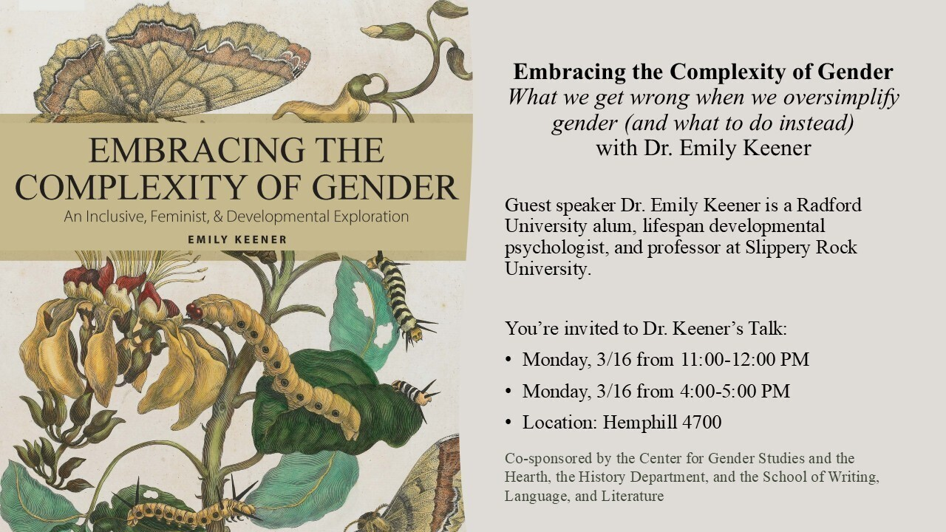
Share your tribute or join the list

CGS Guest Speaker: Dr. Emily Keener Monday March 16th from 11:00-12:00 and again on
Monday March 16th from 4:00-5:00 Location for both talks: Hemphill 4700

Embracing the Complexity of Gender
What we get wrong when we oversimplify gender (and what to do instead)

Emily Keener, PhD, is a developmental psychologist and professor at Slippery Rock University whose work integrates feminist, inclusive, and lifespan approaches to gender development.
Learn more about Dr. Keener's Book

Padding Out History: Menstrual Management in the 19th and 20th Century United States, PLUS a drive for menstrual products
Featured Speaker: Dr. Caroline Greer Professor in History
Monday, March 10 at 6:30 PM in Hemphill Hall 4800

On March 10 at 6:30 pm, Dr. Caroline Greer will be giving a talk discussing historical methods of managing menstrual cycles, or periods. She will discuss the use of homemade, reusable methods, the transition to disposable methods, and a contemporary return to reusable products. This talk is co-sponsored by the Center for Gender Studies, the Hearth, the History Department, the School of Writing, Language, and Literature, as well as the Social Work Club. The Social Work Club has also organized a drive for menstrual products, and drop boxes are located in the following places:

- Waldron Student Lounge – 251
- Social Work - Front Ofﬁce 206 – between 9 - 3
- Library – Front Desk in the Reading Room
- Hemphill Hall 4400 – Between 11 - 5


Ibero-American Film Festival:
SWLL is pleased to again co-sponsor the Ibero-American Film Festival. Films are screened on Wednesdays from 2/4 to 3/11 from 7:00-9:00 pm in the Bonnie. In collaboration with African American Studies, Appalachian Studies, the Program of Women’s Studies, and the student organizations Spanish Conversation Club and Latino Student Alliance. The Spanish Film Club series was made possible with the support of Pragda, The Ministry of Education, Culture and Sports of Spain, and SPAIN Arts & Culture.

Film list:
WEDNESDAY FEBRUARY 25th-- SUBLIME. WEDNESDAY MARCH 11th --CHINAS

Annual Lunar New Year Celebration:
For 25 years, the Lunar New Year celebration at Radford University has brought together 200–300 participants from both the university and the surrounding community. This event, along with the Mid-Autumn Festival, provides meaningful opportunities for our students and community members to engage with and learn about diverse cultures. This year’s celebration will be especially meaningful, as we will welcome 165 students from the Virginia Tech TRIO Program to the Radford University campus. The event also strengthens connections between the Radford University Theatre Department and community partners, including the Blacksburg Chinese School, Dragon Tiger Eagle Wushu Kung Fu, and Mike Petersen’s Kempo Karate School. In addition, the celebration will feature interactive activity tables representing Chinese, Japanese, Korean, and Vietnamese cultures.

The School of Writing, Language, and Literature is pleased to announce a new publication by Dr. Rick Van Noy: the short story “Trespassing” published in Appalachian Places: https://www.appalachianplaces.org/post/trespassing-a-short-story -by -rick-van-noy

Director of Undergraduate Curriculum and SWLL professor Dr. David Beach's new play, Lost and Found in Pulaski, will be featured in the Fringe Festival at the Southeastern Theatre Conference in March 2026.
Learn more about SETC

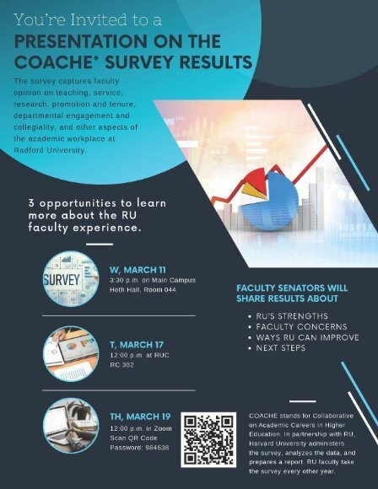

You’re invited to a presentation on the COACHE survey results.
The survey captures faculty opinion on teaching, service, research, promotion and tenure, departmental engagement and collegiality, and other aspects of the academic workplace at Radford University. Faculty completed the survey in Spring 2025, and the results are ready to be shared with faculty.
Please plan on attending one of the following three sessions:
- March 11, 3:30 p.m., Heth 044
- March 17, 12:00 p.m., RC 302
- March 19, 12:00 p.m., Zoom (Password: 984638)
Faculty Senators from the Campus Environment Committee will share results about:
- RU’s strengths
- Faculty concerns
- Ways RU can improve
- Next steps

COACHE stands for Collaborative on Academic Careers in Higher Education. In partnership with RU, Harvard University administers the survey, analyzes the data, and prepares a report. RU faculty take the survey every other year.


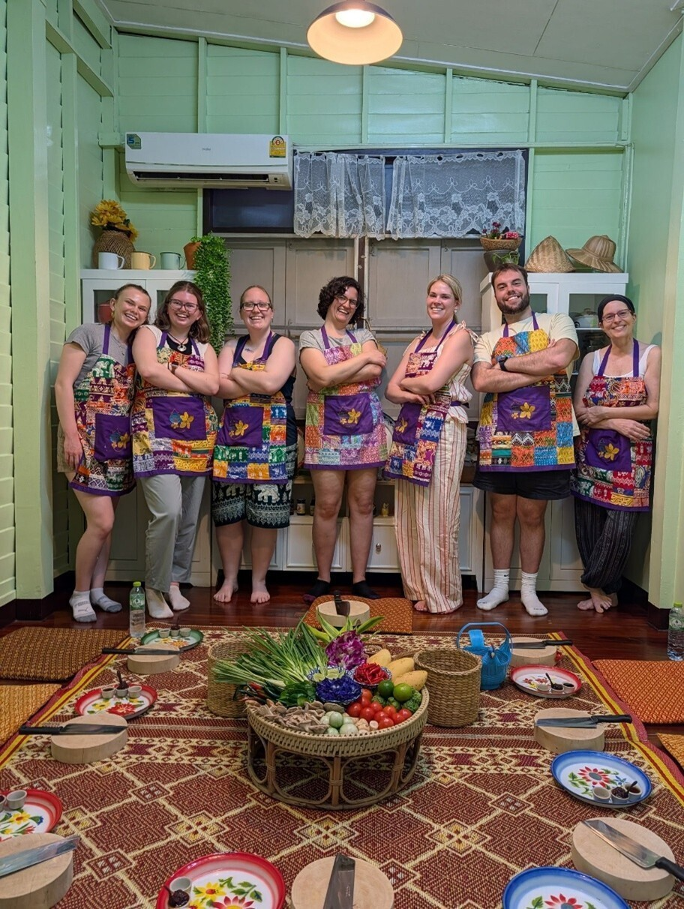

Global Learning in Action: Occupational Therapy Students Travel to World Congress in Bangkok
The Department of Occupational Therapy recently launched a unique study abroad initiative, enabling 13 occupational therapy students to attend the 2026 World Federation of Occupational Therapy Congress in Bangkok, Thailand. Developed and led by Dr. Sarah Garrison and Dr. Sarah Smidl, the study abroad initiative provided a structured opportunity to engage in international professional exchanges and cross-cultural learning with people from many different countries. The WFOT World Congress convenes OT practitioners, scholars, and students every four years from around the globe to learn from one another, share relevant practice, education, and research trends, and situate the profession of Occupational Therapy in its local and global cultural contexts.

Complementing the participation in the week-long conference, students engaged in guided cultural activities - including a Thai cooking class, visits to local historical sites, and an elephant sanctuary. This trailblazing study abroad opportunity has paved the way - we look forward to taking another group of students across the globe to the next WFOT congress in 2030!
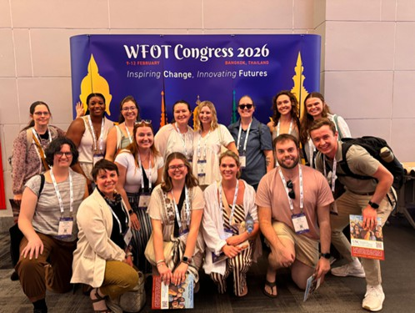

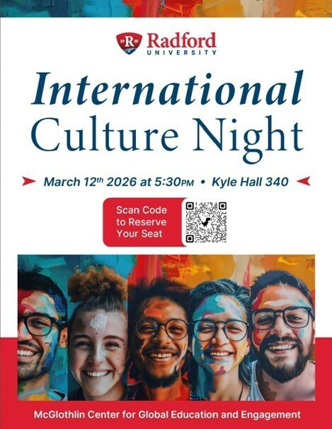
You will not want to miss the 2026 International Culture Night! The event is open to all faculty, staff, students and community members for only $5. An RSVP is required. The event will take place in Kyle Hall, Room 340 on March 12, 2026. The event begins at 5:30pm.


Revamping Your Grantseeking Strategy in a Changing Landscape

As funding priorities and requirements evolve, grant seekers must adapt their strategies to remain competitive.
This webinar will offer insights into updating your approach in seeking external funding, including strategies for tracking trends, revising proposal narratives, and exploring new opportunities.
Participants will learn how to respond to shifts in the funding environment and position their projects for success.
Webinar: Revamping Your Grantseeking Strategy in a Changing Landscape Date: Thursday, February 26th

Time: 12pm ET / 9am PT

Speakers:
- Tom Kuhn — Senior Grants Consultant, Hanover Research
- Clinton Doggett — Senior Grants Advisor, Hanover Research

Unable to attend? Register and we will send a copy of the recording and slides after the webinar.

Register for this Webinar

Accessibility Bootcamp: Wed., March 4, 9:00 AM-12:00 PM, Heth 043 and via Zoom
This 3-hour bootcamp will give you the nuts and bolts of document accessibility. We will discuss Word, PowerPoint, and PDF accessibility. This training is for anyone who has responsibilities for creating or remediating documents that will be housed in digital formats (on web pages, in D2L, in social media).
Bring a laptop and a few documents to work on—a Word document, a PowerPoint presentation, and a PDF.
This training is a collaboration of the Center for Innovative Teaching and Learning (CITL) and Academic Technologies.
While we would love for you to attend in person, there is a Zoom option. There are two registration sites, one for in-person attendance and one for Zoom attendance. In-person attendance is limited to the ﬁrst 40 registrants. Find both registration sites at the CITL Registration System.
Please address questions to Merrie Winfrey mwinfrey3@radford.edu. Schedule:
- 9:00-9:10 Introductions
  - Accessibility Mindset
  - Intro to Accessibility/Legal landscape
- 9:10-10:10 How to make Word documents and PowerPoint slides accessible
- 10:10-10:20 Forms—Which platform to use—Qualtrics, Microsoft Forms, Kuali?
- 10:20-10:30 Break
- 10:30-11:30 How to start making PDFs accessible
- 11:30-12:00 Q & A and time to work on documents with our assistance available

Reviewing Our Learning Management System: Planning for the Future

The Learning Management System (LMS) is a foundational tool supporting teaching, learning, and student engagement across campus. To ensure that our LMS continues to meet the evolving needs of faculty and students, the Center for Innovative Teaching and Learning (CITL) and Information Technology Services (ITS) have begun a comprehensive review process to assess campus needs and identify the best solution for the future. A steering committee is being formed to provide strategic guidance and campus perspective. Between now and the end of the semester, they will be engaging departments and collecting input to better understand instructional, accessibility, integration, and support requirements.
CITL and ITS will use these requirements to develop a Request for Proposal (RFP), which Procurement plans to release in May to solicit vendor responses. A smaller RFP review committee will be established to evaluate submissions. The goal is to invite a short list of vendors to campus in August 2026 for demonstrations and open presentations, allowing faculty and the broader campus community to provide feedback before any ﬁnal decision is made.


Now is the time for students to be seeking summer internships. Your encouragement and communication to students is essential for them to act now. There are always a limited number of internships each year and the sooner students search, the better. Students can ﬁnd opportunities by logging into Handshake to apply for open positions. Schedule an appointment with a career coach to establish a strategy by emailing Debbie Fenderson at dfenderson@radford.edu.

Etiquette Dinner
The Radford University Center for Career and Talent Development will host the Annual Spring Etiquette Dinner on Tuesday, March 10, from 6-7:30 p.m. in Kyle Hall 340. Let your students know about this great opportunity.
This event provides our students with the opportunity to enjoy a free three-course meal while they learn how to interact with others in a professional setting. Participants can use this dinner to develop their professional networking and dining etiquette skills.
The event’s etiquette instructor is Kathleen Harshberger, a Radford University alumna, graduate of the Protocol School of Washington and a certiﬁed consultant and trainer in business etiquette.
This will be a fun, judgement free environment.
Learn more about the Annual Spring Etiquette Dinner: https://calendar.radford.edu/event/14814-annual-spring-etiquette-dinner


Could you—or your students—use expert research support?
Radford University's Research Services Librarians are here to help with any stage of the research

process, including:
- Developing or reﬁning a research topic
- Choosing the best places to search (our 250+ subscription databases, AI research tools, SuperSearch, and our RadfordU-authenticated Google Scholar)
- Building an effective search strategy to ﬁnd scholarly articles, industry reports, news, and more
- Citing sources in APA, MLA, Chicago, and other styles
- Finding books, eBooks, streaming videos, and full-text articles
- Exploring personal interest questions

Please reach out—and encourage your students to do the same! We offer multiple ways to connect:

- Chat with a real librarian 24/7 via Ask a Librarian
- Visit the Research Help Desk in McConnell Library or the RUC Library desk
- Book a librarian consultation for Zoom or in-person
- Email or call us!

Do you have a course assignment that requires some of the above skills? If your students may beneﬁt from library instruction, contact Aly ssa Archer, Head of Research Services at McConnell Library, or Mary Catherine Santoro at RUC Library with questions.
We also offer asynchronous D2L modules that you can assign to your class (including quizzes) that take less than an hour to complete on APA 7th, evaluating sources, SuperSearch, avoiding plagiarism, and more! Your students can win up to $750 for course-embedded research projects undertaken between Spring 2025 through the current semester with the Winesett Awards for Library Research.


OURS: Research Ready Series
The Ofﬁce of Undergraduate Research (OURS) is excited to announce the continuation of a regular faculty and student support seminar series for the Spring semester. All seminars are open to Radford University students, faculty, and staff. The upcoming meeting will be hybrid through zoom and in person. Information as follows.
March 10, 2:00 pm; McConnell 231 - Ethical Conduct of Research
Ethical research is fundamental to academic success—but it requires navigating complex issues like authorship, fraud, and the guidelines of IRB and IACUC. In this workshop, you'll explore how to address these challenges, ensure ethical decision-making, and uphold the integrity of your research from start to ﬁnish.
https://radford.zoom.us/j/91054731270 Password: OURS
Save the Date for Tuesday, March 24th at 2pm for our Professional Presenting Seminar.
OURS is happy to meet individually or with groups all across campus and can be contacted at ours@radford.edu, 831-7203, or in Whitt 118-126. OURS can also run workshops on various

professional development areas for your class or research team. These include the above and other topics, such as writing abstracts, preparing for a conference, and more!


The Ofﬁce of the Registrar is excited to launch two new enhancements: Graduate Certiﬁcates Now Available in Degree Works
We are thrilled to announce an enhancement to graduate student support. Graduate certiﬁcates are now in Degree Works! This milestone brings greater clarity, consistency, and transparency to our graduate certiﬁcate programs. This feature launches with the 2025–26 catalog, and students using that catalog and forward will enjoy full access to these streamlined audits.
Students enrolled in both a graduate degree program and a certiﬁcate can easily switch between audits. To view certiﬁcate requirements, select the Degree Dropdown in the upper-right corner (next to the student’s name) and choose “Certiﬁcate Only”. This new feature makes navigating certiﬁcate programs smoother, clearer, and more intuitive than ever for students and advisors.
We’re excited to offer this improved experience and help graduate students track their certiﬁcate progress with ease and conﬁdence.

Waitlists Now Available for Summer Courses
Waitlists are now available for summer courses. Students may add themselves to a course waitlist through Registration in OneCampus. Waitlist status and waitlisted seats are also reﬂected when searching the class schedule. For questions about waitlists, please contact the Ofﬁce of the Registrar at registrar@radford.edu or 540-831-5271.


Welcoming New Staff
We’re pleased to share that Brittney Looney has joined the Ofﬁce of Graduate Affairs as our Education Support Specialist. She will be the frontline touchpoint for students needing support. Reach her at blooney1@radford.edu.

COVES Fellowship Recipient
We’re proud to share that Paige Dickerhoof has been selected as a recipient of the Commonwealth of Virginia Engineering and Science Fellowship (COVES). The COVES Fellowship places graduate scholars in Virginia state agencies to provide research support and inform public
policy. Congratulations, Paige!

Outstanding Student Award Nominee Information
Nominations for the OGSAs have closed. Applications for Outstanding
Graduate Student Award nominees are due Wednesday, March 4, 2026. For more information,

please visit the OGSA website or contact OGA Graduate Assistant Adriana Garcia at agarcia37@radford.edu.

Graduate Student Travel Funds
OGA has funds available to support students traveling to present research at conferences. Direct your students to apply here.

Highlander Research Blitz – A 3-Minute Thesis Competition
Students (graduate & undergraduate) showcase their work with just one slide in three minutes. For more information on this event, please check out the HRB website or contact OGA Faculty
Fellow Dr. Paige Tan at etan3@radford.edu.

Graduate Research & Scholarly Projects Stories
We are collecting stories of faculty and graduate student conferences, presentations, publications, and new research initiatives. Please email submissions to gradaffairs@radford.edu.

Ofﬁce of Graduate Affairs Student Newsletter
Please share our professional development opportunities and community-building events with your graduate students. For a complete list, direct them to our Graduate Student
Newsletter, LinkedIn, or the Professional Development and Events website.

Join OGA, faculty, and graduate students for Coffee Hour
Tuesday, March 3, 2026 | 12:00 PM – 1:00 PM | Red Provisions Café, Highlander Hotel
Meet our staff, connect with students, and enjoy coffee with us at our biweekly gathering. Our treat!


Two concerts this week
The Radford University Choirs will present “Earthly and Heavenly Love” at 7:30 p.m. Monday, Feb. 23, in Davis Performance Hall. The Symphonic Wind and Jazz Ensemble will perform “Angels in the Architecture: A Journey through Darkness and Light” at 7:30 p.m. Feb. 26, also in Davis Performance Hall.
All concerts are free and open to the public.

Congratulations to Theatre student Katy Pendelton
Kathryn “Katy” Pendleton, a junior majoring in performance and directing in the university’s Theatre Department, has been accepted into the highly competitive Disney College Program, a four- to six-month internship.
Pendleton will travel to Walt Disney World in early summer, where she will spend the fall semester working as an entertainment attendant, service worker and guest associate, gaining hands-on industry experience.
Pendleton said she is grateful for the opportunity and thanked the Theatre Department and its professors for their continued support inside and outside the classroom.

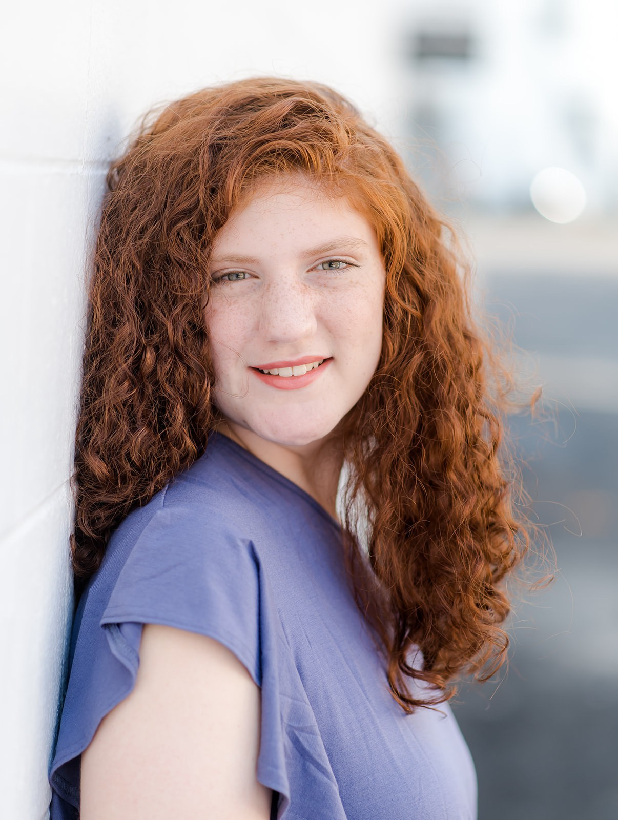


Radford University has joined forces with Georgetown University to create a program bringing our students together to delve into the cultures of Appalachian Virginia and metropolitan D.C. and also learn Conﬂict Resolution skills to tackle the divisions between rural and urban America.
The program is a unique opportunity to earn college credit, collaborate with new friends at Georgetown, and learn more about one of the most difﬁcult challenges facing our country.
The program consists of a week-long immersive experience taking place between Sunday evening, May 10, and Friday, May 15.
Participants from both schools will spend the ﬁrst half of the week living together in a bunk-style setting at Radford’s scenic Selu Conservancy . While there, they’ll partake in cultural experiences related to the Appalachian experience and learn important Conﬂict Resolution skills taught by Georgetown Associate Professor Rachel Milner Gillers.
During the second half of the week, students will live together in a dorm style setting in downtown Washington, D.C., where they will learn about the history and culture unique to the nation’s
Capital.
In that setting, they’ll also apply their newfound conﬂict resolution skills in experiential exercises. In the Fall Semester, Radford students will be required to present a researched lecture on a topic of their choice related to the experience.
Accepted Radford students will be enrolled in the 3-credit Fall 2026 class, APST 490 or POSC 390, Power of Dialogue: Conﬂict Resolution and the Rural-Urban Divide. Only 10 students from each school can participate, though. So, interested students must apply soon. The program
beneﬁts from students coming a variety of different backgrounds, so applicants are not required to have backgrounds in any speciﬁc region of the country.
You can ﬁnd more information and the link to the application here -- The Power of Dialogue | Conﬂict Transformation Lab | Georgetown University The deadline for applications for Radford students is February 26. For additional information, contact program coordinator, Don Martin, at dwmartin1@radford.edu."

The Radford Law Society is hosting admissions ofﬁcers from 3 law schools - Wake Forest,



Richmond, and WVU — on Friday, February 27 at 10:30 am in Heth Hall 16.
Subscribe to our email list.

801 East Main Street | Radford, VA 24142 US
This event will provide an excellent opportunity for students to learn about law school admissions directly from the professionals who make those admissions decisions.

Survey on Professional Development/Conference Travel

We invite colleagues to complete an anonymous survey on their experiences with professional development and travel support while being employed at Radford University.
https://radford.co1.qualtrics.com/jfe/form/SV_bjiAXJXOxV3i0IK
This survey should take 7 to 10 minutes to complete and will remain open until Monday, March 16th at 5 pm.
This survey was developed by members of Faculty Senate's Resource Allocation and Faculty Issues committees, with input by the Provost’s ofﬁce. Questions? Please contact either committee chair: Resource Allocation - Alyssa Archer aarcher2@radford.edu or Faculty Issues - Dr. Kevin Farrell kfarrell2@radford.edu

Ofﬁce of the Provost Radford University Martin Hall 331
540-831-5404

