

February 10, 2025

A Message from Provost Usher
I’ve heard several times in the last week that “January was the longest year!” I concur. What I appreciate most about our Radford community is that even in turbulent times, you continue to value teaching our students and supporting each other. This newsletter is long, and I hope that you take advantage of the many opportunities.
There is a lot in the news that has the potential to affect higher education, colleges in Virginia, and Radford University. We are monitoring this, staying in contact with our colleagues across the state and nationally, and doing our best to have contingency plans in place. We are committed to our values and our mission, and we will be transparent with you when and if we have to make any changes to our operations. In the meantime, you are welcome to ask me any questions (I’ll answer what I can, ﬁnd out what I can, and sometimes just let you know what we don’t know).
Last week I attended the inaugural Undergraduate Research Showcase at the Capitol in Richmond, where our students Cora Burt and Lauren Grifﬁn (supported by mentors Joe Wirgau and Joe Brummette) presented. They, along with students from 13 other Virginia institutions, made a strong case for the value of engaged undergraduate education, and I was buoyed by their collective brilliance and enthusiasm.
Stay warm and safe as we have another round of winter weather this week. We will let you know as soon as possible if we make any changes to the schedule.
With appreciation, Bethany

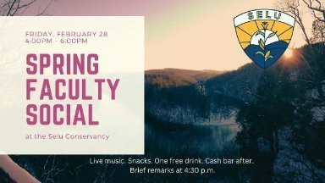
All Radford University faculty are invited to the Spring Faculty Social. This social will be held at Radford University’s Selu Conservancy on Friday, February 28, 2025 from 4-6pm. Take time to learn about or get reacquainted with Selu! Enjoy live music, snacks and drinks. The Conservancy will be available for exploration or stay warm inside and connect with colleagues. An RSVP is requested.
Those who RSVP will receive one free drink ticket. A cash bar will be available as well. A brief program will take place at 4:30pm and you are welcome to spend the remaining time exploring Selu Conservancy! We hope to see you there. This event is a collaboration between Academic Affairs and Student Affairs.

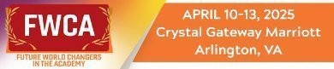

The upcoming 13th Annual Future World Changers in the Academy being held April 10-13, 2025 in Arlington, VA, which will be hosted by Virginia Tech.
The conference has changed and is open to anyone, regardless of race, ethnicity, national origin, sex, sexual orientation, gender identity and expression, immigration status, religion, or disability. FWCA does not discriminate on the basis of any identity.
Everyone who attends, especially as allies, advocates, and activists, is encouraged to support the advancement and elevation of the voices and experiences of those who have often been overlooked, questioned, doubted, and challenged because of their identities.
FWCA recognizes that experiences in higher education are impacted by many factors, including background, experiences, and identities. It seeks to create a space where communities that have often been marginalized and silenced in higher education can feel empowered to share their voice, wisdom, perspectives and experiences.
For more information
For Individual Registration

The School of Writing, Language, and Literature

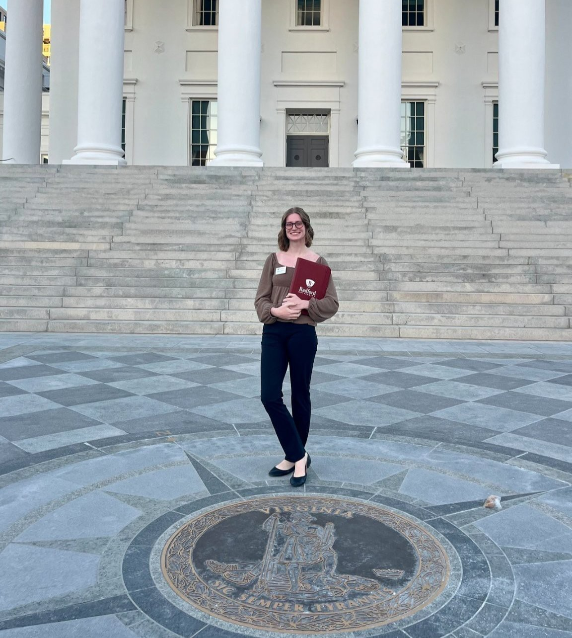
The School of Writing, Language, and Literature is pleased and proud to have had representation in Richmond on Advocacy Day 2025. Graduate student Nina Aidam (pictured right) and undergraduate Anne Miron (pictured left) traveled to Richmond to advocate for the humanities at Radford University, alongside their peers, faculty, and President Bret.



Did you know that both McConnell and RUC libraries have collections of new and popular DVDs available for checkout for a period of 28 days? You can ﬁnd a wide selection of Academy Award winning ﬁlms and popular TV shows available on McConnell Library’s 4th ﬂoor in front of the Harvey Center for Learning and Writing. RUC patrons can ﬁnd popular DVDs available across from the circulation desk. You can ﬁnd DVDs of ongoing TV shows such as Abbott Elementary, Doctor Who, The Handmaid’s Tale, The Good Place, and more. Our collections also include ﬁlms from DC Comics and the Marvel Cinematic Universe as well as animated ﬁlms from Disney, Pixar, and Studio Ghibli. You can browse McConnell’s DVD collection anytime online by visiting https://www.radford.edu/libraries/collections/index.html.
Radford University Libraries have something in their DVD collections for everyone.

Women's History Month

Women's History Month 2025 Call for Proposals
The Women’s and Gender Studies Program at Radford University is excited to host the Women’s History Month events for March 4 (Tuesday afternoon), March 5 (Wednesday all day), and March 6 (Thursday morning), at Andrew W. Ross Student Art Gallery in McConnell Library.

Please submit y our proposals via Women’s History Month Proposal 2025 Form by February 19 (Wednesday), 2025.
Please note that all presentations, creative works, posters will be scheduled for these three days. The only exceptions are month-long activities, book clubs, and special events. We appreciate your submission and look forward to celebrating Women’s History Month with you.

Lifetime Achievement Award Nomination 2025

Women’s and Gender Studies (WGST) at Radford University is honored to announce the call for nominations for the 2025 Lifetime Achievement Award. This year, we aim to honor an individual whose work signiﬁcantly impacted the Women’s and Gender Studies Program at Radford University, the broader ﬁeld of Women’s and Gender Studies, or the advocacy for women’s rights and social justice within the Radford community.
We welcome and encourage both self-nomination and the nomination of others.

Please submit your nominations through the Award Nomination Form by February 19th (Wednesday), 2025.

We look forward to receiving your submission and are excited to celebrate the remarkable achievements of this year’s Lifetime Achievement Award recipient. The honoree will be recognized at the Women’s History Month Celebration event in March 2025.


Civil Discourse Working Group
Are you interested in incorporating research-based, meaningful work in dialogue across differences in your courses, department, ofﬁce, residence hall, committee, or student organization? Anyone with an RU email has free access this year to the Constructive Dialogue Institute's "Perspectives" program—six modules aimed at helping us to have more constructive and meaningful discussions across political, social, and other divides: https://constructivedialogue.org/perspectives/. Contact Heather Keith (hkeith1@radford.edu) to have a look at the modules and/or get your own course to use with students.

CITL Introduces Special Reading Group



Are you interested in helping students to think and act productively to save the planet and our communities? Are your students (and you) anxious about wicked problems like climate change? Do you want to hear about how to regain hope and cultivate community for solving problems?
Please join us for this special reading group on William Throop's Flourishing in the Age of Climate Change, co-sponsored by the Wicked Problems Initiative, CITL, and Sustainability. We'll read this short book over three meetings, with the author zooming in for our last discussion.

Please commit to attending at least two meetings in order to claim your free book! The meetings will be in-person in CITL and available on Zoom. Register here. Contact hkeith1@radford.edu for more information. All faculty, staff, and graduate students are welcome. If you have class until 12:15 those days, arriving late is OK!
March 20, 12pm-1pm | April 3, 12pm-1pm | April 17, 12pm-1pm

Global Education
The McGlothlin Center for Global Education and Engagement is hosting its annual International Culture Night event on Thursday, March 6th. We are in search of additional performers to contribute to the event. If you are interested in participating or would like more information, please send us an email at globaled@radford.edu.


OURS: Research Ready Series
The Ofﬁce of Undergraduate Research and Scholarship (OURS) is excited to announce the creation of a regular faculty and student support seminar series for the Spring semester. All seminars are open to Radford University students, faculty, and staff. The meeting the ﬁrst week of the month will be focused on faculty support and the meeting the third week of the semester will be focused on providing student support. The meetings will be hybrid through zoom and in person at the Center for Innovation Teaching and Learning (CITL, McConnell Library 270).
February 18, 3:30 pm; CITL, McConnell Library 270- Ethical Conduct of Research https://radford.zoom.us/j/92483448509 Password: OURS
March 4, 12:30 pm; CITL, McConnell Library 270- Publishing with Student Co-Authors

https://radford.zoom.us/j/93037494821 Password: OURS
March 18, 3:30 pm; CITL, McConnell Library 270- Creating Audience Centered Posters https://radford.zoom.us/j/98485989204 Password: OURS

2nd Annual Highlander Research Blitz Competition Overview
On April 2, 2025, OURS and the Ofﬁce of Graduate Affairs will host the second annual Highlander Research Blitz Competition for students enrolled in graduate and undergraduate programs through Radford University (main campus, RUC, RHEC, SVHEC).
Contestants will have three minutes to describe their original mentored research or creative inquiry. Aided by a single image or graphic on a PowerPoint slide, participants compete to see who can best communicate their work and its signiﬁcance to a non-specialist (layperson) audience.

Apply Now!
Radford and Radford University Carilion students interested in participating should complete the Research Blitz application online by February 19, 2025.
Visit the OURS Blitz webpage and the Graduate Affairs webpage for more information.


Seed Grant Program
Seed Grants are one-year grants to fund pilot or preliminary work leading to external funding for large research/creative projects by members of the faculty and staff.
Apply and ﬁnd out more about this program

Career and Talent Development
Virginia Education Career Fair Spring 2025 February 21, 2025
11:00 am – 3:00 pm
Student Recreation and Wellness center

3rd Annual Etiquette Dinner March 3, 2025
6:00 pm-7:30 pm

Kyle Hall 340

If you would like to participate in either of these events, please contact Paula McGraw at pmcgraw@radford.edu.

General Education Improvement Task Force UPDATE
From February 12 to 19, the General Education Improvement Task Force will be holding Town Halls with each college and one in Roanoke. On February 11, Faculty Senate will send an email to all faculty with updated drafts of the general education model.
We have listened to the feedback from faculty and staff (thank you for the feedback!) and have continued to work on the model. In these sessions, your college rep, the Faculty Senate rep, and the chair will discuss the updated draft of a general education model and elicit more feedback from the faculty. We also plan to have sessions with students.
After completing the town halls, the Task Force will convene to discuss the feedback and make any necessary revisions. Our recommendation will be delivered to the Faculty Senate and the Provost on February 21.
We look forward to our continuing discussion on general education. David Beach, Chair

Starﬁsh Progress Report Opens Monday, Feb 10
The Week 4 Progress Report, facilitated through Starﬁsh, allows faculty to quickly raise Academic Performance Flags and submit referrals to campus support services. These ﬂags enable early intervention for students facing academic challenges. Referrals connect students with vital campus resources and support.
The Week 4 Progress Report will include students in all 100- and 200-level courses. By prioritizing these foundational courses, we can strategically provide support to strengthen students’ academic success during a pivotal time in the semester. However, instructors of any course can manually raise ﬂags and submit referrals at any time during the semester.
Report Opens in Starﬁsh: Monday, February 10
Report Closes in Starﬁsh: Monday, February 17, 5:00 PM

Tracking Items included on the Week 4 Progress Report:
- Keep Up the Good Work Kudo - Provides a "pat on the back" for students who are doing well
- Academic Performance Flag - Alert students about attendance concerns, missing or late assignments, low online participation, low grades, or any concern related to their academic performance. This ﬂag is intended as communication between the ﬂag raiser and the student, but it can be paired with referrals to campus partners for resources and support. Students are notiﬁed about this ﬂag and the message will include instructor comments. Students with multiple Academic Performance Flags will be contacted by the Highlander Success Center.
- Academic Advising Referral - Use this referral if a student needs assistance with academic policy, course withdrawal, or other advising processes or questions.

- Peer Academic Coaching Referral - Use this to refer a student who may beneﬁt from peer coaching and mentoring regarding time management, study skills, organization, goal setting, motivation, etc.
- Tutoring or Writing Assistance Referral - Use this if a student needs additional help in a speciﬁc course or subject area. If the referral is speciﬁcally for writing assistance, please specify the student’s needs.

If you have questions about the Week 4 Progress Report or Starﬁsh, please contact Susan Hudson at smhill@radford.edu or (540) 831-6735.


Saxophone Recital

Dr. Sheldon Johnson will perform a recital entitled “Fantaisie” on February 18 in the Davis Performance Hall of the Covington Center at 7:30 p.m. The event is free.

Artrageous Comes to Radford:

The University Performance Series brings Artrageous to the Artis Center Main Stage Theater on February 25 at 7:30 p.m. Artrageous is “a creative arts troupe” of singers, musicians, dancers and painters bringing artwork to life on the stage. Here is a look at what y ou will experience live.
$15 General Admission; $7.50 children 12 and under; Free with Radford University ID. Tickets available here.

Midday Music Concert Celebration of Black History Month:

A chamber quartet featuring Matt Cataldi, Erica Sipes, Robert Trent and Sheldon Johnson will honor Black History Month with a Midday Music concert in the Performance Hub of Artis Center. This free 30 minute concert is from 12:15 - 12:45 p.m. on Feb 26. The public is invited to bring a lunch and enjoy the music.

Born to Run:

Were you born to run? For two nights only, the Radford University Commercial Music Ensemble and Dept. of Dance will present a live performance of Bruce Springsteen's entire landmark album to celebrate its 50th anniversary--and its absolutely FREE! Come join us in the new Artis Center Main Stage Theater on Feb. 28 and March 1. Show starts at 7:30. Everyone welcome.

Graduate Affairs - Award Opportunities

Outstanding Graduate Student Awards
Faculty Nominate your Awesome Graduate Students for One of Five Categories!!

Extended - Nomination Forms Due: February 26, 2025
Student Application Package Due Date: March 5, 2025
Please remind your students who were nominated (by a faculty member or self-nomination) to work on assembling their package.
Awards:
- One award of $750 will be presented in each of the following ﬁve categories:
  - Graduate Student
  - Doctoral Student
  - Graduate Assistant
  - Graduate Teaching Assistant
  - Graduate Teaching Fellow

For more information, please visit the Ofﬁce of Graduate Affairs Website under the "Awards" tab or click here.

Graduate Affairs - Professional Development Opportunities
New: Truist Leadership Institute
In Person on Main Campus, Kyle Hall Venture Lab (lower level)
Friday February 21, 2025; 2:00 – 5:00 pm;
Saturday February 22, 2025; 12:00 – 3:00 pm
RSVP – Use the QR Code:


Inclusive Citation Practices: Amplifying Marginalized Voices
Monday, February 24, 2025; 6:00 – 7:00 pm Zoom Link: https://radford.zoom.us/j/97766499495
Dr. Richard Benson's Presentation: The Legacy of Malcolm X After 100 Years

Dr. Richard Benson's Presentation: The Legacy of Malcolm X After 100 Years
Tuesday, February 25, 2025; 12:30–2:30 PM, Heth Hall 014 Free Pizza

RSVP by February 18, 2025; Email: rugsc@radford.edu

Dr. Richard Benson and Dr. Fredrick Douglas Dixon’s Presentation Beyond Academia: Embracing Social Responsibility for Future Generations
Tuesday, February 25, 2025; 2:30–4:30 PM, Whitt 116 Free Pizza
RSVP by February 18, 2025; Email: rugsc@radford.edu

Mr. Dale Long's Presentation: Cinematic Realism: Surviving the 1963 16th Street Baptist Church Bombing in Birmingham, Alabama
Thursday, February 27, 2025; 12:30–2:30 PM, Heth Hall 014
RSVP – February 18, 2025; Email: rugsc@radford.edu

Self-Care Book Club Series: Daring Greatly by Brene Brown Led by Dr. Nadine Hartig, mhartig@radford.edu.
Wednesday, February 26, 2025; 12:00–1:00 p.m. (In-Person) Whitt Hall 116 (In-Person)
Wednesday, February 26, 2025; 4:00–5:00 p.m. (Online)
Zoom Link: https://radford.zoom.us/j/93597982444 Password: 314660

Graduate Student Coffee Hour
Connect with fellow graduate students, enjoy a free cup of coffee and engage in meaningful conversations!
Location: Highlander Hotel Coffee Shop Address: 604 Tyler Ave, Radford, VA 24141
When: Second Monday of every month, 12:00-1:00PM (starting Feb 10, 2025)

Graduate Affairs New Electronic Forms
The Graduate Academic Petition and Program Change Request form is now fully online. This form can be located via a link on the Graduate Affairs website (https://www.radford.edu/graduate-affairs/forms.html) as well as through a OneCampus tile. A brief tutorial for creating and reviewing the Undergraduate Academic Petition form, which is like the Graduate form, is available through the OneCampus platform.


Ofﬁce of the Provost Radford University Martin Hall 331
540-831-5404
Subscribe to our email list.

801 East Main Street | Radford, VA 24142 US

