

December 1, 2025

Message from Provost Usher

"Two weeks! How can there be only two weeks left of the semester?" I’ve been in higher education, starting as an undergraduate, for… many years, and every year I am surprised! We’ll all be incredibly busy over the next few weeks, but I love this type of busy-ness, and I hope that you can appreciate it, too. Our students come to Radford with potential, and because of the opportunities that everyone at Radford provides - especially the teaching, mentorship, and support in Academic Affairs - they really shine. Please take the time, between exams and grading and events, to bask in their pride through the ﬁnal projects, Winter Card, the holiday concerts, and graduation.
The Board of Visitors will be meeting this week in Kyle Hall, and I’ll be happy to be presenting a summary of our progress on the two-year plan that President Bret initiated in 2023 (TL;DR version - Academic Affairs has met and exceeded almost every goal!). We’ll also be talking about moving forward with the 2031 Strategic Plan. There are many elements to this, but in Academic Affairs, we are distilling our priorities into six areas that came through your participation in the process clearly. Hopefully, everyone in our division sees themselves in this view, and is enthusiastic about supporting this vision for the next 6 years!
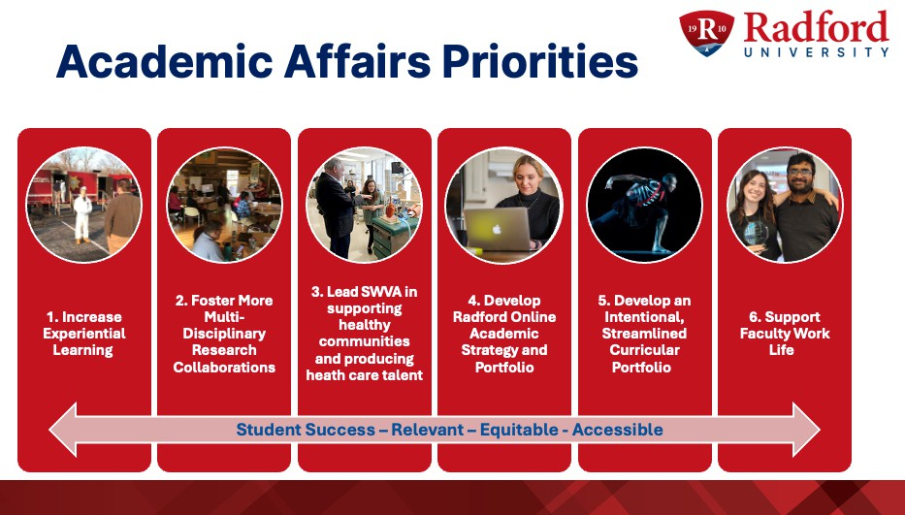
A couple of updates: yes, my daughters beat me again in the Turkey Trot 5k. And my reading has

been limited to reading responses to RFPs, application packets, and other reviews. We did start watching “Man on the Inside.” In season 2, Ted Danson is solving a mystery at a small college that is both witty and sharply insightful about the pressures of higher education (the provost is a main character!). I’m working on my list for the break - I’m happy to take (and share) recommendations for reading and watching.
Good luck (and have fun) with the end of the semester. I look forward to seeing you at events and graduation.
As always, I appreciate you all! Bethany


Fall Final Grading Deadline – December 15 at 5 p.m.
As we near the end of the fall semester, this is a reminder to submit all ﬁnal grades by 5 p.m. on Monday, December 15th. Please ensure that all ﬁnal grades are submitted by this deadline.
Timely grade submission plays a vital role in ensuring students receive ﬁnancial aid, maintain accurate academic standing, graduate on schedule, and can access ofﬁcial transcripts without delay.
Thank you for your continued effort and diligence in submitting grades on time and helping ensure a smooth ﬁnish to the semester for students.
More information about grading is available online. Contact registrar@radford.edu with questions.


Dr. Laura Vernon to be new Faculty Fellow for Nationally Competitive Awards
The Honors College is delighted to announce the appointment of Dr. Laura Vernon to the role of Honors Faculty Fellow for Nationally Competitive Awards starting in January 2026. In this position, Dr. Vernon will lead university efforts to identify and support students eligible for nationally competitive awards and fellowships (e.g., Goldwater, Udall, Gaither). Although administered through the Honors College, this position will serve honors and non-honors students from across campus. Dr. Vernon is Professor of English in the School of Writing, Language, and Literature, having taught a range of undergraduate and graduate courses at Radford since 2013. She has served as an Honors Faculty Fellow and currently serves as a RISE Faculty Fellow and Faculty Development Fellow. Her doctorate in professional communication, track record of peer-reviewed work, and

applied experience in public relations makes her especially well-suited to guide students on how to make a clear and compelling case for their own excellence.



Free Holiday Concerts: There will be several opportunities to enjoy live holiday music in the ﬁrst week of December on Radford’s main campus. The Radford University Jazz Ensemble, conducted by Dayl Burnett, will present “A Swinging Little Christmas Time” on Tues. Dec. 2 at 7:30 p.m. in the Davis Performance Hall in the Covington Center. The show will feature special guests Denise Bernardini and Robert Trent. Everyone is welcome.
On Wed., Dec. 3, at 12:15 in the Atrium of the Artis Center, the year end installment of Midday Music will bring more Christmas favorites. This time it is Denise Bernardini, Matt Cataldi, Sheldon Johnson, Will Newton and Robert Trent providing lunch-time entertainment. The atmosphere is casual and we invite you to bring a friend and your lunch for something unique to break up the day. This is a public event open to all.
Then, on Fri., Dec. 5, at 7:30 p.m. in the Davis Performance Hall in the Covington Center is the big Holiday Extravaganza 3.0. Join the Music Department in a celebration of seasonal tunes sure to lift your spirits. This is a free public event and one of the most fun and exciting of the year. Unwrapped toys will be accepted for local donations . . . and did we mention COOKIES?


ACCESSIBILITY UPGRADES COMING TO LIBRARY RESOURCES
By April 2026, vendors serving Virginia public institutions must comply with ADA Title II and WCAG
2.1 AA. This is a positive step toward more inclusive access — but the transition may be a bit bumpy. Many of our database and publisher vendors are still working on updates to meet these requirements. As a result, you may notice changes in interfaces or functionality over the coming months.
We’re updating our instructional materials including our Accessibility and Library Resources guide and will keep you informed as vendors roll out improvements. If you have questions or run into accessibility issues, please reach out — we’re here to help

HOLDS AND PAGING
The University Libraries have over 200,000 physical materials which can be checked out by our patrons. Did you know that we have wonderful student library assistants who will pull those materials from the shelves for you, and have them ready for checkout at the McConnell Library or RUC Library Front Desk? You can place your request for a speciﬁc book, DVD, etc. via our online catalog or in person. Shortly afterward, you’ll receive an email letting you know that your hold is ready for pickup.
You can request items to be sent from McConnell Library to the RUC Library, or vice versa. You can also request certain items to be delivered to or from the Teaching Resources Center in Peters Hall on main campus, or from the youth library in the main campus School of Writing, Language and Literature.

AI Research Tools Trials
Trials of two AI research tools, Consensus and Scite, will run through February 12 through our academic library consortium, VIVA.
Consensus:
- Product URL: https://consensus.app/
- Product Description: Consensus is an AI-powered academic search engine. It summarizes insights from the literature (with citations), ranks the top 20 papers for a search,
and offers snapshots of individual studies. If a user enters a yes/no question, Consensus tags individual articles with yes, no, mixed, and possibly, and provides a Consensus Meter that visualizes the balance of supporting and contrasting evidence.
- Trial Access Instructions: Sign up for an account using your institutional email.
Scite:
- Product URL: https://scite.ai/
- Product Description: Scite is an AI-powered research tool for discovering and evaluating scholarly articles. Smart Citations allow users to see how a publication has been cited by providing the context of the citation and a classiﬁcation describing whether it provides supporting or contrasting evidence for the cited claim. Scite Assistant generates a summary of the scholarly literature on a topic, with cited references. Scite is also useful for impact analysis.
- Trial Access Instructions: Sign up for an account with your institutional email. This will give you access to the trial on or off campus networks. Trial access is also automatic on any campus network or VPN, no account needed.

Please submit any feedback about these research tools to Alison Armstrong, Collection Management Librarian, via email at amarmstro@radford.edu.

Learn more about the University Libraries

Don’t Miss Out! Highlander Works Grant Deadline is November 30.
Radford University is excited to offer the Highlander Works Grant Program in Spring 2026. The program offers undergraduate students an opportunity to apply for funding to help reduce the ﬁnancial barriers associated with work-based learning opportunities, including internships, ﬁeld placements, clinicals, etc. Please see the website for eligibility and details.
Application submission for Spring 2026 is open and closes November 30.

Find out more about the Highlander Works Grant

OURS invites everyone to the 7th Winter Creative Activities & Research Days at Radford University. Each semester, we celebrate the close of term by showcasing students who, through curiosity and determination, have created new knowledge while working closely with faculty and peers to address questions that matter to society.

Winter CARD Schedule at a Glance:
Tuesday December 2nd Heth 014 & 022
Psychology & Gender Research Symposium 5:30 – 6:45 pm

Wednesday December 3rd McConnell Library, Ross Gallery
Musical Exploration of the Oud 9:00 – 9:30 am Perspectives on Global Travel and Tourism 1 11:00 – 11:50 am Perspectives on Global Travel and Tourism 2 12:00 – 12:50 pm Interdisciplinary Session 1 3:00 – 3:50 pm
Interdisciplinary Session 2 4:00 – 4:50 pm

Thursday December 4th Center for the Sciences, Planetarium
Cosmic Catastrophes: How the Universe 2:00 – 3:15 pm is Trying to Kill You

Thursday December 4th: Poster Sessions Artis Center Performance Hub
Interdisciplinary Poster Session 1 11:00 am – 12:15 pm
Interdisciplinary Poster Session 2 12:30 – 1:45 pm
Interdisciplinary Poster Session 3 2:00 – 3:15 pm
Interdisciplinary Poster Session 4 3:30 – 4:45 pm
Interdisciplinary Poster Session 5 5:00 – 6:15 pm



Radford University's January Our Turn Call for Session Presentations
Our Turn is an opportunity for faculty, staff, and professionals to come together as a teaching and learning community to discuss best teaching practices, participate in essential training, learn about and experiment with new technologies and become informed about new initiatives on
campus. On January 6-7, we will host workshops and presentations via Zoom.
If you would like to offer a session, please complete the online form before close of business on Monday, December 8. Feel free to share this information with other interested parties.
Submit a Session

Note- The link above will allow you to select the day you want to offer your presentation and request your session information, including the time slot you would like to present your session and all relevant meeting details.

If you have questions or concerns about this event, please email Samantha Blevins (sblevins@radford.edu), Center for Innovative Teaching and Learning.


Graduation
- Ceremony: December 12th, 2025 at 5:00 PM, Bondurant Auditorium
- Graduates & Hooders: Please arrive at 4:00 PM

Celebrating Graduate Faculty & Students
Outstanding Graduate Student Awards
The Ofﬁce of Graduate Affairs is accepting nominations for the Graduate Student Awards, recognizing outstanding achievement in academics, research, teaching, and professional development. Please notice the extension for our nominations.
Nominations Due by December 19, 2925

Highlander Research Blitz – 3-Minute Research Competition
Students (graduate & undergraduate) showcase their work with just one slide in 3 minutes. For more information on this event, please check out the HRB website.
Graduate Research & Scholarly Projects Stories


We are collecting stories of graduate student and faculty conferences, presentations, publications, or new research initiatives. Please email submissions to gradaffairs@radford.edu.
Ofﬁce of the Provost Radford University Martin Hall 331
540-831-5404
Subscribe to our email list.

801 East Main Street | Radford, VA 24142 US

