

August 4, 2025

Message from Provost Usher
There is so much to celebrate and so much to be excited about as we approach the end of “academic summer”! This newsletter is full of celebrations and plans for welcoming our students and faculty (back) to campus in the fall.
I want to take a moment, before the rush of the semester begins, to give a shout-out to many of the people who have been working over the summer to keep the campus a safe and lively hub of academic and social life, and to prepare for another great year. This is not an exhaustive list, so please forgive me if I have left anyone out.

- The Faculty, staff and students who participated in a wildly successful Quest. This is a university-wide commitment that showcases our investment in students, with Academic Colleges, Highlander Success Center, Enrollment Management, Student Life, Finance, Facilities, and many others coming together to welcome students. Most sessions had over 90% of students who signed up come to campus! This event is vital to ensuring a successful fall semester, and it was a joy to work with them.
- The Facilities staff who have responded to not one but two record rainfalls and the subsequent ﬂooding and water damage across campus. And have been working hard to get our air conditioning in multiple buildings to meet the increasingly hot weather (and the to the faculty and staff still working in warm buildings).
- The Faculty and Staff of the three Governor's Schools (Arts and Humanities at Radford and Health Sciences in Roanoke) who ran amazing three week events for some of the most talented high schoolers in the state.
- The College of Science staff who ran three different science camps over the summer, hopefully bringing a new generation of students a love of science and STEM careers.
- The leaders of the Strategic Plan, and everyone who has been contributing. We should have an exciting full draft for the campus as you return (Please attend the info sessions as you are able).
- Faculty who have taught summer classes, online and in person. We had 462 sections that enrolled over 5500 students!
- Faculty Senate Executive Committee who have continued to meet with me and each other over the summer, and to plan for a successful next year
- Human Resources staff, who have been working all summer to institute a state-mandated change to our hiring software, and have been patiently trying to help us get our work done.
- Our Registrar’s Ofﬁce has been spending the summer updating systems to make things run more smoothly for everyone. Stay tuned for regular updates here in Threads this year.
- The Academic Affairs Leadership Team and support staff, who have been here and meeting all summer with a positive and problem-solving perspective. I'm grateful that Radford has such great leadership for our central mission.

- And many others - everyone's contributions are valuable and you are appreciated.

President Bret and the VPs are reading The Caring University : Reimagining the Higher Education Workplace after the Great Resignation by Kevin McClure for our retreat in mid-August. It comes highly recommended - I’ll give an update when I have ﬁnished it! Please remember to send in your book recommendations by replying to this newsletter! We’ll compile a list of best summer readings for the end of August newsletter.
Bethany


What are you reading this summer?
The Radford University Carilion Library’s Summer Reading Program is so close to our goal of 300 books read this summer! At our last ofﬁcial count, only 15 more books need to be read and submitted to the program by August 15. So far, 285 books have been logged, which is 95% of our goal. To participate, you can stop by the RUC Library to add your title and author to our ﬁshbowl, or reply to a Summer Reading Program post on our Facebook page (Radford University Carilion Library)! If we get to 300, we'll have a special tiny animal in the RUC Library this Fall.
Mary Catherine Santoro says, "We’ve read 49 nonﬁction books and 236 ﬁction books. The most popular author has been Sarah J. Maas. The most popular book has been Suzanne Collins’s Sunrise on the Reaping. The most popular nonﬁction book has been Everything is Tuberculosis by John Green. "

UPDATE: Public Safety Information Sessions
Public Safety Information Sessions for faculty ahead of fall semester:
- August 11 at 11:00 a.m.
- August 12 at 11:00 a.m.
- August 20 at 11:00 a.m.

All sessions will be held in Cook Hall room 107

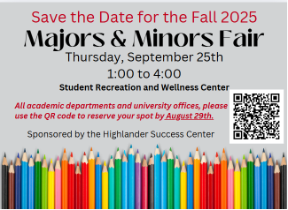

Exciting News: Navigate360 Selected as the Student Success Management Platform

We are excited to announce that Navigate360 has been selected as our next student success management platform. After a thorough review, Navigate360 stood out for its ability to support key institutional priorities while improving the user experience and operational efﬁciency.
Navigate360 will become the primary tool for faculty, advisors, and support staff to schedule and document advising interactions and coordinate student support.
While we will continue using Starﬁsh through the 2025–2026 academic year, we will begin using select features of Navigate360 and engaging stakeholders in planning and training throughout the year. Our goal is a full system-wide implementation by April 2026.
Faculty, advisors, and student support staff are essential to the success of this platform. More details, training opportunities, and ways to get involved will be shared this fall.

Let’s Welcome the Incoming 2025 Class Together! | New Student Convocation Invitation
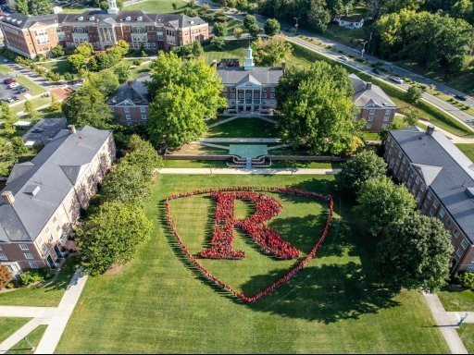
Following Faculty and Staff Convocation on Friday, August 22, we invite all faculty and staff to stick around and help us celebrate our newest Highlanders as they take their ﬁrst ofﬁcial steps into the

Radford community.
Immediately following Faculty/Staff Convocation, gather outside of Bondurant Auditorium to cheer on our new students as they arrive for New Student Convocation. Your warm welcome helps set the tone for a supportive, engaged, and spirited start to their Radford journey.
Then, make your way to Moffett Lawn for two other opportunities for engagement:
- 6:00 PM – Community Photo with the 2025 Incoming Class;
- Pick up your event t-shirt just before the photo, join us in creating a bold wave of Highlander red!
- Immediately following – New Student Social with music, games, and campus celebration
Your presence throughout these moments speaks volumes to our students about the community they are joining. Let’s show the Incoming 2025 Class what it means to be a Highlander.


Announcing the Radford University Community History Research Collective
Convening this fall and housed within the Ofﬁce of the Provost, the Radford University Community History Research Collective (RUCHRC) will work to foster a more connected and better-informed community—both on and off campus—through the shared work of public history, curating community memory and sharing narratives and interpretations that reﬂect the university’s evolving identity. As Radford University looks ahead to its 125th anniversary in 2035, the Collective’s efforts will help illuminate a more inclusive and representative institutional history. Through this process of history-telling, the Community History Research Collective seeks to strengthen relationships among students, faculty, staff, and the surrounding communities.
The Radford University Community History Research Collective is a community of scholars committed to telling a holistic and authentic history of Radford University. Their work explores the institution’s founding, growth, and transformations across decades, placing these developments within broader historical and regional contexts. Together, participants in this research collective will discover, preserve, and communicate the stories of Radford University’s past and its connections to Southwest Virginia, to interpret and understand our present and possible futures and deepen ties between Radford University and our neighboring communities.
By coming to better understand the stories of this place, we aim to support current and future Highlanders in ﬁnding their place here—rooted in a shared past and inspired to shape what comes next.

RU Community History Research Collective Team

The initial composition of the Research Collective is the following faculty members who completed the Inclusive History Certiﬁcate Program—co-sponsored by the Jessie Ball duPont Fund and the University of Virginia-based Universities Studying Slavery research consortium—during the 2024-2025 academic year:

- Sharon Roger Hepburn,
- Tiesha Martin, Associate
- Geoffrey Pollick
- Carter Turner
- Bethany Usher

More information about the RU Community History Research Collective and ways to participate will be shared as the collective gets underway. If you have interest in participating in the work of community history, please contact any member of the team to request more information.


Save the Date

August 22, 2025, 9 am – 3 pm, Graduate Teaching Assistant, Teaching Fellow, and Research Assistant Training.

Celebrating Graduate Faculty and Graduate Students

Contact Jean Mistele, jmistele@radford.edu if you have accomplishment or interesting experiences to share about your professional work and/or your students’ professional growth.

Recruitment Support

- Program coordinators: Schedule your Graduate Recruitment 2025-2026 Strategy Meeting with Cris Thompson from Graduate Admissions. Calendar link: (https://doodle.com/bp/cristhompson1/gradrecstrat2526
- Program coordinators: Fund your Recruitment Strategy with funding! Proposals due August 9, 2025. Awards up to $2000 for innovative ideas that lead to sustained student engagement. Proposal Link: Proposal: https://radford.co1.qualtrics.com/jfe/form/SV_4JkbGPfPRVGUGCG
Recruitment Funding Proposal Toolkit contains proposal requirements and evaluation rubric. Toolkit link: Graduate Recruitment
Funding Proposal Toolkit 2025-2026.docx

Professional Development Planning 2025-2026
Book Clubs/Workshop/Other: If you are interested in supporting a professional development opportunity for graduate students during the 2025-2026 academic year, please contact Jean Mistele, jmistele@radford.edu. We can help you promote your event.

The Highland Summer Conference continues to thrive at Radford University

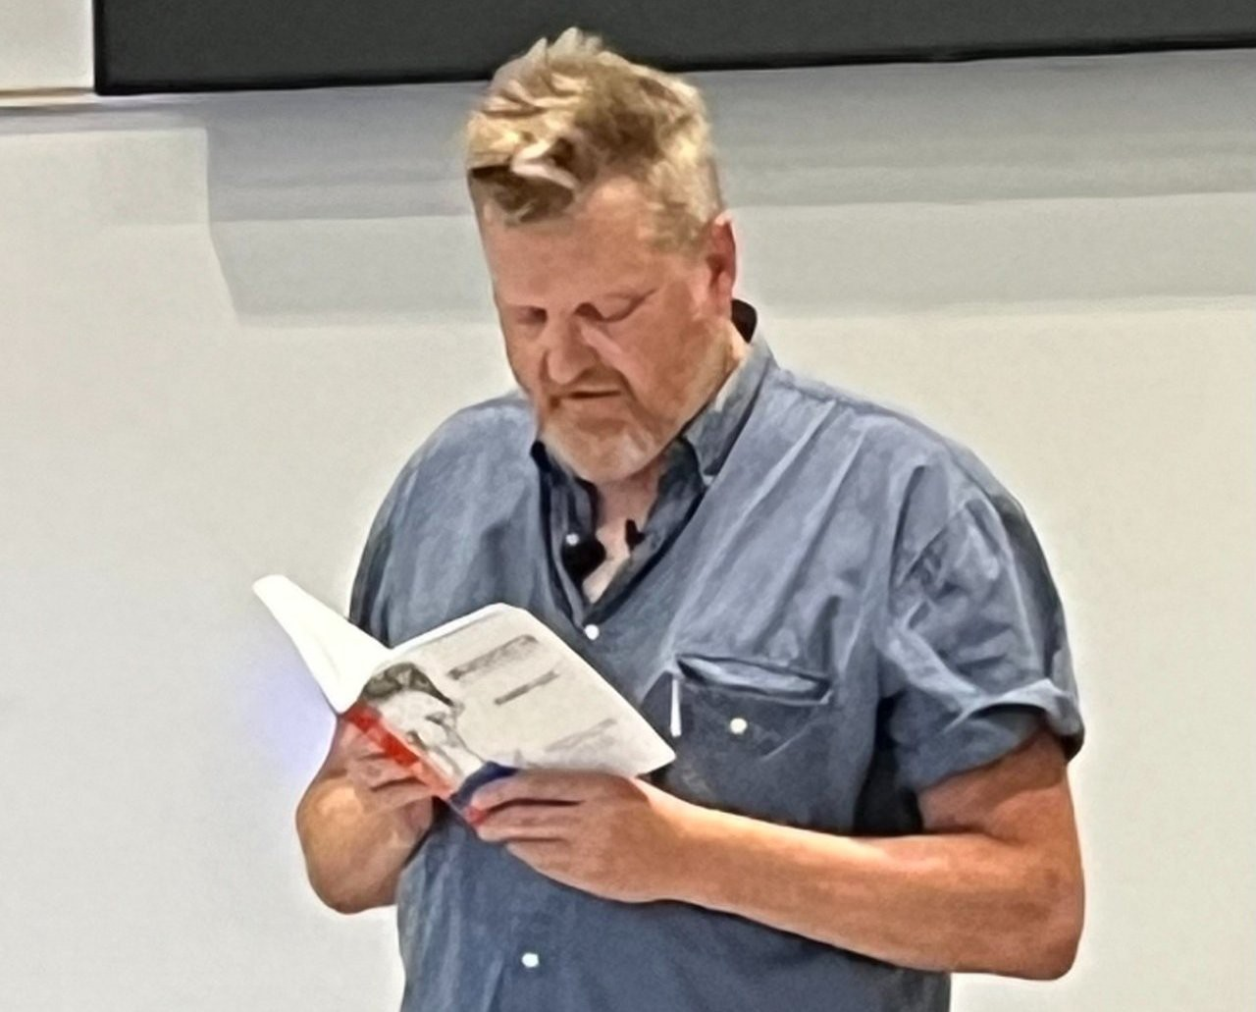
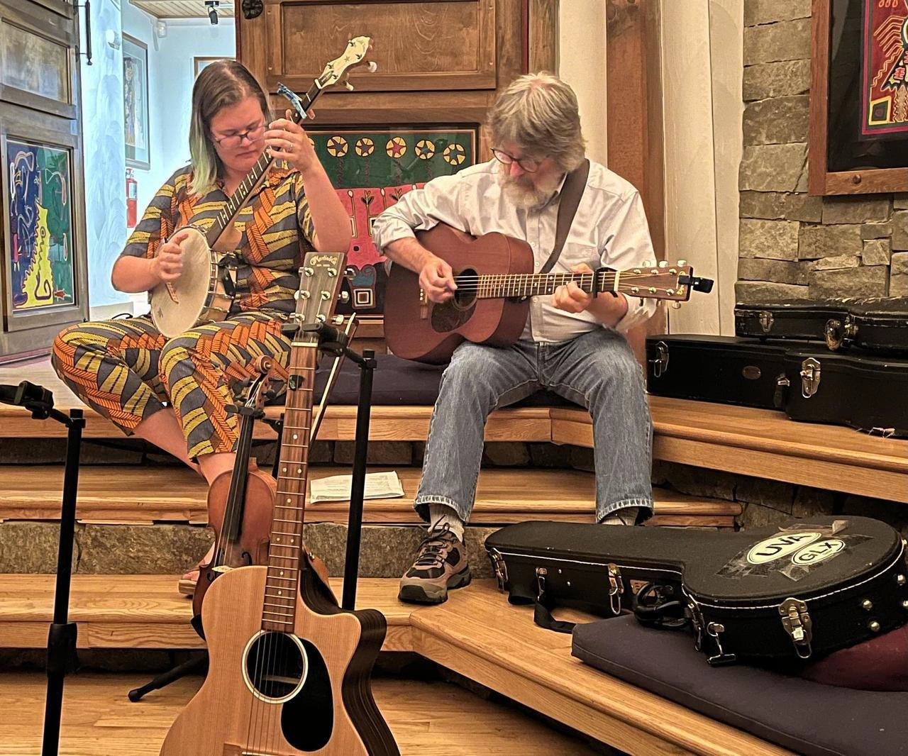
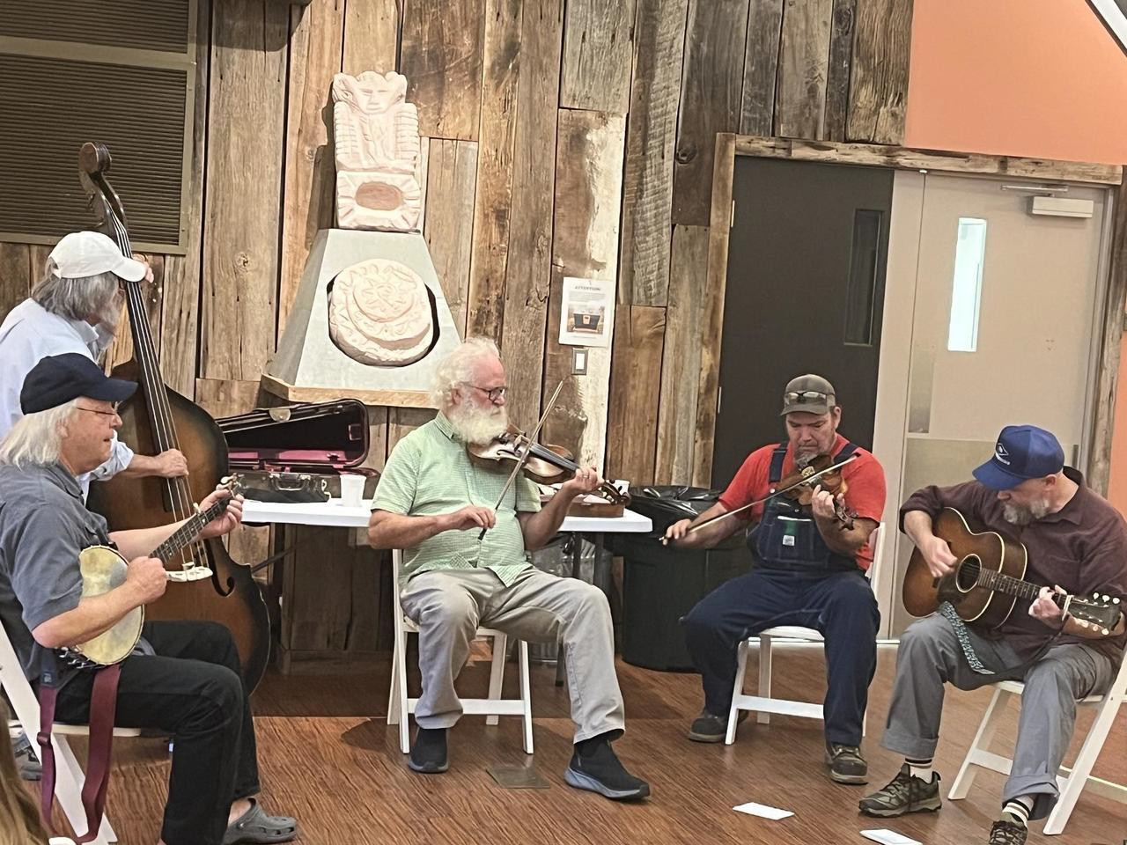

From July 14-18, 21 participants, including Radford University students, ﬁrst-time visitors to campus, and community members, attended the ﬁve-day workshop at Selu Conservancy.
This year’s guest instructor was Robert Gipe, an artist, author, and workshop-leader from eastern Kentucky. Gipe led the workshop in creative writing prompts, exercises in character and dialogue, and readings of diverse Appalachian writers, from Harriet Arnow to Rae Garringer.
Evening programs included an evening of music with traditional instruments performed by Sula’s Front Porch, featuring Tim Thornton and Aran Garnett-Deakin. and a concert by the Reed Family Tradition String Band. On July 15, Robert Gipe read from his work Weedeater, a sequel to the award-winning visual novel Trampoline, as well as new, unpublished work.
On the ﬁnal night, participants read aloud their own work in Selu’s seven-sided room. The week concluded with a visit to the Farm at Selu . . . And plans for next year’s event are already underway with co-directors April Asbury and Tim Thornton.
The Highland Summer Conference, established at Radford University in 1978, celebrates education, creative writing, regional music, and Appalachian culture. Students who enroll in the course can earn credit in English or Appalachian Studies, for graduate or undergraduate credit. Other participants may enroll for the experience itself, with a conference discount for students and seniors.


The Ofﬁce of Sponsored Programs and Grants Management (SPGM) successfully secured a total of 48 new external grants and contracts throughout Fiscal Year 2025, totaling $8,172,048. Thanks to the dedication and hard work of our faculty—and their commitment to supporting students, collaborating with community partners, and advancing intellectual discovery—this achievement represents a 13% increase in total funding compared to last year!
Congratulations to everyone who successfully secured funding, and sincere appreciation to those who devoted long hours to developing and submitting external proposals. Well done!


Radford University is once again partnering with SCHEV to make available the Constructive Dialogue Institute's "Perspectives" modules aimed at building skills for engaging in civil discourse and collaboration across differences (including political differences). These six modules are available for free to anyone with an RU email address to be used in classes, clubs, residence hall ﬂoors, department meetings, etc. Contact Heather Keith to gain access so that you can see the programming or to build your own course in the LMS to be used with students, department members, etc. hkeith1@radford.edu


Key Dates for OURS Events and Services for the Coming Year
OURS is excited to announce the addition of a new program Supporting early-stage student research and creative inquiry projects.
The OURS Student Seed Grant provides up to $500 to help undergraduate students launch new research projects. This small grant is designed to help you take those ﬁrst steps exploring a new research question.
Applications are reviewed on a rolling basis and can be submitted by students with faculty or staff support at: https://radford.co1.qualtrics.com/jfe/form/SV_1TXle93PiOOpXqS

- 7th Winter CARD
  - November 4, 2025: Deadline to submit presentations
  - November 10, 2025: Soft deadline for submitting posters for printing
  - December 3, 2025: Oral and other presentation styles ﬁt for a classroom
  - December 4, 2025: Poster and other presentation styles ﬁt for an atrium
- 5th Student Engagement Forum
  - March 11, 2026: Deadline to submit presentations
  - April 6, 2026: Soft deadline for submitting posters for printing
  - April 21, 2026: Poster and other presentation styles ﬁt for an atrium
  - April 22, 2026: Oral and other presentation styles ﬁt for a classroom
- SURF applications are due by midnight February 11, 2026.
- Highlander Research Blitz
  - February 20, 2026: Deadline to submit applications


April 1, 2026: Event held 5-7:30 pm
Subscribe to our email list.

801 East Main Street | Radford, VA 24142 US
Poster printing for dissemination of research is free for all faculty, staff, graduate, and undergraduate students. Submit those requests here: www.radford.edu/ours-posters
The Ofﬁce of Undergraduate Research (OURS) supports undergraduate students presenting their research or creative work at professional conferences and events; whether in-person or virtual. Apply at www.radford.edu/ours-travel

To learn more about any OURS support please visit www.radford.edu/ours or email ours@radford.edu.

Ofﬁce of the Provost Radford University Martin Hall 331
540-831-5404

