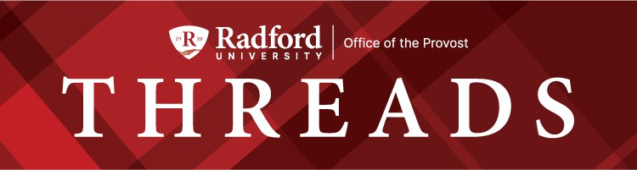

August 18, 2025

Welcome back! It’s so exciting to see the activity on campus as we gear up for the semester. And for everyone who has been here all summer, thank you for not being grumpy about the longer lines at Starbucks! Back-to-school has been the “new year” for me since I was ﬁve years old (which is way too many years to count). As it approaches, excitement and a little nervousness keep me from getting a good night’s sleep. We’ve already welcomed the new faculty with a very active-learning, community-focused orientation, and meeting them was a joy. Over the next couple of weeks, I’m looking forward to the college and department meetings, convocations, and, of course, ﬂoating down the New with the students!
Every two years, all Virginia public colleges and universities are required to update their planning documents for the next six years - creating a rolling window of plans. The plans are reviewed by state leaders, and then we meet in person with the “Op-Six” team (the Secretary of Finance, the Secretary of Education, the Director of the Department of Planning and Budget, the Staff Director of the House Committee on Appropriations, and the Staff Director of the Senate Committee on Finance and Appropriations) to discuss the plans and their alignment with SCHEV’s strategic plan. You can think of this as having written and oral comprehensive exams on the university every two years. President Bret and I, along with VPs Dannette Gomez-Beane and Rob Hoover, and Lisa Ghidotti (Executive Director of Government Relations and Strategic Initiatives), met in Richmond today with the Op-Six. We shared all the positive information about our enrollment and retention data, our new brand, our strong ﬁnancial position, the strength of our academic portfolio, and our plans for the health sciences in Roanoke. It was a very positive meeting, and I wanted to share how proud we should all be of the work that we are doing together.
Thanks to everyone for making the beginning of the academic year such a success! I look forward to seeing you all, and our students, soon!
Bethany


What are you reading this summer?

Dr. Donna McCloskey, Dean, DCOBE, suggests The Women by Kristin Hannah. This book is about nurses during the Vietnam War and still has her thinking about it.
Also, Unreasonable Hospitality: The Remarkable Power of Giving People More Than They Expect by Will Guidara is the BEST leadership book she has read this year. This book would make an awesome book club selection.
Lastly, she suggests The Checklist Manifesto: How to Get Things Done Right by Atul Gawande. It's an oldie but goodie that reminds us that we don't have to reinvent the wheel. Documenting the steps/process ensures that things don't get forgotten and knowledge is transferred. She is going to re-read this book before the semester ofﬁcially starts.
Dr. Rhett Herman, Department of Physics, read The Best Science Fiction of the Year, edited by Neil Clarke (short stories). "The reason I like this series includes the fact that I really have to think about the physics involved for these stories. These ideas often make you think about the direction humanity is heading in one or more aspects of our existence. Sometimes these directions are disturbing, and they make you want to see what can be done now to make a better future for ourselves."
Dr. Jerel Benton, Student Success, suggested The Irresistible Introvert: Harness the Power of Quiet Charisma in a Loud World by Michaela Chung.
Dr. Michelle Lenhart enjoyed Happy Place by Emily Henry, which led her on an Emily Henry binge. She says this author is perfect for reading by a body of water!


Name that series, win free coffee!
We are excited that The Provost Speaker Series will be starting back up again this year. We have some really great speakers in mind for fall and spring.
We need your help! We would like our RU Community to help us name this series. Once we get all the entries, the Academic Affairs Leadership Team will vote for the winner.
Provost Usher will buy the winner coffee at Arabica in Downtown Radford and you will also get a 'shout out' in the next Threads Newsletter.
Please enter nominations before 5pm, Tuesday, August 26th. The winner will be announced in the Threads edition on Tuesday, September 2nd (Sept 1st is a holiday).
Enter here, win free coffee!

COACHE Update:
We are pleased to share that our institution has received the results from the Collaborative on Academic Careers in Higher Education (COACHE) faculty survey, offering valuable insights into faculty experiences, perspectives, and priorities. Last week, two Faculty Senate Executive Committee members and the Assistant Provost for Faculty and Curriculum traveled to Harvard University to learn from COACHE experts and peer institutions about best practices for using this data to guide meaningful improvements. In the months ahead, Institutional Research and Effectiveness, in collaboration with the Faculty Senate, will review the ﬁndings, share key themes with the campus community, and work together to identify opportunities to strengthen our faculty experience.
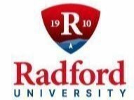
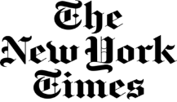

Did you know that every student, faculty and staff member at Radford University has free and full online access to the New York Times? Radford University participates in the New York Times College Network, and so every Highlander can sign up for a free account and access all the beneﬁts of the New York Times on a web browser or the NYT app. To ﬁnd out more and sign up for your free access account, use the LibGuide from McConnell Library, https://radford.libanswers.com/faq/376738.
Questions? Contact Chapman Rackaway at crackaway@radford.edu
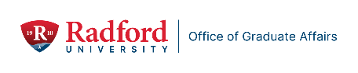

Graduate Affairs: By the Numbers

- Academic Performance Recovery: During Summer 2 and Summer 3, 27% of students who had been ﬂagged for academic performance earlier in the year regained good academic standing.

Celebrating Graduate Faculty and Graduate Students
- The Ofﬁce of Graduate Affairs will highlight research stories in a new section: Graduate Research

and Scholarly Projects. This may include students presenting at conferences, students authoring or co-authoring published articles, or stories about initiating new research projects. This is open to faculty sharing their successes, too. Send your stories to gradaffairs@radford.edu .
- We are also collecting stories from faculty about their research with their graduate students. This will be sent to Amy Cox to be included in the September 2025 issue of CUR, Council on Undergraduate Research. This publication focuses on undergraduate research and includes opportunities for us to highlight our graduate students. This can be a great way to advertise our graduate programs. Please send your research stories to Amy Cox, arcox1@radford.edu by September 2, 2025.

Professional Development Planning for 2025 – 2026

- Save the Date: August 22, 2025, 9 am – 3 pm, Graduate Teaching Assistant, Teaching Fellow, and Research Assistant Training, Heth 114.
- Book Clubs/Workshop/Other: If you are interested in supporting a professional development opportunity for graduate students during the 2025-2026 academic year, please contact gradaffairs@radford.edu. We can help you plan and promote your event.
- All graduate students have access to Udemy training modules through OneCampus. Udemy offers a wide variety of training modules that are accessible and ﬂexible for graduate students. These can help graduate students to enhance their resume, develop new competencies, and prepare for professional opportunities in a ﬂexible online format. format. https://radfordu.udemy .com/organization/home/

Coming in September: Leadership Summit – Rooted in Values, Rising in Vision.
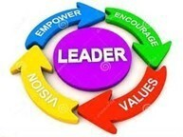
Hosted by Omicron Delta Kappa (ODK). ODK is a National Honors Leadership Society. ODK is intergenerational and accepts members of all ages. It is open to graduate students. If you are interested in ODK, please contact Dr. Jean Mistele, jmistele@radford.edu

- September 18, 2025, 11 – 12:15, HH 3016 Character Building for Aspiring Leaders. Dr. Tay Keong Tan
- September 22, 2025, 5 – 6, Location: TBD Leaders Round Table, ODK Ofﬁcers
- September 24, 2025, 5 – 7, COS M173 (Pending) Ethical Leadership Workshop, Dr. Timothy Reed, ODK VP for Membership and Operations
- September 25 – 26, Kyle 137 (Pending) Truist Emerging Leaders Certiﬁcation, Dr. Ben Biermeier-Hanson

Community Building Planning for 2025 – 2026

- Coffee Break at the Highlander Hotel in Radford, Tuesday, September 9, noon – 1. Free coffee – Ofﬁce of Graduate Affairs is paying! Come join us and meet other graduate students. We meet every other Monday.
- Graduate Student Council Events: Events and activities are forthcoming.



Key Dates for OURS Events and Services for the Coming Year
OURS is excited to announce the addition of a new program Supporting early-stage student research and creative inquiry projects.
The OURS Student Seed Grant provides up to $500 to help undergraduate students launch new research projects. This small grant is designed to help you take those ﬁrst steps exploring a new research question.
Applications are reviewed on a rolling basis and can be submitted by students with faculty or staff support at: https://radford.co1.qualtrics.com/jfe/form/SV_1TXle93PiOOpXqS

7th Winter CARD
  - November 4, 2025: Deadline to submit presentations
  - November 10, 2025: Soft deadline for submitting posters for printing
  - December 3, 2025: Oral and other presentation styles ﬁt for a classroom
  - December 4, 2025: Poster and other presentation styles ﬁt for an atrium

35th Student Engagement Forum
  - March 11, 2026: Deadline to submit presentations
  - April 6, 2026: Soft deadline for submitting posters for printing
  - April 21, 2026: Poster and other presentation styles ﬁt for an atrium
  - April 22, 2026: Oral and other presentation styles ﬁt for a classroom
- SURF applications are due by midnight February 11, 2026.

Highlander Research Blitz
  - February 20, 2026: Deadline to submit applications
  - April 1, 2026: Event held 5-7:30 pm
- Poster printing for dissemination of research is free for all faculty, staff, graduate, and undergraduate students. Submit those requests here: www.radford.edu/ours-posters
- The Ofﬁce of Undergraduate Research (OURS) supports undergraduate students presenting their research or creative work at professional conferences and events; whether in-person or virtual. Apply at www.radford.edu/ours-travel

To learn more about any OURS support please visit www.radford.edu/ours or email ours@radford.edu.


VTOP Professional Development Scholarships
Scholarships for professional development are available to professionals whose career involves connecting students, institutions of higher education, and employers with the goal of expanding paid and credit-bearing internship and other work-based learning opportunities (job shadowing, tours, mentorship, externships, apprenticeships, ﬁeld experiences, etc.). Details are available on the Professional Development Scholarship page.

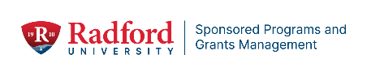

Faculty Professional Development Leave Program
The Radford University Faculty Professional Development Leave Program provides tenured faculty an opportunity to engage in advanced study, research, and/or other scholarly and creative activities that will enhance their competencies as teachers/scholars and better prepare them to fulﬁll their teaching and other professional obligations to the university. This program supports traditional forms of professional development as well as alternative opportunities that would enable a faculty member to intern with a company, agency, school, or other such entity in order to enhance, reestablish, or re-energize their research, scholarship, or creative activity in their area of professional practice. Leave may be requested at full pay for one semester or at one-half pay for two semesters, according to the terms speciﬁed in the Faculty Handbook.
There will only be one call for applications. If you are interested in applying by the November 3, 2025 deadline, please see the link to our application guidelines.
https://www.radford.edu/sponsored-programs/internal-funding.html

Sponsored Programs Seed Grant Program
As you begin planning for funding in the upcoming academic year, the Ofﬁce of Sponsored Programs would like to remind you about our Seed Grant Program. Seed Grants are one-year grants to fund pilot or preliminary work leading to external funding for larger research/creative projects by members of the faculty and staff.
We will once again be accepting applications on a rolling basis, beginning September 15 through April 15, 2026.
If you're considering applying for a Seed Grant, we encourage you to make an appointment with our ofﬁce to discuss your project ideas and explore how we can support your efforts. Please visit SPGM’s website for more details: https://www.radford.edu/sponsored-programs/internal-funding.html

AI Community of Practice
The AI Community of Practice is ready for year two. This community formed last year and will continue during AY2025-2026. We are more than 50 participants strong. You are invited to participate in the community. Participation is voluntary, and you can participate as much or as little as you want. Please email Laura Vernon, the community's faculty development leader, at lvernon@radford.edu to be added to the email distribution list so that you can
receive community communications. From there, you can decide how and when you want to participate.

You may have questions about a community of practice. The information below may be helpful.

What is a community of practice?

- A community of practice is a group of people who have an interest, passion, or concern and come together to learn more about it.
- Participants collaborate and communicate, sharing knowledge as a community. They have a shared identity that is built around their common interest.
- A community of practice is based on the theory that a community can act as a living curriculum.
- The community takes part in collective learning where each individual shares their knowledge with others in the group.
- Participants need to be practitioners in their domain. They work toward a shared goal of learning how to do things better and further their knowledge. They generate ideas and resources aimed at improving their practice.

What are the beneﬁts of a community of practice?
- Fosters learning
- Encourages collaboration
- Offers opportunities for creative problem solving and innovation
- Pools resources
- Improves practice

We had a good ﬁrst year, but there is still more we can do to support each other as we continue to navigate the use of AI in our practice. For starters, the community will host the following two Our Turn sessions:

- AI and Your Syllabus, August 14, 2:00-2:50 p.m., in Zoom
- AI Community of Practice (Planning Session), August 15, 9:00-9:50 a.m., in Zoom
You can register for these sessions through the CITL registration system. We look forward to another great year with you as part of the community!

Highlander Success Center wants to remind you...
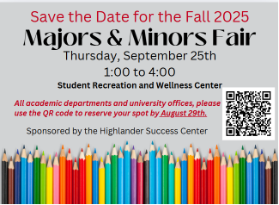

Ofﬁce of the Provost Radford University Martin Hall 331
540-831-5404

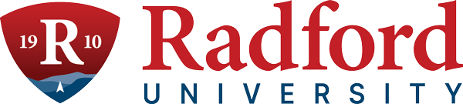
Subscribe to our email list.

801 East Main Street | Radford, VA 24142 US

