

April 7, 2025

Message from Provost Usher
What a semester! The end of the spring semester always rushes up to me in a sudden ﬂurry of happy activity. All the curricular updates that people have been working on get to ﬁnal approval, student performances ﬁll every evening, research events ﬁll the hallways and classrooms, and people are suddenly already planning for the summer and the start of the fall semester! This newsletter has lots of evidence of all of those. With so much uncertainty in higher education and many of the institutions we are integrated with, taking a step back to see the way that our students are thriving because we continue to embrace our institutional values can be grounding. So, please take the time to step back and enjoy seeing your work in educating and mentoring our students come to fruition.
Thanks to the General Education Task Force, the REAL general education Committee, and Faculty Senate for General Education plan they are considering. I’m excited about the potential, and I have committed resources - time and ﬁnancial - to support your work in making this successful if it passes. Dannette Gomez Beane, Rob Hoover, and I have all committed to teaching sections of the RADF101 Find Your Place here course if we have the opportunity!
Thanks, too, to the committees for the CHBS and CVPA Dean searches, and to everyone who has taken time to meet the candidates and give feedback. We are nearing the end of the public presentations and visits. After the candidates complete their interviews, the search committees meet to give me feedback about the viability of each candidate. If, after the interview, they decide that a candidate is viable, they give me their feedback on their strengths and areas for growth or learning to be successful. Then we move into what looks like a “silent phase” (but is busy for me and my team) as I make ﬁnal decisions, make offers to candidates, and negotiate contracts. Once we have a contract, we coordinate announcements so that the candidate has a chance to tell their current university before we put out a splashy announcement. As soon as I can, I let the search committee, the college, and the whole community know about the new Dean. Then it falls into your hands to help welcome the new person and help them Find Their Place. Here!
Please also take time to join me for my Lunch-and-Learns, sponsored by CITL - the ﬁrst is today! I look forward to talking informally with you.
Bethany

You Are Invited!
We hope you are able to join us for the Academic Affairs Awards Ceremony & Reception, celebrating the outstanding achievements of our colleagues!
Date: April 30, 2025 Time: 1pm – 4pm Location: Kyle 340
This special event will honor T&R and AP Faculty members who this year were awarded external funding, SEED Grants, Faculty Professional Development Leave, University Awards, Dalton Eminent Scholars, Undergraduate Research Mentor Awards, and those who submitted external awards.

The reception will begin at 1pm. Award recognition will begin at 2pm with President Danilowicz and Provost Usher.


Lunch and Learn
with Provost Bethany Usher
Drop in to ask questions and engage in conversation about University initiatives and national conversations.
Feel free to bring your own lunch. No registration or RSVP needed.
Main Campus McConnell ILCB (3rd ﬂoor) | April 7 | Noon RUC Board Room | April 16 | Noon
Main Campus McConnell ILCB (3rd ﬂoor) | April 22 | Noon RHEC Room 510E | May 1 | Noon

Provost's Speaker Series with Sallie Beth Johnson

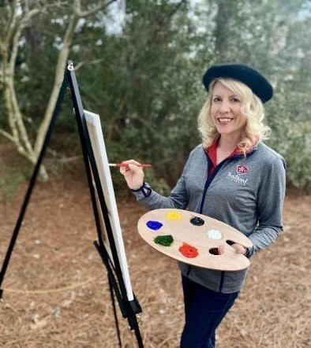
A Picture of Health: How We Create Thriving Communities Together

What makes a community healthy? It’s more than healthcare—it’s shaped by many factors, such as the air we breathe, food we eat, places we live and work, and relationships we nurture. Everyday forces shape our well-being, determining whether we thrive or struggle with chronic disease—a leading cause of death and disability in the United States.
On Earth Day, please join Dr. Sallie Beth Johnson, Chair of Radford University’s Department of Public Health and Healthcare Leadership, at the Taubman Museum of Art, for an engaging talk on the art and science of health behavior change. Drawing on her 25 years in community health, she will share insights from research and real-world examples of how communities in Virginia are improving health through programs, policy, and partnerships.
Included with the talk will be a faculty and student photo exhibit showcasing the often-overlooked ways our surroundings promote health. Whether you're a student, professional, or community member, take this opportunity to connect, collaborate, and paint a healthier, thriving future together.

April 22, 2025 7:30pm
Taubman Museum Healthy Snacks Included!


Celebrate National Library Week with the University Libraries!

April 6-12 marks National Library Week and we want to celebrate with you! Join us in the McConnell Library Ross Gallery at noon on Thursday, April 10 for Ken Smith and Suzanne Loscscio's graphic design students’ “Library Quotes” display and reception. Cake will be served!

You Asked For It...

Based on feedback from our user satisfaction survey, McConnell Library has new subject/genre signs to make it easier to ﬁnd the books you need. Check them out the next time you are in the library, and let us know what you think!
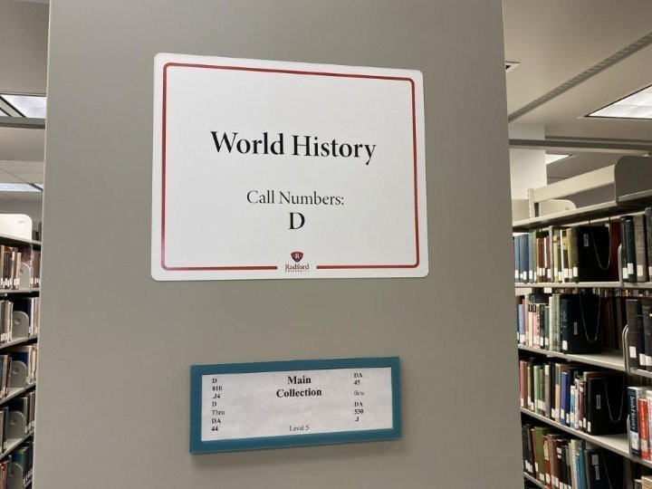

Graduate Affairs

Award Celebrations

Highlander Research Blitz WINNERS!
Congratulations to all our graduate students who participated in the competition and to their faculty mentors.

The 2025 Winners Include:
1st Place: MaKayla Dulaney – Dating Apps and Attachment: Anxiety and Avoidance in Modern Romance
2nd Place: Jeff Wolfe – Understanding Cross-neurotype Communication
3rd Place: Kalyn Stiles – Balancing the Equation: Setting Boundaries for a Sustainable Life

We look forward to next year’s competition and encourage this year’s participants and all other graduate students to consider engaging in this exciting event.

Outstanding Graduate Student Awards Celebration
Date: April 18, 2025
Time: 11 am – 1 pm Location: The HUB
One award of $750 will be presented in each of the following ﬁve categories:
- Graduate Student
- Doctoral Student

- Graduate Assistant
- Graduate Teaching Assistant
- Graduate Teaching Fellow

Join us as we celebrate our outstanding graduate students!

Building Our Community

Graduate Student Appreciation Days!
April 7th Graduate Student Coffee Hour at the Highlander Hotel, 12 - 1 The ﬁrst 7 students get a free book - Daring Greatly by Brene´ Brown

April 8th 9 am – 4 pm Mental Wellness Kits; Come by the Graduate Affairs Ofﬁce to get yours while supplies last!

April 9th 11 – 1 Game Time and Lunch Time, Roanoke Campus at the Highlander House Free Pizza; Win Prizes!
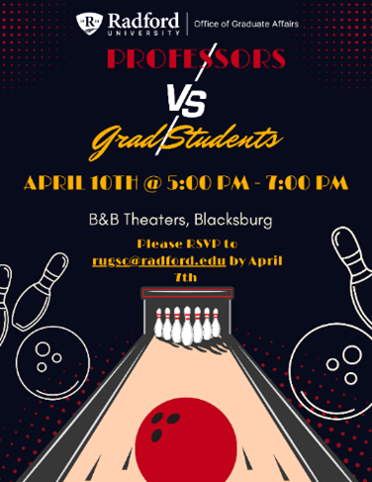

Professor vs. Grad Student Bowling April 10, 2025; 6 – 8 pm; B&B Theatres Blacksburg; RSVP by April 8, rugsc@radford.edu. Hosted: Graduate Student Association


Sponsored Programs Internal Funding Opportunity
As you begin to think about funding for next academic year, Sponsored Programs would like to remind you to check out our Seed Grant Program. We will once again be accepting applications on a rolling deadline beginning September 15th through April 15, 2026. Sponsored Programs would

like to encourage those who are considering going after a Seed Grant to make an appointment with our ofﬁce to discuss your plans and how we can help assist you.
If you have questions about the internal grant program, please contact Tom Cruise at tcruise@radford.edu.
Please visit SPGM’s website for more details

Faculty Professional Development Leave Program
For tenured faculty who are eligible,

The Radford University Faculty Professional Development Leave Program (FPDL) is an opportunity for you to broaden your professional horizons and develop new teaching and research perspectives. The University has supported numerous faculty over the years, so we would like to encourage you to explore this option. More information about the application form and instructions for the 2025-2026 program will be posted on SPGM’s website very soon! Until then, if you are eligible to submit and have questions about the program please feel free to reach out to Jeanne Mekolichick or Tom Cruise.

Career and Talent Development

Available Internship Grants

V-TOP Highlander Works Internship Grant

Radford University is excited to offer the V-TOP Highlander Works Internship Grant program in Summer 2025. The program supports students participating in internships and will be administered through the Center for Career and Talent Development Ofﬁce. Grant funds will go directly toward removing ﬁnancial barriers to student participation. Requests can be funded in part or in full up to $4,000 per student. Deadline to apply for Summer 2025 is April 11, 2025.

Enterprise Mobility Internship Grant

Requests can be funded in part or in full up to $2,500 per student. Deadline to apply for Summer 2025 is April 11, 2025.

C.E. Richardson Internship Grant - Students must reside in Pulaski County, VA to be eligible for this grant.

Requests can be funded in part or in full up to $2,500 per student. Deadline to apply for Summer 2025 is April 11, 2025.

For more information, contact Debbie Fenderson dfenderson@radford.edu

Find out more about Internship Grants


How do humans learn best?
After reading the book, How Humans Learn, come spend a morning honing your craft with other Radford educators as we explore the science behind learning, and the instructional practices that yield the highest results.

In this book exploration, we’re going to roll-up our sleeves and engage in new strategies, grapple with the latest research, and collaborate with fellow educators on what really works (and what doesn’t). This interactive workshop will leave you with plenty of ideas to consider over the summer to infuse into your practice and the participants will receive a free copy of the book, “How Humans Learn – The science and stories behind effective college teaching” by Joshua R. Eyler.
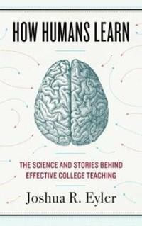


RISE up!

This year’s cohort of RISE faculty are well on their way to implementing signiﬁcant change ideas within their classes through participation in the RISE Spring Institute. They're doing the hard work of digging into their outcomes to explore who their practices are working for (and who they’re not) and what challenges or barriers are potentially preventing success. They’re engaging in constructive dialogue with each other around their own strengths and blind spots, exploring instructional and inclusive best practices, and collecting data to determine key leverage points for change.
How do they have the time to do all of that? Well, participation in the RISE Institute comes with a full course reduction giving them the needed time (and hopefully renewed energy) to critically examine their own practice, learn about new innovations/ideas, and build collaborative, constructive relationships with faculty all over the campus. If this sounds like something you’d like to engage in, registration for the 2026 RISE Faculty Cohort is now open. For more information, click here.

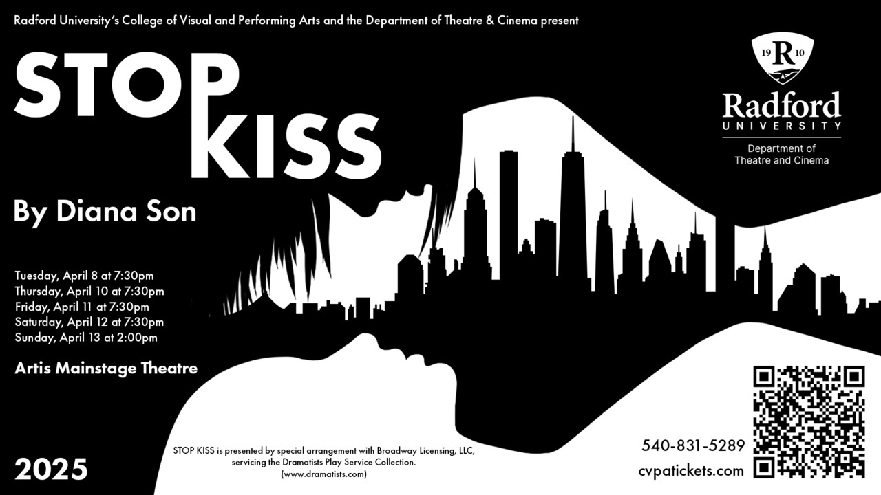

Final Play of the Semester: Stop Kiss
Stop Kiss by Diana Son opens on April 8 at 7:30 p.m. in the Artis Center Main Stage Theater. This is a quirky yet moving play of self-discovery, tolerance, and love in a sometimes-unforgiving world. (Note: This play contains mature themes: discrimination, sexual content, and adult language.) For more on the play, available times and dates and tickets, visit our Current Season page.

The 24th International Guitar Festival Arrives
The 24th International Guitar Festival will open its doors on April 11 and 12 and welcome four fantastic guitarists for masterclasses and concerts. Massimo Delle Cese (Italy), Martha Masters (US), Octavio Deluchi (Brazil), and Kareem McCullough (US) bring their experience and talents to the Covington Center for a FREE public event. No registration required. For more information, check out www.radford.edu/igf.

BFA Art Exhibitions
Our senior BFA students in Art will present their work in two simultaneous shows in the Covington and Tyler galleries. Beginning April 18 and running through April 26, you can enjoy the work from our graduating seniors with concentrations in Graphic Design (Covington) and Studio Art (Tyler).
There is also a dual reception on Friday, April 18 from 5-7 p.m. in Covington and 6-8 p.m. in Tyler. The reception is free, open to the public and will offer refreshments.



Spring Fashion Fete Fashion Show
Subscribe to our email list.

801 East Main Street | Radford, VA 24142 US
The spring tradition of the Fashion Fête Fashion Show, courtesy of the Design Department, continues this year on Saturday, April 19 at 7:30 p.m. in the Artis Center Performance Hub. The event is sponsored by the Fashion Society Student Club and the event is free. However, if you’d like ﬂoor seating, it is $10 per person in advance and $15 at the door. For more info and tickets, call 540-831-5386.

Ofﬁce of the Provost Radford University Martin Hall 331
540-831-5404

