

April 6, 2026
Message from Provost Usher

Happy spring! What an exciting time of the year - we get to see the culmination of our all of our efforts to support students as they do their culminating activities for the academic year. Whether those are the SRO performances of the Little Shop of Horrors, Wicked Fest student presentations, career launches off the Kyle patio, theses defenses up and down the hall of Hemphill Hall, or summations of student teaching, they are everywhere. Our students are very proud of what they are doing, and, in a way that I have not seen anywhere else, able to articulate exactly how their faculty and staff have supported them. That’s a culture of care that we can’t take for granted.
I’m also proud of the activities in the Academic Affairs Division this year (so far- more to come!). My goal is not just to have short-term wins, but to do the hard things that will support Radford University through the 2031 strategic plan, the 125th anniversary in 2035, and beyond. As my grandmother would say- “ye gads and little catﬁsh!” (I never really understood that one). She also said that I should “always do the right thing, which isn’t always the easy thing.” That’s advice to live by.

- I was thrilled to see our fall to spring retention jump to 93%, with our Pell students retained at almost exactly the same rate as all of our students (and that’s up more than 5% in the past few years). This student success goal is because of many small changes that collectively support student persistence. Our average retention/persistence rates (in undergraduate and graduate areas) continue to rise, too, which will ultimately result in strong graduation rates.
- The University Shared Governance Committee (UIGRC) has completed an update of the shared governance documents, which more clearly deﬁne our commitment to working together as a community - and these are being presented through Faculty Senate to be adopted this year. The documents professionalize our institutional processes and will ensure an active Shared Governance committee process moving forward.
- The BOV passed our tuition and budget documents in March, which included raising allowed credits (without additional tuition) to 18 - something I know that faculty and students have wanted since the cap was lowered in 2020. I appreciate the advocacy of Faculty Senate and the Student Success Council, as well as the Division of Budget and Finance, to make this happen. We continue to align and simplify the tuition and fee structure for students.
- We’ve hired a new Assistant Provost for Graduate Affairs (Agida Manizade) and Dean of the College of Humanities and Behavioral Sciences (Jeff Aspelmeier) this year, and we have excellent candidates for the AVP positions in Radford Online and Health Sciences who will hopefully be joining us by fall to help us meet our Academic Affairs Strategic Priorities.
- We have maintained the size of the faculty this year, leveling off after years of decline. I believe that the faculty size is now well-aligned with the size of our student population and programs; as long as we continue to maintain the size of our student body and our state support, we will not need to seek any additional total reductions in faculty lines.

- We increased adjunct pay rates to be competitive with our regional institutions, resulting in small to fairly substantial increases for some of our part-time faculty. I’m glad that we are better able to support these important members of our Academic Affairs community.
- We ran a very successful pilot of using Watermark Faculty Success for Faculty Annual Reports and annual evaluations in the fall. With the support of our Institutional Effectiveness team, chairs, and deans, we plan to continue to roll out the digital process next fall. The Pilot faculty appreciated being able to see all the documents in one place and being able to track their process!
- I worked with the other provosts and the SCHEV academic affairs staff to soften the impact of the new Program Productivity policy, and to give us options to update the curriculum and improve enrollment in ﬂagged academic programs. I appreciate everyone’s feedback, and the creative work of our faculty to get ahead of the mandates. While we will still have to address a few ﬂagged programs, I feel like we are prepared to handle this new state-wide policy.
- The Registrar’s ofﬁce has continued to be responsive to faculty, working with campus partners to update technology and processes. Our new degree audit tool is working well, and we have implemented both visible and behind-the-scenes updates to tools like the Degree Audit. More to come!
- The Student Success Team is building a robust plan to adopt Navigate 360 across Radford to support our shared efforts to create a “culture of care” and increase student enrollment, persistence, and graduation. More to come!
- We are steadily working towards the new General Education curriculum, through the implementation committee chaired by Faculty Senate President Matt Close and I. Four subcommittees (curriculum, assessment, technology implementation, and RADF101) have been focused addressing “wicked programs” to support a successful launch. I appreciate the value that the Radford community puts on having a quality liberal-arts shared curriculum that sets our students up for life-long success with their roots in ﬁnding their place here. It is so important that we work together across the entire university to ensure our own success as an institution, rooted in a strong (and consistent) general education program! While it won’t ever be perfect (there is no such thing), I look forward to having a single general education curriculum that we can iteratively improve for at least a decade.
- We are continuing to articulate a strong Health Sciences vision, ﬁrmly rooted in a commitment to the health and well-being of our region. With funding secured for planning the new facility in Roanoke; the opportunity to the be the premier health sciences university in the region; and our teaching, research, and service opportunities through the nascent Center for Rural Health, we are fulﬁlling the opportunity presented by the merger of Radford University and Jefferson College.

No matter what, I’m most proud of every student who walks across the stage to get their degree in the next month. I know behind everyone one of them was a team of supportive faculty and staff who are cheering their success.
Good luck with these busy days as we approach the end of the semester! Bethany
PS Radford University has been awarded a small grant from AAC&U to support academic engagement in the implementation of the new General Education program. The grant is helping support a small contingent of T&R and AP faculty to attend the Conference on Learning and Student Success later this month. Therefore, I’m now reading the abstracts for the AAC&U CLASS! In my spare time, I’m reading The Connected College by Elliot Felix and Bryan Alexander’s Peak Higher Education.

CORRECTION from Threads Newsletter 3/23/26:

Dr. Diana Willeman-Buckelew with Waldron College of Health and Human Services, Department of Public Health and Healthcare Leadership, earned promotion to PROFESSOR, not Associate Professor.

Planning for new Academic Health Sciences building in Roanoke
As shared in the April 3 CONNECTED newsletter, planning is underway for a new Academic Health Sciences building in Roanoke. Radford University has partnered with Perkins & Will—selected through a competitive process—to lead the effort. The facility will bring together Roanoke-based health sciences programs in a modern, collaborative environment featuring advanced classrooms, labs, and simulation spaces.

What to expect next:

- Engagement opportunities: In the coming weeks, faculty and staff will be invited to participate in surveys and town halls to help shape the building’s design and functionality. Also the academic programs and support units that will be housed in the new building will be asked to complete questionnaires to identify current and future space needs.
- Inclusive planning approach: Input from faculty, staff, and students will be a critical part of the early design phase to ensure the building meets academic, research, and operational needs.
- On-site activity: The week of April 13th, representatives from Radford and the design ﬁrm Perkins & Will plan to visit both Roanoke and main campuses to observe spaces and gather feedback.
- Ongoing communication: Regular updates will be shared through university communications and a dedicated project website that will be launched soon.

For questions, contact Margie Vest, Assistant Vice President for Business Operations, or Paul Ely, Director of Capital Planning and Construction.


Join us for RAD Talks
With Sharon Roger Hepburn and Geoffrey Pollick
Exploring Community History in Radford and Southwest Virginia
April 14 at 7pm Glencoe Museum, Radford
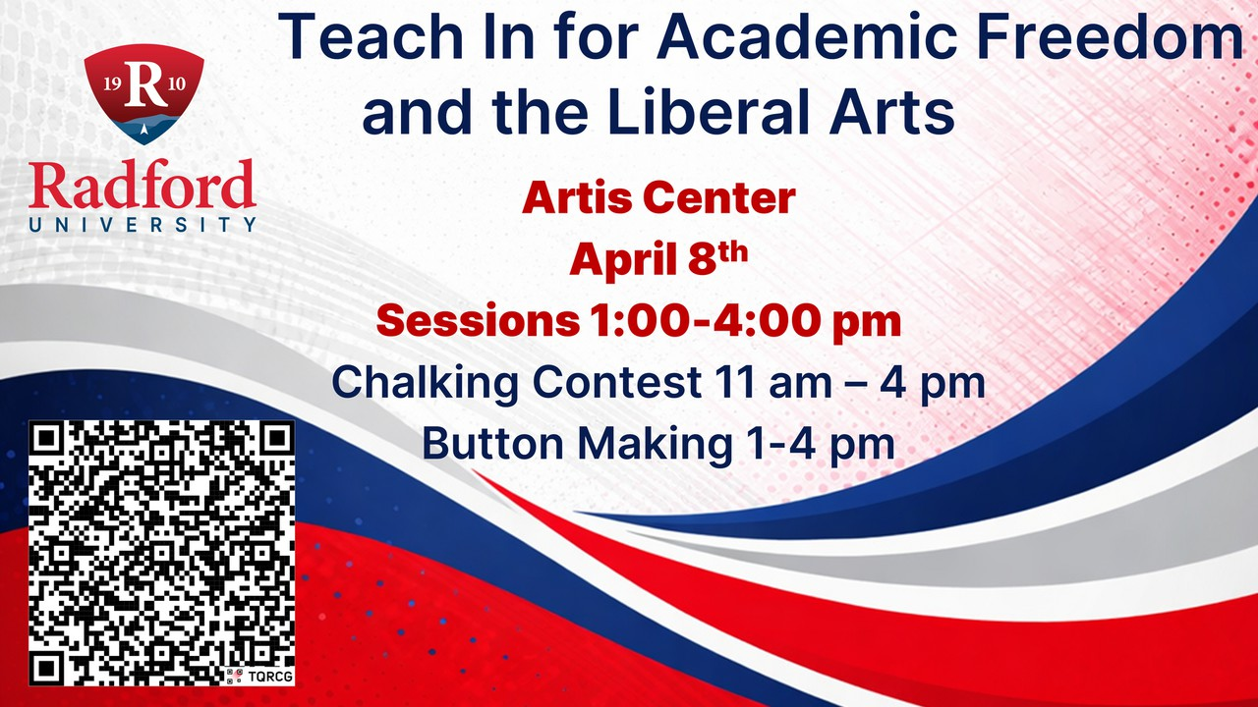

Teach In for Academic Freedom and the Liberal Arts April 8 with sessions 1:00pm - 4:00pm
Artis Center

Schedule of Events

2026 Honors Capstone Showcase
The entire campus community is invited to attend any portion of the 2026 Honors Capstone Showcase, where Honors College seniors present the outcomes of their yearlong scholarly endeavors. More than 50 students from departments across campus will deliver either spoken or poster presentations. All presentations will take place on the 2nd- and 3rd ﬂoors of Kyle Hall on Sunday, April 19th.

Spoken Presentations 1a – Kyle 320 – 1pm-2pm Spoken Presentations 1b – Kyle 204 – 1pm-1:45pm


Poster Session – Kyle 340 and atrium – 2:15-3:15pm Spoken Presentations 2a – Kyle 320 – 3:30-4:45pm Spoken Presentations 2b – Kyle 204 – 3:30-4:00pm

Important Dates & Opportunities – Spring 2026
- Withdrawal Dates (Full Semester):
  - From All Classes: April 10, 2026
- Withdrawal Dates (Fast Track B):
  - Partial Withdrawal (Not All Classes): April 10, 2026
  - From All Classes: April 16, 2026
- Thesis/Dissertation Submission (Required Programs):
  - Format Review Deadline: April 20, 2026
  - Final Deadline: April 8, 2026

Highlander Research Blitz – A 3-Minute Thesis Competition
Thank you to everyone who joined us for this year’s Highlander Research Blitz, held on April 1, 2026! Congratulations to our winners: Danielle Moore (1st place), a Criminal Justice graduate student, for Women’s Re-entry in the New River Valley; Jaimi Evans (2nd place), a Design Thinking graduate student, for Utilization of Design Thinking to Understand 10-Dimensional Student Well-Being: Sustainable Solutions; and Tori Billings (3rd place), an Education graduate student, for Appalachia: Teachers as De Facto Social Workers in Underserved Communities. All winning students received certiﬁcates and cash prizes in recognition of their outstanding research and presentations.

Outstanding Student Award Applicant Information
The winners of the Outstanding Graduate Student Awards have been notiﬁed. They will be publicized campus-wide after the award ceremony, which will be held on April 17, 2026. For more information, please contact OGA Graduate Assistant Adriana Garcia at agarcia37@radford.edu.

Graduate Assistantships
Please direct interested students to apply for Graduate Assistantships (GA) for the Summer and Fall 2026 semesters. Eligible applicants must be enrolled in a degree-seeking graduate program, be in good academic standing, and be registered full-time (3 Credits Summer, 9 Credits Fall). Graduate Assistantship opportunities can be found here. If you are interested in requesting a GA for the Summer 2026 semester, please contact OGA at gradaffairs@radford.edu.




Course Development Grant Opportunity

Support for Course Development
This RFP is a solicitation for development for new courses or modiﬁcation of existing ones that align with the goal of interdisciplinary leadership development, focused on social or ethical leadership.
Proposals for this opportunity may be submitted to Dr. Ben Biermeier-Hanson (bbiermeierhan@radford.edu). Applications will be accepted on an ongoing basis up through May 1st at 5pm.

Funding
The grant will provide funding of $1,000 to the instructor for development and $1,000 to their department’s foundation funds with the agreement that the new course will be offered no later than Fall 2027, and at least twice over the next 5 semesters. Funding will be disbursed from the DCOBE Dean’s ofﬁce in Spring, 2027.
Eligibility, Requirements, & Application Process

Review of Proposals
Applications will be reviewed at the time of submission. Decisions will be made on applications within two weeks of submission. A formal memo of understanding will be developed with the academic department and faculty applying for each of the accepted proposals. Faculty who have not previously received this grant will receive priority though previous winners are eligible for application.


Student Choreography Showcase on April 8 and 9
Experience the creativity and talent of student artists at the Student Choreography Showcase, April 8 and 9 at 7:30 p.m. in the Artis Center Studio Theater (AC 428). This free event features original works choreographed and performed by students in an intimate setting. Seating is limited to 75, so reserve your spot in advance by ordering online or calling 540-831-5420.

Symphonic Wind Ensemble concert April 9
Join the Symphonic Wind Ensemble for “A Journey Remembered” on April 9 at 7:30 p.m. in Davis Performance Hall. Under the direction of Shelley Axelson, with graduate conductors Megan Whatley and Dakota McBride, this free concert offers an evening of reﬂective and powerful wind ensemble repertoire. Don’t miss this opportunity to experience a moving musical program performed by talented student musicians.

International Guitar Festival April 10 – 11
This is the 25th year of Radford University’s International Guitar Festival which will take place April 10–11, 2026, at Davis Performance Hall in the Covington Center. We invite everyone to come and experience something new with performances and workshops not just on guitar, but also the Baroque lute and a guzheng, a Chinese stringed instrument. And best of all, all events are free and open to the public. The featured artists include Hao Yang (China), James Piorkowski (US), Duo Chinoiserie (Bin Hu and Jing Xia, China), Christopher Wilkie (US), and the Community Guitar Orchestra. The festival schedule includes masterclasses and workshops with Hao Yang, James Piorkowski, Duo Chinoiserie, and Christopher Wilkie, plus evening concerts each night. For more information, visit www.radford.edu/igf
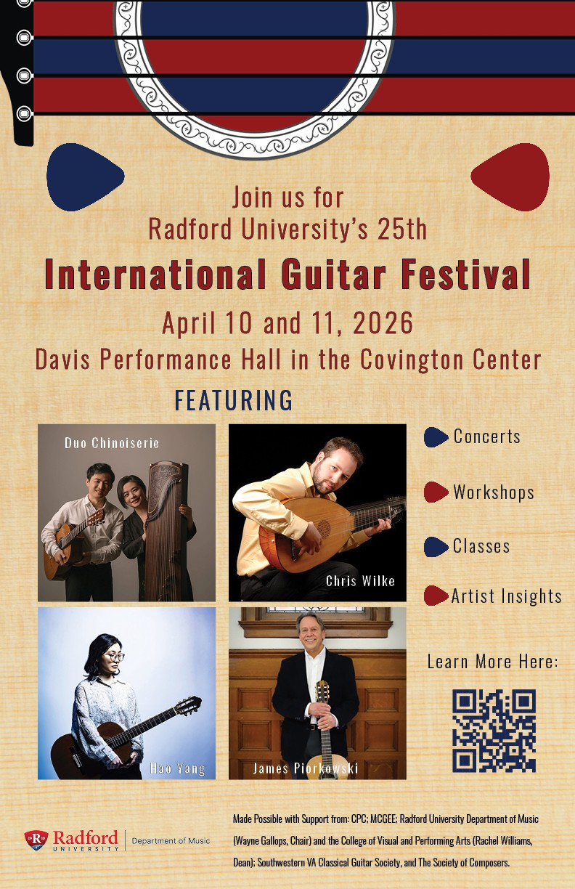


Fashion Fête and Fashion Show Returns, April 11
Get ready for an evening of style and celebration at the Spring Fashion Fête on April 11 at the Artis Center. The Fashion Show begins at 7 p.m. in the Performance Hub, with free open seating and reserved seating available by ticket. Kick off the night at the Fashion Fête Fundraising Dinner at 5
p.m. in the Black Box Theatre. Join us for fashion, community, and a great cause. For details, call 540-831-5248.

Spring Dance Concert, April 16-18
Celebrate the season with the Spring Dance Concert, April 16 and 17 at 7:30 p.m. and April 18 at 2
p.m. in the Artis Center Main Stage Theater. Featuring dynamic performances by student dancers, this lively program showcases a range of styles and choreography. Guest choreographer Amy Miller Tickets are $10 for adults, $6 for children, and free with RU ID. Purchase online or call 540-831-5420.
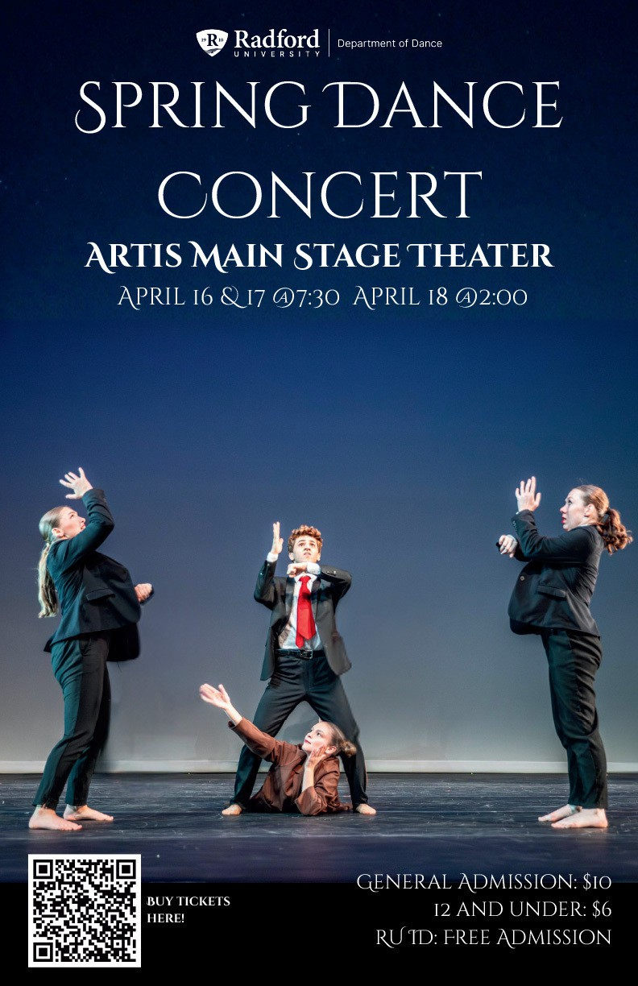

Senior Interior Design Show in Covington
Here’s an event for fans of HGTV. Design seniors will showcase their interior design work in the Covington Gallery from April 9 -19 with a catered reception on Sunday, April 19 beginning at 2 p.m. The exhibition and reception are both free and open to the public. If you want a look at what’s going on now in interior design, please make a point to come by.


Leisure Reading Requests at the University Libraries
While the University Libraries’ primary collection goal is to support faculty and student research and the curriculum, we have some materials speciﬁcally for your leisure time as well. We are actively growing our Graphic Novel, Young Adult, and Popular Reading collections. Based on feedback from students, we are adding more Science Fiction and Fantasy books at both McConnell Library and RUC’s Library.
If you have any requests for books you would like to read, please submit them using this form. Of course, we also recommend Interlibrary Loan and using your public library as well, but we want to hear about forthcoming ﬁction and non-ﬁction books you are looking forward to reading.
For faculty who want to request books to support the curriculum, please contact your library liaison.



Highlander Works Grant Program
The Highlander Works Grant Program for Internships and Work-Based Learning offers undergraduate students an opportunity to apply for funding to help reduce the ﬁnancial barriers associated with internships and work-based learning opportunities, including practica, co-ops, ﬁeld placements, clinicals, etc.

Applications for Summer 2026 are now open. The submission deadline is April 24.
If you have any questions, please email Debbie Fenderson dfenderson@radford.edu.

Just in Time Career Fair
Thursday, April 16 | 4:00 PM – 6:00 PM | Student Recreation and Wellness Center
If you would like to participate in this event, please contact Paula McGraw at pmcgraw@radford.edu.

Highlander Center for Character and Public Impact
Are you doing academic work on character?

Be a research fellow with the Highlander Center for Character and Public Impact!
Projects could include pedagogical studies, philosophical or theoretical research, creative writing, artwork and performance, analyses of literature or history, research on civic life and institutions, studies of ethical leadership and decision-making in business or government, community-based health or well-being initiatives, research on environmental stewardship and sustainability, and interdisciplinary projects linking character and public impact across ﬁelds.
$500-1000 awards are available in AY 2026-27 for students and/or faculty. Contact hkeith1@radford.edu for more information or see the description on the application. The application deadline is May 1.

Apply Here

Provide Feedback on D2L
Radford University is conducting a structured review of its Learning Management System (Brightspace/D2L) as it approaches the end of its current contract period. Broad stakeholder feedback is essential to ensuring this review reﬂects the needs of our campus community.



We invite the campus community, faculty, staff, and students to participate in one of the following feedback sessions:
Subscribe to our email list.

801 East Main Street | Radford, VA 24142 US

April 14, 4:00 PM-5:00 PM, Heth Hall 043, or via Zoom(link below)
April 15, 4:00 PM-5:00 PM, Heth Hall 043, or via Zoom(link below)

Zoom link for both days

Your feedback on features, tools and usability will help us develop a formal Request for Proposals (RFP) that addresses our needs to ensure instructional quality, student success, and responsible institutional stewardship. There is no assumption at the outset of this review that the current LMS will be replaced. To do a thorough review, we need your time and participation in this important process. Contact Merrie Winfrey with questions: mwinfrey3@radford.edu

Just two brief announcements:
- This D2L Safe Zone Module will be retired soon as Safe Zone transitions to Connected Communities
- Please help Connected Communities design their new training(s) by completing this survey:

Connected Communities Survey

Ofﬁce of the Provost Radford University Martin Hall 331
540-831-5404

