

April 21, 2025

Message from Provost Usher
In conversation with faculty colleagues today as I was dashing from one thing to another, they reminded me that there were less than two weeks of classes left - and we all hyperventilated together. Like a ball rolling down a hill, the end of the semester picks up speed until it levels off and slows after commencement. I'm happy to see so much coming together, and the result of the hard work of you and our students.
Instead of writing a long piece, I'll return to celebratory student events and end of semester meetings, and give you the chance to do the same. Thank you, deeply, for all you are doing!
Bethany



Lunch and Learn
with Provost Bethany Usher
Drop in to ask questions and engage in conversation about University initiatives and national conversations.
Feel free to bring your own lunch. No registration or RSVP needed.
Main Campus McConnell ILCB (3rd ﬂoor) | April 22 | Noon RHEC Room 501E | May 1 | Noon


Happy Occupational Therapy Month!
April is occupational therapy month and we want to share our celebrations with you!
Occupational therapy is a holistic healthcare profession that helps people to engage in meaningful "occupations", or those things we do in our everyday life that 'occupy' our time. Occupational therapists work with individuals across the lifespan and support everyone's participation in life! We are excited to share the joys of this wonderful profession and celebrate OT awareness month every April through various awareness and advocacy activities.
This year, our students participated in a unique advocacy opportunity. Schools offering Occupational Therapy (OT) and Occupational Therapy Assistant (OTA) programs in Virginia joined together for a statewide campaign to introduce high school students to the OT profession. We’re especially proud to highlight that several students in Radford's Master of Occupational Therapy program took part in this campaign. They connected with high schoolers in the New River and Roanoke Valley areas and are helping to inspire the next generation of occupational therapy professionals.
So far, the initiative has reached more than 800 high school students and staff in Virginia!


Accessible Documents Drop In

Do you have questions about making documents (Word, PowerPoint, or PDF) accessible? Don’t quite remember from training where all the accessibility features are in Word, PowerPoint, or Adobe Acrobat? Struggling with alt text for images? Bring your documents, your laptop, and your questions to CITL, 270 McConnell Library, on Fri., 4/25, 11:30 AM-1:30 PM. Drop in any time between those hours and we’ll help you.
Contact mwinfrey3@radford.edu for further information.
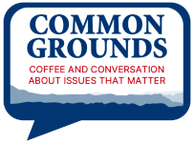

Please join students, staff, and faculty for an open discussion of:
“What is the role of higher education (including students, faculty, and leadership) in encouraging freedom of expression, academic freedom, and the exploration of difﬁcult ideas in a political landscape where these activities may be constrained?”

Wednesday, April 23, 4-5pm
Ross Gallery, 3rd ﬂoor in McConnell Library
Coffee, tea, and bakery snacks will be served!

Common Grounds events are aimed at building our community’s capacity to converse and collaborate across differences. This series is sponsored by the Civil Discourse and Freedom of Expression Working Group


2025 Honors Capstone Showcase

The Honors College invites the entire campus community to the 2025 Honors Capstone Showcase on Sunday, April 27th in Kyle Hall. Over thirty students will be presenting the outcomes of their honors capstone projects, with topics spanning 18 majors and every college. A full program of the speakers and capstone titles can be requested through the Honors College associate director, Dr. Jason Davis (jdavis319@radford.edu).

Spoken Presentations I – 1:15-2:15pm – Kyle 320 Poster Presentations – 2:00-3:00pm – Kyle Atrium Spoken Presentations II – 3:00-4:00pm – Kyle 320


Night Against Procrastination

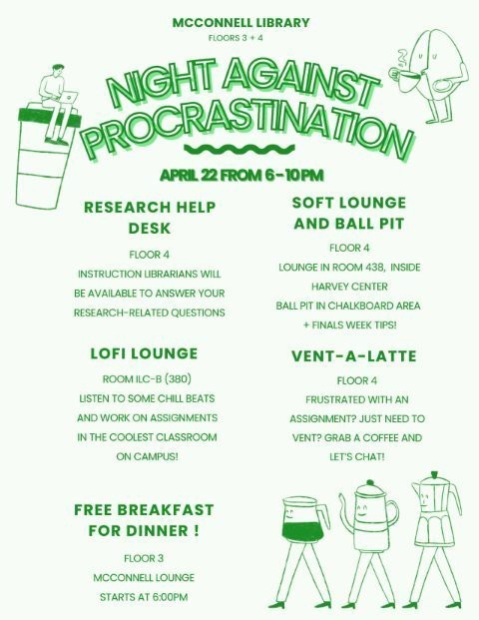

Let your students know that it's time for the McConnell Library Stress Buster #38!
Tuesday, April 29, 2025 Events begin at 10am!

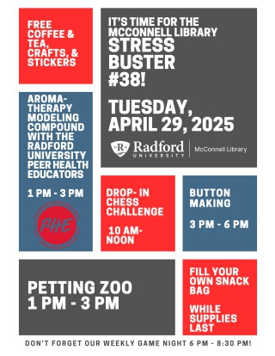
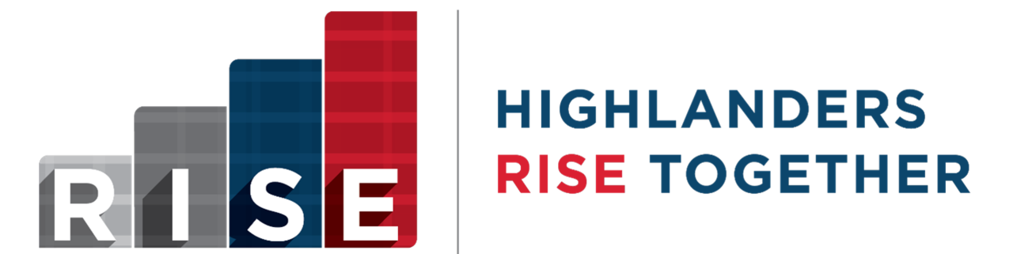

Do any of these thoughts resonate with you?
- If only I could get students to come to class!
- I would really like to see how other faculty are engaging with their students and I'd like to share my own ideas too.
- Am I reaching all of my students? Not everyone seems to be engaging with the class.

In the RISE Faculty Institute, we will explore new ways of engaging our students, breaking down learning barriers (that you may not even be aware of!), and designing courses that aim to work for all students. If you are a passionate educator who is ready to take the next step in advancing your professional development or a new faculty member who’d like to build your pedogeological skill set, please consider participating in the next RISE Faculty Institute cohort.

The institute includes training in the spring 2026 semester, a summer course redesign workshop series, followed by a community of practice in the fall 2026 semester. To support participation faculty are granted a course reduction and stipend
Learn more about his program


The 2026 RISE Faculty Institute is currently accepting interested applicants; apply through the QR code or click here.

News from Appalachian Studies
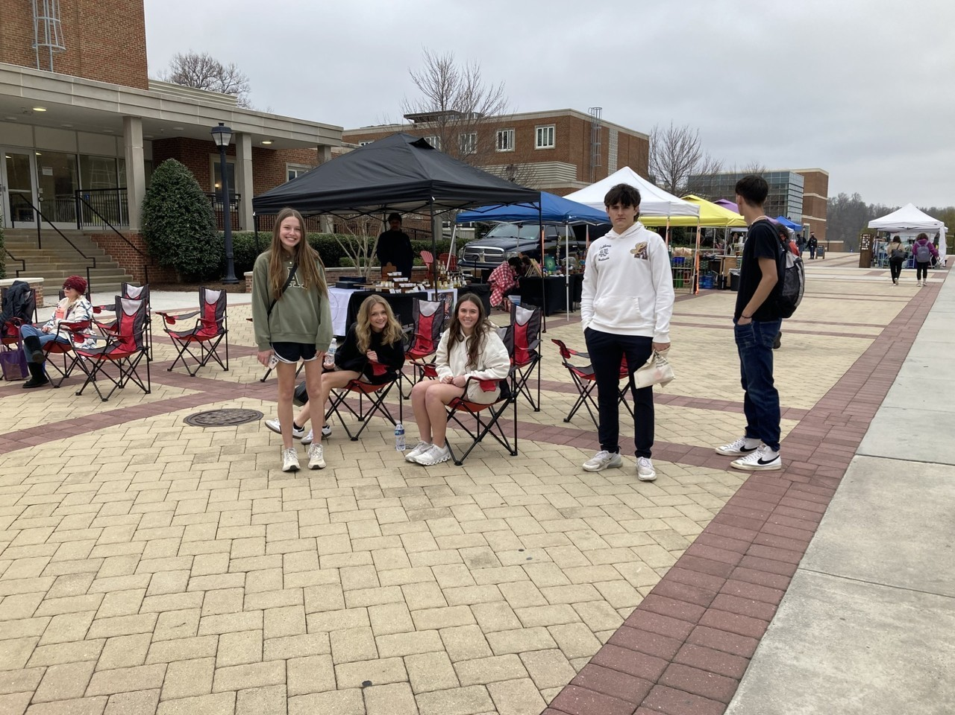
Appalachian Arts and Studies in the Schools brought nearly 60 students from Southwest Virginia high schools to campus April 2. The students, called AASIS scholars, and RU students who serve as AASIS mentors visited a criminal justice class in the department’s mock courtroom classroom, toured the nursing program’s Jo Ann Bingham Clinical Simulation Center and McConnell Library.

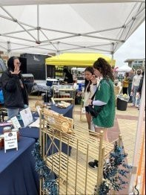

They also had time for lunch, browse the farmers’ market outside the Bonnie and listen to some live music before heading home. About a half dozen of this year’s AASIS scholars intend to join the mentors’ ranks when they become RU students this fall.

Research in Appalachia & Honors Urban Regeneration
Students from the Research in Appalachia and Honors Urban Regeneration classes presented their research on the former Radford Foundry’s history and future to the Radford Economic Development Authority on April 3. The group had already presented to the Appalachian Regional Commission’s Appalachian Collegiate Research Initiative and at the Appalachian Studies Association annual conference. On April 16, they presented their research to the Radford Rotary Club. The foundry operated in various forms from 1896 until 2013, employing 1,500 people at its peak. The city is working to redevelop the 80-acre site. The classes researched the foundry’s history, held focus groups with former foundry employees, surveyed neighbors of the former foundry site, researched similar brownﬁeld developments and suggested several alternatives for the site’s future.
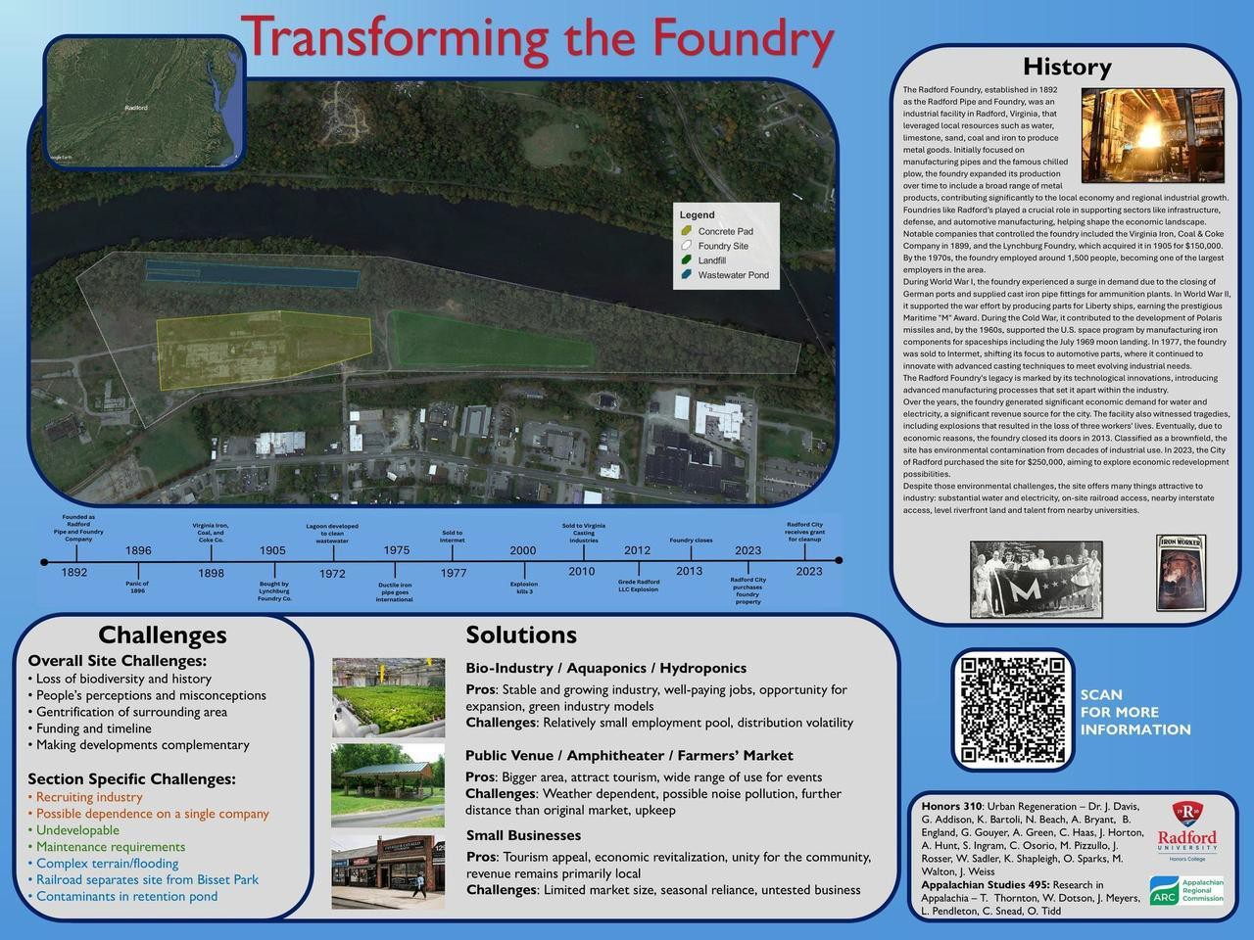


Award Celebrations

Highlander Research Blitz Winners!
Congratulations to all our graduate students who participated in the competition and to their

faculty mentors. The 2025 Winners:
1st Place: MaKayla Dulaney – Dating Apps and Attachment: Anxiety and Avoidance in Modern Romance
2nd Place: Jeff Wolfe – Understanding Cross-neurotype Communication
3rd Place: Kalyn Stiles – Balancing the Equation: Setting Boundaries for a Sustainable Life
We look forward to next year’s competition and encourage this year’s participants and all other graduate students to consider engaging in this exciting event.

Outstanding Graduate Student Awards Winners!
Congratulations to all of the students who participated and their mentors who facilitated their success!

The 2025 Winners:
Graduate Assistant: Rachel Cayton Graduate Student: Laura Bledsoe
Graduate Teaching Assistant: Morgan Gibson Graduate Teaching Fellow: Carly Riggs Doctoral Student: Haley Logan

Building Our Community

NATURE HIKE
Roanoke Star/Mill Mountain Park May 3, 2025 11:30 – 1:30;
RSVP by April 28, rugsc@radford.edu


Reminder! Celebrate Virginia Volunteer Week at a State Park
Governor Youngkin has ofﬁcially declared April 20-26, as Virginia Volunteer Week,recognizing the vital role employee volunteers play in our Commonwealth. We invite you to join us in celebrating by making a tangible difference in Virginia's beautiful state parks. Check out the Governor's inspiring message in this short video and see how your contribution can help preserve and enhance our
state's natural treasures.


This year, we're thrilled to offer state employees exclusive volunteer opportunities at state parks across Virginia. Whether you're passionate about Earth Day, seeking a family-friendly activity or looking for a team-building experience, our parks have something for everyone. As a special thank you, volunteer parking will be provided FREE of charge. Your time and dedication will directly support the preservation of our beloved state parks.
Subscribe to our email list.

801 East Main Street | Radford, VA 24142 US
To locate a state park in your area offering state employee volunteer opportunities, please check out the list of state parks and complete an application to volunteer. If there is not a state park near you, you can ﬁnd additional volunteer opportunities at your local volunteer center! Click here to locate a volunteer center near you through Serve Virginia.
Share your volunteering photos with us! We would like to feature employee volunteer photos in the Employee Experience magazine that is published quarterly. Submit photos here.
Please note: Employees wishing to volunteer at any of these events do not need to complete a volunteer application. Employee volunteers should provide notice to each volunteer site that their hours will be worked during Virginia Volunteer Week. In return, the volunteer site will email a certiﬁed letter to the employee attesting to the volunteer hours and site worked. Employees who share their volunteer letters with us, will receive agency participation credit regarding the upcoming 2025 Commonwealth of Virginia Campaign (CVC).
If you have questions, please contact EmployeeEvents@dhrm.virginia.gov mailbox.

Ofﬁce of the Provost Radford University Martin Hall 331
540-831-5404

