

April 20, 2026
Message from Provost Usher

I’m writing just after the closing of the AAC&U Conference on Learning and Student Success with over 10 Radford faculty and staff. I know that after so many years at Radford, going through so many versions of general education, it can seem like the purpose of gen ed is to annoy faculty and constantly re-write our major and minor curriculum (or so I hear…). But it has been inspiring to be here with peers across the country who are all dedicated to the proposition that an excellent undergraduate education has its foundation in a strong liberal arts curriculum. For students, what they learn as a part of the general education curriculum is as important, if not more, for their lifelong success (in careers and in their lives). As we are doing, investment in a durable general education that helps our students “Find Their Place. Here.” academically will beneﬁt them, our faculty, and the community. Thanks to everyone who participated in CLASS, who have contributed on the various Gen Ed implementation Committees, who gave input on the various proposals this year, and who continue to value general education!
As a reminder, we are searching for the next Director of Undergraduate Curriculum! If you are committed to the value of general education, think that curriculum development is fun (it is!), can work collaborative across colleges, and are looking for new opportunity to gain leadership experience, please apply!
Many thanks for Dean Donna McCloskey, chair, and Sara O'Brien, Kimberly Lane, Ryan Sincavage, Agida Manizade, Nathaniel Lahn, Meg Arthur and Andrea Sharpe-Robinson, who have all volunteered to serve on the search committee for the interim Dean of the Artis College of Science and Technology, following Dean Steven Bachrach’s retirement this summer. The application is now available. This search committee is moving quickly and we hope to have the ﬁnalists named in May, with the appointment starting over the summer.
In the next couple of weeks, we’ll continue to celebrate our students and our faculty and staff. Threads (below) lists many of these events. I’m particularly looking forward to the Employee Service Awards Banquet, the Faculty Awards Ceremony, and, of course, Commencement!
Graduation is my favorite time of the year - the students and their family and friends are so excited, and I love the pride I see in our faculty and staff in these students. In every student I see crossing the stage, in their fancy decorated caps and their sometimes totally impractical shoes, I know that they have made it because of the dedication of their faculty and the Radford staff. Please take the time to celebrate them, and your positive role in supporting them.
I look forward to celebrating with you! Bethany

Learn more about applying for Director of Undergraduate Curriculum
Apply for Interim Dean, Artis College of Science & Technology

Welcome to Faculty Flourishing Week

ALL WEEK
Recreation and Wellness Center (including ﬁtness classes)
Open to all faculty/staff (bring your RU ID)
The student recreation and wellness center and all ﬁtness classes are open to faculty and staff (including cycle, yoga, dance, bootcamp, boxing, bodypump, pick-up basketball and pickleball, and more!)
See the Full Schedule

Spring Commencement
Participating in commencement is one of the ways we live out Radford’s culture of care—showing up in support of our students at this deﬁning milestone. Your presence reﬂects a shared commitment to our students and a collective pride in their accomplishments.


Faculty and staff who plan to participate are asked to register by Monday, April 20.
Register to participate in commencement

LMS Update
The LMS RFP committee continues to make steady progress. Campus-wide listening sessions have been gathering both current needs and broader aspirations for the learning management system. At the same time, technical teams are reviewing evolving backend requirements related to systems integration, data security and new technologies. Purchasing has developed a draft RFP that will serve as the foundation for the ofﬁcial vendor solicitation and is also leading the required

RFP training process. The full committee will meet Friday to review community feedback and assess progress to date.

Academic Health Sciences - Roanoke
Planning for Radford University’s new Academic Health Sciences Building in Roanoke is underway, and your continued engagement is essential.
To keep faculty informed, a dedicated webpage is now available as a central hub for updates, timelines, and opportunities to provide input.

Recent updates:

The Building Design and Steering Committees held their inaugural meeting on April 9.
Perkins & Will conducted an onsite visit April 14–16, including tours of facilities on the main campus and in Roanoke (RUC and RHEC). An information session during the visit drew more than 70 participants and provided an overview of the design process and timeline.
A short survey has been launched to gather faculty and staff feedback on current space use, satisfaction, and priorities to help shape the building’s vision and guiding principles. The survey is open until May 10th.

Your input is critical to ensuring the new facility supports teaching, learning, and collaboration across disciplines and campuses.

Highlanders RISE Together

Radford Rising
Radford Rising is a year-long faculty development experience for second-year faculty at Radford University that focuses on inclusive practices and active learning. Building on your ﬁrst year, it provides time, structure, and support to deepen your teaching practice and expand your impact on student learning. Comes with $1500 stipend and $1000 departmental funds. For more information, click here or contact Tracy at tkwock1@radford.edu.

RISE 2027 Faculty Institute
We are now inviting Radford faculty to join the RISE 2027 Faculty Institute - a year-long professional development experience designed to equip Radford University faculty with the skills, dispositions, and motivation to implement inclusive teaching practices and active learning strategies that promote academic belonging and student success.
Comes with two of the following: a course release for spring, summer, or fall 2027 (pending chair approval), a $1,500 stipend, or $1,500 in departmental funds to support professional development or instructional resources.
For more information, click here or contact Tracy at tkwock1@radford.edu.


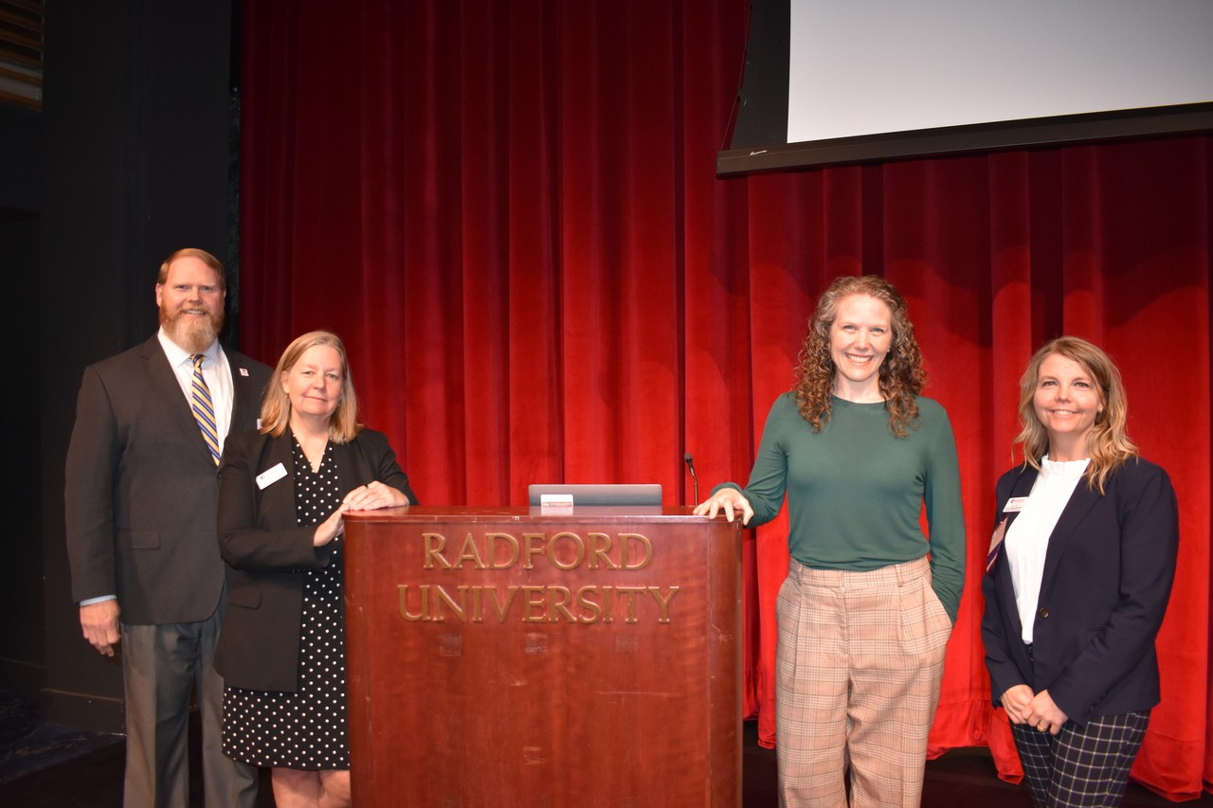
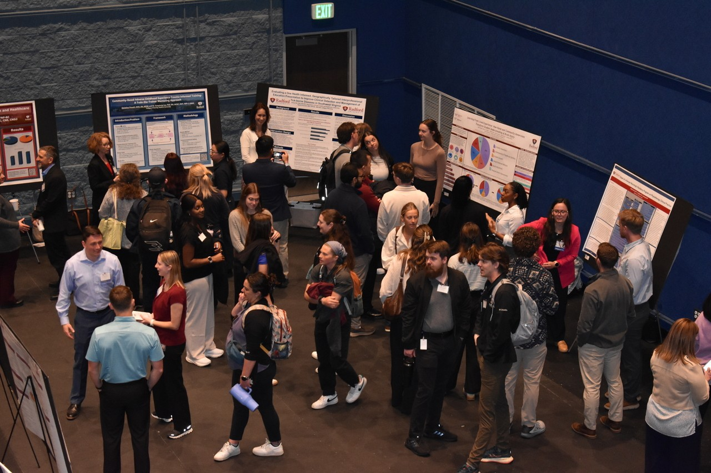
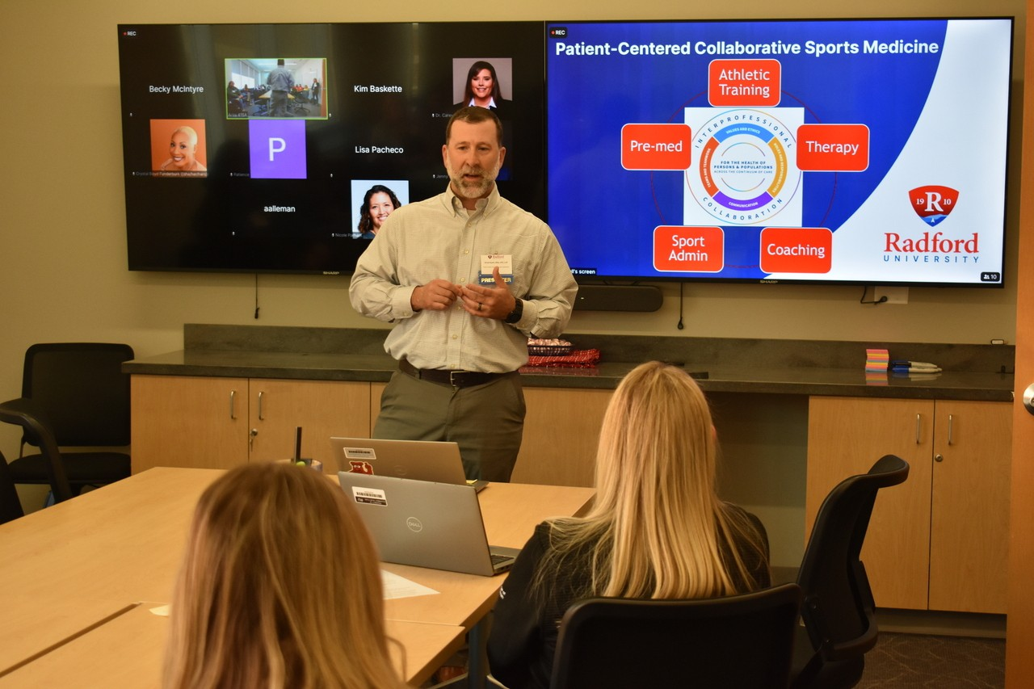

The 11th annual Waldron College Interprofessional Symposium was a resounding success! With around 300 participants and 90 presentations, we showcased the best in innovative teaching and community engagement across health professions. The keynote address was provided by Dr. Sara Parker, Chair of Health Systems and Implementation Science from the Virginia Tech Carilion School of Medicine. The day was ﬁlled with in-person and virtual presentations, including posters, workshops, and roundtables. We’re thankful that six of Radford’s seven colleges were represented, as well as VCOM and VTCSoM, highlighting Waldron’s dedication to interprofessional education. Of the many student participants, Chad Hyatt, DHSc student, Radford University Carilion Public Health and Healthcare Leadership was recognized for his presentation "Navigating the Complex, Uncertain Nature of Injury Management: A Scaffolded Interprofessional Team-Based Simulation Model." Special thank you to Dr. Jenny Hall, Associate Dean for Interprofessional Education for providing event leadership.

Navigate 360 Update
Radford University has launched Navigate 360 as our new coordinated care platform for advising, student support, and student success initiatives. As part of this transition, Starﬁsh will be retired in early July, with all notes and documentation migrated to Navigate 360 prior to sunset. This shift

strengthens our shared culture of care by enabling more intentional, connected, and proactive support for students across the institution.
Faculty interested in getting an early start are encouraged to participate in an in-person “Our Turn” session on May 4. This session offers a hands-on opportunity to explore Navigate 360 and serve as an early adopter within your area.
Additional training opportunities and resource guides will be available beginning in August and continuing throughout the Fall 2026 semester to support a smooth transition. For questions or more information, please contact success@radford.edu.

Register Here

Celebrating Graduate Students


Commonwealth of Virginia Engineering and Science Fellowship Winner
We are thrilled to celebrate Paige Dickerhoof on her selection as a COVES Fellow! This highly competitive fellowship provides graduate students with hands-on experience in science policy and public service, and Paige has been paired with the Virginia Health Workforce Development Authority. In this role, she will contribute to meaningful policy work that supports and strengthens healthcare systems across the Commonwealth.

Outstanding Graduate Student Awards
Thank you to everyone who joined us for the Outstanding Graduate Student Awards, held on April 17, 2026! Congratulations to our award recipients: Jeff Wolfe, Outstanding Graduate Student (MFA, Design Thinking); Andrea Herndon, Outstanding Doctoral Student (EdD, Education); Hayley Bare, Outstanding Graduate Assistant (MSW, Social Work); Joao Ramos, Outstanding Graduate Teaching Assistant (MA, Music); and Nina Aidam, Outstanding Graduate Teaching Fellow (MA, English). All recipients were recognized for their exceptional achievements and contributions to the graduate community.

Graduate Assistantships

Please direct interested students to apply for Graduate Assistantships (GA) for the Summer and Fall 2026 semesters. Eligible applicants must be enrolled in a degree-seeking graduate program, be in good academic standing, and be registered full-time (3 Credits Summer, 9 Credits Fall). Graduate Assistantship opportunities can be found here. If you are interested in requesting a GA for the Summer 2026 semester, please contact OGA at gradaffairs@radford.edu.


Grant Funder Spotlight:
ECMC Foundation https://www.ecmcfoundation.org/
Since its establishment, ECMC Foundation has supported student success in postsecondary education.
The Foundation uses strategic grantmaking and program-related investments on three strategic priorities: removing barriers to postsecondary completion; building the capacity of organizations, institutions and systems; and transforming the postsecondary ecosystem.
A key aspect of their approach is a commitment to being aware of and responsive to developments in the ﬁeld of higher education. As a result, ECMC continues to use an open letter of inquiry (LOI) process and reserve funding that is connected to one or more of their strategic priorities.
To read more about their initiatives and priorities through their strategic grantmaking process, please visit their webpage at https://www.ecmcfoundation.org/funding-approach/grant-initiatives/ and apply for funding at https://www.ecmcfoundation.org/funding-approach/apply -for-funding/

If you are interested in applying for a grant, please contact the Ofﬁce of Sponsored Programs at tcruise@radford.edu

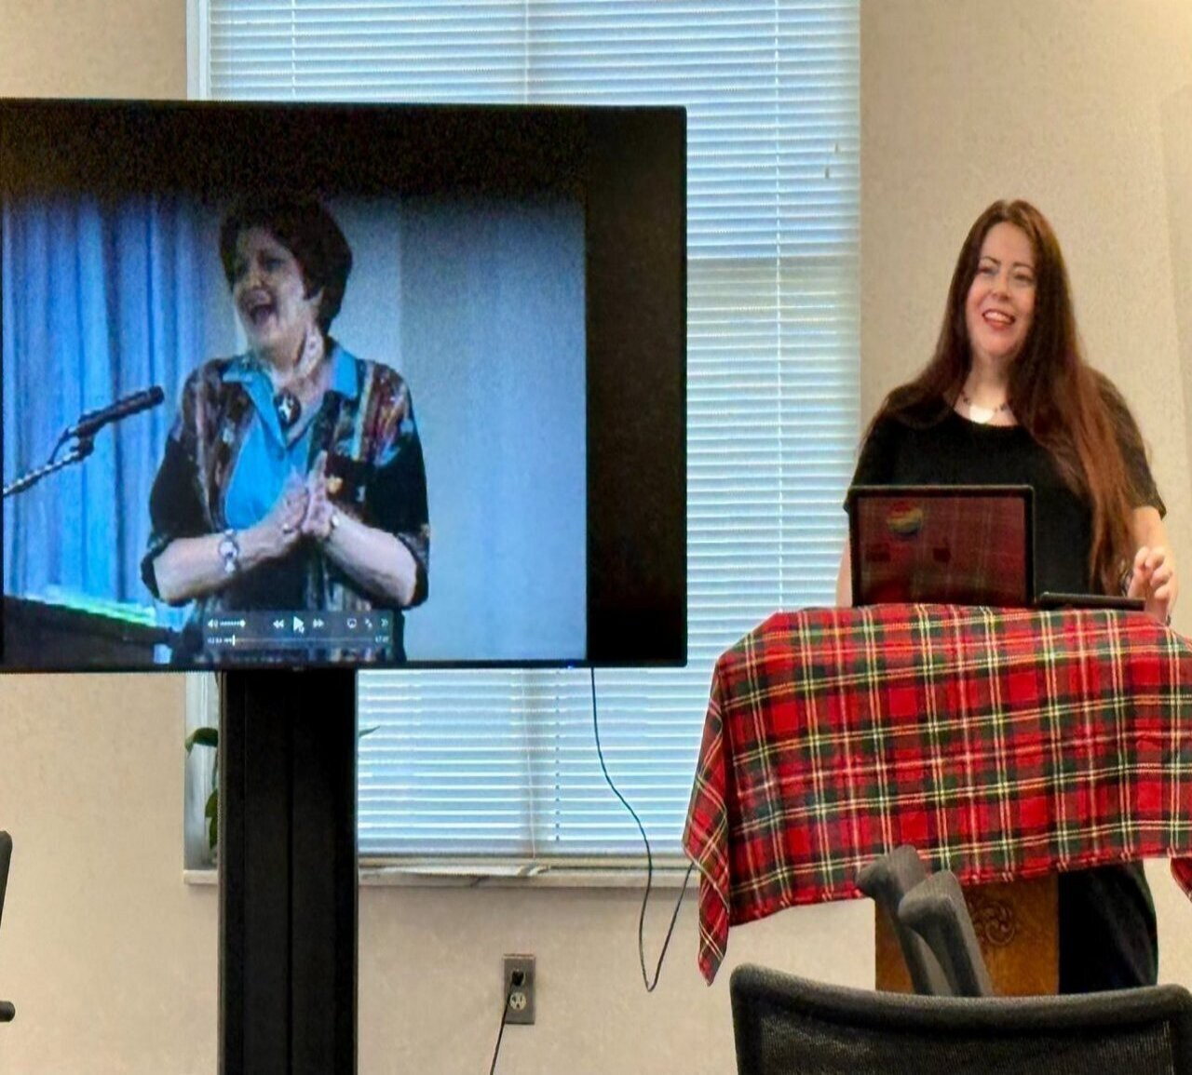
Learn more about Sponsored Programs

April Asbury, M.A.; M.F.A., Director of the Highland Summer Conference at Radford University and part time faulty in English and Appalachian Studies, presented “The Corn Mother and Eye of the

Deer: Marilou Awiakta and the Selu Story” as part of RU’s Women’s History Month Celebration 2026. Marilou Awiakta is a Cherokee-Appalachian writer whose works have had a profound, decades-long impact on Radford University, including the naming of the Selu Conservancy.

Radford University, the College of Humanities and Behavioral Sciences, and the School of Writing, Language, and Literature are delighted to welcome the 6th annual Corridors: Blue Ridge Writing & Rhetoric Conference on Saturday, September 19, 2026. The conference theme is “Writing Home: Where the Power of Place Meets the Page” and the call for proposals is active. More information on proposals, submissions, and the conference can be found here: https://sites.google.com/view/2026-corridors-conference?usp=sharing.

On Monday, April 6, Drs. Ren (English) and Semprevivo (Criminal Justice) took eleven graduate and undergraduate students to the annual Feminism is for Everybody Conference at Virginia Tech. This year marks the ﬁrst time that the conference was opened to students from Radford, the start of a tradition that both VT WGGS and RU WGST hope to continue for years to come.
English Graduate Students: Haley Celso Rosas, Kira Ayers, Catey Mlynski, Jessica Villanueva, Nina Aidam, Grace Sharrett, Catherine Schleife, Aspen Chase, Ryleigh Kenned
Undergraduates from Criminal Justice: Sydney Howell-Wampler and Lily McConkey


Free “Selu Scenery” workshops return
The ﬁrst workshop in the returning series is led by award-winning watercolor artist Matt Gentry on April 25. It will focus on plein air painting, beginning with a guided walk to select a scene. Attendees should bring a sketchbook or drawing pad, pencil, and their preferred painting materials. The program is sponsored by the university’s College of Visual and Performing Arts. Register here by April 23 (additional info supplied on registration). Questions can be directed to Linda Correll at lcorrell83@gmail.com

Two B.F.A. Art Exhibitions open April 24
The BFA Graphic Design and Studio Art exhibitions will be on view later this month, showcasing student work across disciplines. The Graphic Design Exhibition runs April 23–30 in the Covington Gallery, with a public reception scheduled from 4 to 6 p.m. April 24. The Studio Art Exhibition will be on display April 23–29 in the Tyler Gallery, with a reception from 5 to 7 p.m. April 24. Both exhibitions and receptions are open to the public. Both receptions are free and open to the public with light refreshments served.

There are also two bluegrass jam sessions set for 6 to 9 p.m. on April 20 and April 27 in the Performance Hub of the Artis Center. Everyone is welcome to jam, dance or just listen and there is no charge.

There has been one cancellation, unfortunately. Duo Firenze will not play on April 27 as originally scheduled but will hopefully reschedule in the fall semester.

So, you want to learn to line dance?
Get ready to kick up your heels at CVPA’s Line Dance Event on April 22, 2026! Join us in the outdoor courtyard at the Artis Center at 6 p.m. It’s all free and open to everyone regardless of experience levels for a good time. Led by dance major Jenna Adkins and the band Dogwood Drive, the event promises lively music, inviting rhythms, and plenty of opportunities to join in the fun.
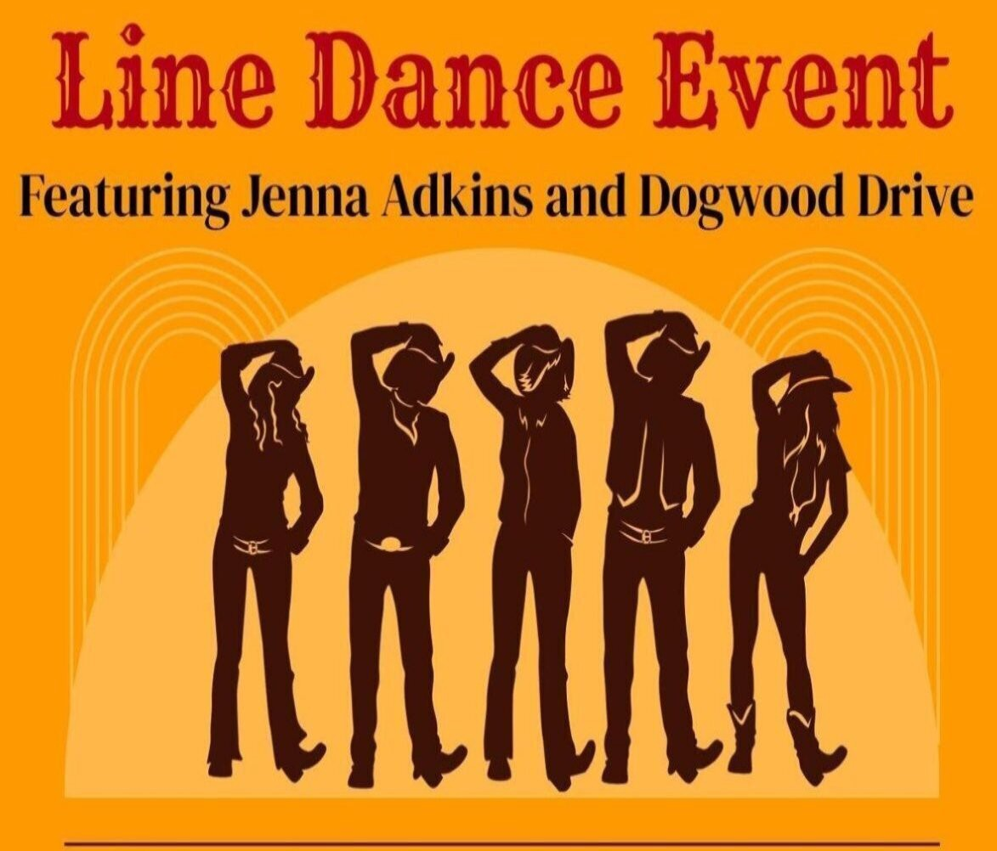


35th Annual Student Engagement Forum Schedule
Radford University will once again celebrate the longest continuous campus-wide research event in Virginia with the 35th Student Engagement Forum. Come hear from more than 400 students presenting the new knowledge they created over the past academic year. The event is open to the public and features interdisciplinary poster sessions, oral presentations, performances, and exhibitions across campus from April 21–24.
Tuesday, April 21 features poster sessions from 11:00 am to 6:15 pm in the Artis Center Performance Hub, with an additional session at 5:00 pm in the Center for the Sciences. Wednesday includes a variety of oral and poster sessions across campus, and creative works will be on display throughout the week in multiple locations.
The full schedule can be found at www.radford.edu/ours-support.


LibKey Nomad is a browser extension that helps connect you directly with the Radford University Libraries’ electronic journals while you're searching sites like PubMed and Google Scholar. It is fast and easy to install and helps put articles right at your virtual ﬁngertips. You'll ﬁnd download instructions for your browser at their site, and you can always a librarian for help if you need it.

McConnell Library is offering extra hours for extra study time! On Friday, April 24, and Saturday, April 25, McConnell Library will stay open until 9:00 pm. Summer academic session hours will be Mondays through Thursdays, 8:00 am – 7:00 pm, and Fridays 8:00 am – 5:00 pm. Hours will be reduced during break weeks to 8:30 am – 4:30 pm.

Please note that both University Libraries will be closed on Wednesday, May 6, for a staff retreat. As always, our online resources and our 24/7 chat service are always open! Visit us at library.radford.edu.


International Activities Survey □
The McGlothlin Center for Global Education and Engagement, in collaboration with the Ofﬁce of Sponsored Programs and Grants Management, cordially invite you to participate in a campus-wide survey to capture all faculty international engagement in the last 5 years. All types of international activities are welcome, including presentations, research, faculty-led programs, sabbaticals, etc., but of particular interest are international scholarship and research activities.

- What types of international research are you currently conducting or are you interested in conducting in the next 5 years?
- Have you participated in any type of international activity in the last 5 years?
- Would you like to collaborate with other faculty around campus?

We would love your input and insight to help capture what we are already engaged in, how we can expand our footprint globally, and how we may be able to connect you with others on campus to collaborate more efﬁciently.
Take the survey

Highlander Center for Character and Public Impact
Please join us at our ﬁnal Common Grounds discussion of the semester on the topic of "How do you sustain yourself and others during times of uncertainty?" Common Grounds is a facilitated discussion, open to all students, faculty, and staff members of our community. Bring your own lunch, and we'll provide delicious bakery goods and coffee/tea.
Tuesday, April 28
12-1 p.m.
McConnell 3rd ﬂoor ILCb classroom

Be a character leader! Are you interested in incorporating character into courses, curricula, or academic activities? Share your passions with colleagues as a Highlander Center for Character and Public Impact Fellow! Variable grant-funded stipends are available.
Faculty Fellows will promote multidisciplinary academic activities and collaboration in advancing character education and public impact at Radford University by:

- Advancing the work of the Center in their College or the University via workshops, reading groups, teaching squares, research circles, assessment planning, or other collaborative activities
- Attending monthly check-ins with the Center director and other fellows

Work in character and public impact could include things like:

- Professional identity in disciplines (such as exploring empathy in healthcare settings, justice and equity in corporate leadership, moral courage in educational institutions, or human ﬂourishing
in politics or planning).
- Character traits for neighborliness, citizenship, or civic engagement
- Human ﬂourishing
- How character overlaps with career competencies and vocation
- Social and/or ecological community resilience
- Community and/or place-based pedagogy
- Wicked problems approaches to teaching
- Assessing character, ﬂourishing, or public impact

Note that compensation depends on an individual TR faculty member’s eligibility per the 2025 Supplemental Pay Policy, which can be found on the University’s policies webpage.


Exploring AI Research at Radford University
Faculty interested in exploring AI are encouraged to connect with campus colleagues and resources. The Center for Innovative Teaching and Learning (CITL) offers multiple entry points, including the Artiﬁcial Intelligence Community of Practice (contact: lvernon@radford.edu) and the Scholarship of Teaching and Learning (SoTL) Community of Practice, which is actively engaging questions about AI in teaching and learning (contact: citl@radford.edu). CITL has also developed an AI Commons intranet site with a growing collection of resources to support learning, spark research ideas, and connect with others doing this work (RU Login
required): https://emailradford.sharepoint.com/:u:/r/sites/OG-citl-radfordaicommons/SitePages/LearningTeamHome.aspx?csf=1&web=1&e=tXJVNP
Faculty may also be interested in joining a new SoTL research initiative that aims to explore the use of AI agents to support teaching and learning. Led by Charles Cosmato (contact: ccosmato@radford.edu) and drawing on principles from The Opposite of Cheating: Teaching for Integrity in the Age of AI by Tricia Bertram Gallant and David A. Rettinger (2025), the Own Your Paper (OYP) agent is a conversational, bounded/semi-autonomous agent (agentic AI) that helps students test and strengthen their ownership of their written work before submission. It is designed to “raise the cost of cheating” by helping students strengthen their connection to their own writing through guided, reﬂective questioning. Faculty collaborators are invited to provide formative feedback on Cosmato's version 0.5 in Summer/Fall 2026 and to participate in a Scholarship of Teaching and Learning study in Spring 2027 examining its impact on student writing and engagement. Co-authorship opportunities available!

Ofﬁce of the Provost Radford University


Martin Hall 331
540-831-5404
Subscribe to our email list.

801 East Main Street | Radford, VA 24142 US

