Section 10.1: Vector Functions and Space Curves

Practice HW from Larson Textbook (not to hand in)
p. 614 # 1-9 odd, 13-25 odd (may want to use Maple for help on sketches), 53-56, 57

Vector Valued Functions

Vector Valued Functions are functions whose domain (normally values of t) are a set of real numbers and whose range is a set of vectors. They involve functions of the form

r(t ) = f (t) i + g (t) j (2D Plane)

or

r(t ) = f (t) i + g (t) j + h (t) k (3D Plane)

Here, f, g, and h are all real value functions of t . In component form, these functions can be denoted as:

r(t ) = < f (t) , g (t) > or r(t ) = < f (t) , g (t), h (t) >

Domain of Vector Valued Functions

The domain of a vector valued function is the intersection of the domain of its component functions f, g, and h .

Example 1: Find the domain of the vector function

r(t ) = 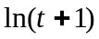 i + 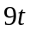 j + 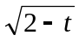 k

Solution:

█

Limit of a Vector Function

We evaluate the limit of a vector valued function by evaluating the limit of each component separately.

Hence, if

r(t ) = f (t) i + g (t) j + h (t) k

then

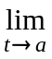r(t ) = f (t) i + g (t) j + h (t) k

provided the limits of f, g, and h exist

Example 2: Find the limit 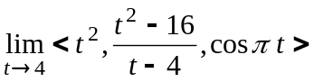

Solution:

█
Example 3: Find the limit 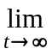( 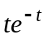 i + 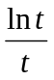 j + 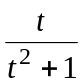 k )

Solution:

█

Graphs of Vector Functions

Geometrically, vector valued functions trace curves in 2D and 3D space. The variable t can be thought of as a time parameter.

2D case:
y

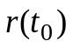
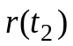
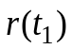

x
3D Case

x
y
z

To assist in graphing vector valued functions, we can plot points or in special cases convert part of the components to rectangular form to assist in seeing the shape of the graph. The orientation of the curve traces the direction we move along the curve as t increases

Example 4: Sketch the graph of r(t) = 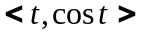. Indicate with an arrow the direction in which t increases (the curves orientation).

Solution:

█
Example 5: Sketch the graph of r(t ) = i + 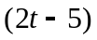 j + 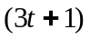 k. Indicate with an arrow the curves orientation.

Solution:

█

Example 6: Sketch the graph of r(t ) = 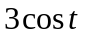 i + 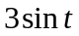 j + k. Indicate with an arrow the curves orientation.

Solution:

█

Note: For more complicated functions, Maple can make the process of graphing much easier.

Example 7: Use Maple to sketch the graph of r(t ) = 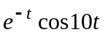 i + 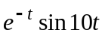 j + 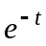 k.

Solution: The following commands will give a sketch of this graph:

> with(plots):
> spacecurve([exp(-t)*cos(10*t), exp(-t)*sin(10*t), exp(-t)], t = -5..5, axes = normal, thickness = 2, axes = normal, numpoints = 1000, view = [-2..2, -2..2, -2..2]);





