Section 4.1: Antiderivatives and Indefinite Integration

Practice HW from Larson Textbook (not to hand in)
p. 224 # 1-25 odd, 41-47 odd, 51

Antidifferentiation or Integration

Suppose we are given a derivative of a function 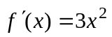 and asked to find .

There are many answers for such as:

In general, we say that

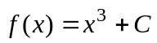

where C is known as the constant of integration.

Antidifferentiation or integration is the opposite of differentiation.

Notation: We use the indefinite integral to denote the antiderivative.

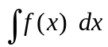

Thus, 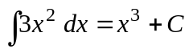.

Basic Antiderivative (Integration Formulas) (Complete List p. 219)

1. 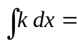

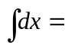

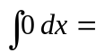

2. 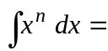

3. 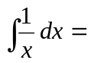

4. 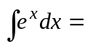

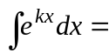

5. 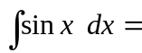

6. 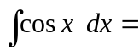

7. 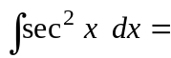

8. 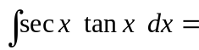

9. 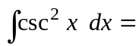

10. 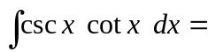

Example 1: Integrate 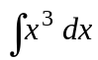.

Solution:

█
Example 2: Integrate 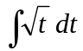.

Solution:

█
Example 3: Integrate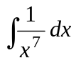 and 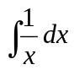.

Solution:

█

Example 4: Integrate 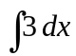.

Solution:

█

Properties of Integration

1. 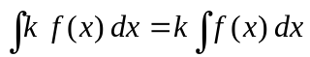 , where k is a constant – in our case a real number)
2. 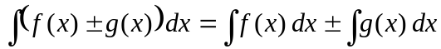

Example 5: Integrate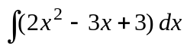.

Solution:

█

Example 6: Integrate 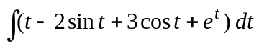.

Solution:

█
Example 7: Integrate 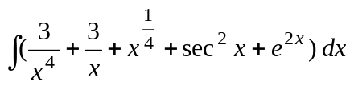.

Solution:

█
Differential Equations

Differential equations are equations involving one or more of its derivatives. A simple example of a differential equation is given by

To find f (x), we integrate both sides with respect to x.

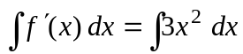
which gives

← known as the general solution

The general solution expresses the solution in terms of the arbitrary constant C. If we are given an initial condition (a value for the function at a particular value of x), we can find
the particular solution (where we find a particular value for the integration constant C).

Example 8: Solve the differential equation when 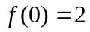.

Solution:

█
Example 9: Solve the differential equation given 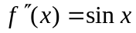 where 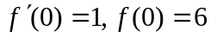.

Solution: To solve the differential equation, we must find . To do this, must integrate twice. First we compute
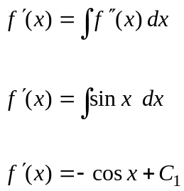

To find the particular solution for the first derivative, we use the initial condition for the first derivative given by 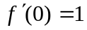. This gives
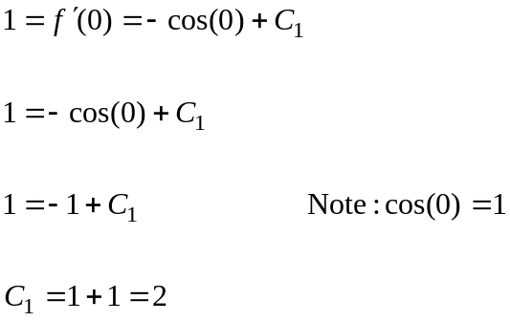

Substituting 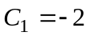 gives 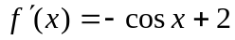. To obtain , we must integrate 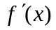. This gives
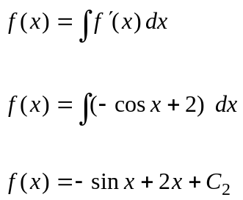

To find the particular solution for the function , we use the initial condition for the fist derivative given by 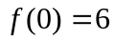. This gives
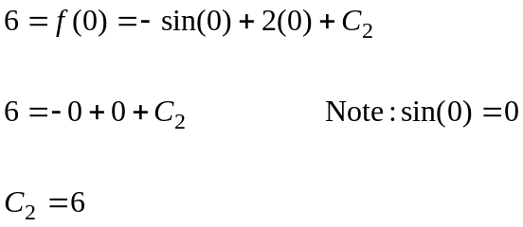
Substituting 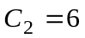 gives the particular solution of 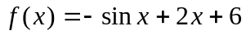 . █
Vertical Motion

Recall that given a position function 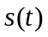.

Velocity: 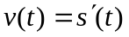
Acceleration: 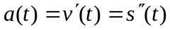

Hence, since integration is the opposite of differentiation, we can say:

Velocity: 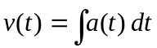
Acceleration: 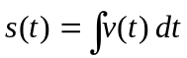

Example 10: A ball is thrown vertically upward from the ground at an initial height of
5 ft with an initial velocity of 64 ft/s.

a. Find the position function
b. How high will the ball go?
c. How long thus it take for the ball to hit the ground.

Solution: Part a. In this problem, we start with the fact that the acceleration due to gravity of a freely falling object is 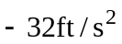 (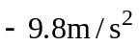 in metric). Thus we can say that the acceleration equation is given by

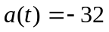

Since acceleration is the derivative of the velocity, we must reverse the process and integrate the acceleration to get the velocity. This gives the following.

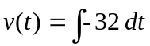

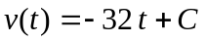

To find the constant C, we can use the fact that the initial velocity (the velocity at time
t = 0) is 64 ft/s, which translates mathematically as 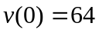. Substituting into the velocity equation gives

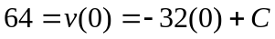
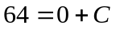
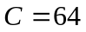
(continued on next page)
Thus, we see that the velocity equation is 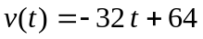. To find the position function , we use the fact the derivative of the position gives the velocity. Hence, we must integrate the velocity to get the position. Hence, we have

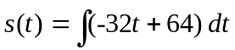

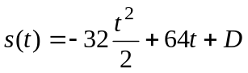
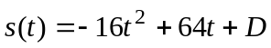

To find the constant D, we use the fact that the initial height (initial position) of the height at time t = 0 is 5 ft. Mathematically, this translates as 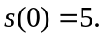 Using this condition, we obtain

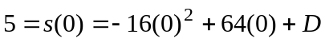
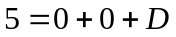
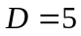

Thus the position function for the ball height is 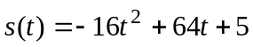.

Part b. The ball reaches its maximum height at the time when the velocity 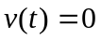. Hence we take the velocity equation we found in part a, set it equal to 0, and solve for t. This gives

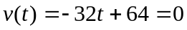
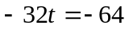
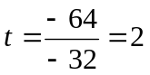.

Thus, the object reaches its maximum height after t = 2 seconds. To find its height at this time, we simply substitute this value of t into the position equation. This gives

Height of ball =

This, the ball goes 69 ft high.

(continued on next page)
Part c. In this problem, we want to find the time t it takes for the ball to go up, come back down, and hit the ground. When the ball hits the ground, its height is 0. Thus, we can find t by setting the height function equal to 0 and solving for t. This gives
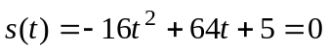

We use the quadratic formula to solve this equation. Recall that this formula says that the solutions to the quadratic equation 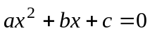 is 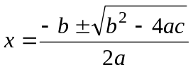.
If we replace x with t and assign a = -16, b = 64, and c = 5, we see that

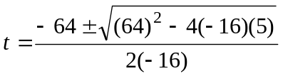.

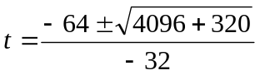

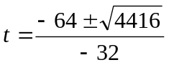

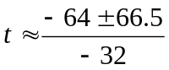

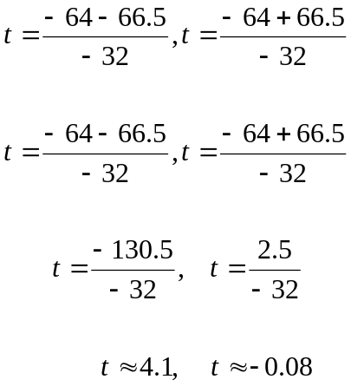

Thus, the ball will hit the ground after 4.1 seconds.

