Section 6.7: Improper Integrals

Practice HW from Stewart Textbook (not to hand in)
p. 422 # 5-8, 5-25 odd, 29, 31

Areas of Infinite Extent

Example 1: Determine the area under the graph of 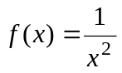 for 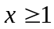

Solution:

█

The type of integral used to compute an area of infinite extent is called an improper integral.
Definition of Improper Integrals (Type 1)

1. 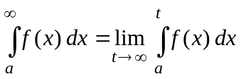

2. 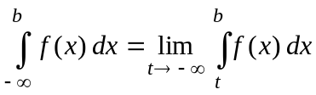

3. 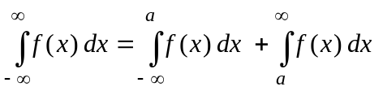

If the limit of an improper integral exists (approaches a fixed number), then the improper integral is convergent. If the limit does not exist, then the improper integral is divergent.

Fact: Note that 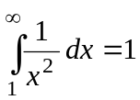 is convergent.

Example 2: Compute 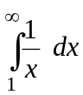

Solution:

█
Example 3: Compute 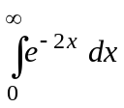 .

Solution:

█

Example 4: Compute 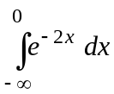 .

Solution:

█

Example 5: Compute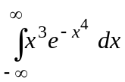

Solution:

█
Discontinuous Integrands

Looks at areas of infinite extent when x approaches a value where the function is undefined.
Example 6: Compute 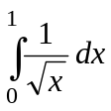

Solution:

█
Example 7: Compute 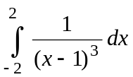

Solution: The function 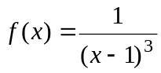 is undefined at x = 1. Hence, we want to examine what is happening to the integral near this point. We rewrite the integral as follows:

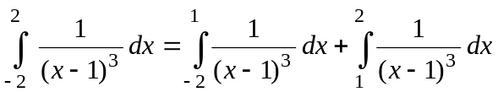

Hence, we must evaluate both of these integrals. We first evaluate 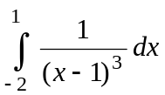. This

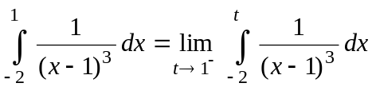

To find 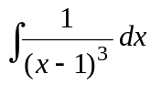, we use a simple u-du substitute. We obtain the following:
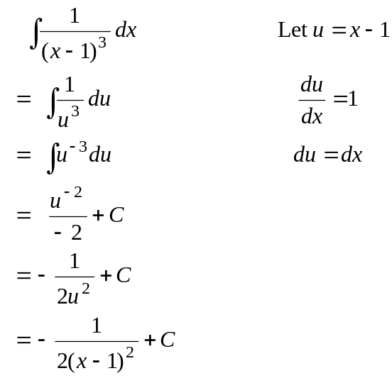

(Continued on next page)

Hence, 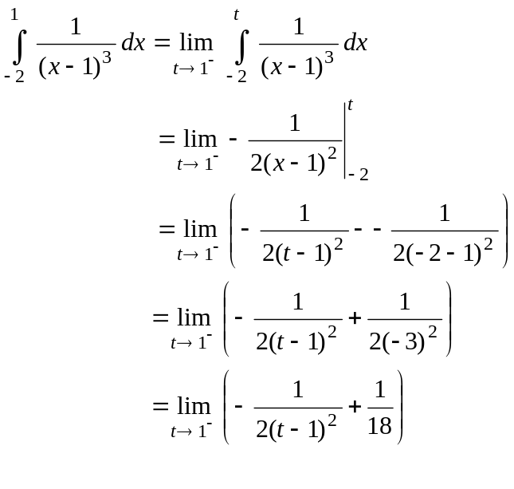
As 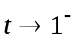, 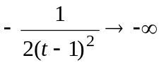. The following chart will help convince yourself of this.

t | 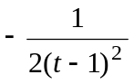
0 | -0.5
0.5 | -2
0.9 | -50
0.99 | -5000
0.999 | -500000
0.99999 | -5000000000

Thus, is divergent. Since ,

we can conclude is divergent (there is no need to evaluate 



