Section 2.8: Newton’s Method

Newton’s Method

Recall: A root (zero) of a function 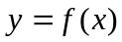 is a value x = c where 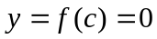.

Example 1: Find the zeros of the function 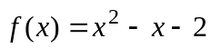. Verify your answer is correct.

Solution:

█

Fact: Graphically, the roots (zeros) give the x-intercepts of a function.

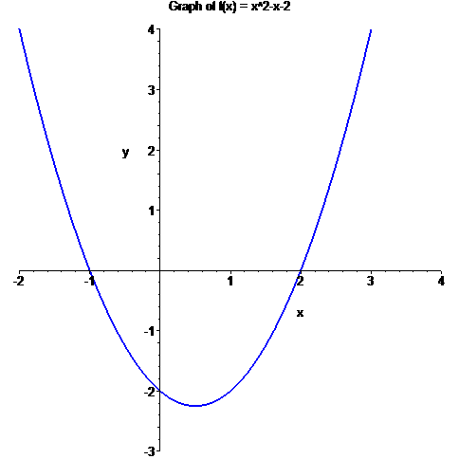

In this section, we need a method to approximate zeros, which are not easily found by algebraic methods.
Suppose we want to find a root x = c of the following function .

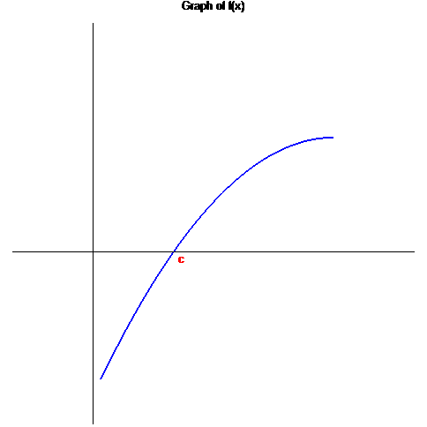

We make a guess 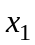 which is “sufficiently” close to the solution. We use the point slope equation to find equation of the tangent line at the point 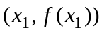.

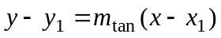

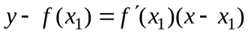

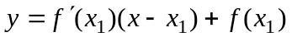

Consider the point where the graph of the tangent line intercepts the axis, which we label as 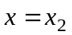. The idea is the value of 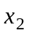 is “closer” to the zero x = c than . At
, y = 0 and we have the point 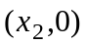. This gives the equation

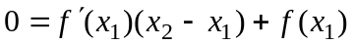

We solve this equation for .

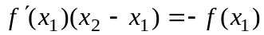

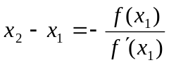

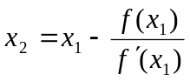

We next find the equation of the tangent line to the graph of  at the point 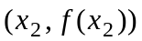. This gives

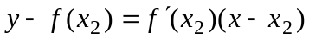

Suppose this tangent line intercepts the x axis at the point 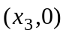. Using a similar process described above, we find that 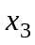 is given by

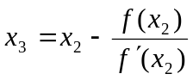

The value 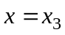 is even closer to the zero of x = c than . Generalizing this idea gives us the following algorithm.

Newton’s Method (Newton Raphson Method)

Given an initial value that is sufficiently “close” to a zero x = c of a function .
Then the following iterative calculation

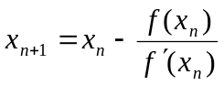

can be used to successively better approximate the zero x = c.

Notes:
1. We usually generate iterations until two successive iterates agree to a specified
number of decimal places.
2. Newton’s method generally converges to a zero in a small number (< 10) iterations.
3. Newton’s method may fail in certain instances.

Examples of Failure for Newton’s Method

1. Iterate produces a tangent line slope of zero.

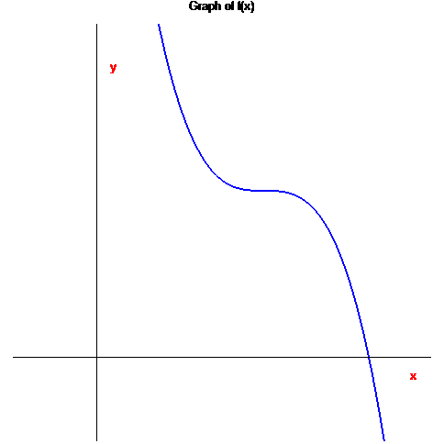

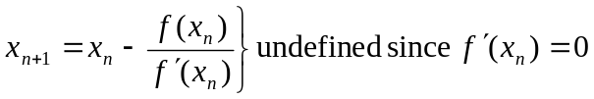

2. Initial guess not close enough

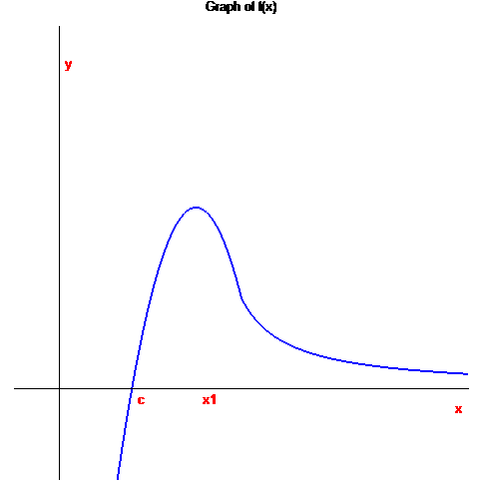
Example 2: Use Newton’s Method to approximate the zero)s of 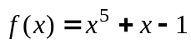 Continue the process until two successive approximations differ by less than 0.001.

Solution: > f := x^5 + x - 1;
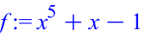
> plot(f, x = -3..3, view = [-3..3, -2..2]);
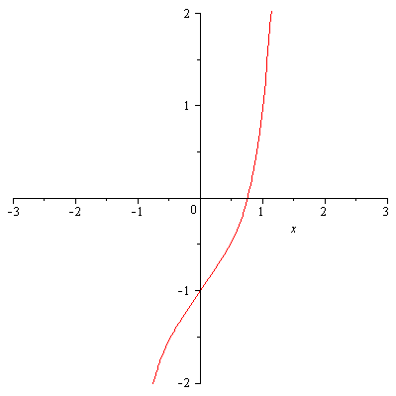

> f := x^5 + x - 1;
> plot(f, x = -3..3, view = [-3..3, -2..2]);
> N := x -> x - (x^5 + x - 1) / (5*x^4 + 1);
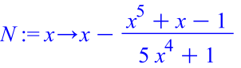
> x1 := 0.75;
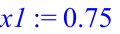
> x2 := evalf( N(x1) );
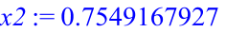
> abs(x2 - x1);

> x3 := evalf( N(x2) );
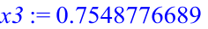
> abs(x3 - x2);
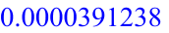
> x4 := evalf( N(x3) );
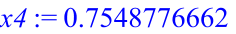
> abs(x4 - x3);
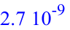

█
Example 3: Use Newton’s Method to approximate the solution of the equation 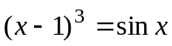. Continue the process until two successive approximations differ by less than 0.001.

Solution:

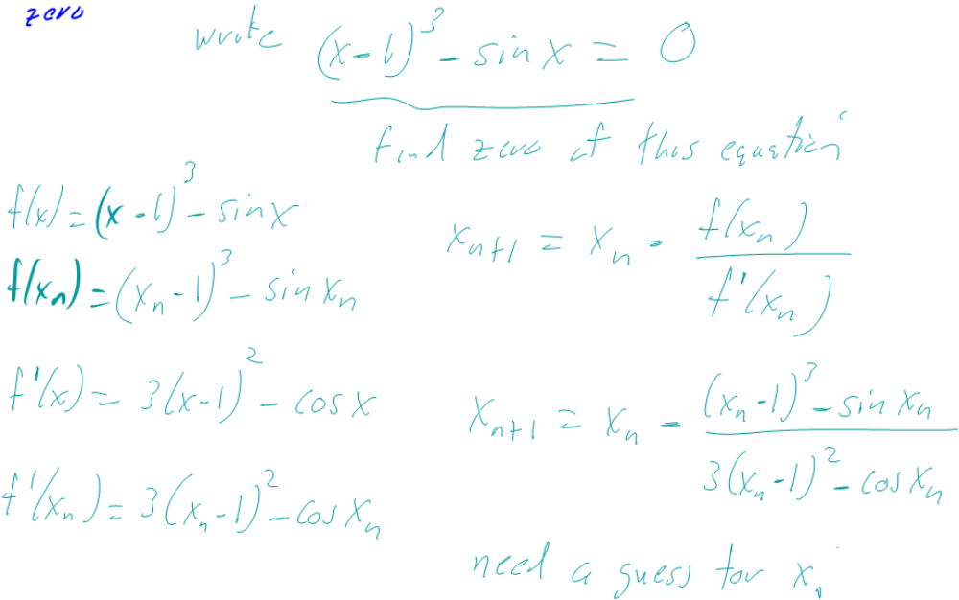

> f := x -> (x-1)^3 - sin(x);
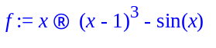
> plot(f(x), x = -3..3, view = [-3..3, -4..4]);
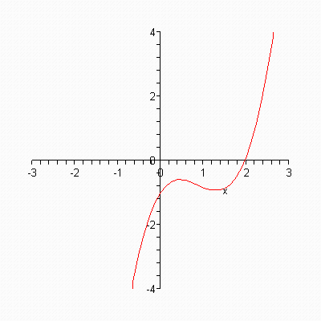

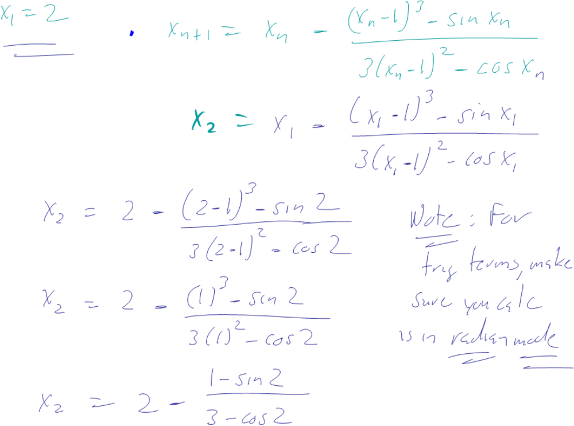

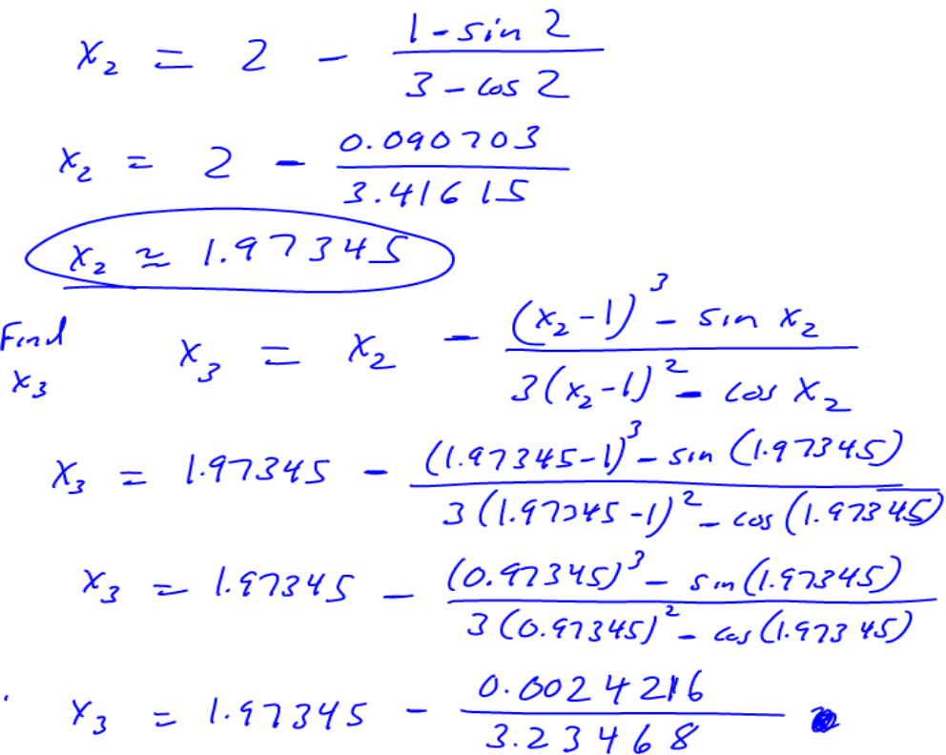
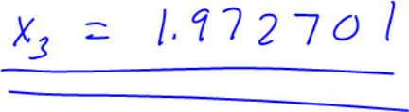

> f := x -> (x - 1)^3 - sin(x);
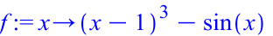
> plot(f(x), x = -3..3, view = [-3..3, -2..2]);
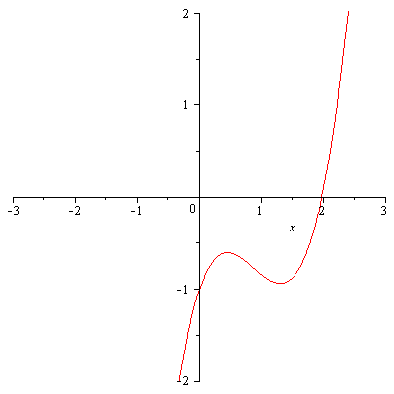
> N := x -> x - ((x-1)^3 - sin(x)) / (3*(x-1)^2 - cos(x));
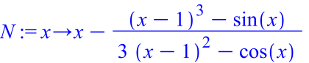
> x1 := 2;
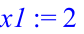
> x2 := evalf( N(x1) );
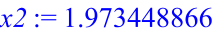
> abs(x2 - x1);

> x3 := evalf( N(x2) );
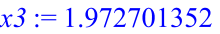
> abs(x3 - x2);

> x4 := evalf( N(x3) );
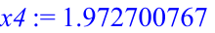
> abs(x4 - x3);


