Section 2.7: Related Rates

In a related rates problem, we want to compute the rate of change of one quantity in terms of the rate of change of another quantity (which hopefully can be more easily measured) at a specific instance in time.

Recall! The instantaneous rate of change (from now on, we just shorten and call the rate of change) of a quantity is just its derivative with respect to time t. In our problems, we will differentiate quantities implicitly on both sides of an equation with respect to the variable t.

Example 1: Given 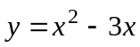, find 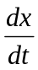 given that x = 1 and 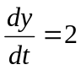.
Solution:

█

Steps for Setting up and Solving Related Rate Problems
1. After carefully reading the problem, ask yourself immediately what the problem wants
you to find. Then determine the quantities that are given. Assign variables to
quantities.
2. You will need to find an equation to obtain the quantities you obtained in step 1. This
equation will be the one you will need to implicitly differentiate to obtain the variables
rate of change quantities you determined in step 1. Drawing a picture sometimes will
help. It may be necessary in some cases to use the geometry of the situation to
eliminate one of the variables by substitution.
3. Implicitly differentiate both sides of the equation you found in step 2 with respect to
time t. Solve for the unknown related rate, using the known quantities at specific instances in time for the quantities you assigned in step 1.

The following geometry formulas can sometimes be helpful.

Volume of a Cube: 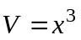, where x is the length of each side of the cube.
Surface Area of a Cube: 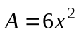, where x is the length of each side of the cube.

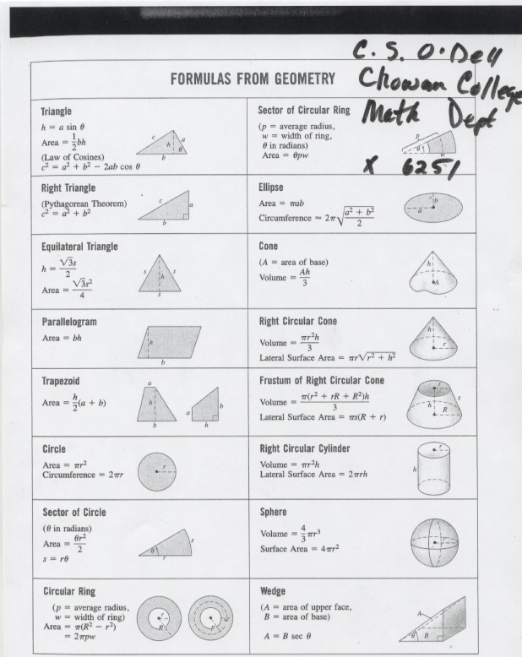
Example 2: A rock is dropped into a calm lake, causing ripples in the form of concentric circles. The radius of the outer circle is increasing at a rate of 2 ft/sec. When the radius is 5 ft, at what rate is the total area of the disturbed water changing.

Solution:

█
Example 3: Suppose the volume of spherical balloon is increasing at a rate of
288 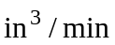. Find the rate in which the radius increases when the diameter of the balloon is 48 in.

Solution:

█
Example 4: The altitude (height) of a triangle is increasing at a rate of 2 centimeters/minute while the area of the triangle is increasing at a rate of 5 square centimeters/minute. At what rate is the base of the triangle changing when the altitude is 11 centimeters and the area is 88 square centimeters?

Solution: In this problem, we want to find how fast (the rate) the base of the triangle is changing. The rate of change is given by the derivative with respect to time. We need to assign our variables. Consider the following figure.

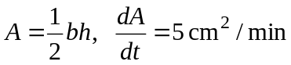
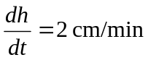

h

b

Here, b = the length of the base of the triangle, h = the triangle’s height, and A = the triangle’s area. The altitude (height) of the triangle is increasing at a rate of 2 cm/min. This represents how much the height h is changing with respect to t, that is, . The area of the triangle is increasing at a rate of 5 cm/min. This represents how much the area A is changing with respect to t, that is, 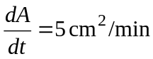. Our goal is the find how fast base of the triangle is changing, that is, the rate of change of b with respect to t, 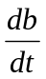. To relate the variable quantities, we use the area formula for a triangle, which is
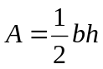
Differentiating both sides implicitly with respect to t (note the product rule is needed on the right hand side) gives

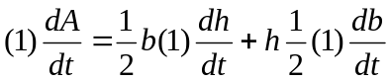

or
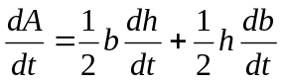

The next three steps solve this equation for .

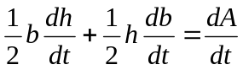

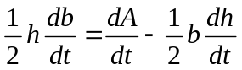

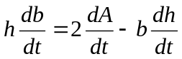

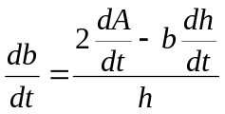

We want to find at the precise point in time when the area A = 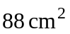 and the height h = 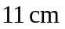. However, we still do not know what the base b is in this precise point in time. We can find it using the triangle area equation.
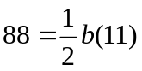
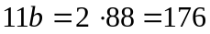

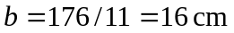

Thus, we want at the precise point in time when A = , h = , b = 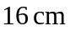, , and . Hence, we have

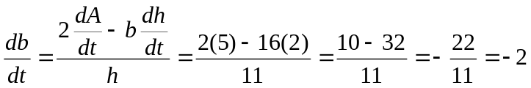

Hence, the base of the triangle is changing at a rate of -2 cm/min (the negative sign just means the base of the triangle is getting smaller at a rate of 2 cm/min). █
Example 5: At noon, ship A is 40 nautical miles due west of ship B. Ship A is sailing west at 24 knots and ship B is sailing north at 22 knots. How fast (in knots) is the distance between the ships changing at 6 PM? (Note: 1 knot is a speed of 1 nautical mile per hour.)

Solution:

█
Example 6: A water tank has the shape of an inverted circular cone where the height and diameter are the same. If water is being pumped into the tank at a rate of 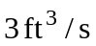, find the rate the water level is rising when the water is 2 ft deep.

Solution: In this problem, we want the rate that the water is rising (the height of the water is increasing) at the precise point in time when the height of the water is 2 ft and the rate of change of volume is . The water tank has the following shape:

r

h

The volume of a right circular cone is given by the formula

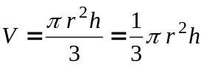,

where h is the height of the cone and r is the radius of the base. In this problem we want 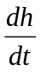 when the height is 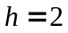 and the volume rate is 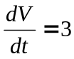. However, nothing is said about the radius r in this problem. However, we can use the fact stated in the problem that the height and diameter d of the cone are the same. Using the fact that the diameter is twice the radius, we can form the following relationship between the cone height and the radius:

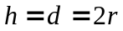

(Continued on next page)
or solving for the radius the equation.

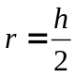

We now substitute the into the volume equation 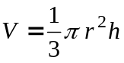 to obtain

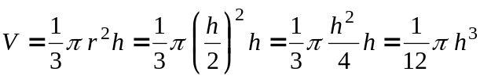.

Now, we take the equation 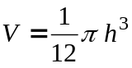 and implicitly differentiate both sides as follows:

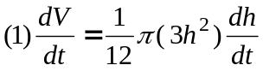

or

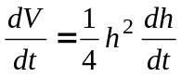

Solving for gives
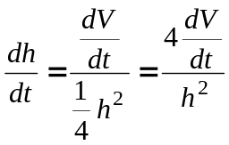

Substituting the values and the volume rate is gives the rate of height increase of the water:

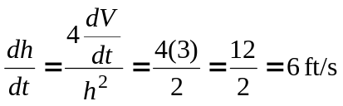

█
Example 7: A street light is at the top of a 20 ft tall pole. A woman 6 ft tall walks away from the pole with a speed of 5 ft/sec along a straight path. How fast is the tip of her shadow moving when she is 50 ft from the base of the pole?

Example 8: Water is leaking out of an inverted conical tank at a rate of 11900.0 cubic centimeters per min at the same time that water is being pumped into the tank at a constant rate. The tank has height 15.0 meters and the diameter at the top is 5.0 meters. If the water level is rising at a rate of 27.0 centimeters per minute when the height of the water is 1.5 meters, find the rate at which water is being pumped into the tank in cubic centimeters per minute.

Solution: In this problem, the water tank has the following shape:

r

h

The volume of a right circular cone is given by the formula

,

where h is the height of the cone and r is the radius of the base. In this problem we want to find the rate the water is flowing into the tank. In terms of rate of change of volume, 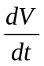, we find this rate using the equation

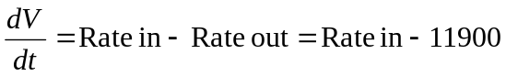

(Continued on next page)
Hence, if we can find the rate the volume is changing, we can find the rate the water is flowing into the tank using the formula

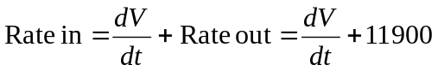

Now, using the volume of a right circular cone formula

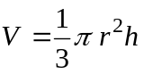,

we first want to find the rate that the volume is changing at the precise point in time when the height of the water is h =1.5 m (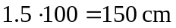) and the rate of change of height of the water is 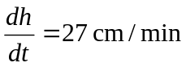. However, nothing is said about the radius r in this problem. However, we can relate the height h and the radius r of the water using similar triangles with the entire conical tank. Using similar triangles, we can say that

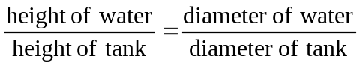

or in variable terms

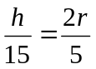

Solving for r in this equation gives

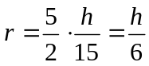

We now substitute the 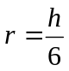 into the volume equation to obtain

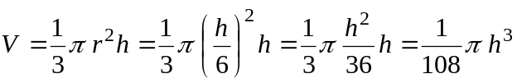.

(Continued on next page)

Now, we take the equation 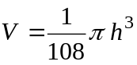 and implicitly differentiate both sides as follows:

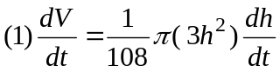

or

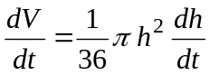

We now find when h =150 cm and .

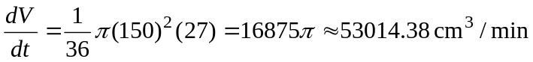

Thus,

█

